CSD430-340A Server Side Development (2267-DD)
Student: Noor El-din Al Salihi
Assignment: Module 7.2 Working with CRUD-CREATE & JavaBeans – Project Part 2
Date: 2026-07-10

Assignment Summary

The application builds upon the Movie Database application to include the CREATE operation via JavaBeans, JSP Scriptlets and MySQL. You can enter in a movie record by way of a JSP form. Upon submission the application will add the record to the database and show all movie records in an HTML table.

Screenshots
Figure 1. Updated index.jsp running with the Create Movie Record form.
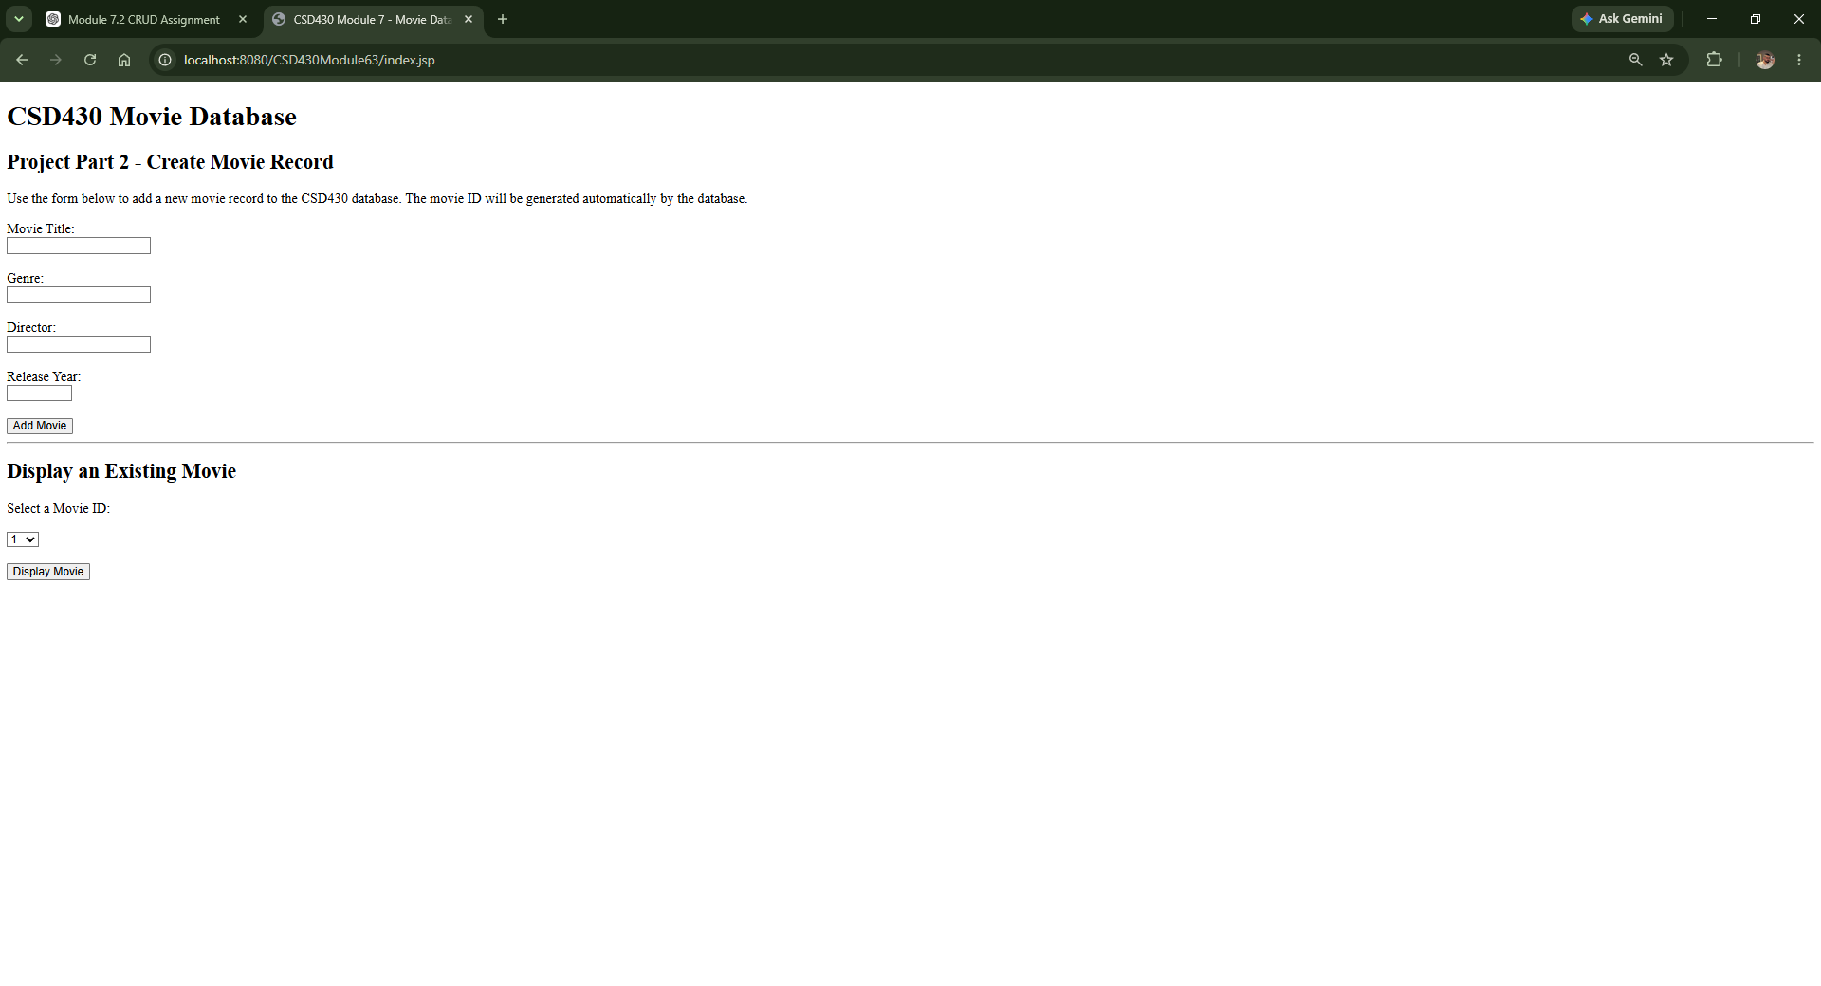
Figure 2. New movie successfully inserted and all records displayed.
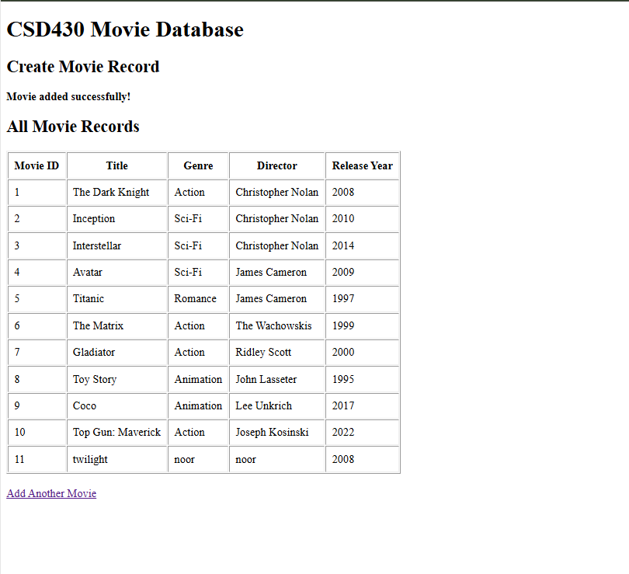
Figure 3. Updated MovieDAO.java with CRUD methods.
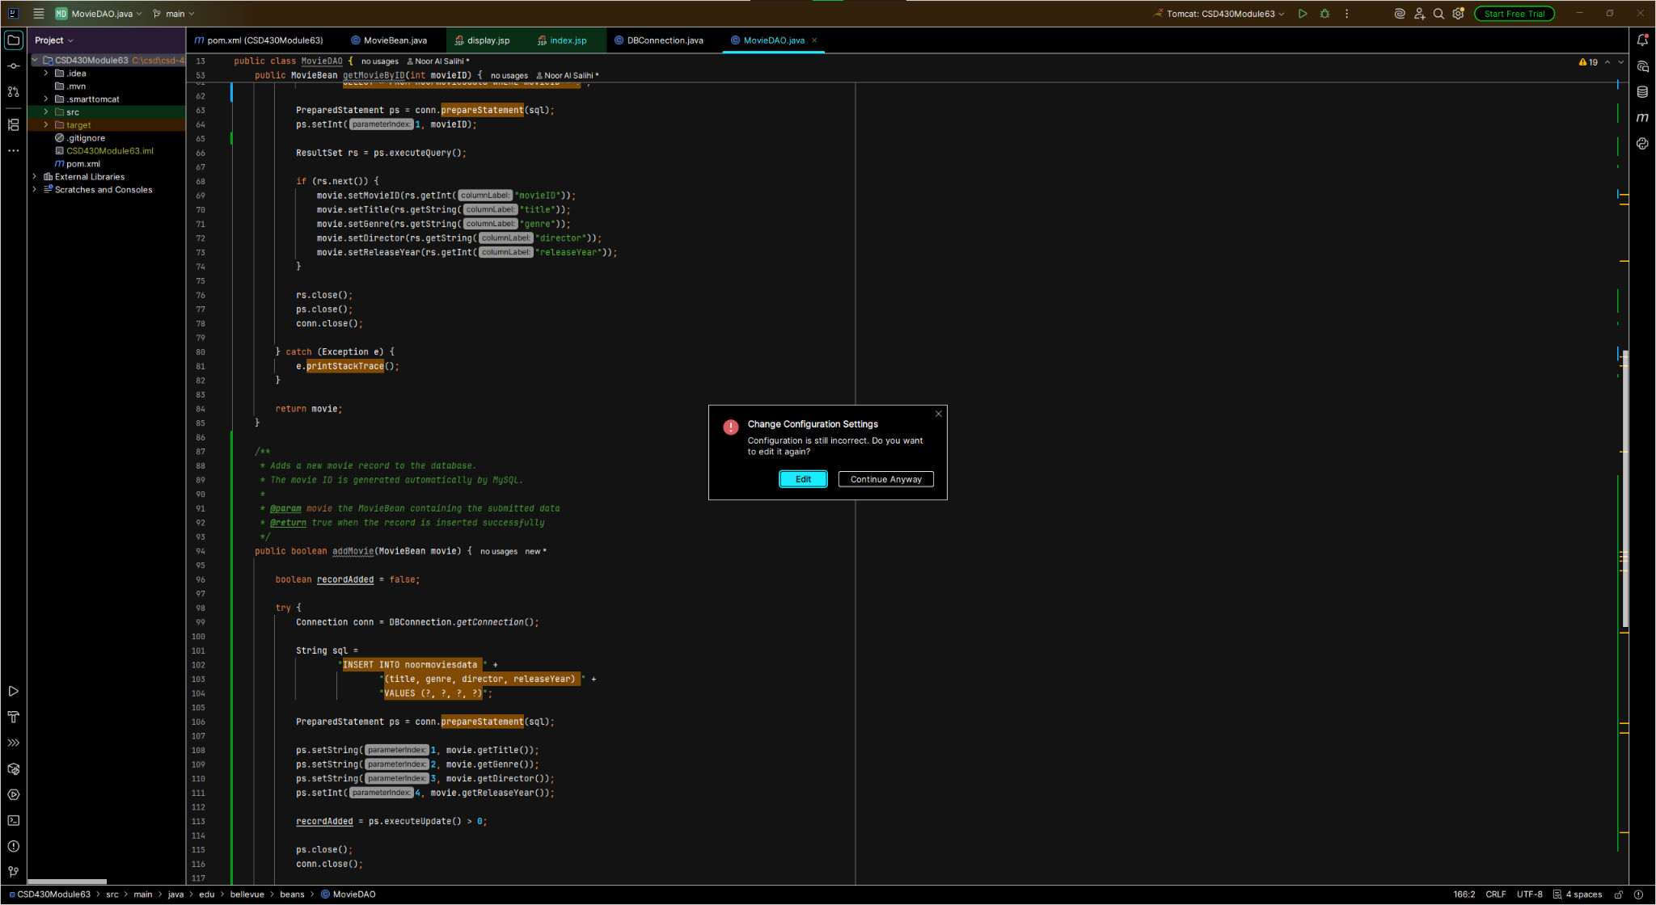
Figure 4. Tomcat configuration used to run the application.
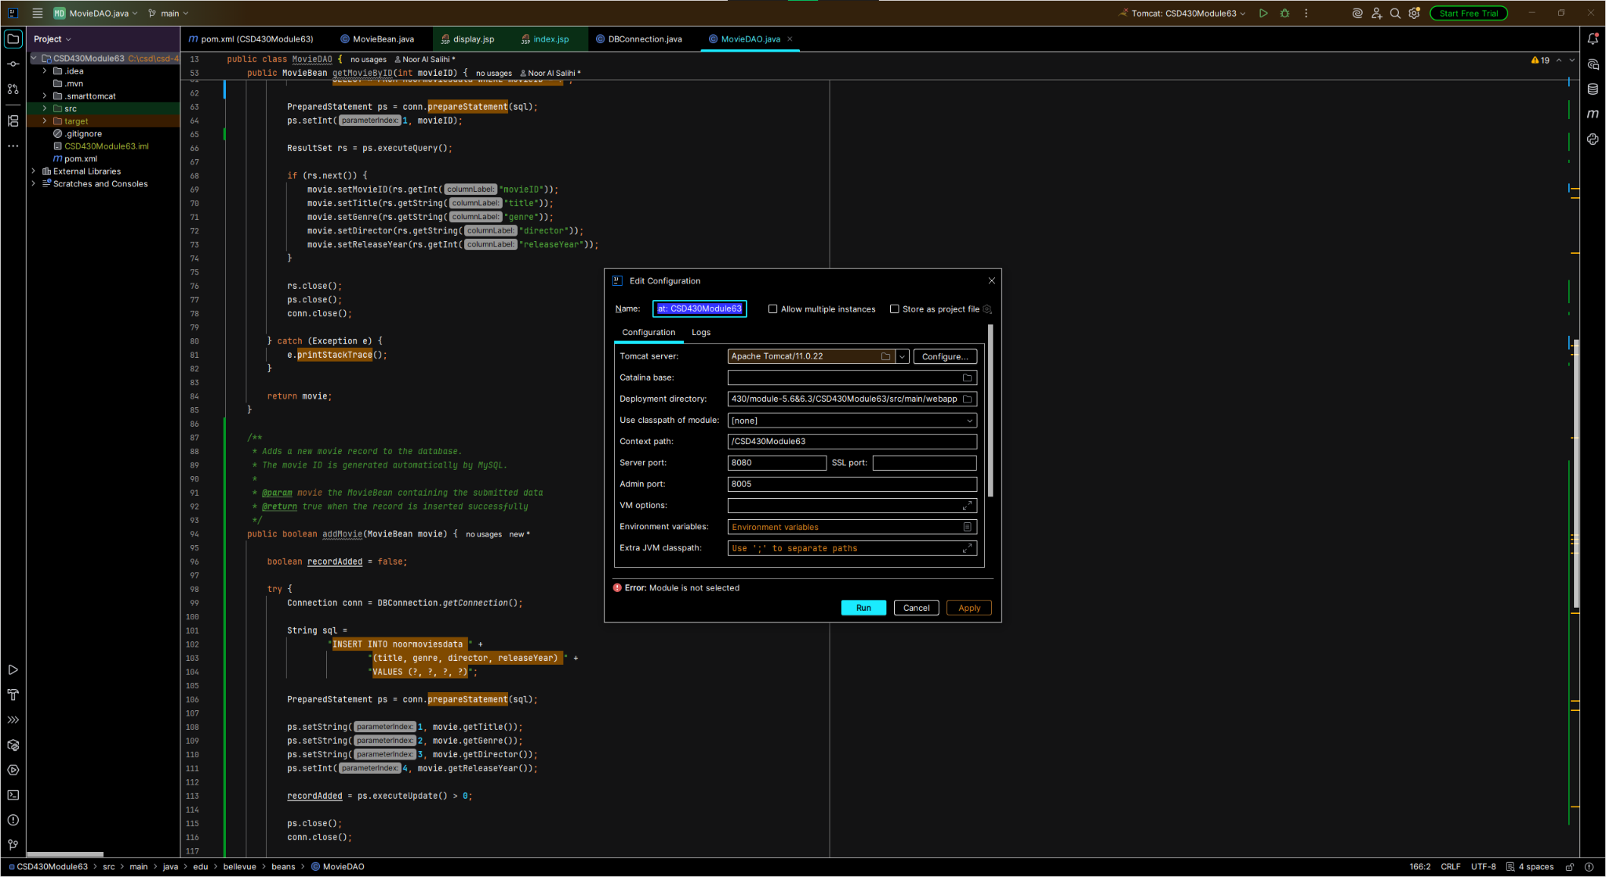

GitHub Repository
Paste your GitHub repository URL here before submitting the assignment.

