Module 8.2 Working with CRUD-CREATE & JavaBeans – Project Part 3
Name: Noor El-din Al salihi
Course: CSD430-340A Server Side Development (2267-DD)
Assignment: Module 8.2 – Project Part 3
Date: July 16, 2026

Screenshots

Updated project structure in IntelliJ.
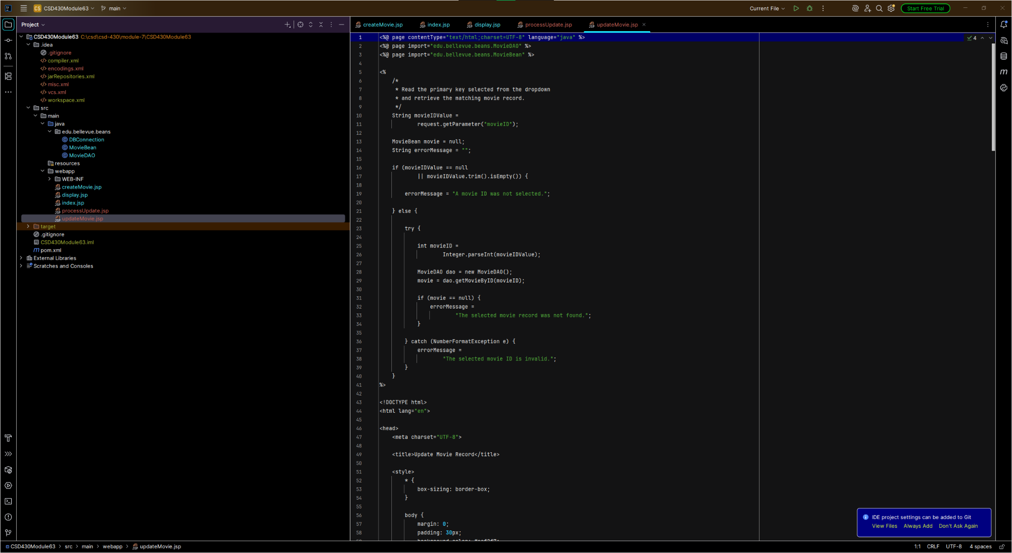

Application home page with Create, Display, and Update sections.
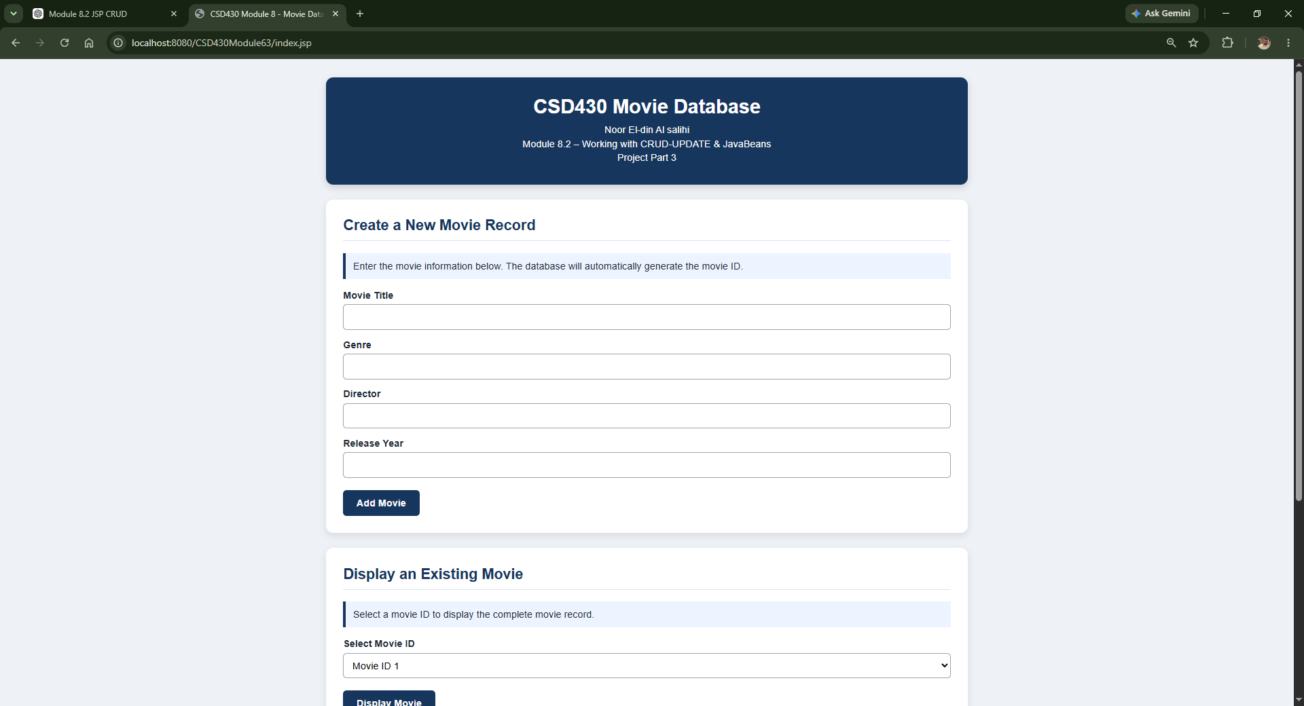

Home page showing Update functionality.
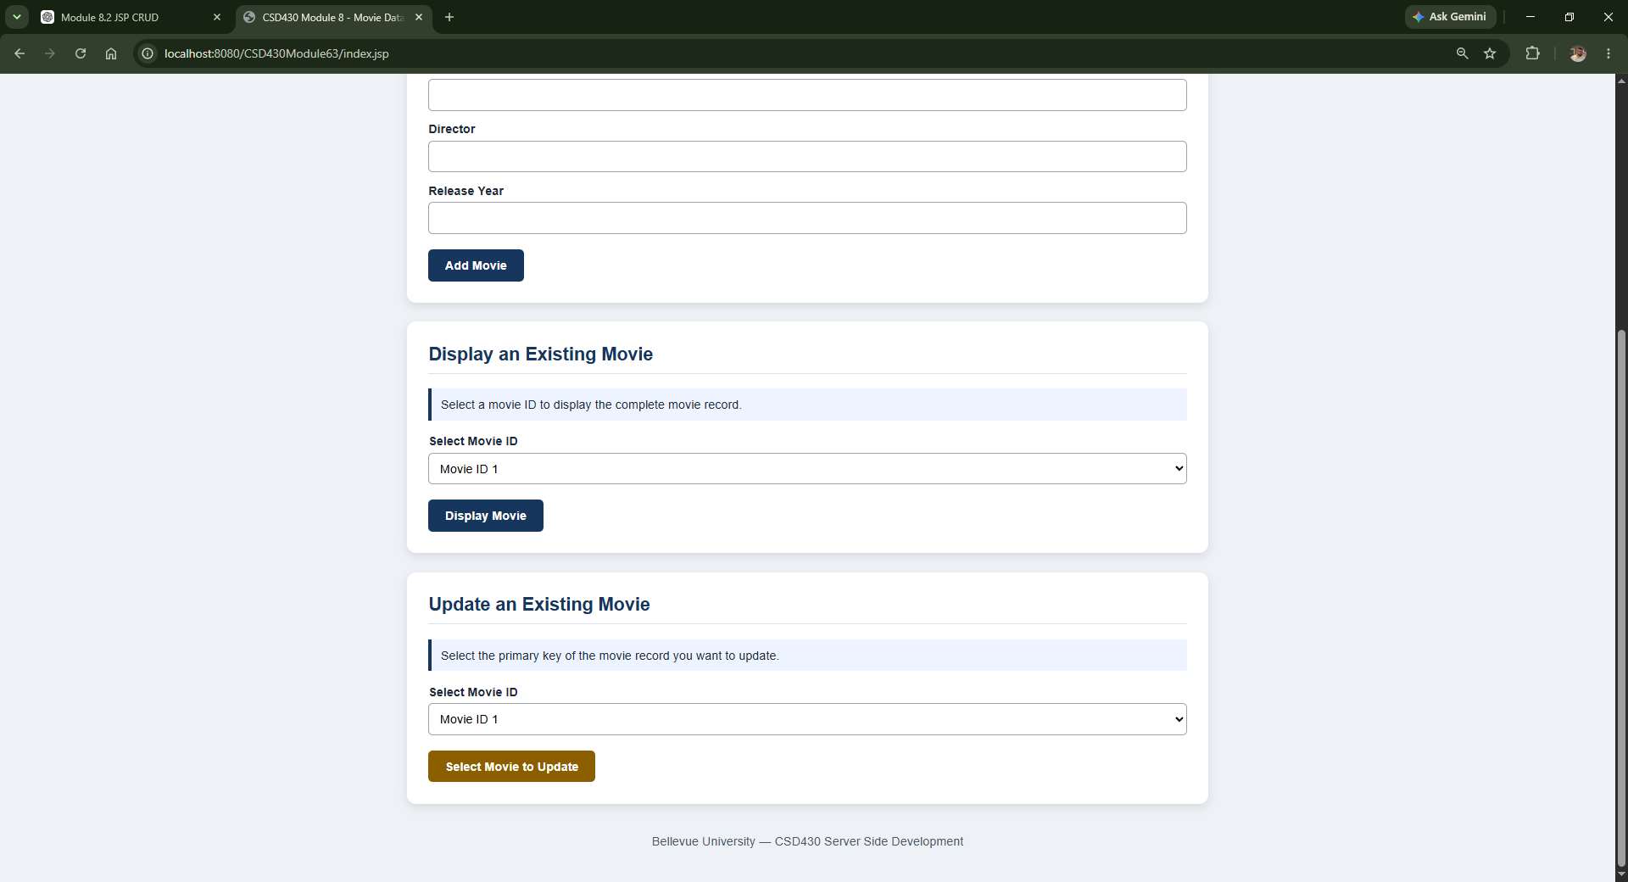

Display Movie page showing selected record.
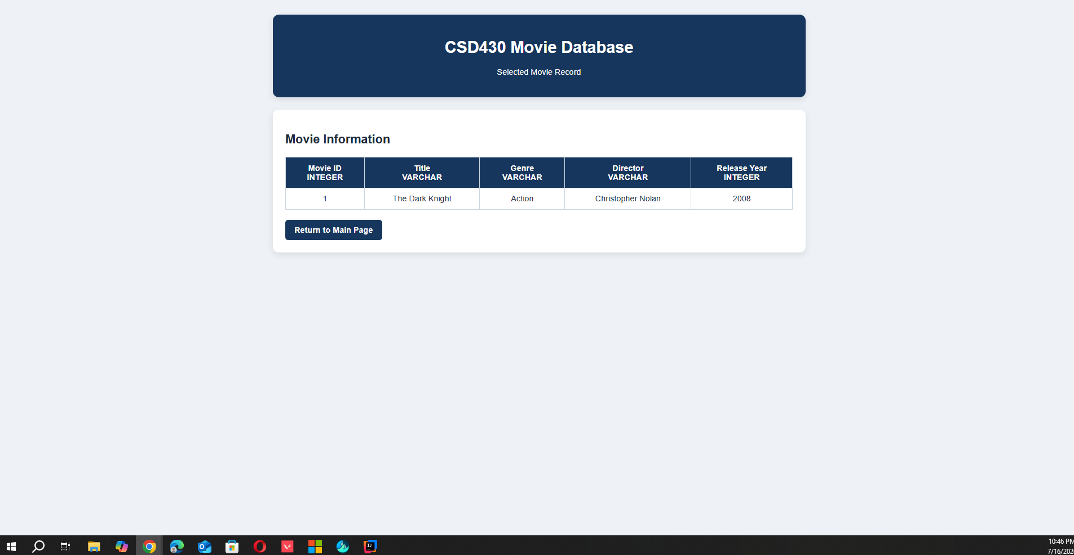

Update Movie page with editable fields and read-only primary key.
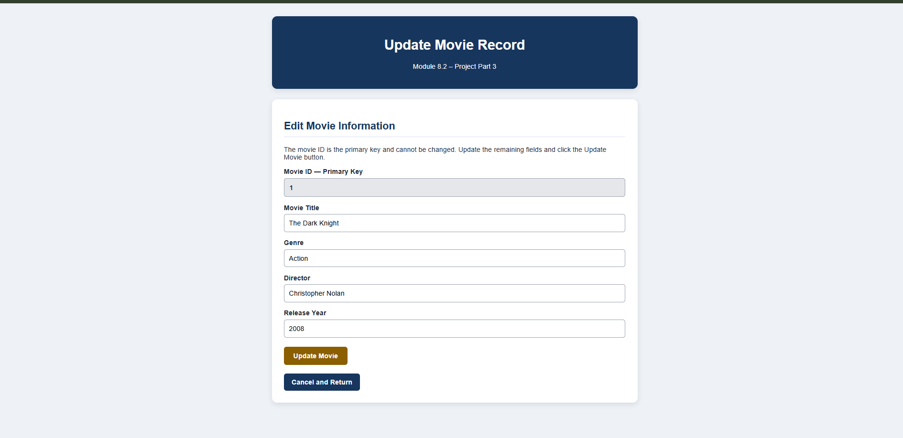

Final project folder structure.
