CSD430-340A Server Side Development (2267-DD)

Modules 5.2 & 6.2 Project Part 1 Documentation
Noor El-din Al Salihi
CSD 430
07/01/2026

Project configuration and PHP files
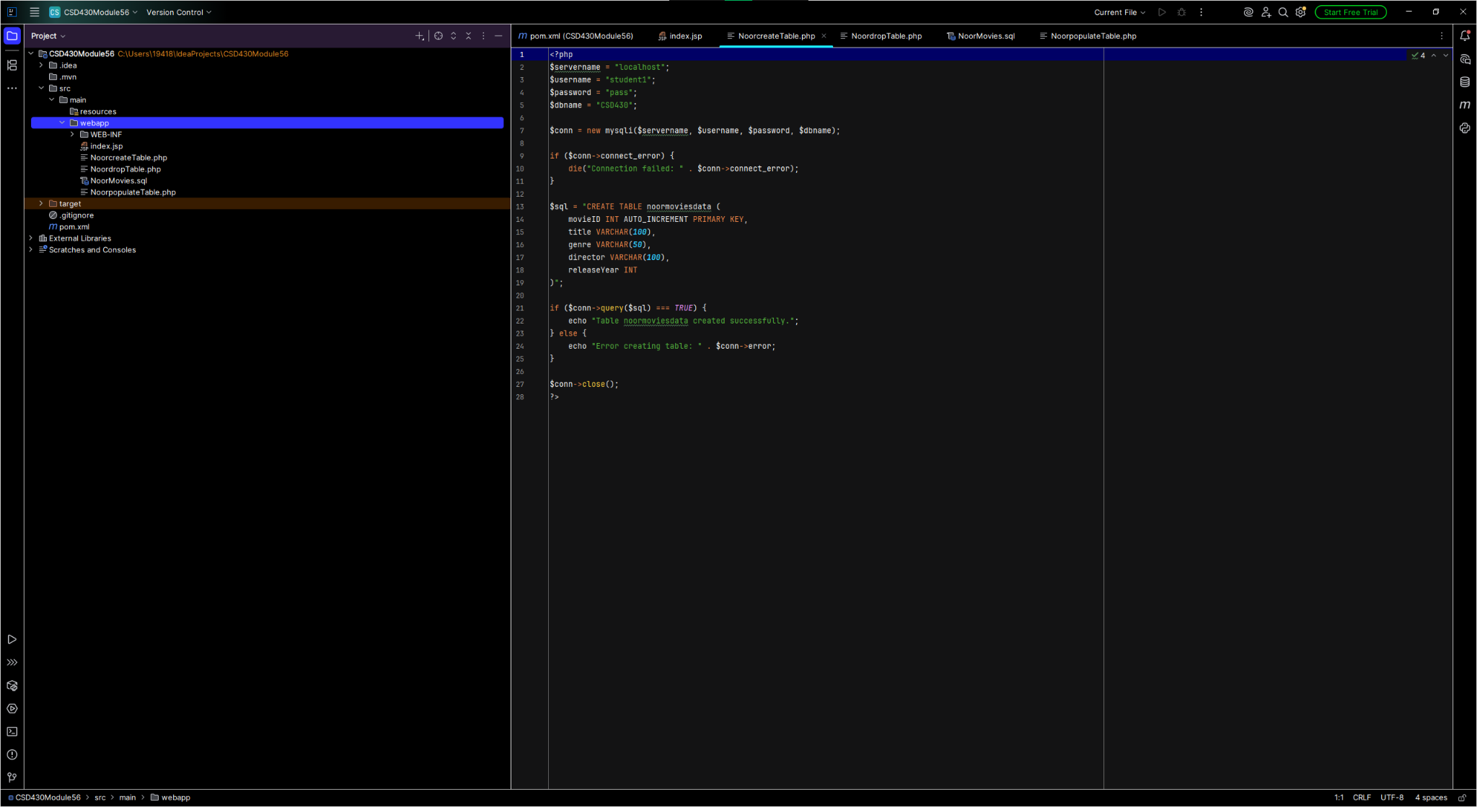

Updated index.jsp and project structure
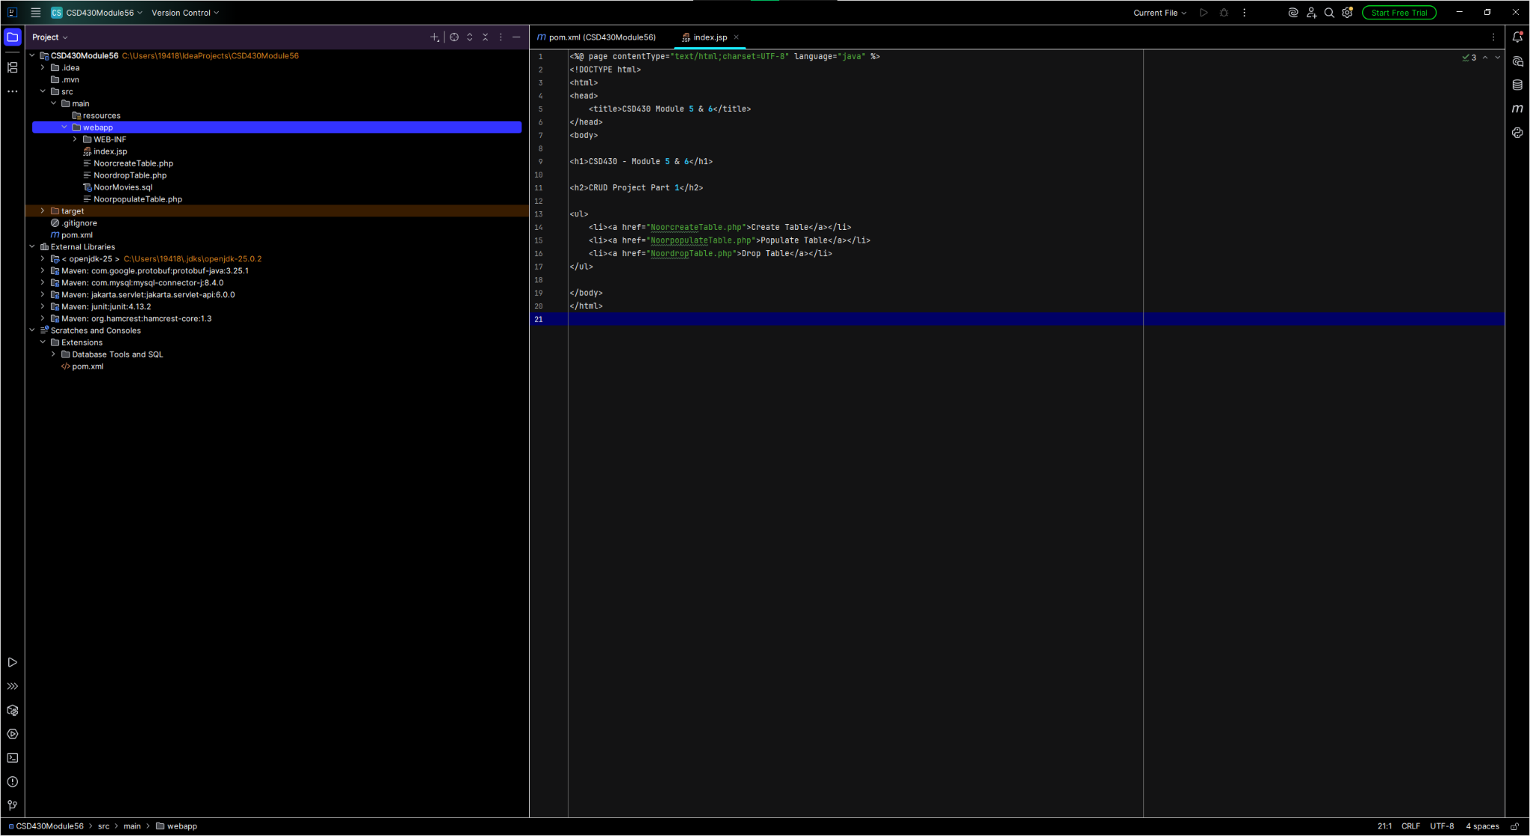

Project structure before moving SQL file
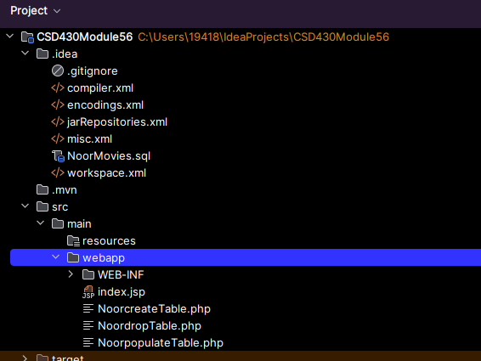

Final project structure
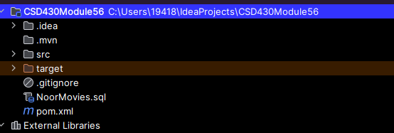

Assignment Summary
Database: CSD430
Table: noormoviesdata
Primary Key: movieID
Records: 10
Files included: NoorMovies.sql, NoorcreateTable.php, NoorpopulateTable.php, NoordropTable.php, index.jsp, pom.xml.

