CSD430 Module 3.2 Programming Assignment
Restaurant Feedback Form JSP Project
Name: Noor El-din Al salihi
Course: CSD430-340A Server Side Development (2267-DD)
Assignment: Module 3.2 Programming Assignment
Date: June 20, 2026
Documentation Screenshots

Project Overview

This document explains the Restaurant Feedback JSP form assignment. Apache Tomcat is used to deploy/run the JSP pages. The form takes input from a user regarding their experience at a restaurant. The user submits the information which is posted to another JSP page where the information they submitted is shown.

Screenshot 1: Apache Tomcat Installation Folder
This screenshot shows the Apache Tomcat 11.0.22 directory used to run the JSP project manually.
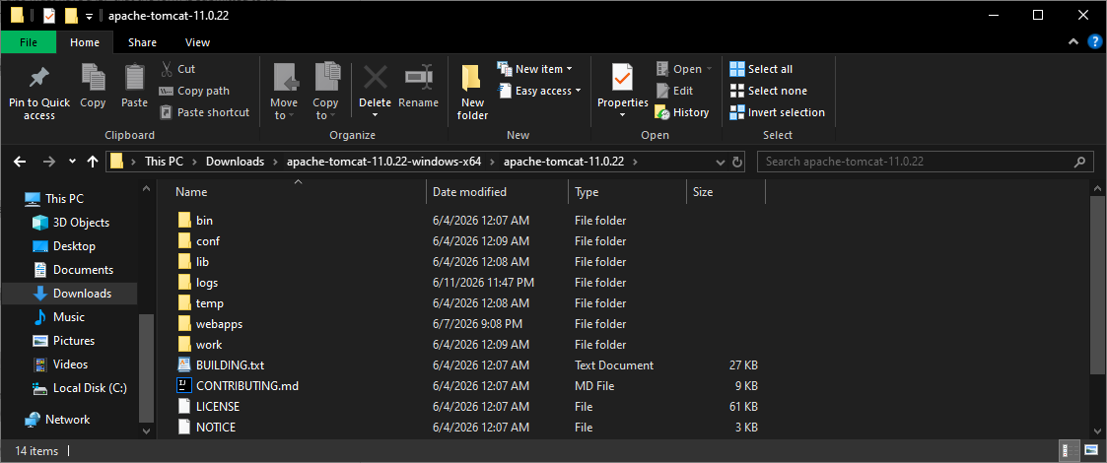

Screenshot 2: Tomcat Bin Folder
This screenshot shows the Tomcat bin folder that contains catalina.bat and startup.bat.
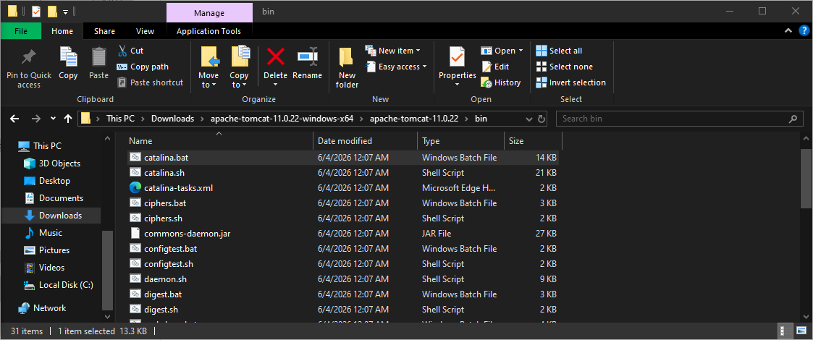

Screenshot 3: Tomcat Running Successfully
This screenshot shows Tomcat running successfully from the command line and deploying the RestaurantFeedback web application.
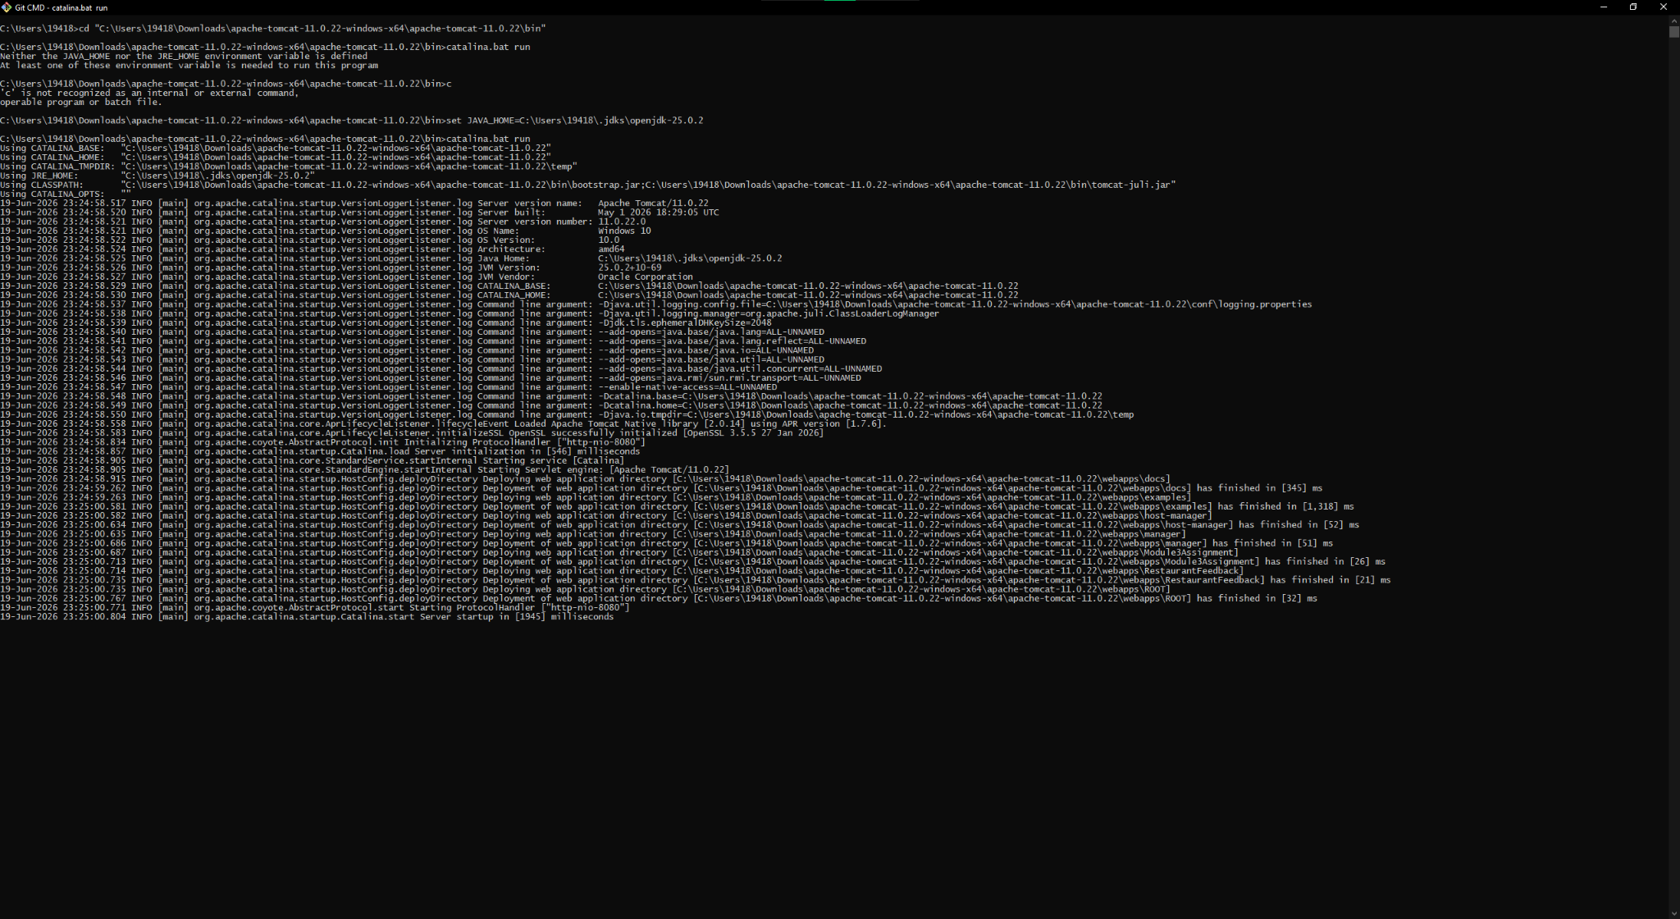

Screenshot 4: Completed Restaurant Feedback Form
This screenshot shows the completed feedbackForm.jsp page with user input entered before submission.
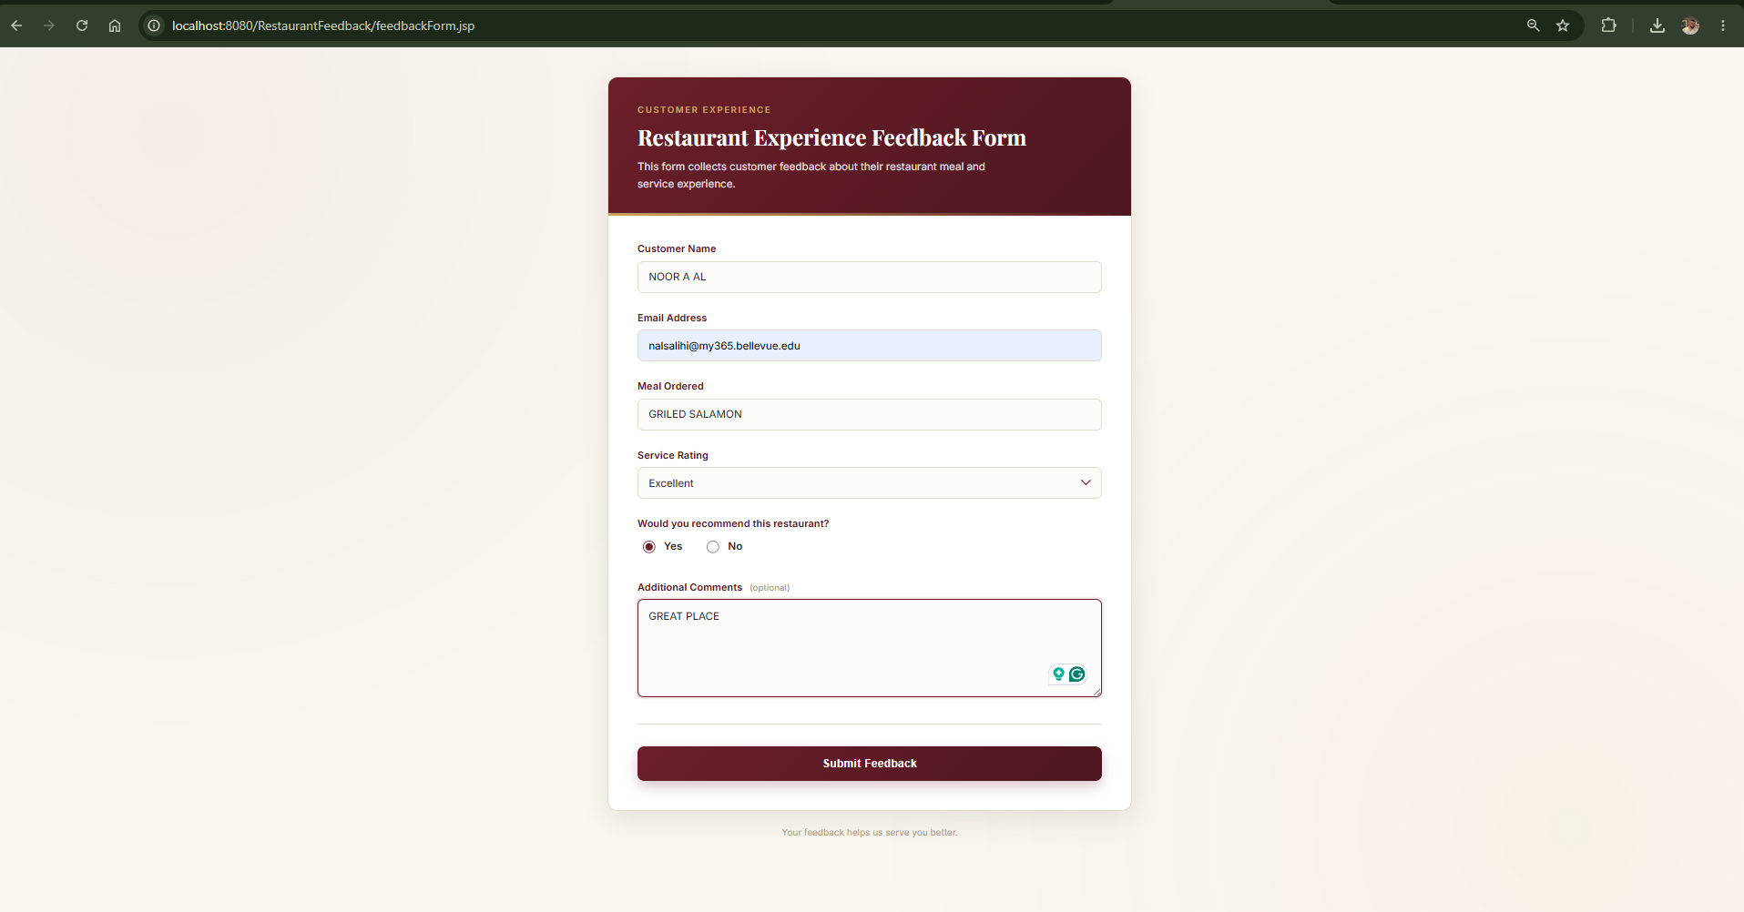

Screenshot 5: Submitted Feedback Results Page
This screenshot shows the separate displayFeedback.jsp page displaying the submitted feedback data.
