CSD430-340A Server Side Development (2267-DD)
Module 6 Programming Assignment
Student: Noor El-din Al Salihi
Date: July 02, 2026
Project: JSP Movie Database Application

Assignment Summary
Example JSP Movie Database Project This example shows how to use JavaBeans, DAO, JDBC, MySQL and Apache Tomcat together in a JSP based Movie Database Application. This application prompts the user to enter a Movie ID. It then displays information about the movie from the database.

Figure 1. MovieDAO implementation in IntelliJ.
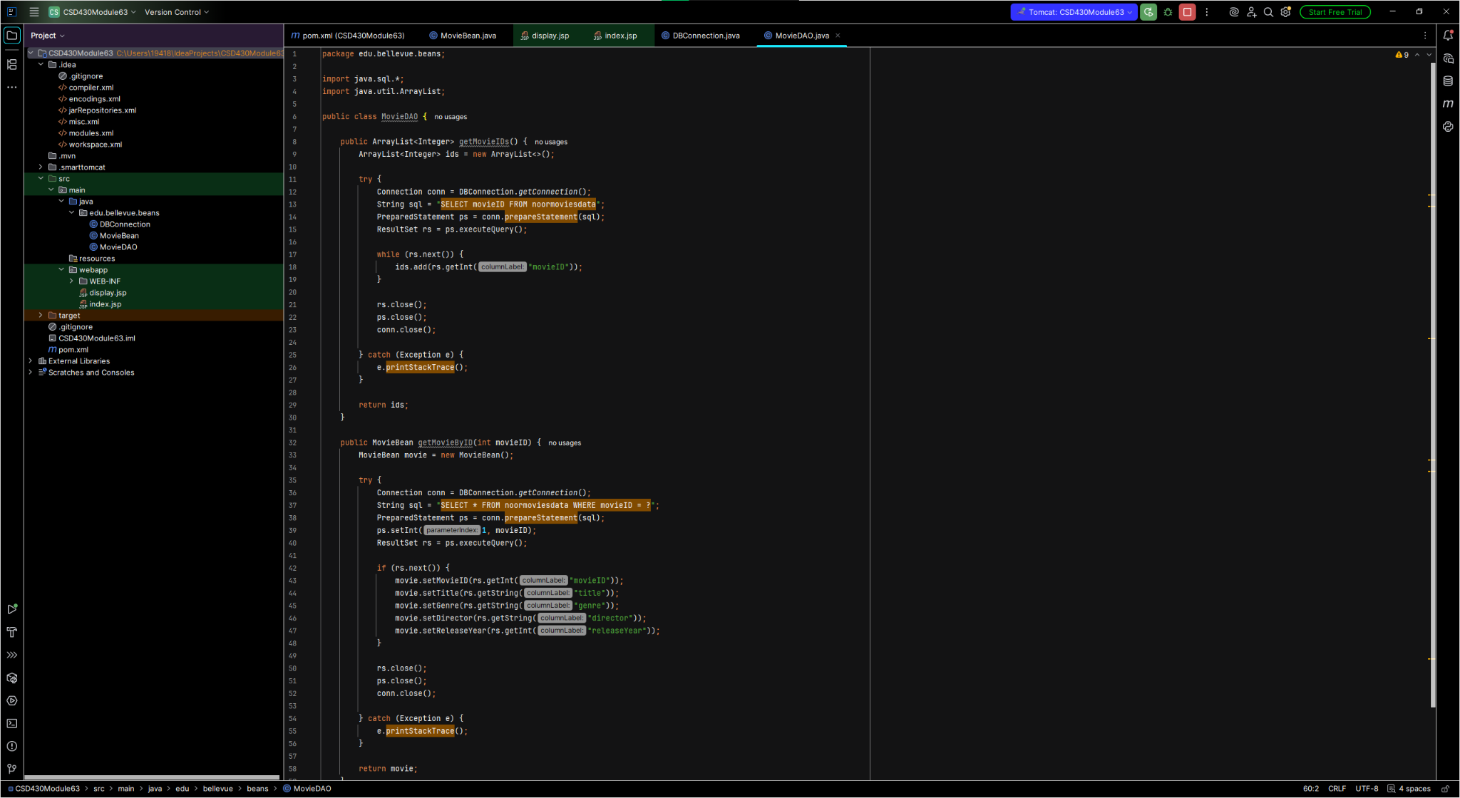
Figure 1. MovieDAO implementation in IntelliJ.

Figure 2. SmartTomcat Run/Debug configuration.
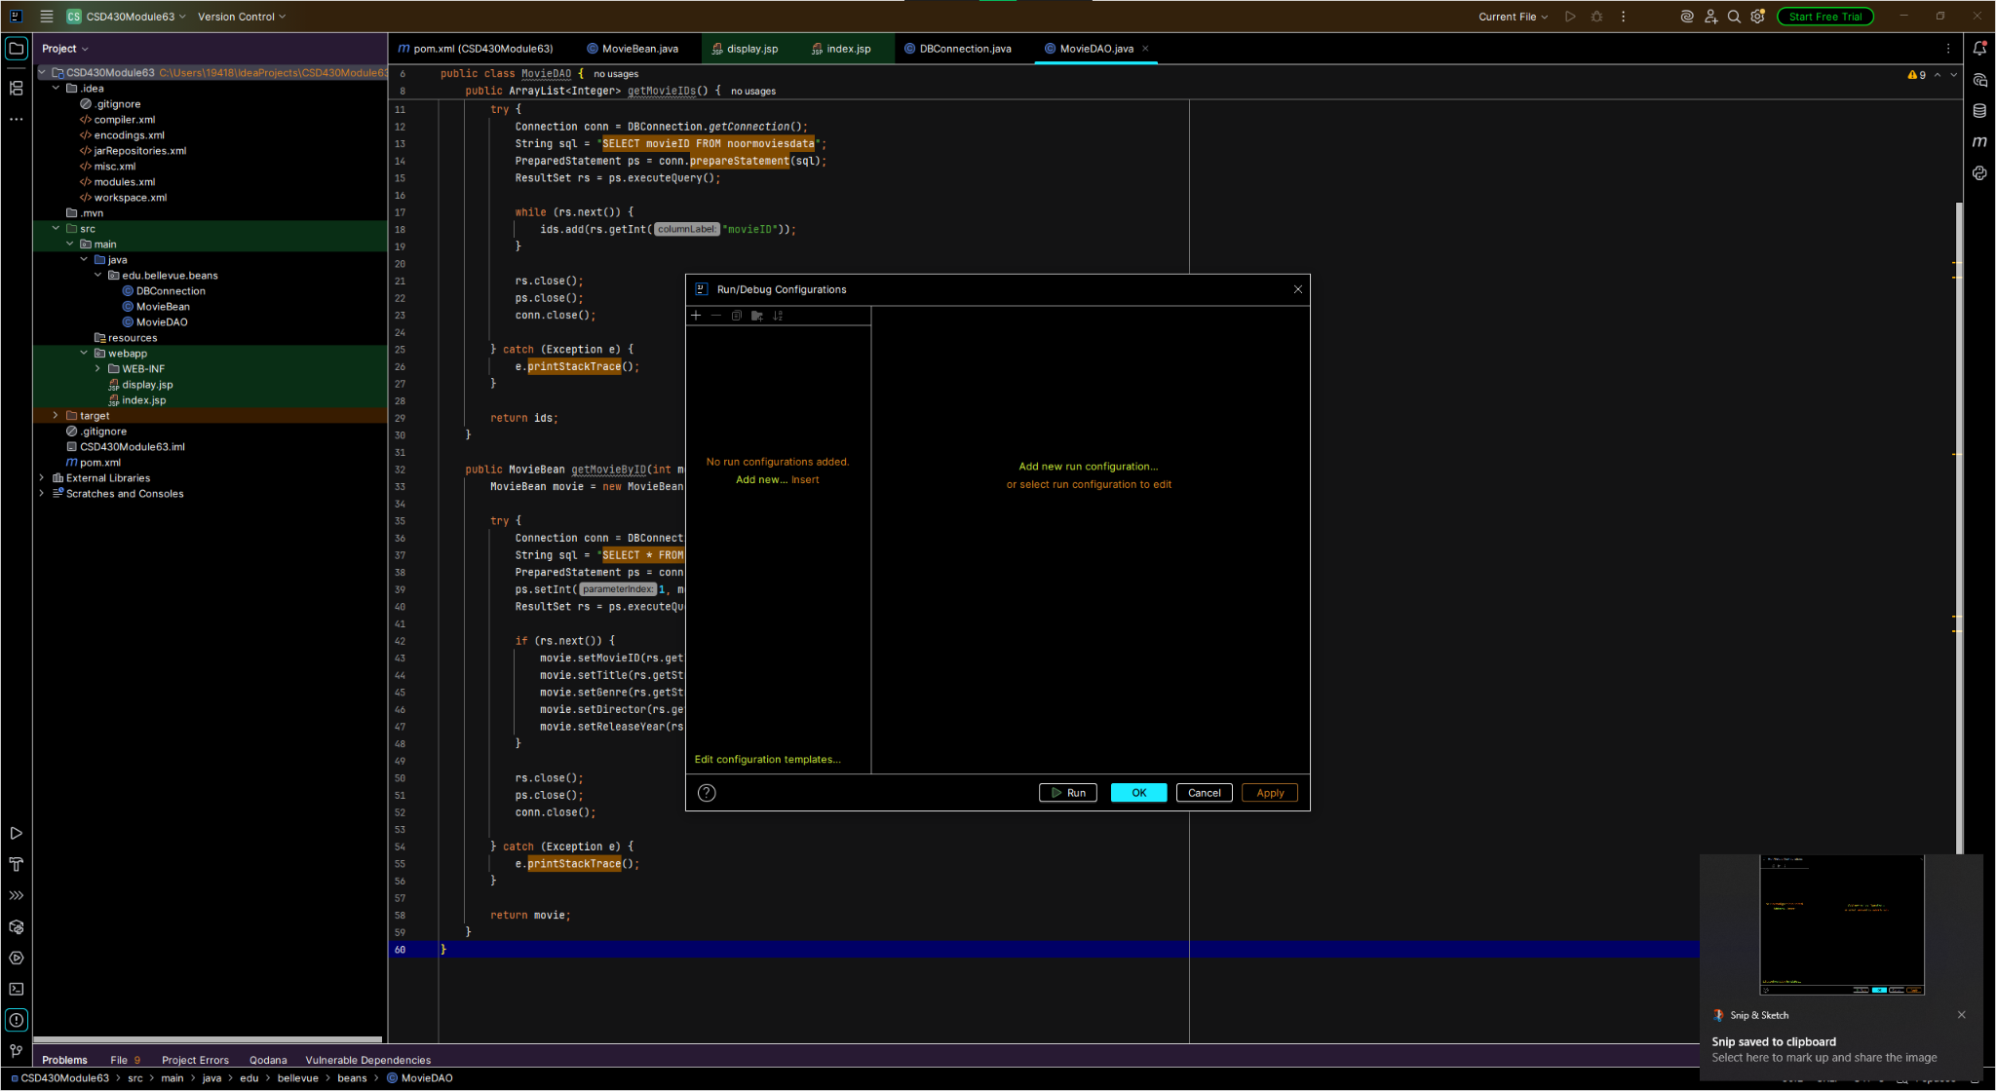
Figure 2. SmartTomcat Run/Debug configuration.

Figure 3. Movie Information page displaying database results.
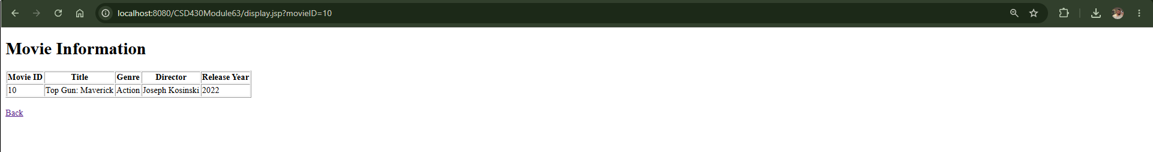
Figure 3. Movie Information page displaying database results.

Figure 4. Movie Database home page.
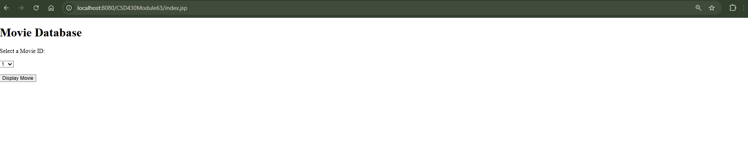
Figure 4. Movie Database home page.

Figure 5. SmartTomcat configuration with Tomcat server and module.
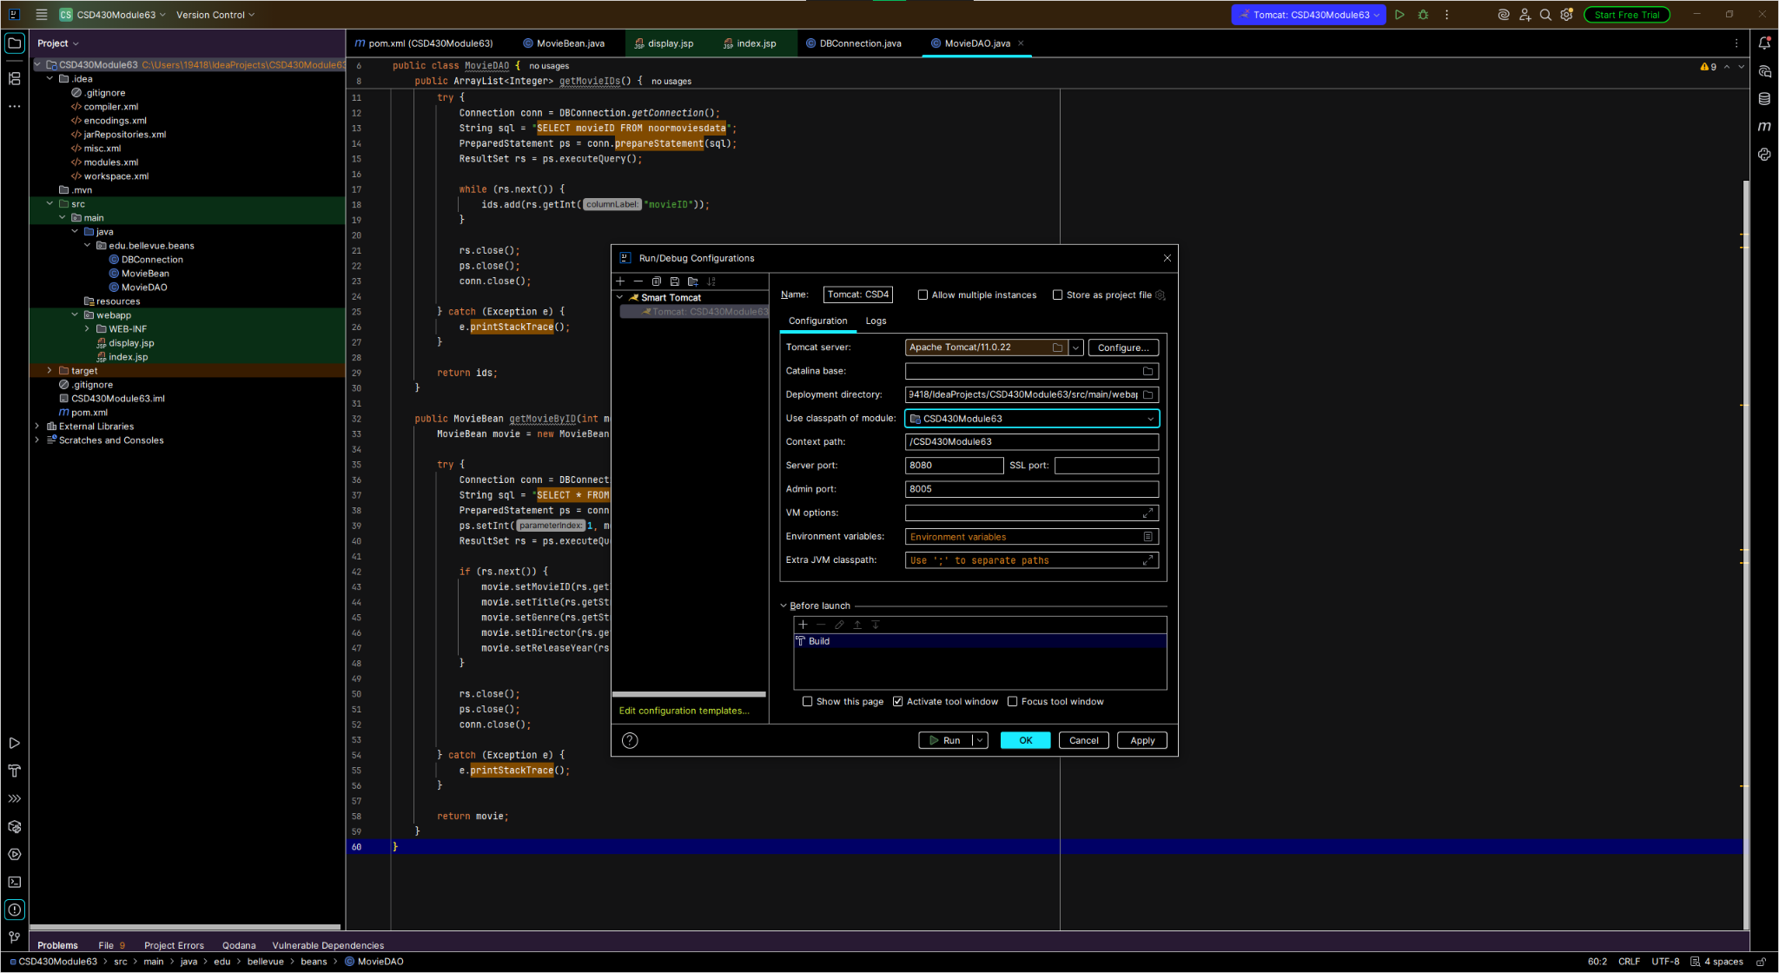
Figure 5. SmartTomcat configuration with Tomcat server and module.

Figure 6. Tomcat server successfully running in IntelliJ console.
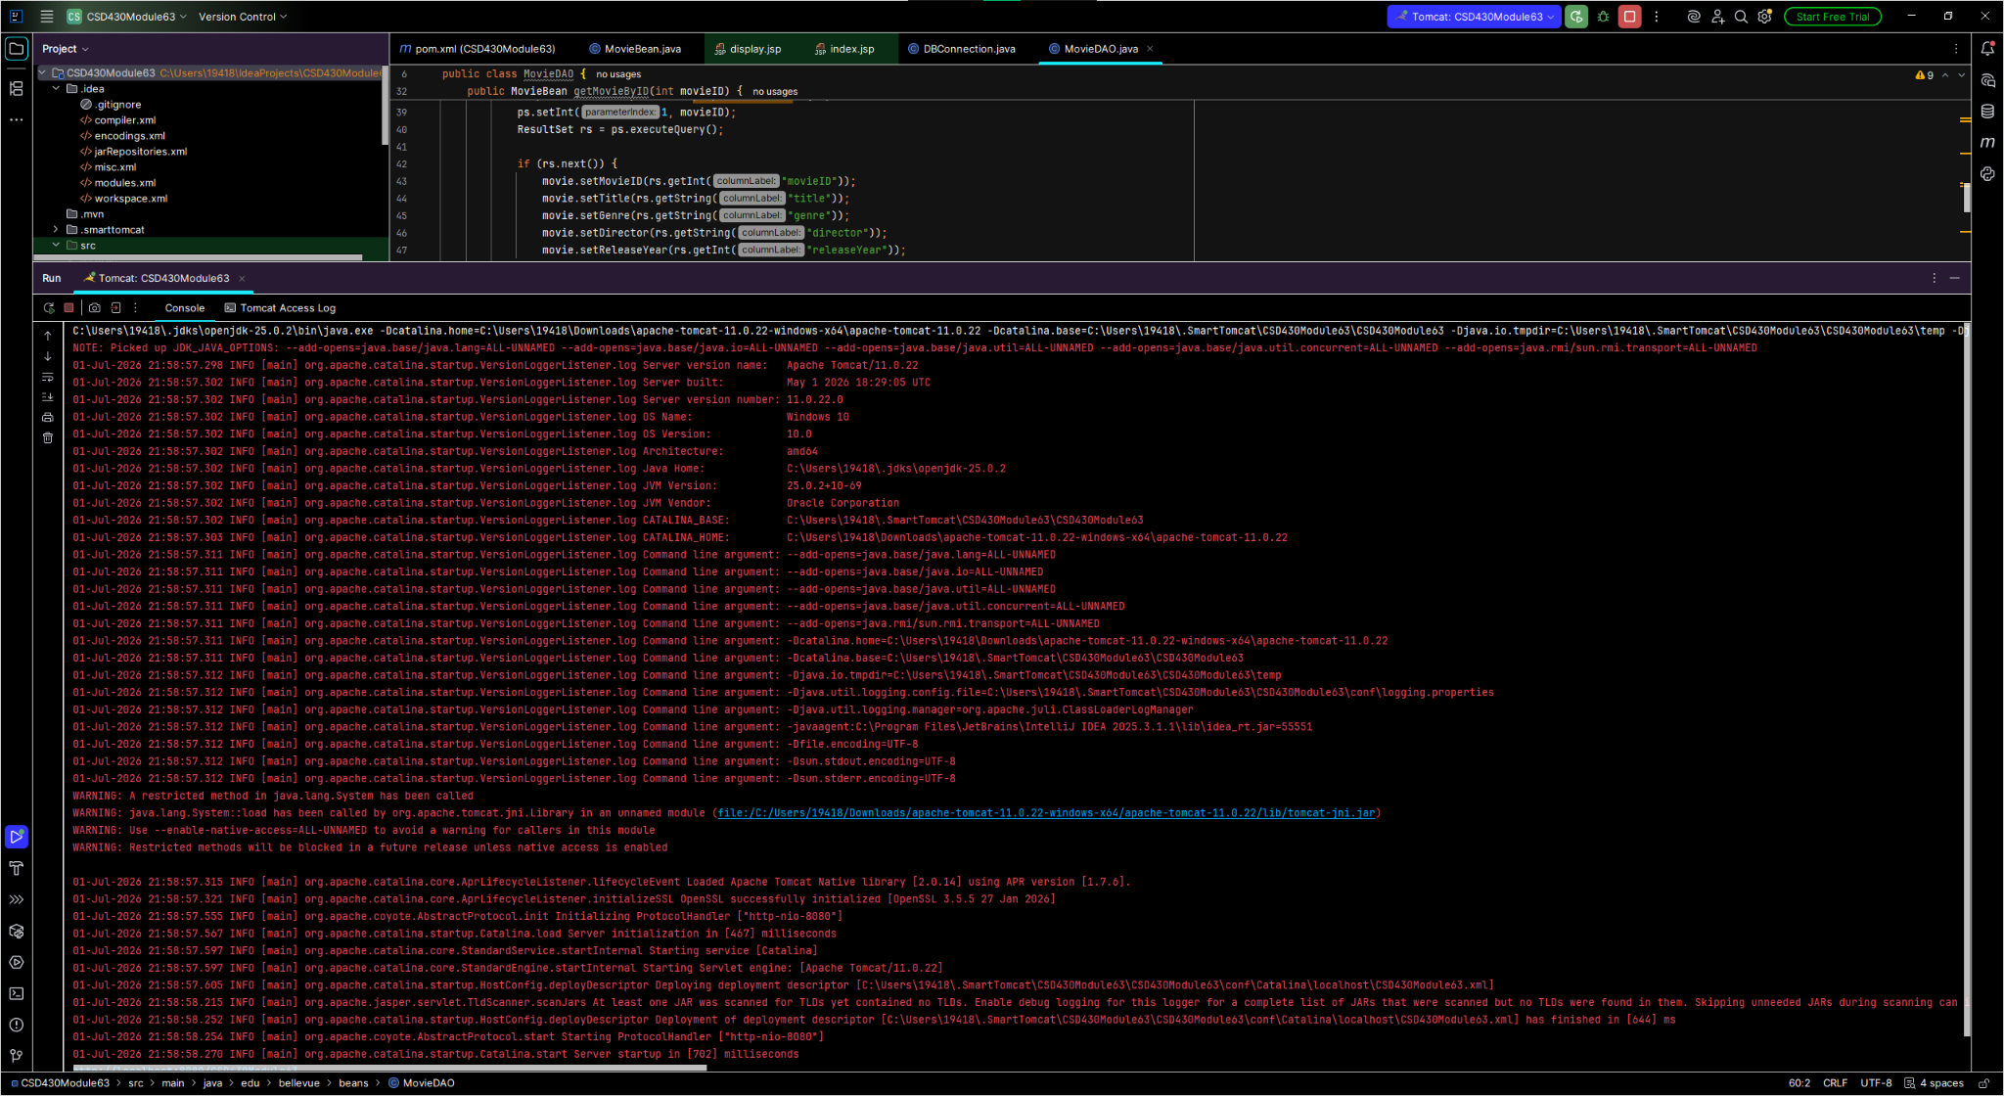
Figure 6. Tomcat server successfully running in IntelliJ console.

Conclusion
Tomcat application deployed fine. Screenshots are proof of project folder, configured SmartTomcat folder, tomcat server running, and jsp pages running while displaying movies from MySQL.

