Module 11.2 Programming Assignment
CSD-440 Server-Side Scripting
Noor Al Salihi
October 10, 2026

Module 11.2 Documentation
The screenshots below demonstrate the NoorPDF.php program and the successful PDF output created from the Module 8 soccer_players database table.
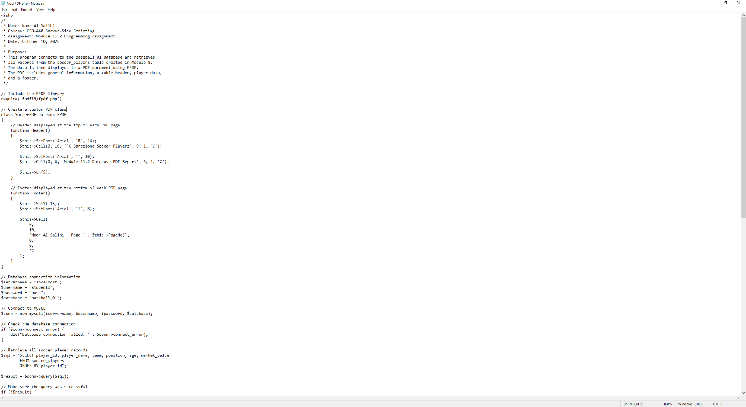
Figure 1. NoorPDF.php - program documentation, FPDF setup, header/footer, and database connection.

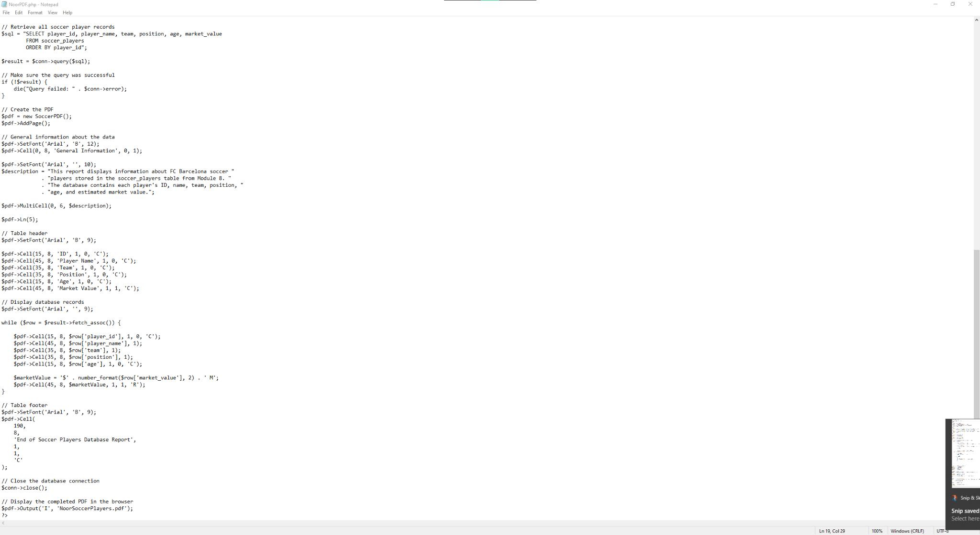
Figure 2. NoorPDF.php - database query, PDF table creation, database records, table footer, and PDF output.

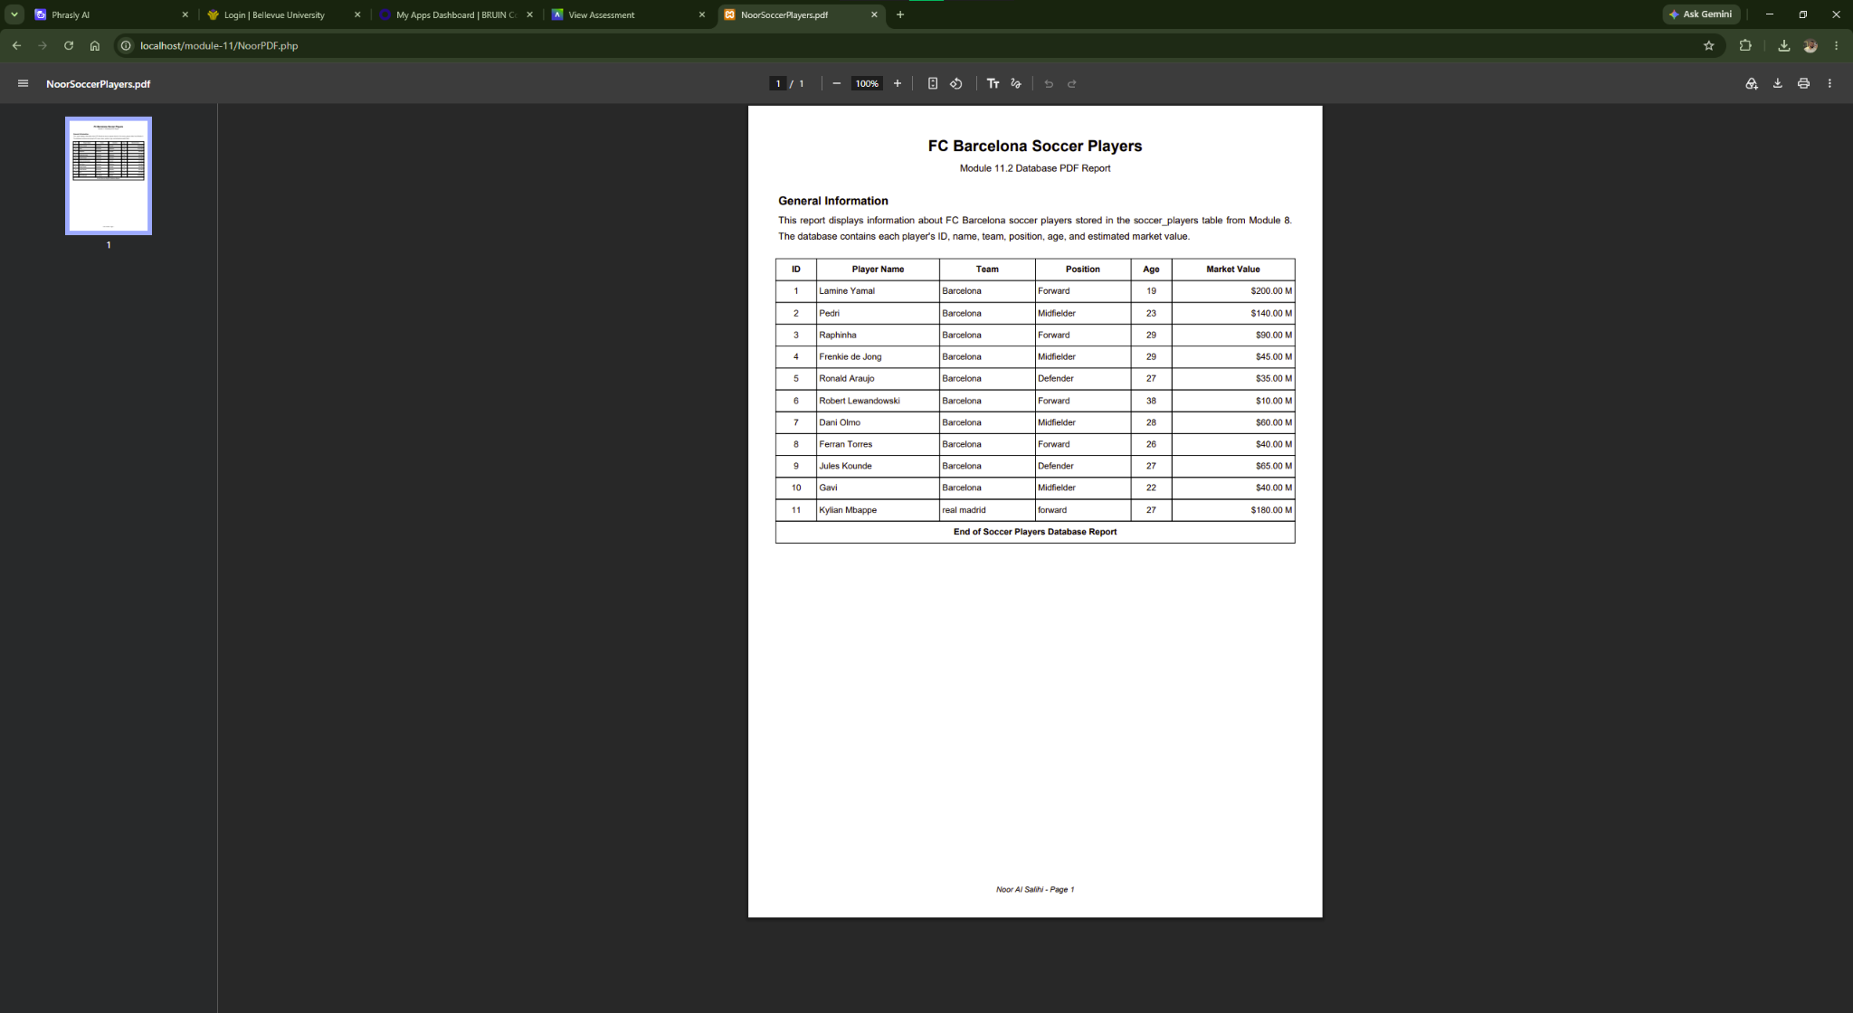
Figure 3. Successful PDF output in the browser showing the database data in table format with general information, header, and footer.

