Module 7.2 Programming Assignment
Documentation

CSD440 - Server-Side Scripting

Noor Al Salihi

September 11, 2026

Module 7.2

Assignment Verification
This is my build, execution, and testing of Module 7.2 PHP form program. The program asks the user to enter seven separate fields of data utilizing numerous types of inputs. Upon submission NoorResponse.php validates the information submitted and outputs either the data entered on a formatted page or validation errors.

Program Requirements Demonstrated
* Seven fields of user-entered data. Your form asks for first name, last name, email address, age, birth date, favorite color and preferred contact method.
* Your form requires at least four different entry/input types. Text input, email input, number input, date input, select menu and radio buttons have been used.
* NoorResponse.php validates that required fields contain data. Validates email address and age for valid entries.
* Valid data entered displays on a nicely formatted response page.
* Missing or incorrect data produces an error that explains what is wrong.
* File names begin with your first name. I used NoorForm.html and NoorResponse.php.
* Uses standard HTML tags. Form was tested through Apache/PHP using XAMPP and localhost.
Testing Summary
I first tested the form using valid data to fill in all fields. This returned a successful response that displayed all seven values. I then tried testing the form leaving the first name and email address blank. The PHP code returned an error page pointing out that those fields were required.

Module 7.2 - Screenshot 1
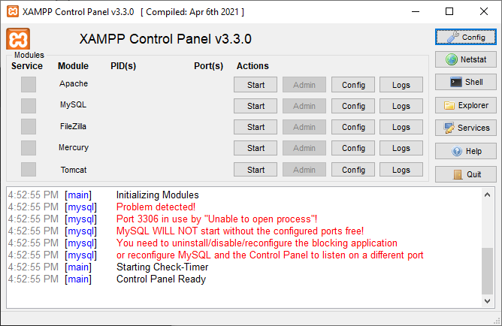
Figure 1. XAMPP Control Panel before starting Apache. This screenshot shows the local XAMPP environment used for the PHP assignment.

Module 7.2 - Screenshot 2
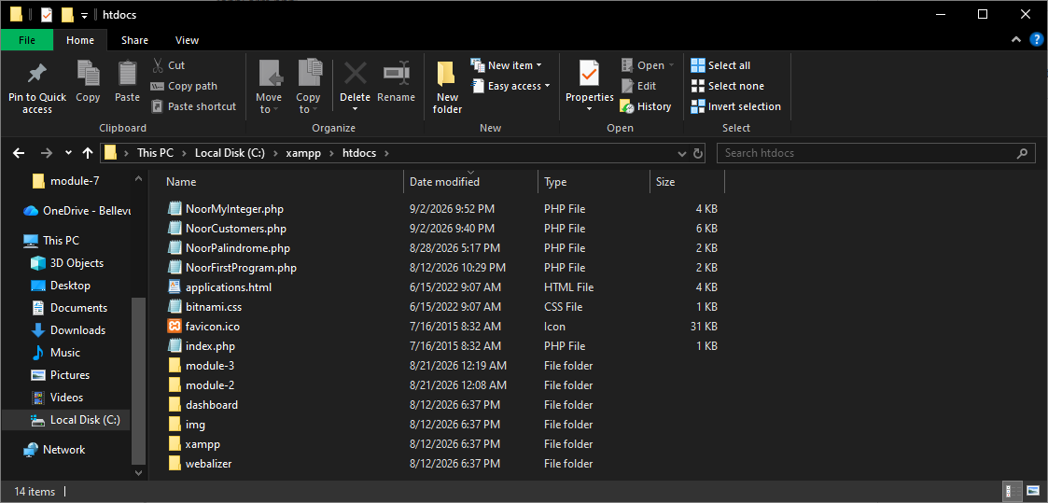
Figure 2. C:\xampp\htdocs directory used to store the PHP course files.

Module 7.2 - Screenshot 3
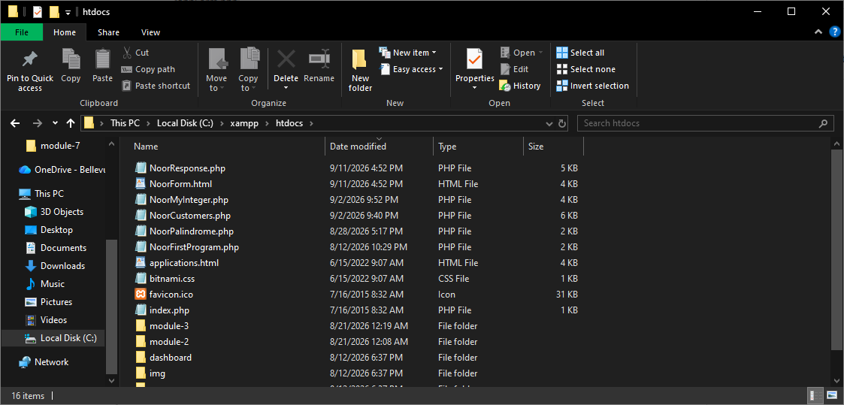
Figure 3. NoorForm.html and NoorResponse.php copied into C:\xampp\htdocs.

Module 7.2 - Screenshot 4
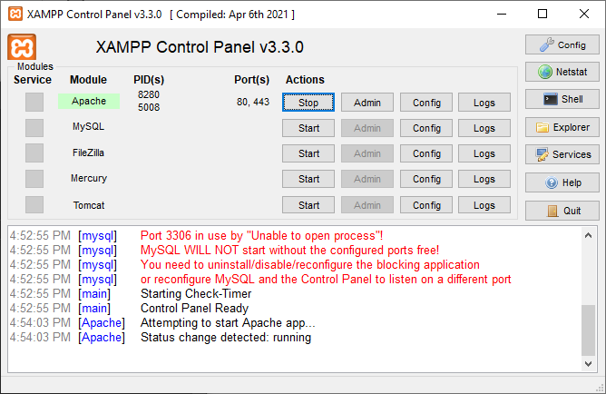
Figure 4. Apache running successfully in XAMPP on ports 80 and 443.

Module 7.2 - Screenshot 5
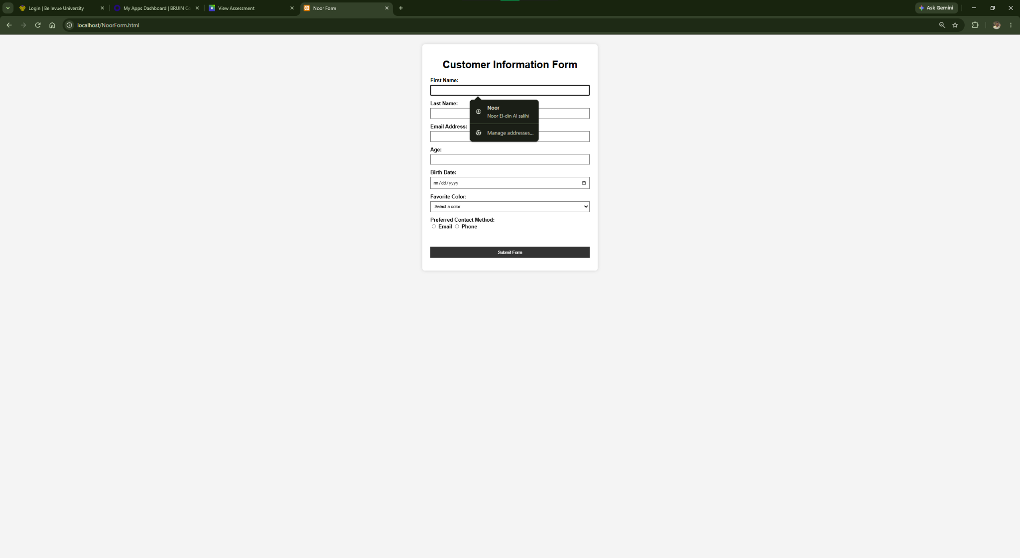
Figure 5. NoorForm.html opened successfully through localhost. The page contains seven fields and multiple input types.

Module 7.2 - Screenshot 6
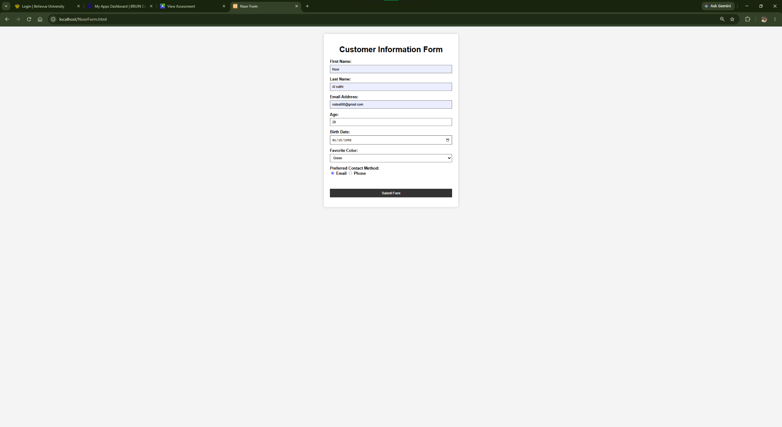
Figure 6. Completed form used to test valid input. All seven fields are populated before submission.

Module 7.2 - Screenshot 7
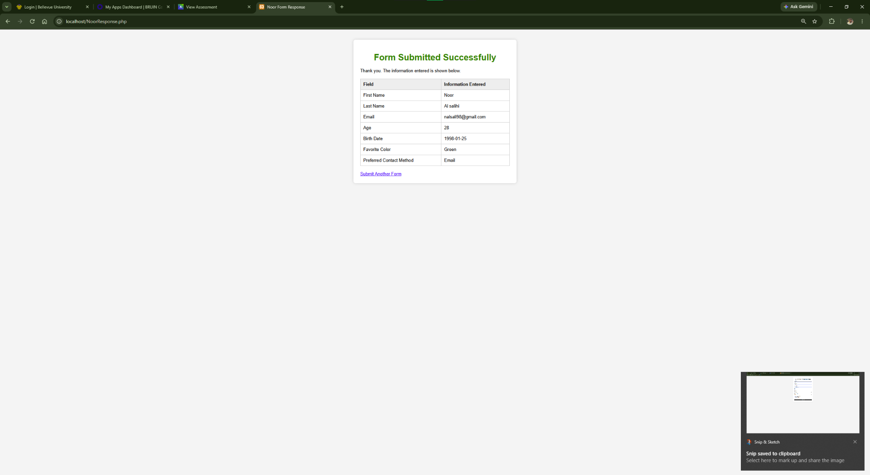
Figure 7. Successful PHP response. NoorResponse.php validates the input and displays all seven submitted values in a formatted table.

Module 7.2 - Screenshot 8
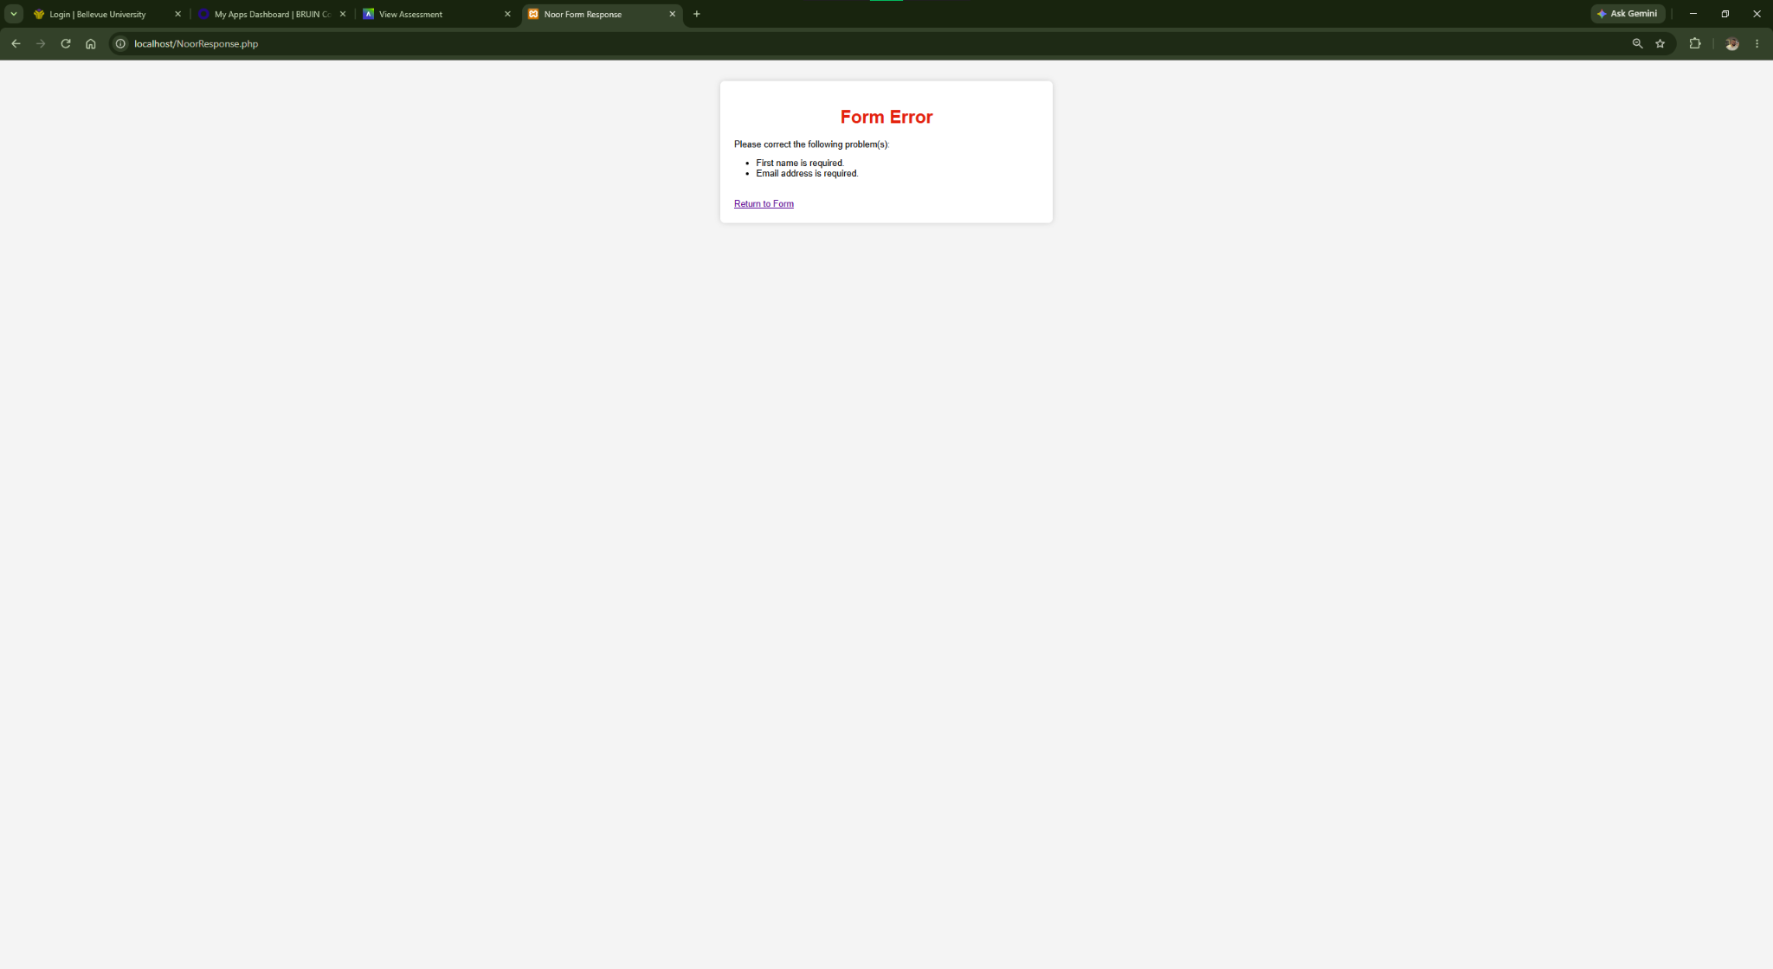
Figure 8. Error validation test. The PHP response correctly reports that the first name and email address are required.

Conclusion
Module 7.2 program ran and tested. Apache successfully hosted files on localhost, formed seven fields with various input types, displayed correct data upon valid entries, and displayed appropriate errors when required data was not entered. These screenshots show the complete testing process.

