CSD440 Server-Side Scripting
Module 5.2 Programming Assignment Documentation
Name: | Noor El-din Al salihi
Date: | September 2, 2026
Assignment: | Module 5.2 Programming Assignment
PHP File: | NoorCustomers.php

Program Description
This PHP script creates an array of 10 customers. It holds customer records with a first name, last name, age, and phone number. The program displays customer records in an HTML table. It also uses PHP array methods to search for customer information based on various data fields. Program Test and Output
The screenshot below shows NoorCustomers.php running through localhost using XAMPP/Apache. The output displays all 10 customer records and successful searches by first name, last name, phone number, and age.
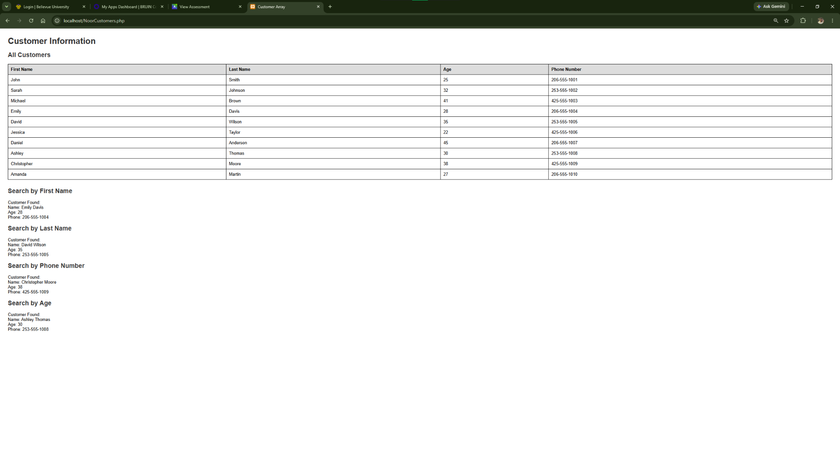
Figure 1. NoorCustomers.php program output in the browser.
Test Results
- All 10 customer records displayed correctly.
- First-name search returned Emily Davis.
- Last-name search returned David Wilson.
- Phone-number search returned Christopher Moore.
- Age search returned Ashley Thomas.
- No PHP errors were displayed during testing.
The program was tested successfully and produced the expected customer information and search results.

