CSD440 Server-Side Scripting

Module 6.2 Programming Assignment Documentation
Name | Noor El-din Al salihi
Date | September 2, 2026
Assignment | Module 6.2 Programming Assignment
PHP File | NoorMyInteger.php

Program Description
This project implements NoorMyInteger class. The NoorMyInteger stores one integer initialized using constructor. Methods implemented include isEven(), isOdd() and isPrime() methods as well as getter and setter methods. Two objects were created to test class methods. Setter method was also tested by changing stored
value.

Code and Testing Screenshots
The screenshots below document the PHP source code, class methods, object tests, file locations, and the final program output running through XAMPP/Apache on localhost.
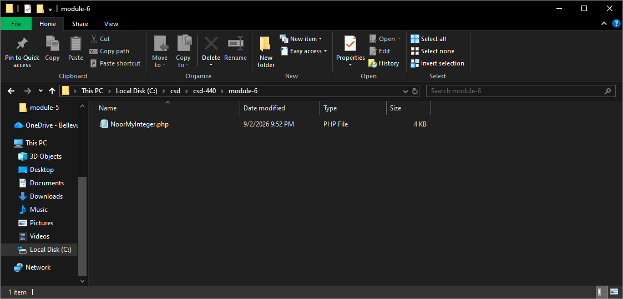
Figure 1. NoorMyInteger.php copied into the Module 6 course folder.

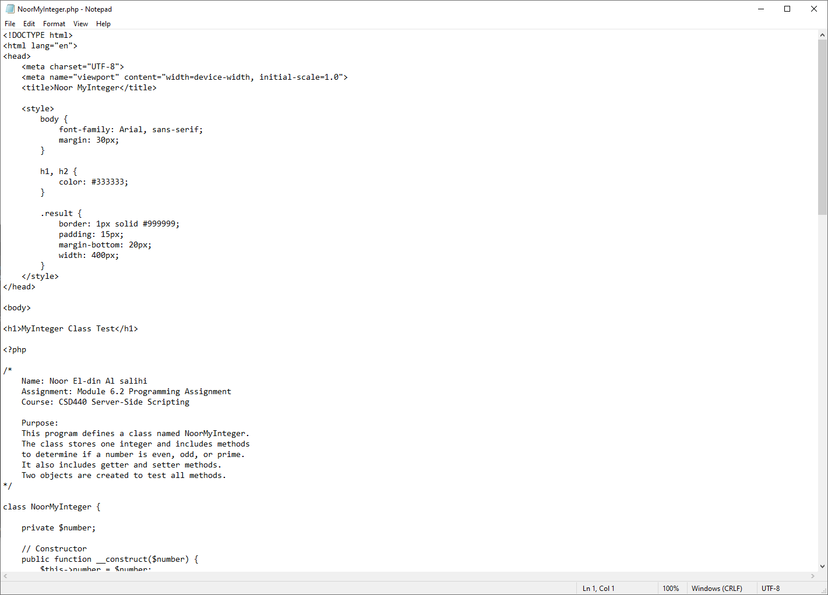
Figure 2. Beginning of NoorMyInteger.php showing standard HTML, documentation, and the NoorMyInteger class.

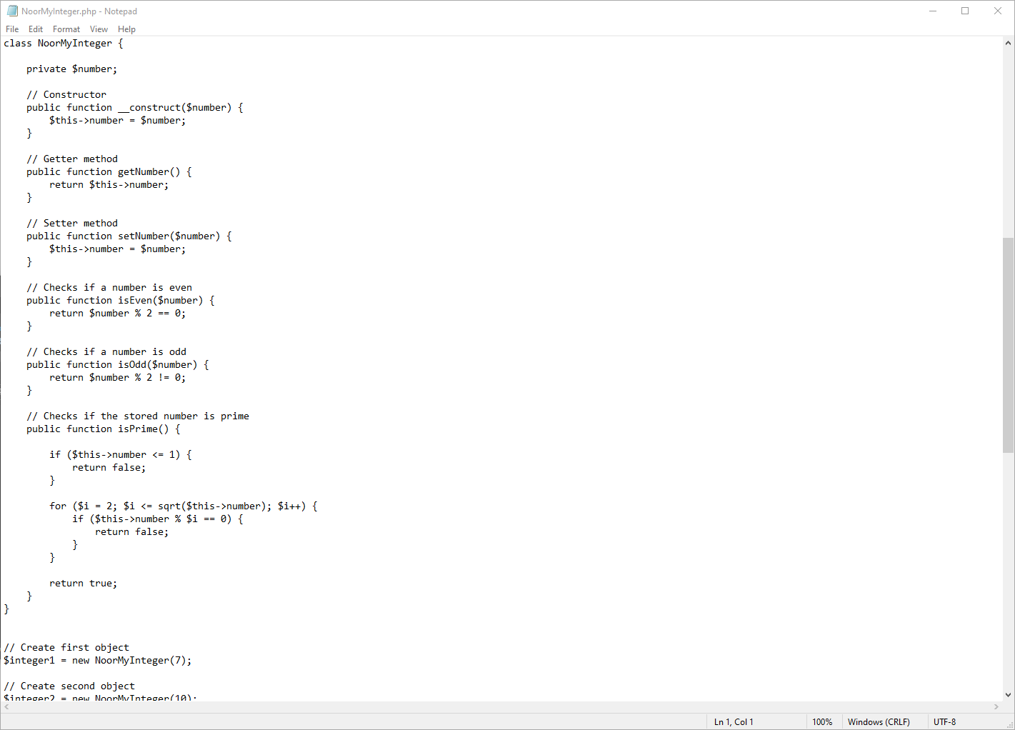
Figure 3. Constructor, getter, setter, isEven(), isOdd(), and isPrime() methods.

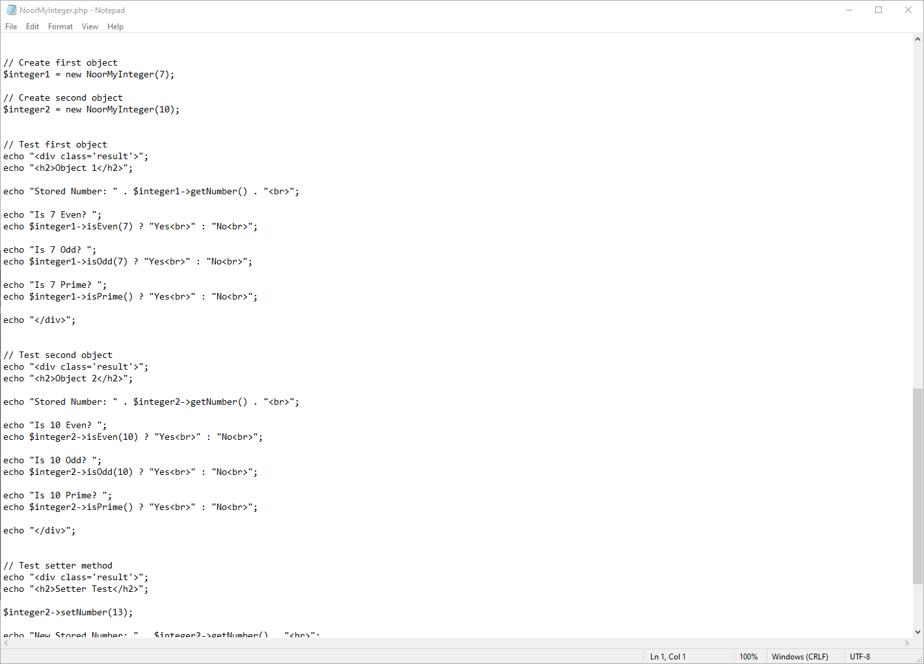
Figure 4. Two NoorMyInteger objects and method tests.

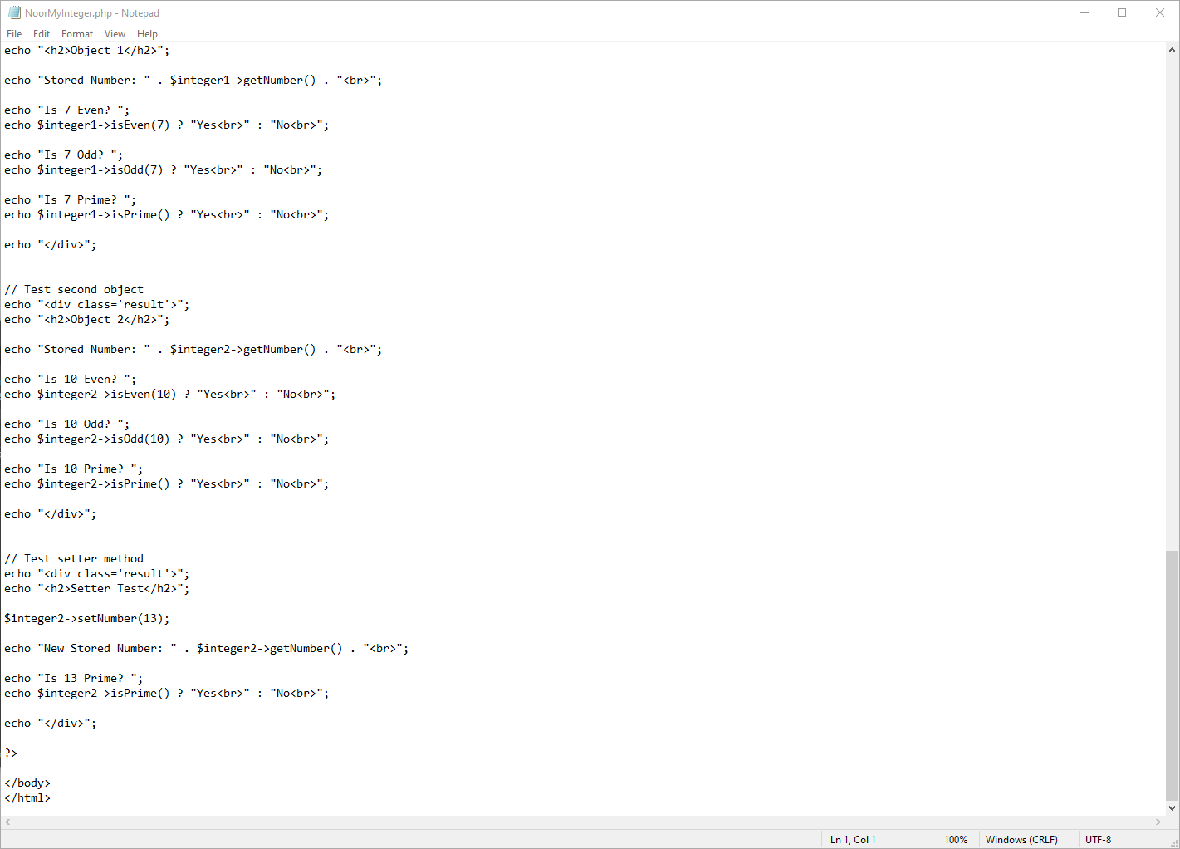
Figure 5. Remaining object tests and setter test.

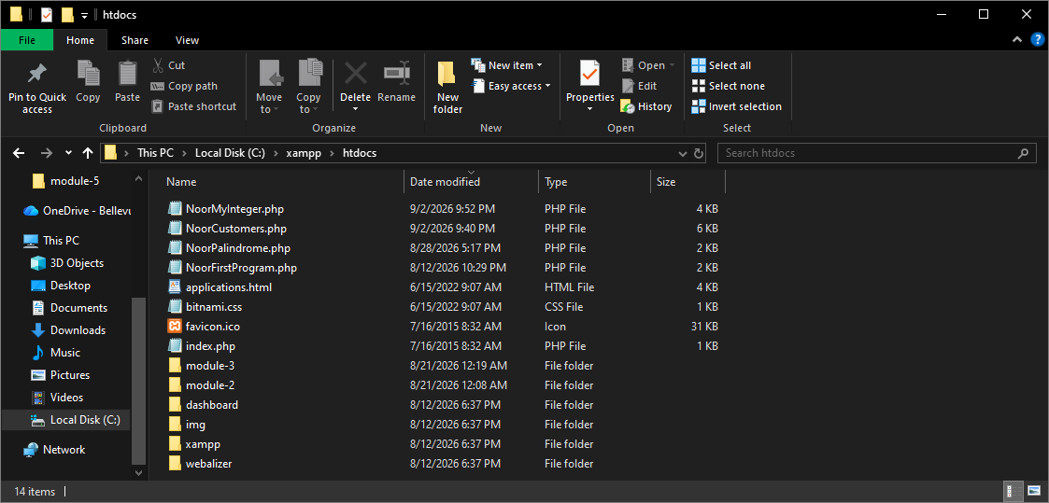
Figure 6. NoorMyInteger.php in the XAMPP htdocs folder for local testing.

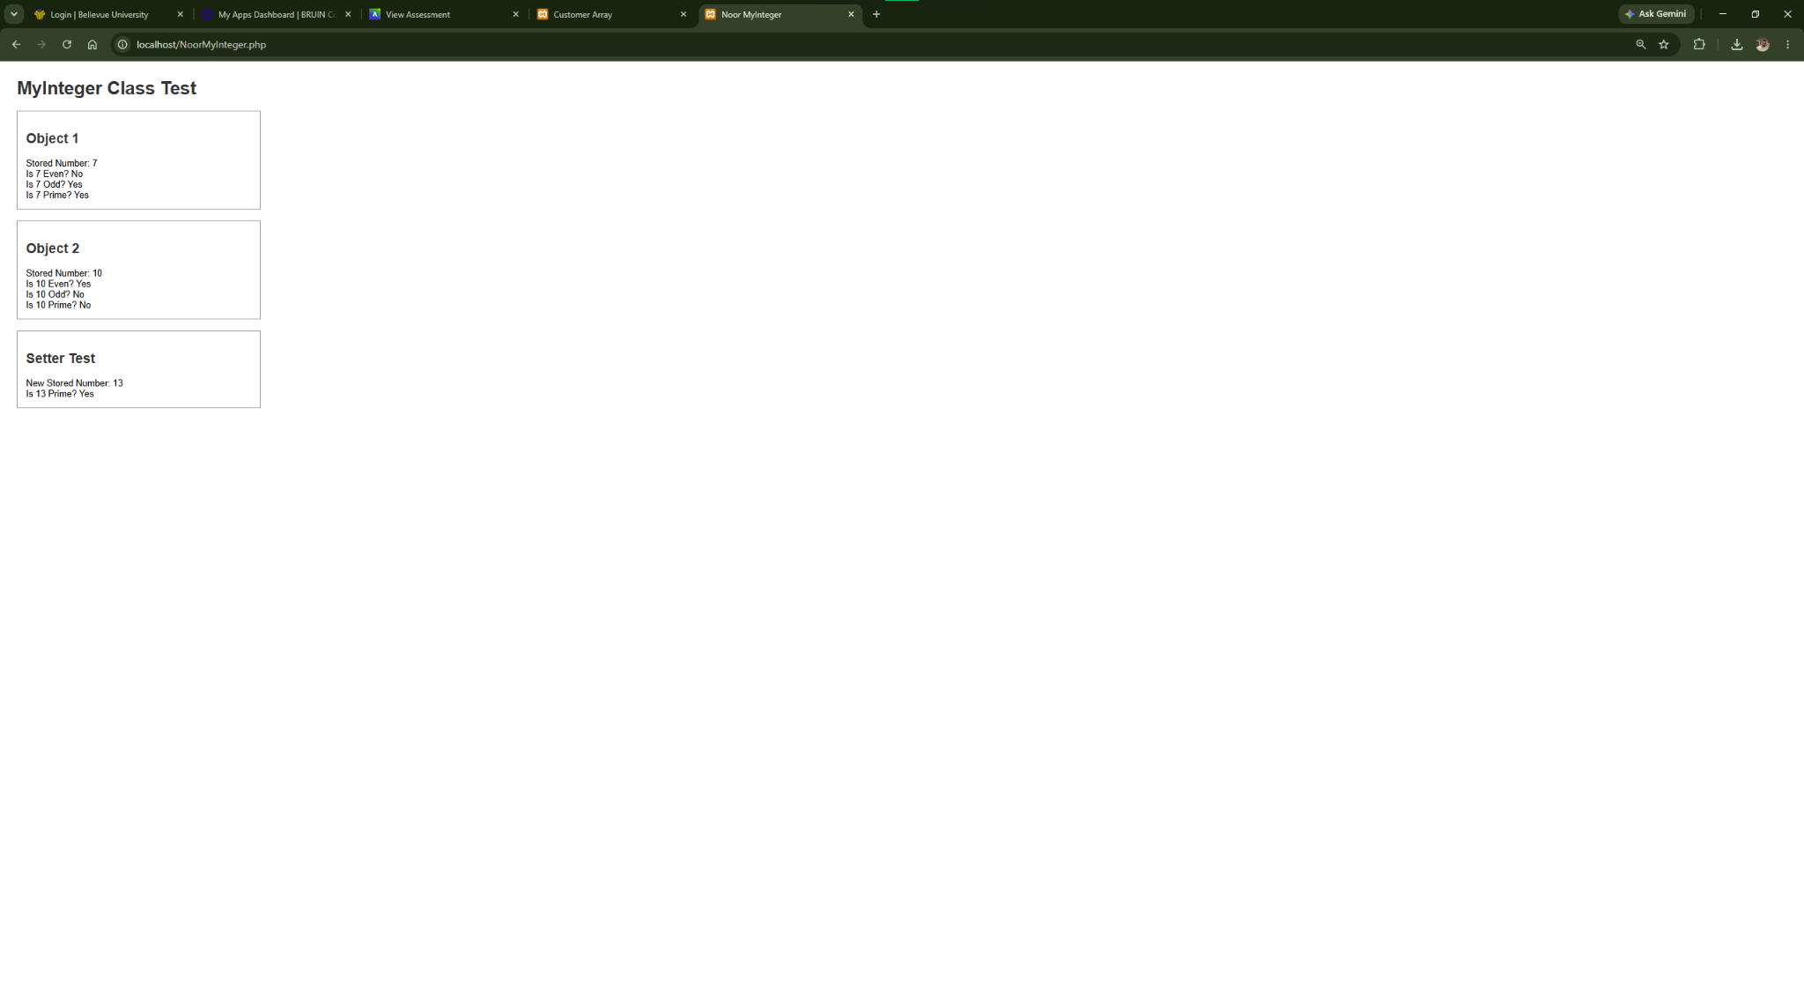
Figure 7. Final successful output through localhost.

Final Test Results
- Object 1 stores the integer 7.
- The program correctly reports that 7 is not even, is odd, and is prime.
- Object 2 stores the integer 10.
- The program correctly reports that 10 is even, is not odd, and is not prime.
- The setter changes Object 2's stored integer from 10 to 13.
- The getter correctly returns the new value of 13.
- The program correctly reports that 13 is prime.
- The final localhost test displays without visible PHP errors.
The program was tested successfully and produced the expected results for the constructor, getter, setter, even, odd, and prime functionality.

