Module 2.2 Programming Assignment
PHP Nested Loop Random Number Table
Name: Noor Al Salihi
Date: August 21, 2026
Assignment: Module 2.2 Programming Assignment

Screenshot 1 - PHP Source Code
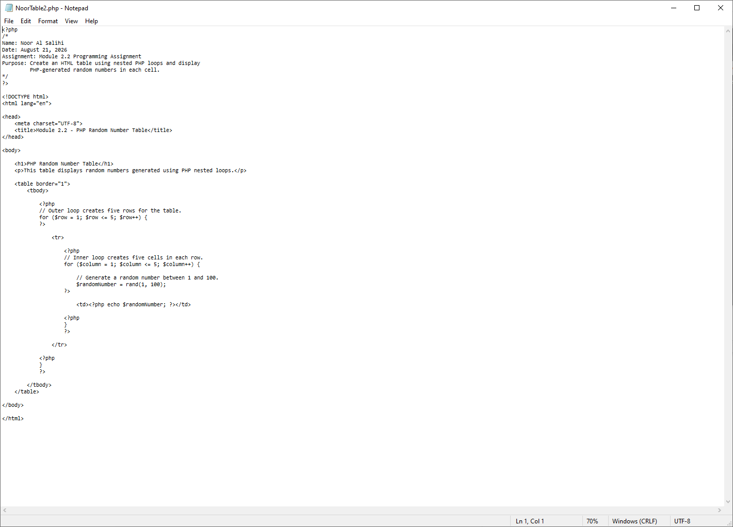
The source code includes the required documentation header, standard HTML, nested PHP loops, and PHP-generated random numbers displayed inside HTML table cells.

Screenshot 2 - Program Output
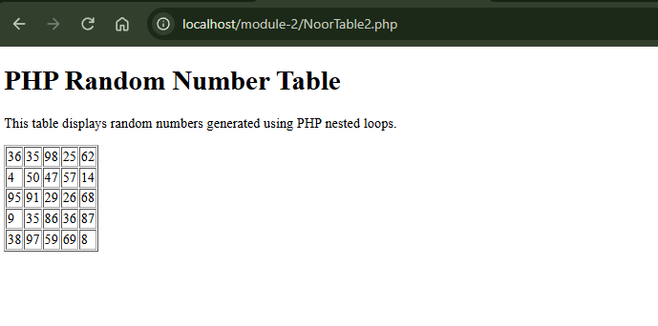
The browser output shows a 5 x 5 HTML table containing random numbers generated by PHP. Refreshing the page produced a new set of values, confirming that the random-number generation works correctly.

Testing Summary
The program was tested through XAMPP using Apache and loaded successfully at localhost/module-2/NoorTable2.php. The nested loops produced five rows and five columns, and each cell displayed a PHP-generated random number between 1 and 100. The page was refreshed to confirm that the numbers changed on each execution.

