Module 4.2 Programming Assignment
Documentation
Noor El-din Al salihi
August 28, 2026
CSD440
Screenshot Verification of Module 4.2 PHP Palindrome Program Running Locally Successfully in XAMPP Environment Producing Desired Output. Screenshot 1 - XAMPP Apache Running
Apache is running in XAMPP, providing the local web server used to execute the PHP program.
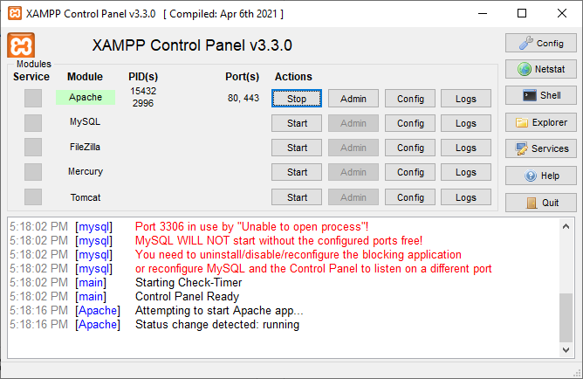
Screenshot 2 - PHP File in XAMPP htdocs
NoorPalindrome.php is placed in the XAMPP htdocs directory so it can be executed through localhost.
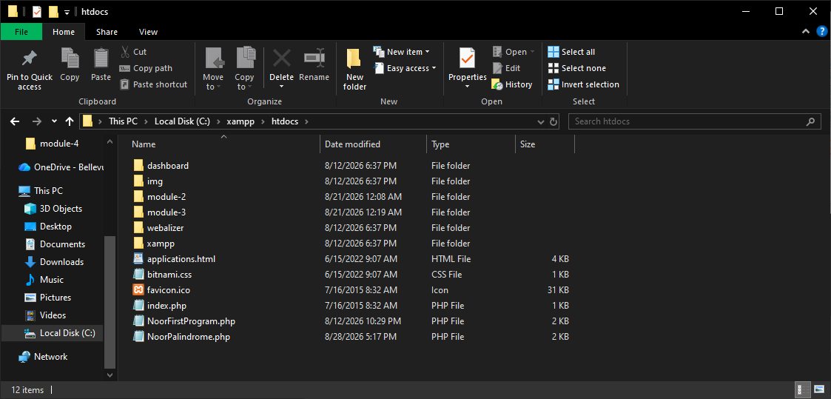

Screenshot 3 - Palindrome Program Output
Displayed in the browser are all six strings needed for testing, three that are palindromes and three that are not. For each string the original, reversed and results are displayed. 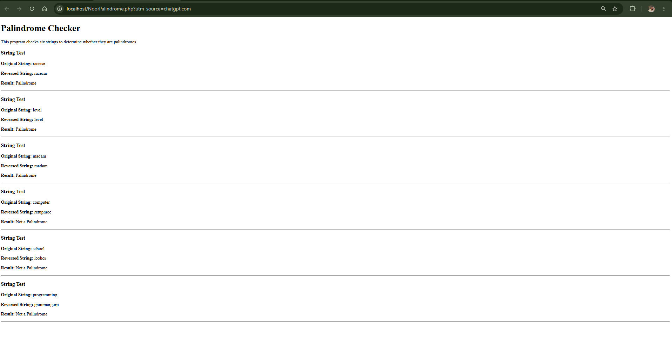
Successfully tested program. Palindrome strings used were racecar, level, and madam. Non-palindrome strings used were computer, school, and programming.

