Module 8.2 Programming Assignment
Noor Al Salihi
CSD 440 – Server-Side Scripting
September 16, 2026
MySQLi Database Table Testing Documentation
Below you will find my tests for the 4 php programs from module 8.2 create a data base table, populate data into the table, query the table and drop the table with mysql i. I will be using the data base baseball_01 and a table called soccer_players.

1. Create Table Test
The soccer_players table was created successfully in the baseball_01 database.
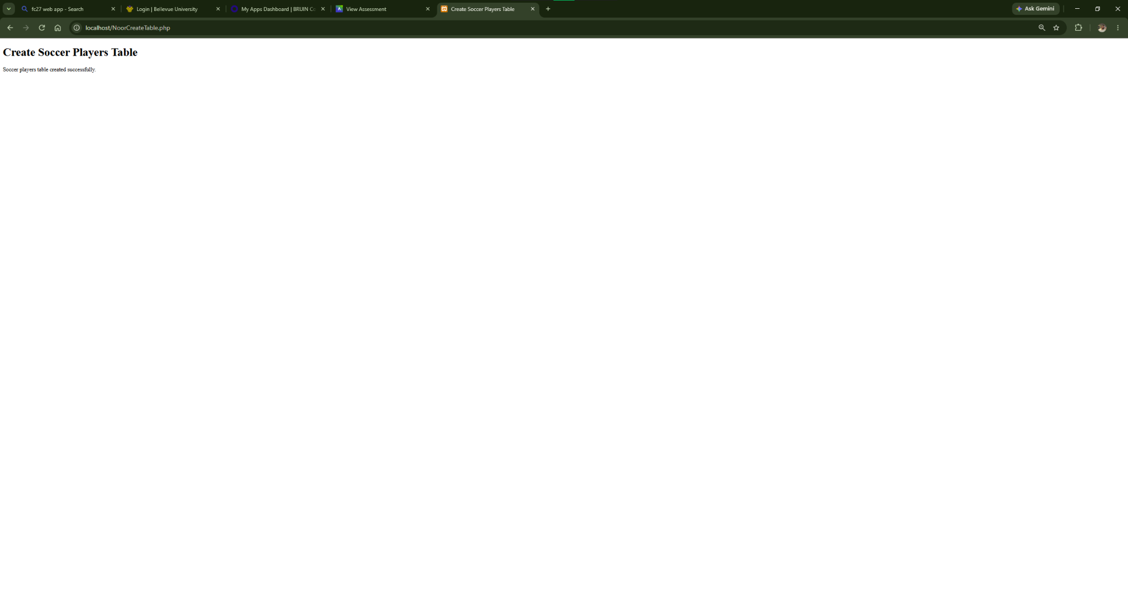
Figure 1. Create Table Test

2. Populate Table Test
The soccer_players table was populated successfully with 10 player records.
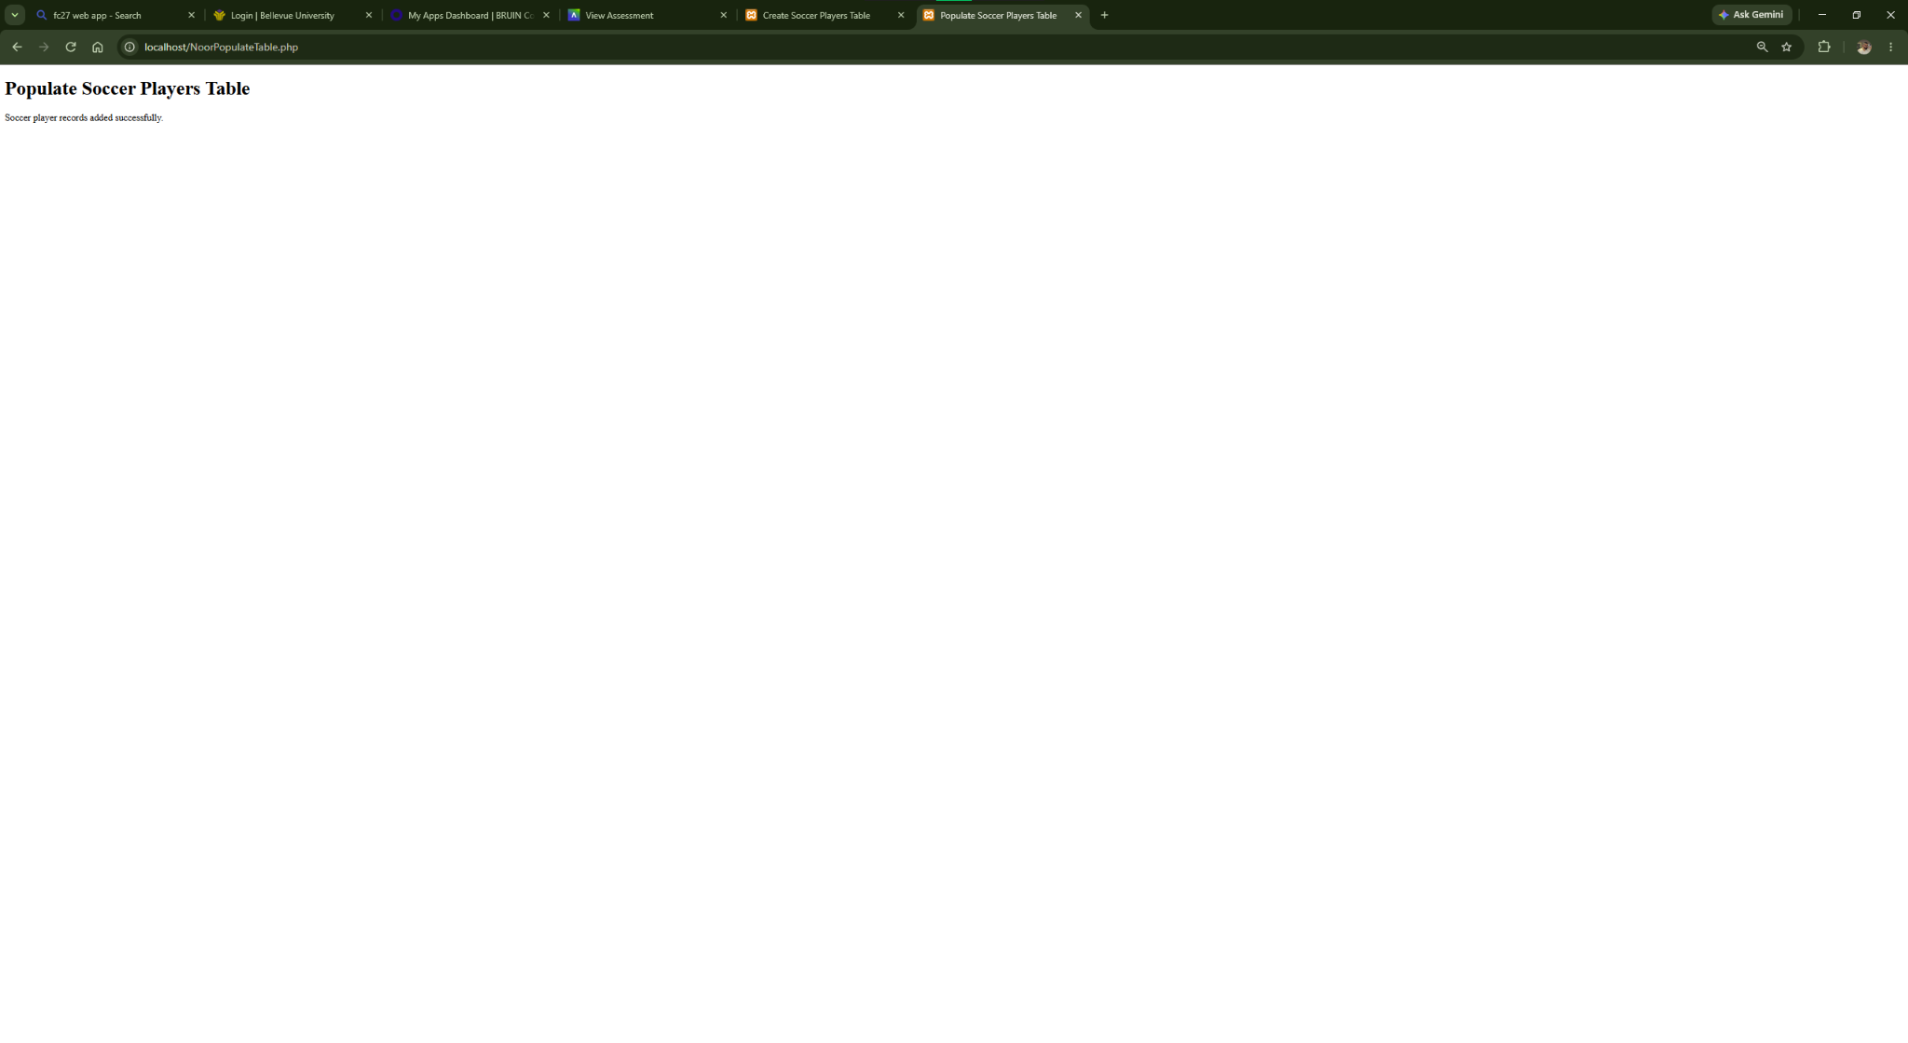
Figure 2. Populate Table Test

3. Query Table Test
The query successfully displayed all 10 records from the soccer_players table.
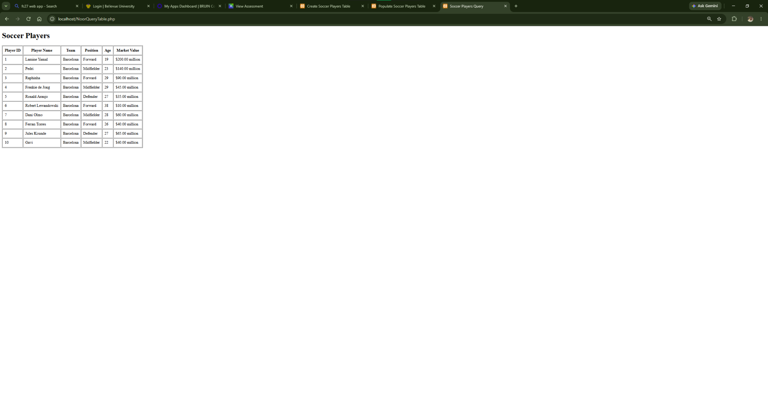
Figure 3. Query Table Test

4. Drop Table Test
The soccer_players table was dropped successfully.
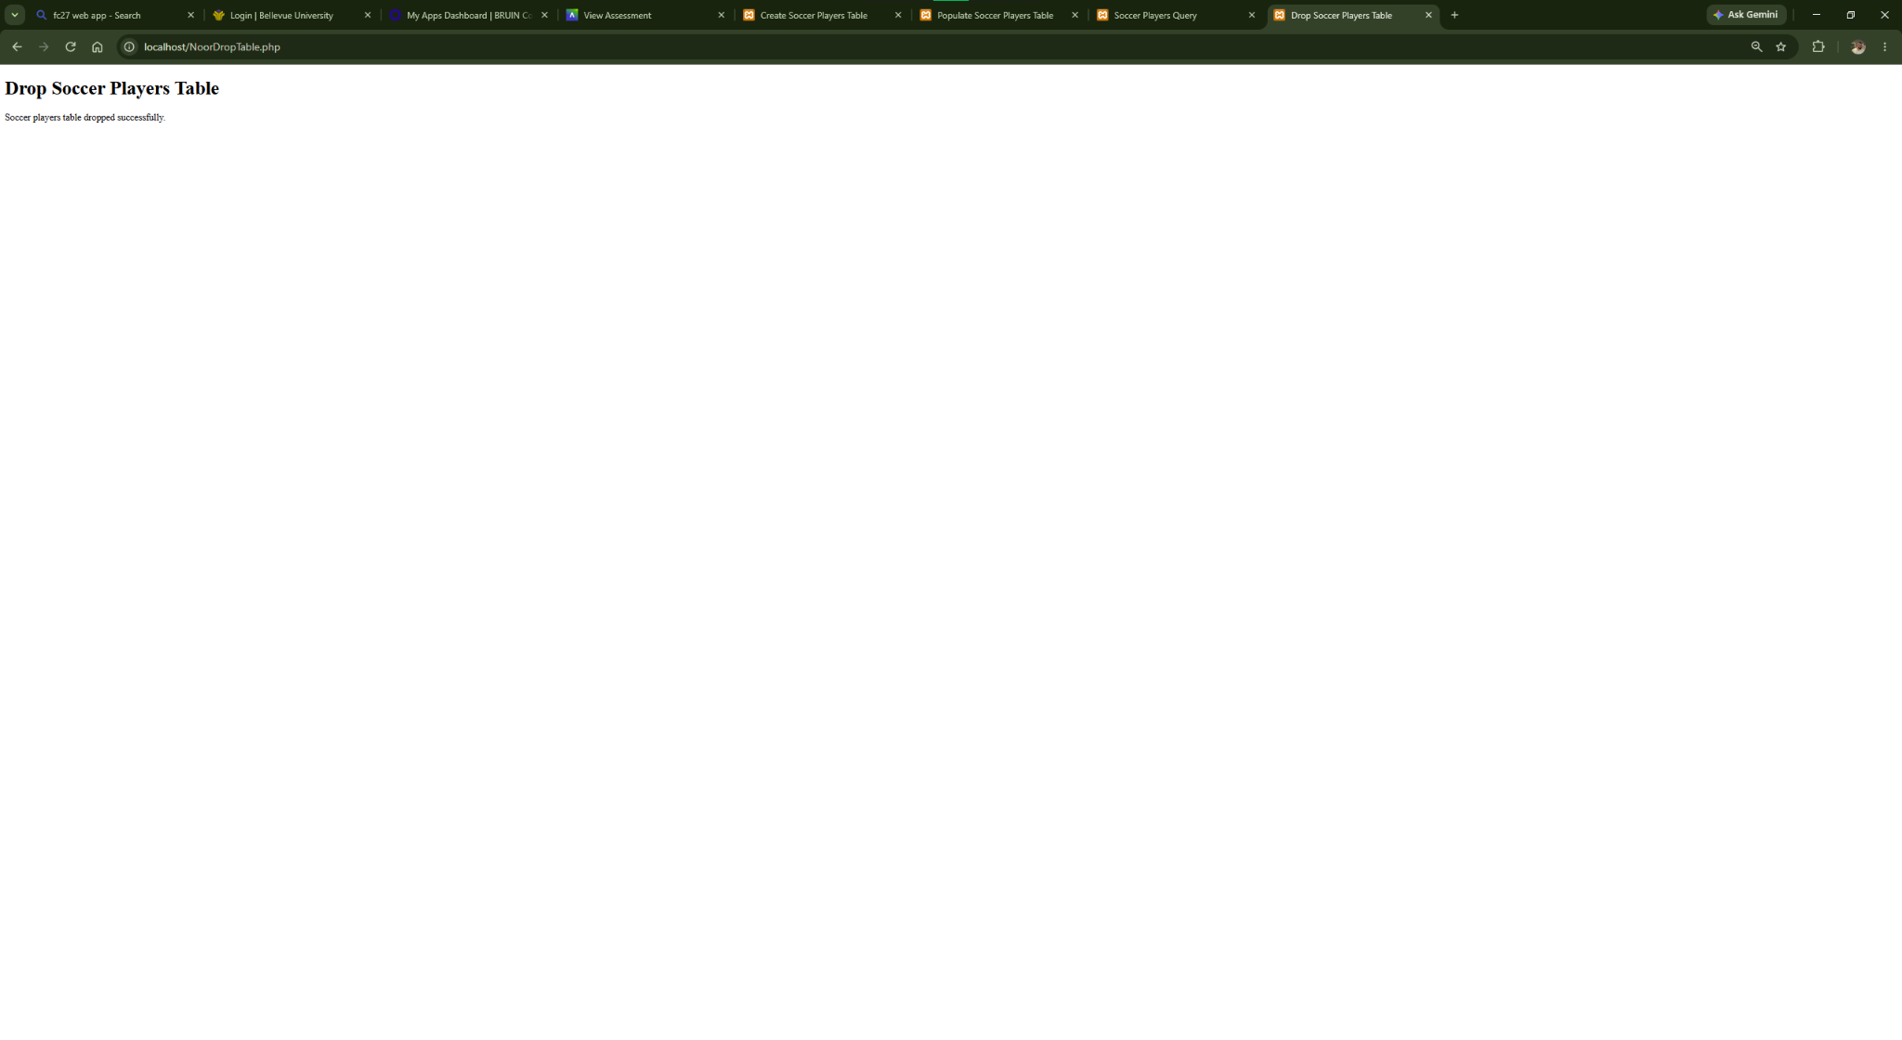
Figure 4. Drop Table Test

5. Final Query - Table Ready for Module 9
After testing the drop program, the table was restored and populated again. The final query confirms the 10 records are available for Module 9.
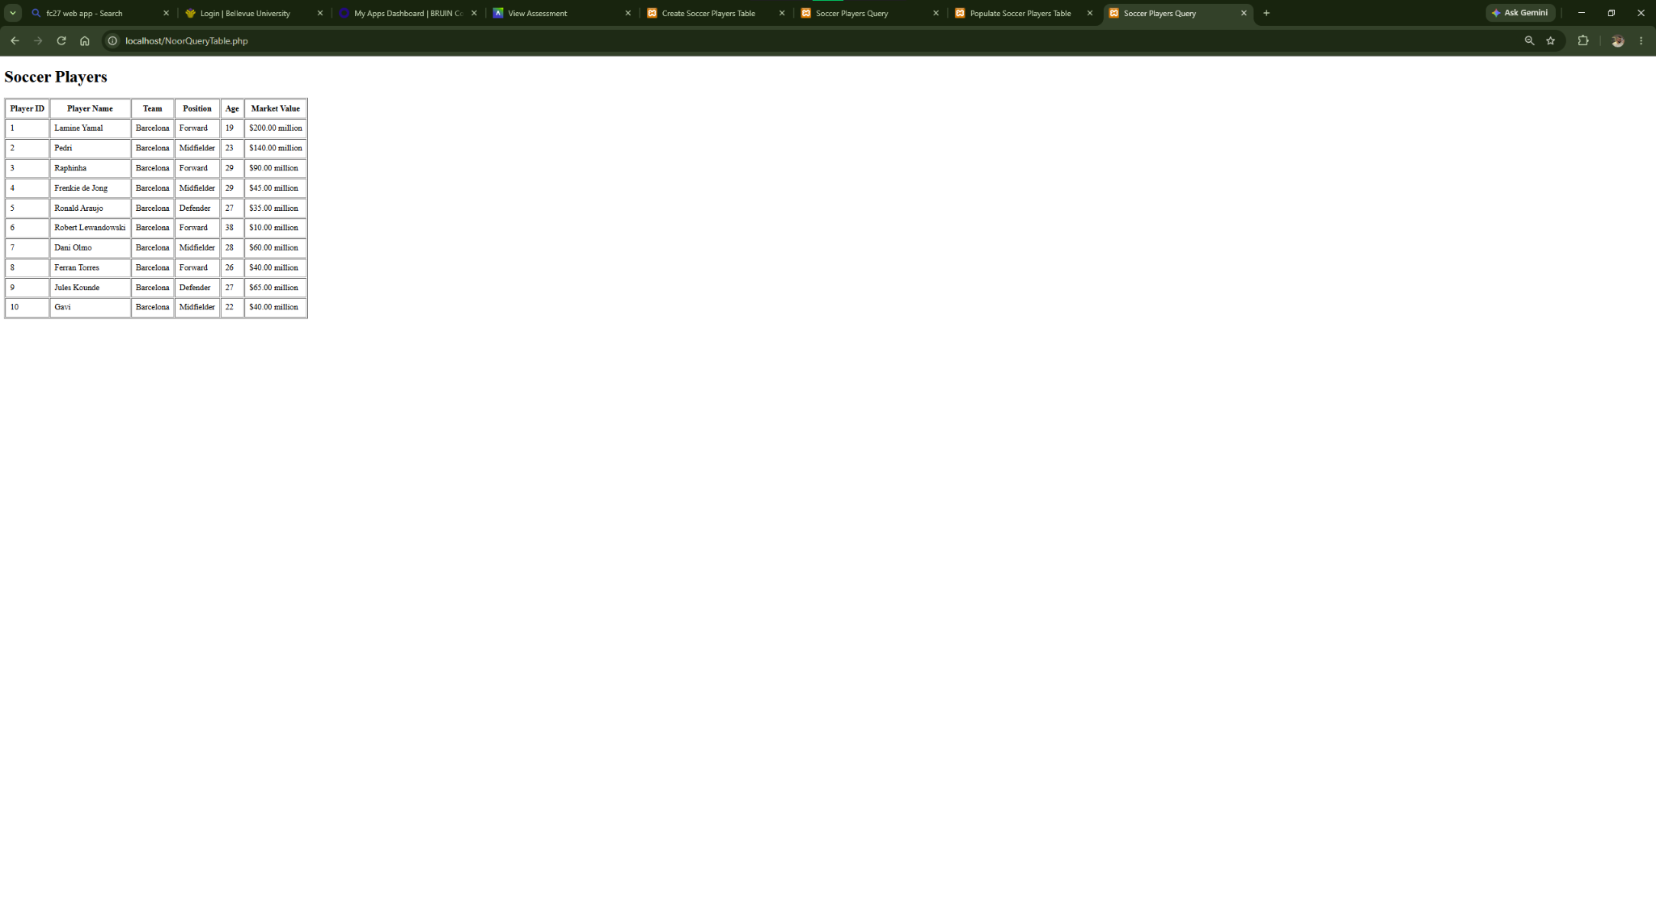
Figure 5. Final Query - Table Ready for Module 9

