Module 3.2 Programming Assignment
PHP Random Number Sum Table
Name: Noor Al Salihi
Date: August 21, 2026
Course: CSD440
Assignment: Module 3.2

Program Summary
Program starts off from the PHP table introduced in Module 2. Nested PHP loops are used to generate a 5 × 5 HTML table. Two random numbers are generated for each cell and passed to a function within the external NoorFunctions.php file. Returned value of the sum is placed inside each table cell.

Figure 1. First program execution
The PHP page successfully displays a 5 × 5 table containing the sums of two randomly generated numbers.
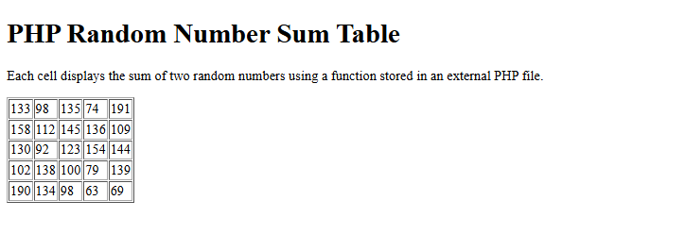

Figure 2. Program execution after refresh
After refreshing the page, the table displays different values, demonstrating that new random numbers are generated for each execution.
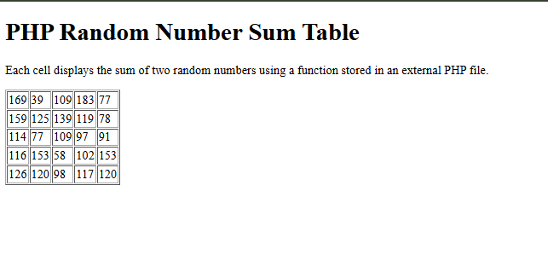

Figure 3. Module 3 project files
The module-3 folder contains NoorTable3.php and the required external NoorFunctions.php function file.
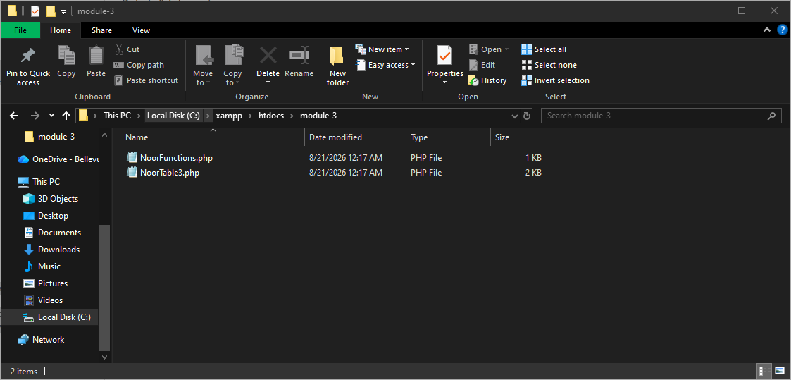

Testing Results
--------------------
Program ran successfully in browser using the local XAMPP Apache server. Table displays properly at five rows by five columns. Random numbers populate upon page refresh indicating random-number logic is working. External function .php file exists and is being called to calculate sum of each cell.
Result: Program tested successfully.

