Module 1.2 Assignment
GitHub Repository Setup

Name: Noor Al Salihi
Course: CSD440-340A Server-Side Scripting (2267-DD)
Date: August 12, 2026
GitHub Repository Link
https://github.com/nalsali98/csd-440
GitHub Repository Screenshot
The screenshot below shows the public csd-440 GitHub repository with the README.md and Python .gitignore files.
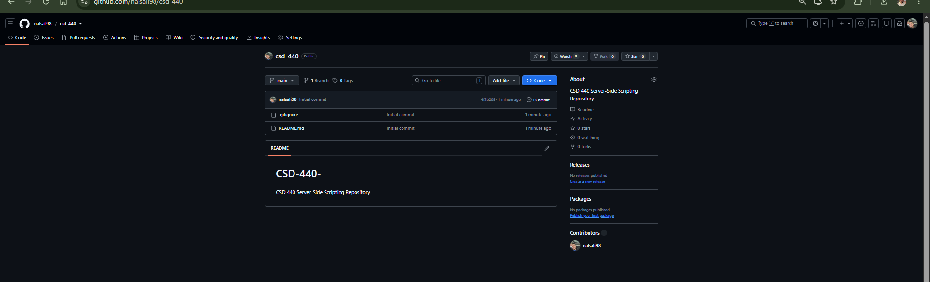
Figure 1. CSD-440 GitHub repository.

Local Directory Screenshot
The screenshot below shows the local C:\csd directory, the successful clone of the csd-440 repository, the C:\csd\csd-440 directory contents, and the configured global Git username and email.
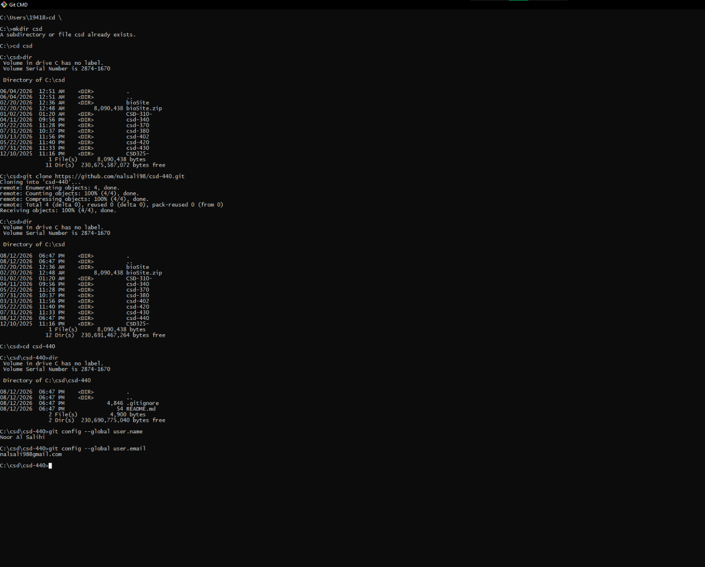
Figure 2. Local C:\csd\csd-440 repository setup and Git configuration.

