Module 1.3 Programming Assignment
XAMPP and First PHP Program

Name: Noor Al Salihi
Course: CSD440-340A Server-Side Scripting (2267-DD)
Date: August 12, 2026
PHP File: NoorFirstProgram.php
1. XAMPP Installation and Configuration
The screenshot below demonstrates the successful XAMPP configuration. Apache is running on ports 80 and 443, and MySQL is running on port 3307.
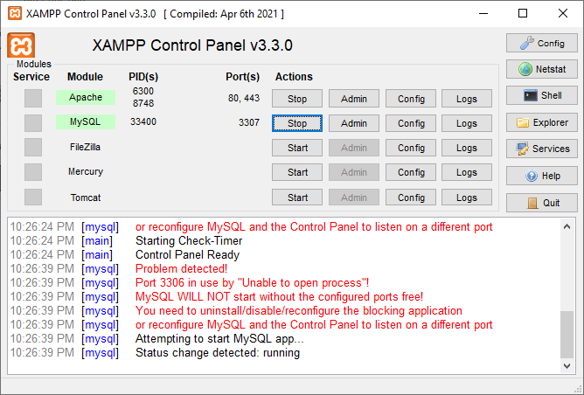
Figure 1. XAMPP Control Panel with Apache and MySQL running.

2. PHP File in the XAMPP htdocs Directory
The screenshot below shows NoorFirstProgram.php saved in the XAMPP htdocs directory at C:\xampp\htdocs so Apache can serve the PHP file through localhost.
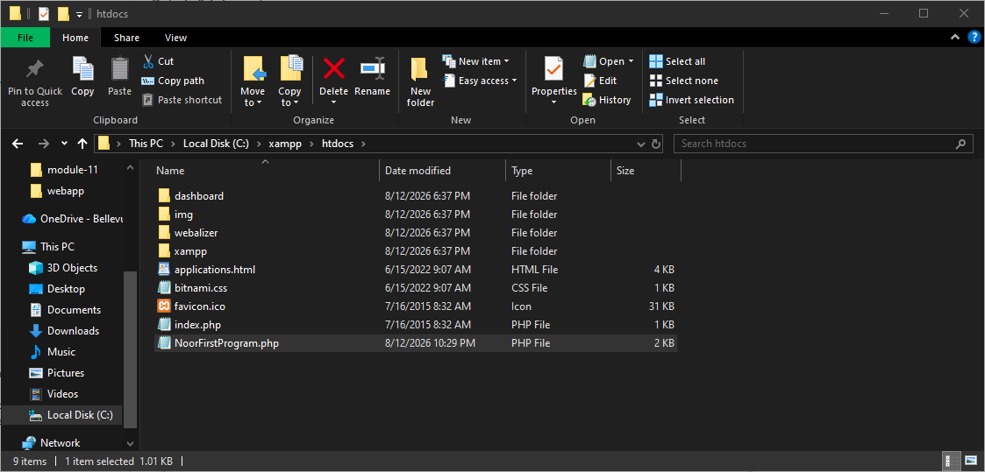
Figure 2. NoorFirstProgram.php saved in C:\xampp\htdocs.
3. Successful PHP Program Output
The screenshot below shows NoorFirstProgram.php running successfully through localhost. The output displays student information and the PHP calculation 10 + 5 = 15.
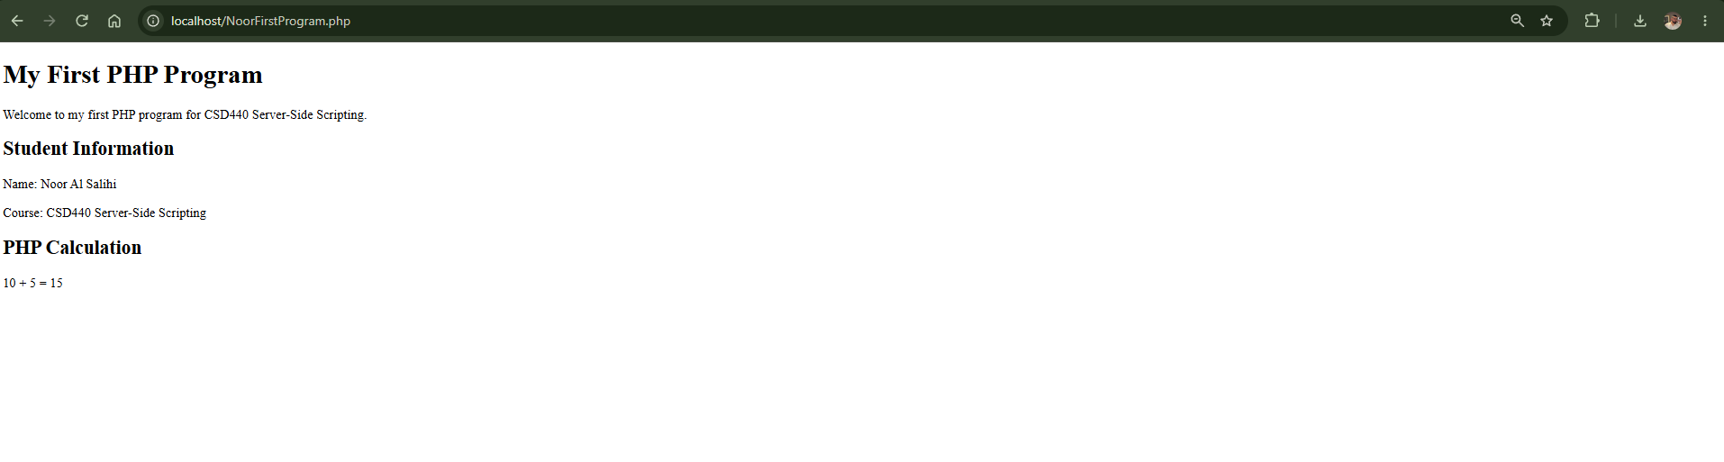
Figure 3. NoorFirstProgram.php successfully running in the browser.

Testing Result: The PHP program was tested successfully and displayed the expected output without visible PHP errors.

