CSD 440 - Server-Side Scripting

Module 9.2 Programming Assignment

Student: | Noor Al Salihi
Date: | September 23, 2026
Assignment: | Module 9.2 - Database Forms

PHP / MySQLi Database Program Documentation

Assignment Overview

In this module I again used my database from Module 8 which was soccer_players. I took my PHP files from Module 8 and created three more php programs one that has my index page. Another one to query the data base using what they type on the form and the last one that will input a new record. Below are my screen shots of my programs working through XAMPP.

Files Used
- NoorCreateTable.php (Module 8)
- NoorDropTable.php (Module 8)
- NoorPopulateTable.php (Module 8)
- NoorQueryTable.php (Module 8)
- NoorIndex.php (Module 9)
- NoorQuery.php (Module 9)
- NoorForm.php (Module 9)

Index Page
The index page provides links to the Module 9 programs and the PHP programs carried forward from Module 8.
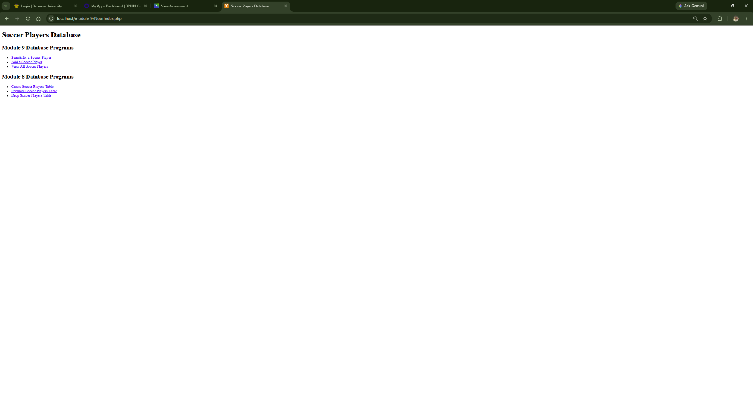
Figure 1. NoorIndex.php - Module 9 index page with links to the Module 9 and Module 8 PHP programs.

Query Page Test
The query page was tested by searching for Lamine Yamal. The program returned the matching player information from the soccer_players table.
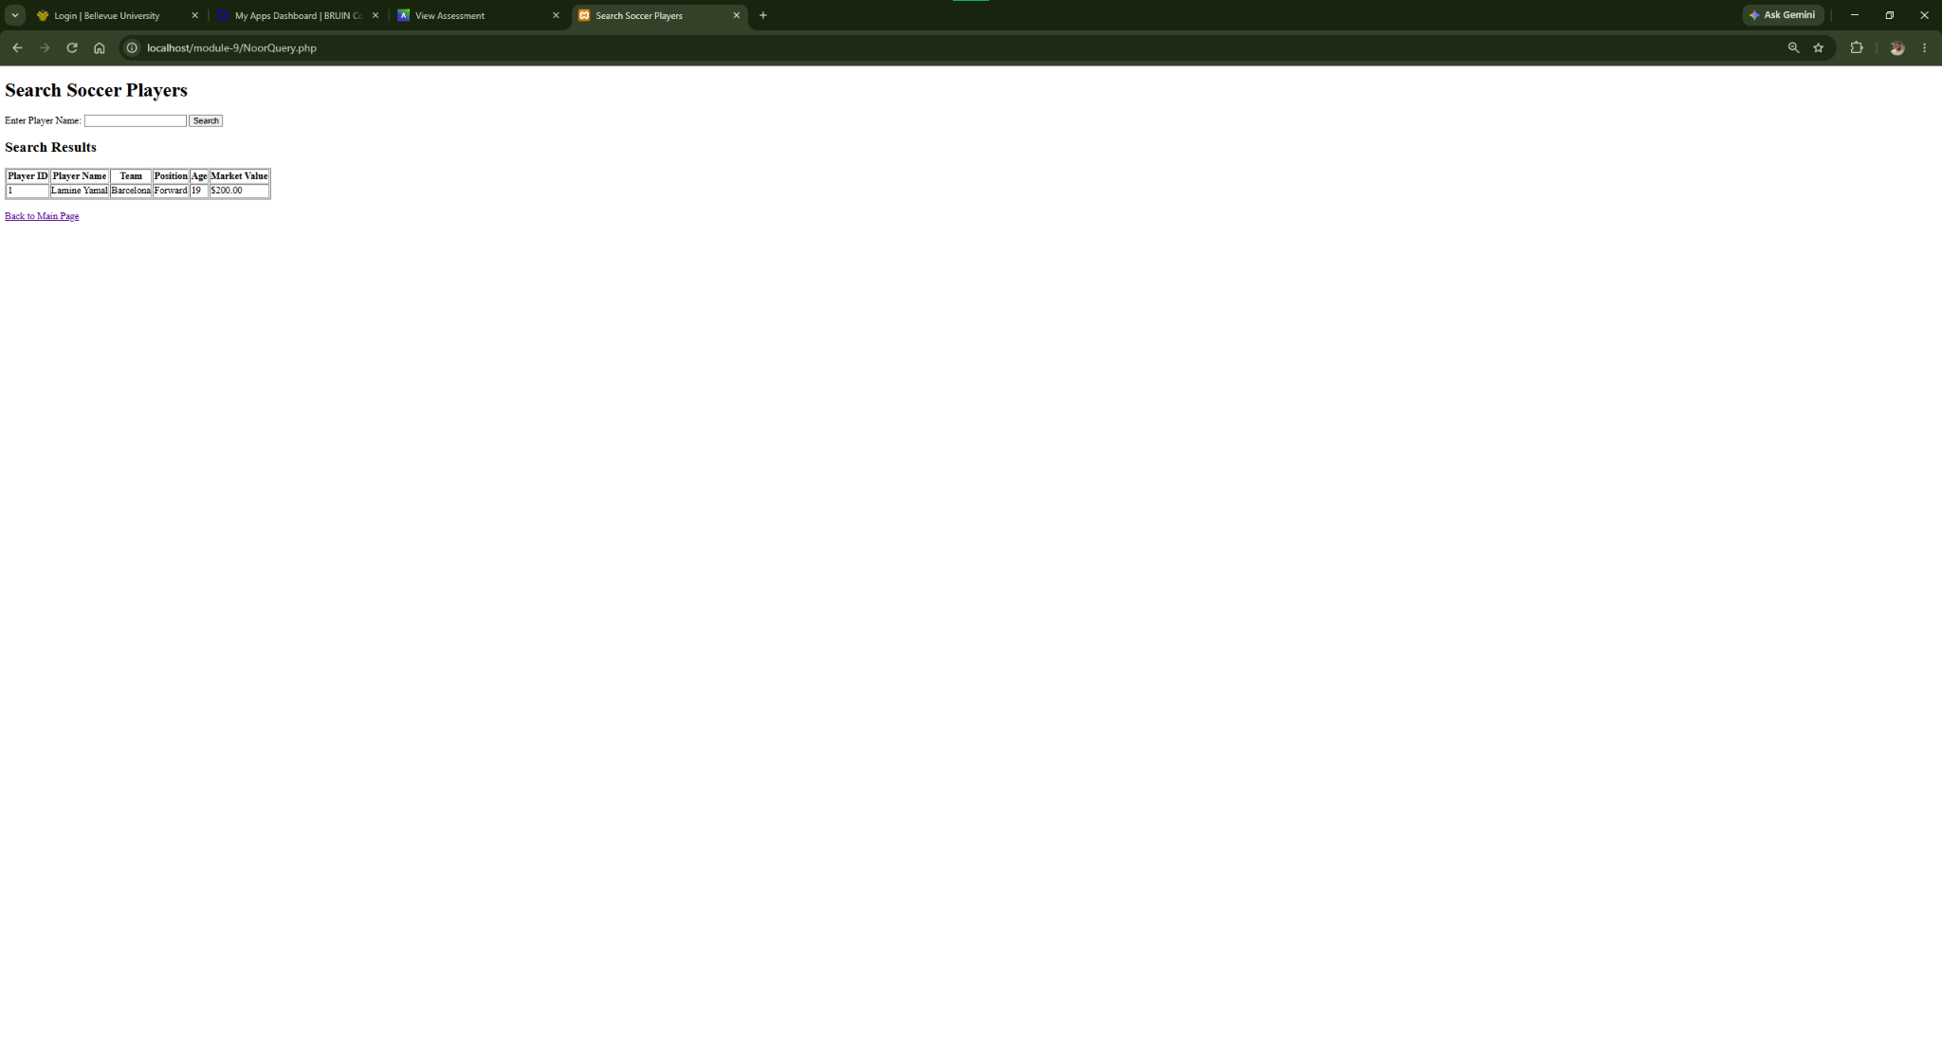
Figure 2. NoorQuery.php - Search result for Lamine Yamal using user form input.

Add Record Form Test
The add-record form was tested by entering a new soccer player. The program displayed a confirmation message showing that the insert completed successfully.
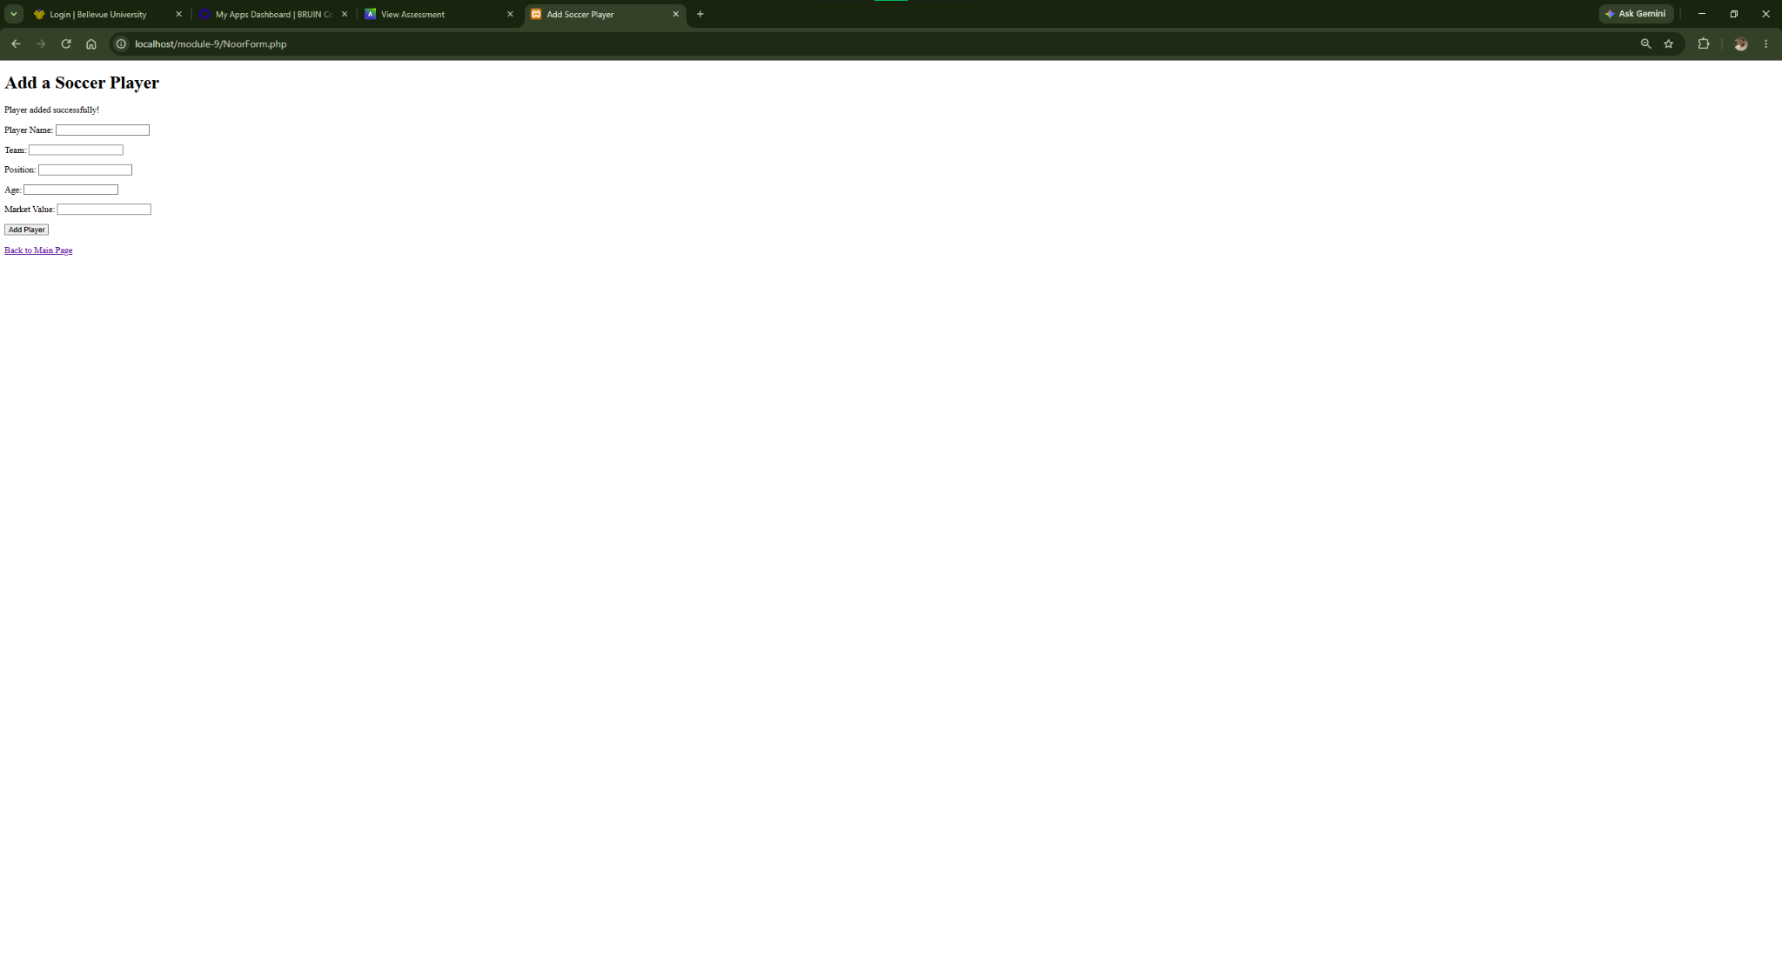
Figure 3. NoorForm.php - Confirmation that a new soccer player record was added successfully.

Database Verification
The full player table was displayed after the insert. Kylian Mbappe appears as Player ID 11, confirming that the new record was stored in the database.
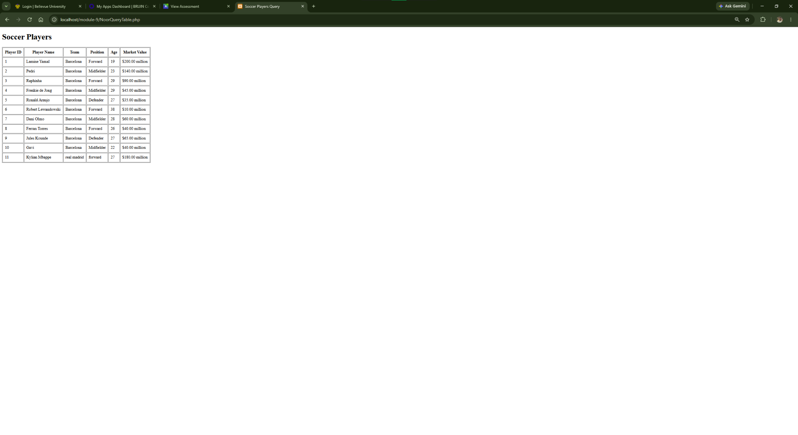
Figure 4. NoorQueryTable.php - Database table after adding Kylian Mbappe as Player ID 11.

Testing Summary
I was able to test all functions required for Module 9.2. I used NoorIndex.php to show program links. Used NoorQuery.php to get a players information. NoorForm.php allowed me to input a new player. Once i tested my new table it showed my information was inputted.

