CSD 440 – Module 10.2 Programming Assignment

JSON Form Program

Noor Al Salihi

September 30, 2026

Program Description
I made a PHP form for this assignment. It has 10 inputs for the user to enter data. Once the form is submitted, the information is directed to my PHP response page. Where I used JSON encode() to turn the info into a JSON string. My program will print out the JSON information. And if no information was entered through my form, it will show an error message.
Figure 1. Completed JSON user information form before submission.
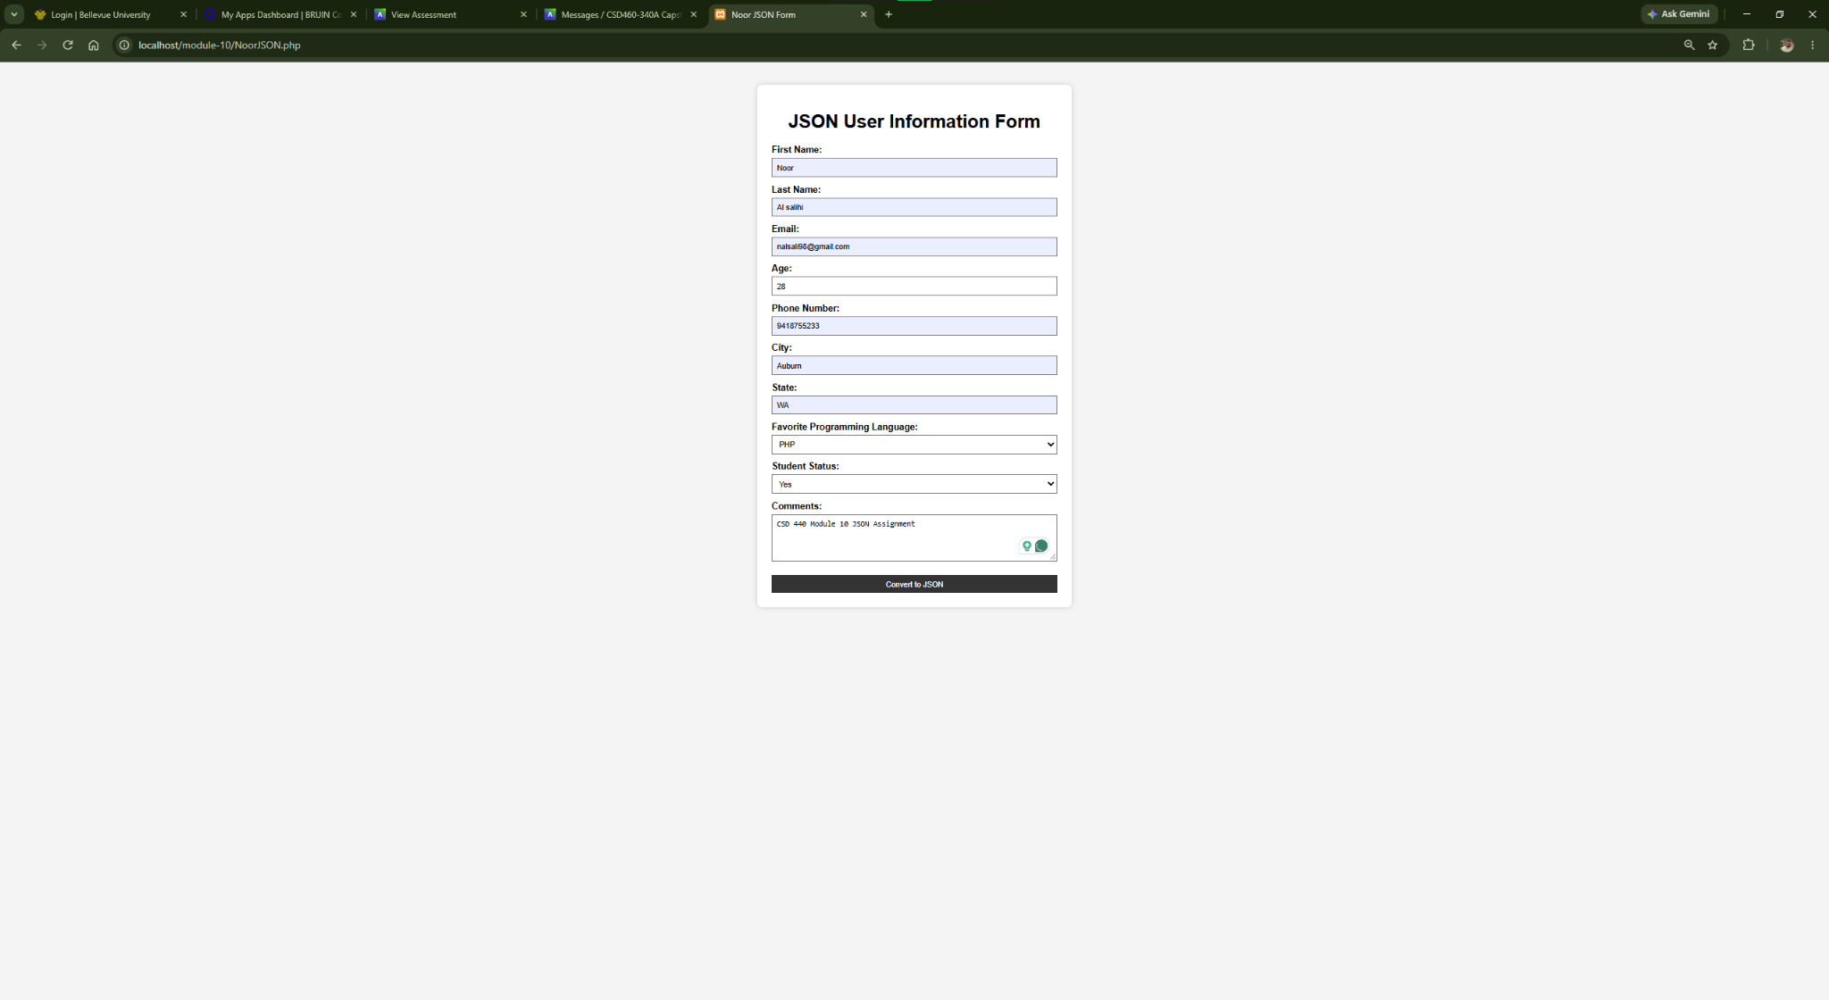

Figure 2. Successful JSON encoded output generated after submitting the form.
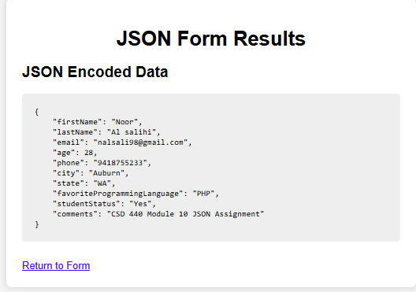

Figure 3. Error handling test showing the message returned when no form data is submitted.
