Ansible

+++++++++++++++++++++++++++++

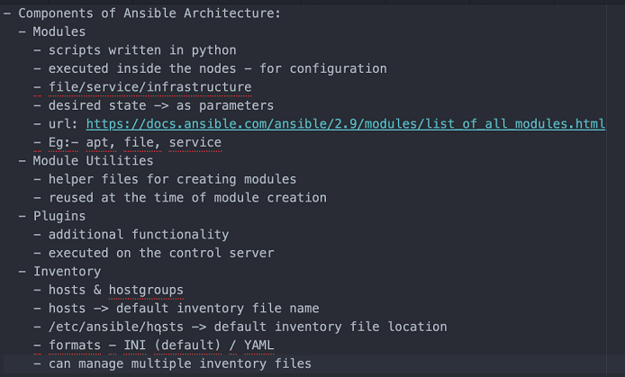

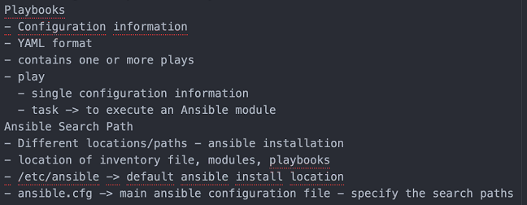

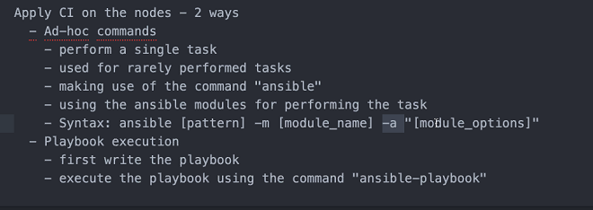

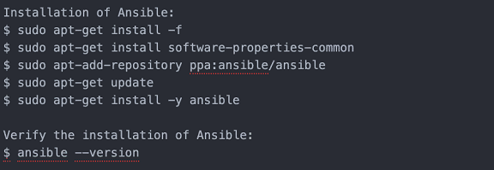

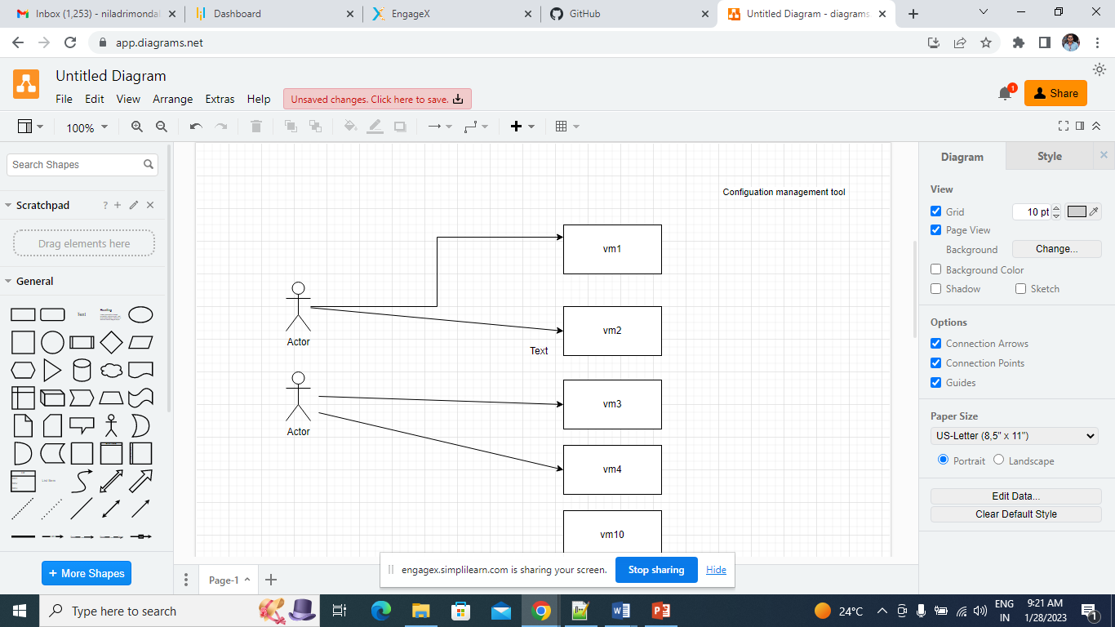

Configuration Management Tools

Ansible

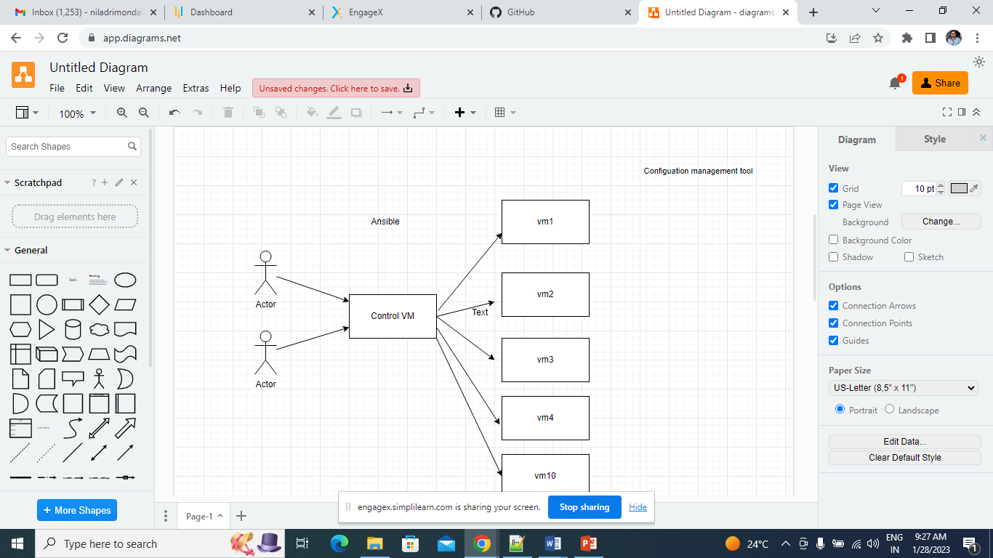

Ansible Module:

<https://docs.ansible.com/ansible/2.9/modules/list_of_all_modules.html>

Install Ansible in 3 Nodes, 1 would be control Server another 2 Hosts

Launch 3 instance:

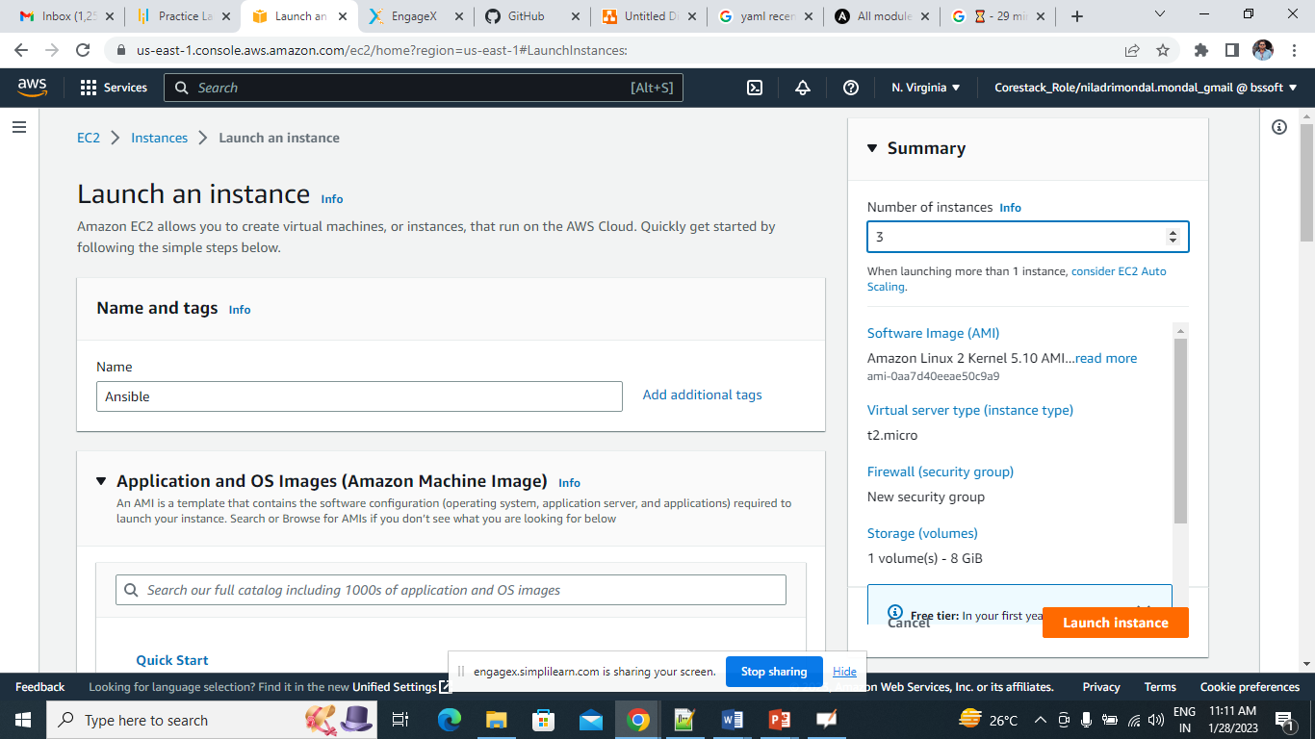

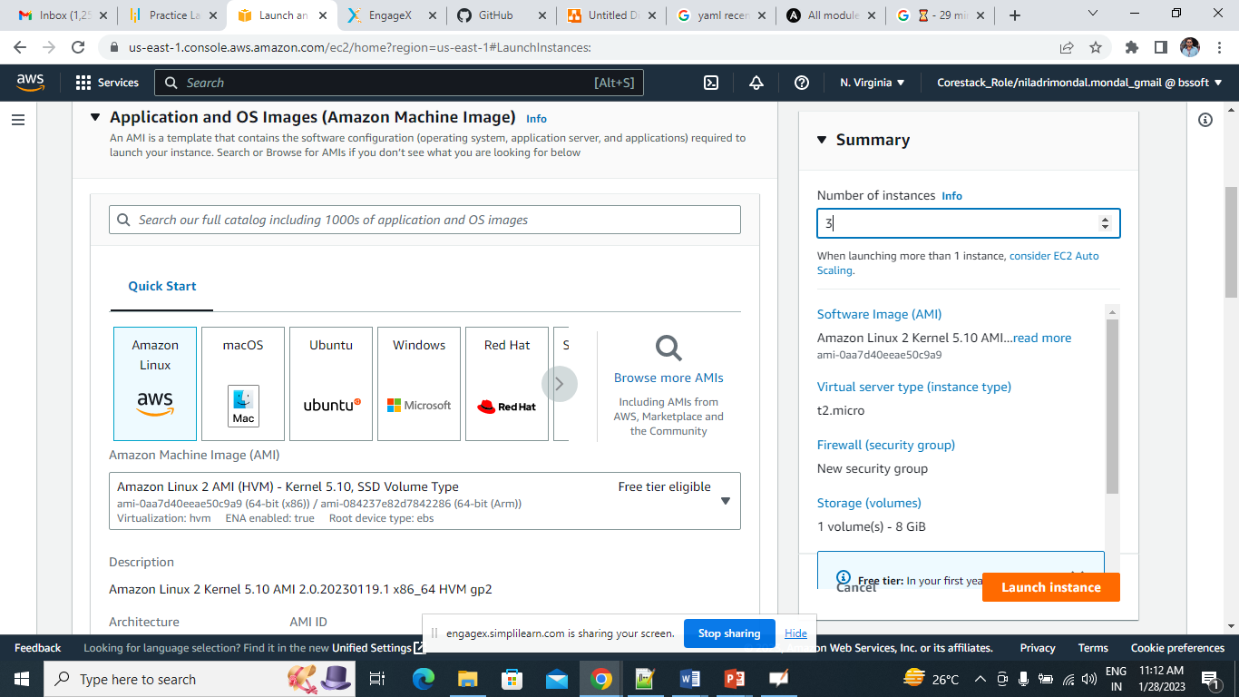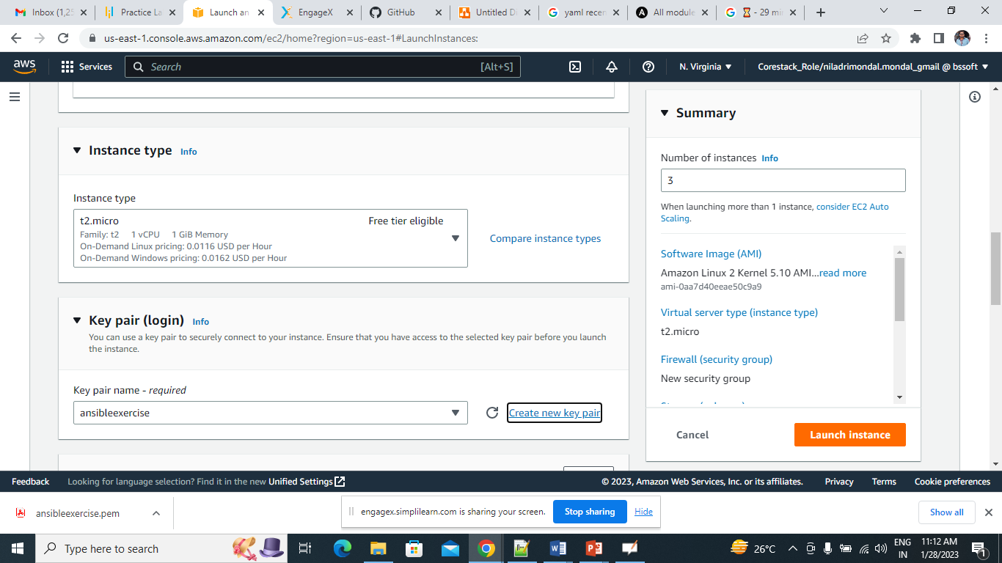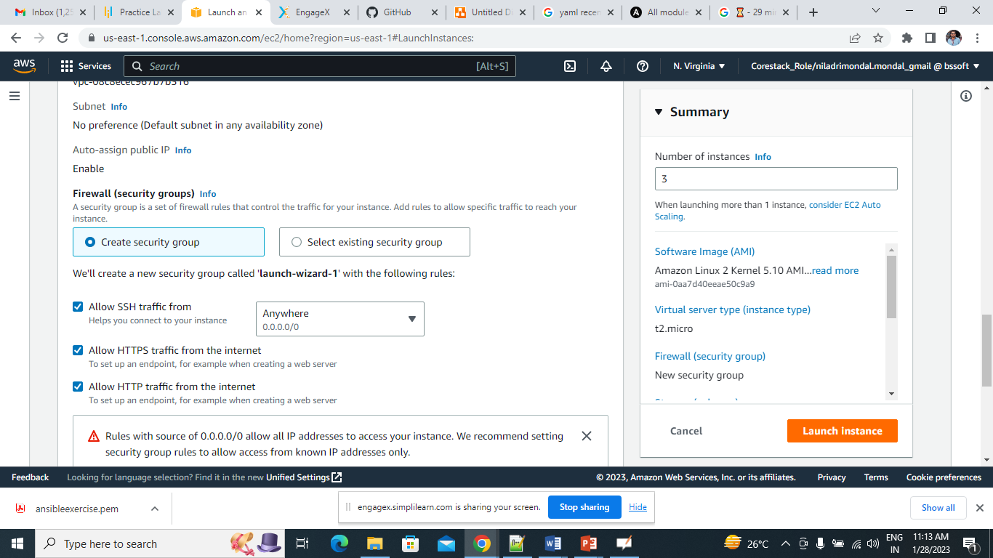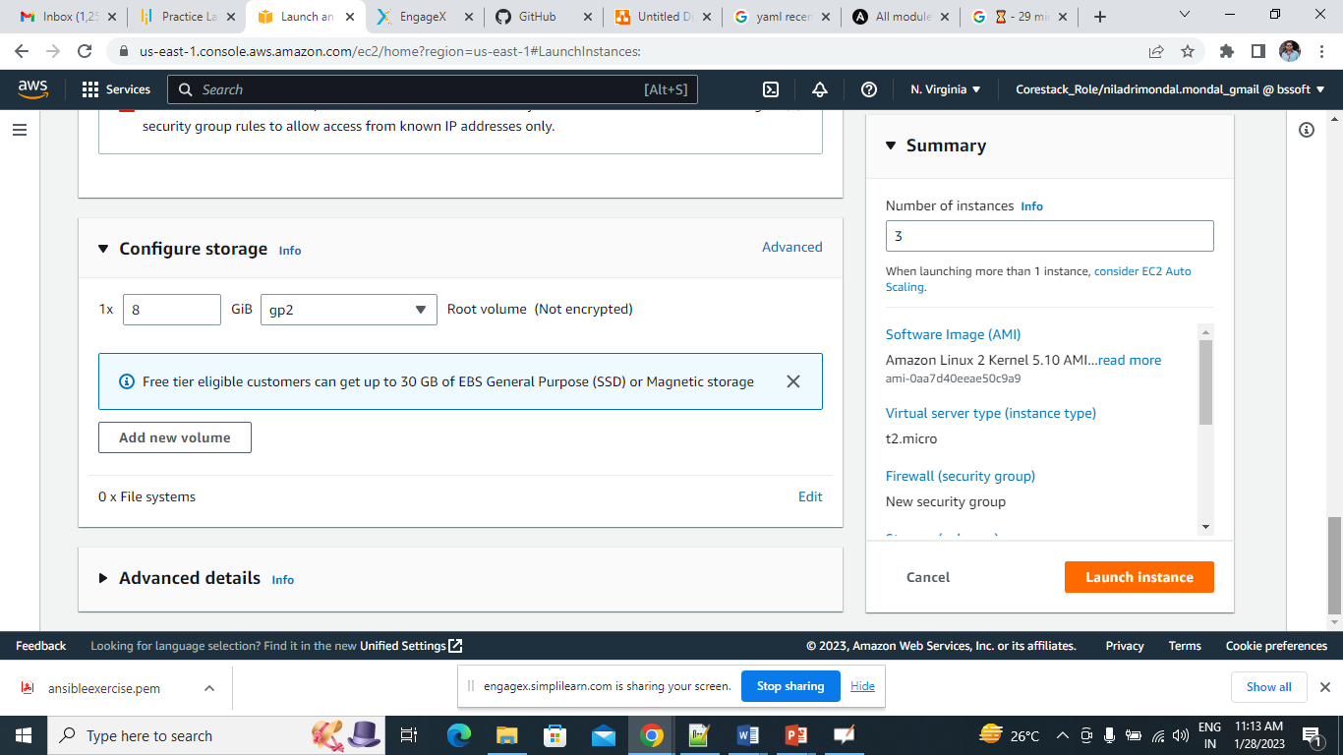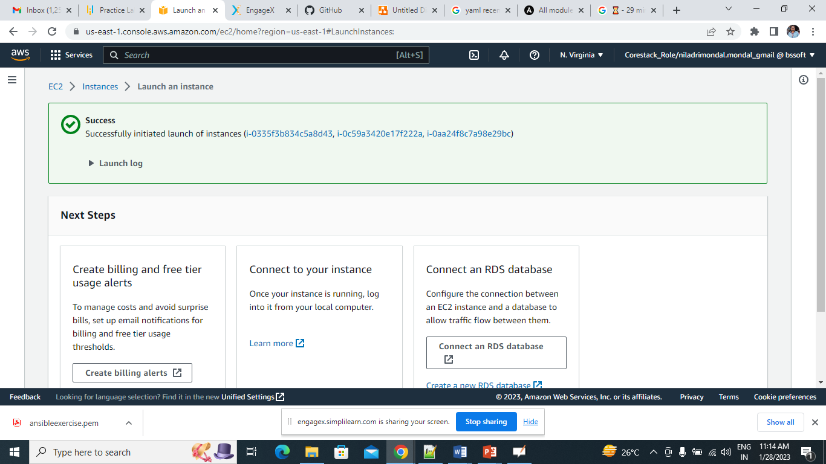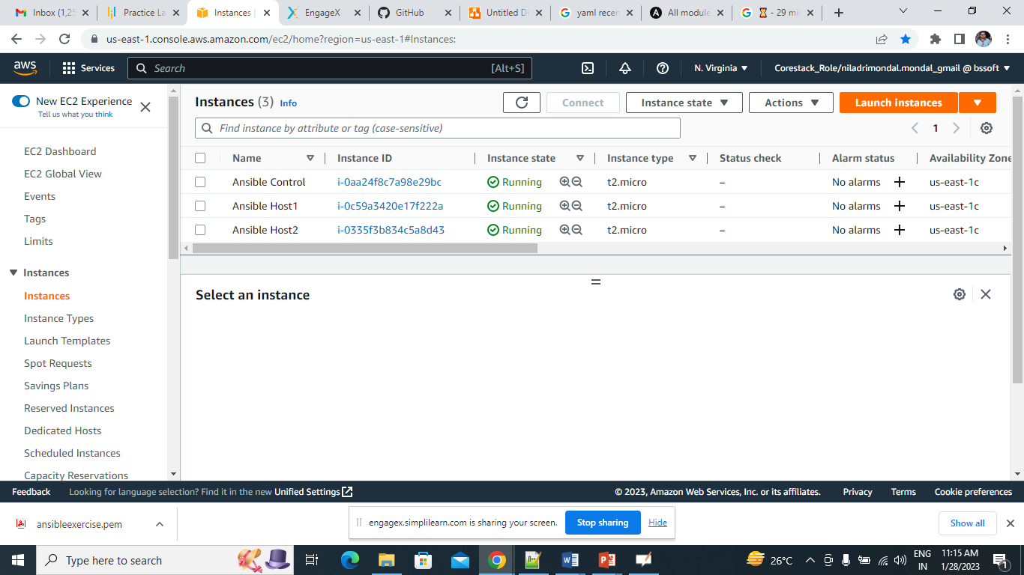

We are going to install Ansible in All the 3 Nodes

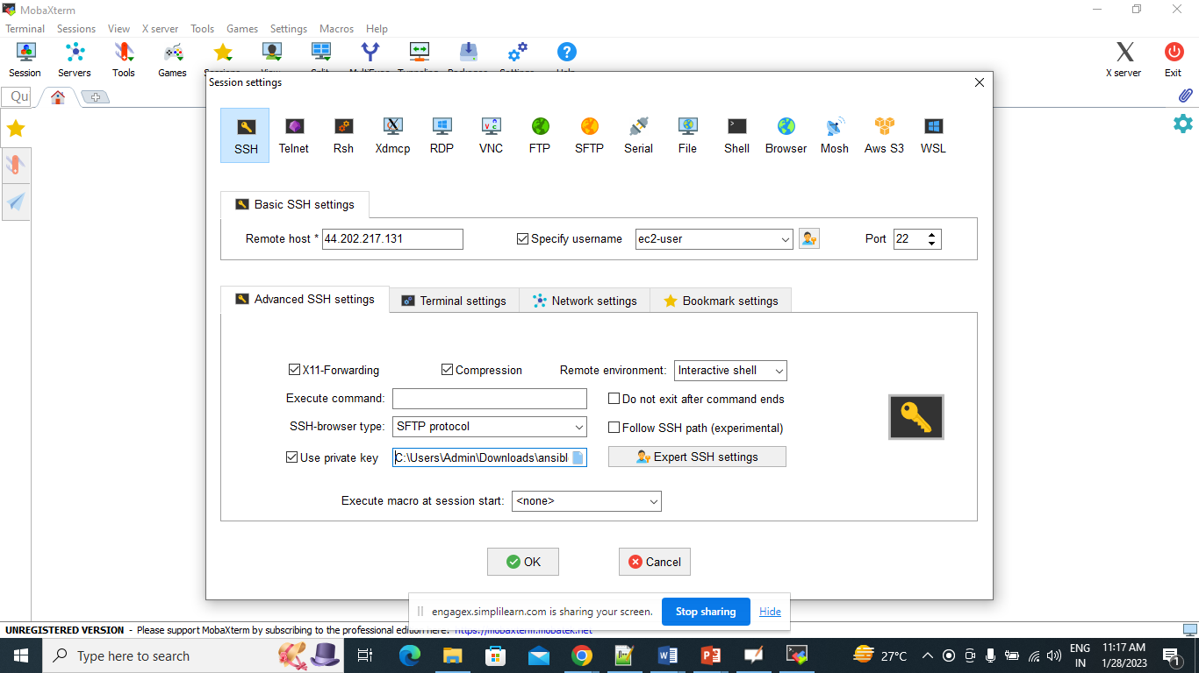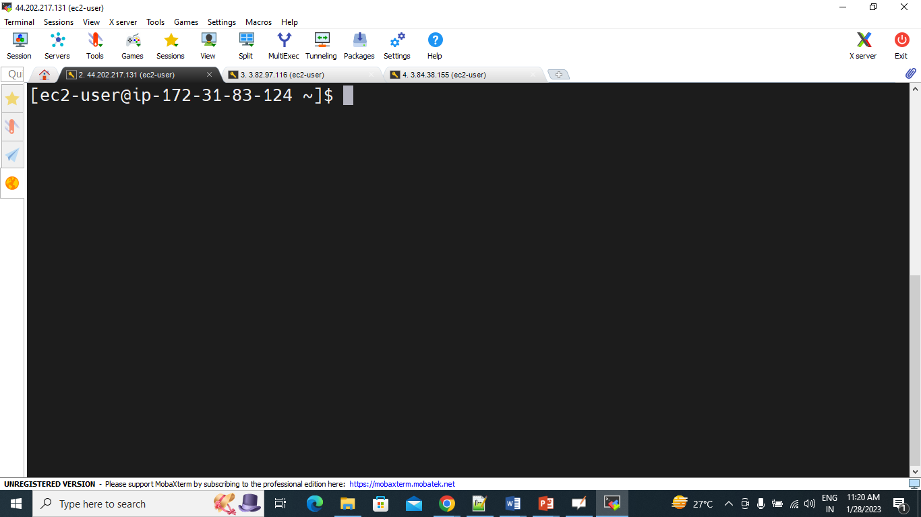

Installation steps:

#create 3 ec2 amazon linux vm , 1 Master and 2 Worker Nodes and install ansible

#connect to the servers

#switch to root

sudo su –

#To come out of any user

logout or exit

#update serverpackages

yum update -y

#5. Install the ansible

It we install Ansible we need to follow below pre-requisites.

#Download epel repository.

wget https://dl.fedoraproject.org/pub/epel/epel-release-latest-7.noarch.rpm

#Verify epel repository

ls

#Install epel repository.

yum install epel-release-latest-7.noarch.rpm

#Update epel repository.

yum update -y

#Install all individual packages inside the repository.

yum install git python python-devel python-pip openssl ansible -y

#Chek the Ansible version

ansible --version

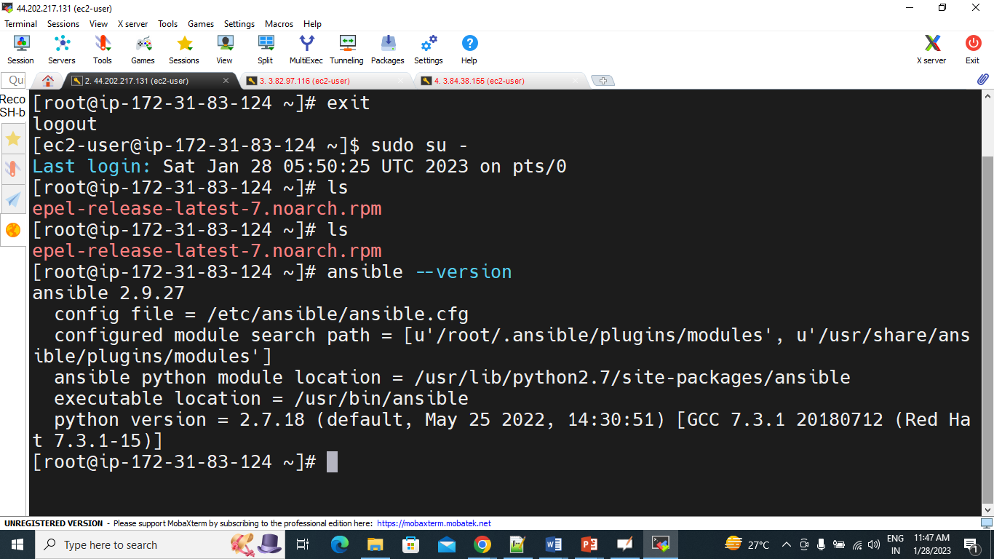

Ansible componets:

[ec2-user@ip-172-31-83-124 ~]$ sudo su -

Last login: Sat Jan 28 06:10:11 UTC 2023 on pts/0

[root@ip-172-31-83-124 ~]# clear

[root@ip-172-31-83-124 ~]# cd /etc/ansible/

[root@ip-172-31-83-124 ansible]#

