INFORMATION SYSTEMS ANALYSIS AND DESIGN

SHOPEE LIKE MULTIVENDOR E COMMERCE PLATFORM
Detailed System Analysis Architecture and Prototype Report
Student information | Details
Full name | Trần Quang Tiến
Student ID | B23DCVT414

Fictional academic design inspired by a large marketplace operating model

Executive Summary
This report specifies a Shopee-like multivendor marketplace in which customers discover products, compare offers, place and pay for orders, track delivery, review purchases, and request returns; sellers manage catalogues, inventory, pricing, fulfilment and campaigns; platform staff govern content, risk, disputes and operations. The design treats the marketplace as a distributed socio-technical system rather than a single shopping website.
The recommended architecture separates presentation, domain services and data/integration responsibilities, then subdivides the domain into bounded services for identity, catalogue, search, cart, promotion, order, inventory, payment, logistics, review, chat, notification, risk and reporting. Transaction boundaries, idempotency, event publication, auditability and recovery are specified because a marketplace must remain correct when external services time out or messages are delivered more than once.

Main Design Decision
The order service owns the order lifecycle, while inventory, payment and logistics retain ownership of their own records. A checkout saga coordinates these services through explicit commands and compensating actions. Search and recommendation may be eventually consistent, but money, stock reservation, voucher usage and order status transitions require stronger controls.

Deliverables
- Complete stakeholder, scope, functional and non-functional analysis.
- Traceable business rules and acceptance criteria.
- Detailed specifications for six UML and architecture diagrams to be drawn in Visual Paradigm.
- Executable Python prototype for search ranking and checkout quotation.
- Test strategy, risk register, deployment and operational design.

Report Contents
Section | Topic | Main Coverage
1 | System Context and Objectives | Business context, outcomes and value stream
2 | Stakeholders and Responsibilities | Actors, ownership and personas
3 | Scope Assumptions and Business Rules | Boundary, rules and invariants
4 | Functional Requirements | Customer, seller, transaction and operations
5 | Quality Requirements and Standards | Performance, security, accessibility and quality
6 | Use Case Model | Diagram specification and detailed use cases
7 | Architecture Components and Contracts | Layers, services, APIs and events
8 | Data and Information Model | Entities, integrity, localization and governance
9 | Interaction and Lifecycle Models | Checkout, return and order state
10-12 | Intelligence Security and Operations | Ranking, fraud, scale, settlement and incidents
13-15 | Prototype Testing Risks and Conclusion | Evidence, traceability and drawing checklist

Document Conventions
The platform name in this report is MarketplaceX. It is a fictional design inspired by the operating model of a large Southeast Asian marketplace and is not an official Shopee system description. SHALL indicates a mandatory requirement; SHOULD indicates a strongly recommended quality target; MAY indicates an optional extension.
Bracketed figure notes are deliberate placeholders. Each placeholder is followed by an exact drawing specification so the final Visual Paradigm project can be created without inventing missing actors, messages or dependencies.

1 System Context and Objectives

1.1 Business Context
MarketplaceX connects independent sellers with customers while coordinating product discovery, commercial rules, payments and delivery. The platform does not merely display products. It establishes trust by verifying participants, preserving evidence, calculating fees, protecting payment flows, enforcing service levels and resolving exceptions across organizations that do not share one database.

1.2 System Objectives
Objective | Business Outcome | Measurable Indicator
Fast discovery | Customers find relevant offers across a large catalogue | Search p95 below 500 ms; zero-result rate monitored
Safe transaction | Money and stock cannot be lost or duplicated | No duplicate charge; auditable state transition
Seller growth | Sellers can publish and fulfil at scale | Listing lead time; cancellation attributable to seller
Trusted marketplace | Fraud, counterfeit and abusive behavior are controlled | Risk-review precision; complaint resolution time
Operational resilience | Partial failures do not corrupt customer orders | Availability, recovery time and backlog age

1.3 End to End Value Stream
- Seller onboarding and shop verification.
- Product and offer publication with policy validation.
- Customer discovery through search, recommendation and campaign pages.
- Cart consolidation, voucher evaluation, shipping quotation and checkout.
- Stock reservation, payment authorization and order creation.
- Seller fulfilment, carrier handover and delivery tracking.
- Settlement, review, return, refund and dispute management.

2 Stakeholders and Responsibilities
Stakeholder | Primary Goals | System Responsibilities
Customer | Relevant products, transparent price, safe purchase | Search, cart, checkout, payment, tracking, review, return
Seller | Reach buyers, control offers, receive settlement | Shop profile, listing, stock, pricing, fulfilment, analytics
Platform administrator | Policy enforcement and configuration | Category, campaign, user, content and permission management
Customer support | Resolve enquiries and exceptions | Case history, evidence, controlled order/refund actions
Risk analyst | Prevent fraud and abuse | Rule management, alert review, account and transaction decisions
Payment provider | Authorize, capture and refund funds | Signed callbacks, transaction reference, reconciliation
Logistics provider | Quote, pick up, transport and confirm delivery | Shipment label, tracking events and proof of delivery
Notification provider | Deliver email, SMS or push | Template rendering, delivery receipt and retry

2.1 Responsibility Boundaries
MarketplaceX owns the marketplace account, catalogue policy, order record and audit trail. A payment provider owns authorization and settlement evidence; a carrier owns physical tracking events. The platform records immutable references to those external outcomes rather than treating a local success message as final proof.

2.2 Primary Personas
- Mobile-first customer with intermittent connectivity and a preference for local language search.
- Small seller using one phone to manage listings and fulfilment.
- High-volume seller integrating inventory through APIs.
- Support agent who needs a single chronological case view with protected actions.

3 Scope Assumptions and Business Rules

3.1 In Scope
Capability Group | Included Capabilities
Identity and trust | Registration, login, MFA for sensitive actions, role and shop verification
Commerce | Catalogue, offers, search, recommendation, cart, vouchers, checkout and order
Fulfilment | Inventory reservation, shipment creation, tracking and delivery confirmation
After-sales | Review, return, refund, dispute, support case and evidence
Platform operations | Campaign, moderation, risk, audit, notification, reporting and observability

3.2 Out of Scope
The report does not specify warehouse robotics, lending, live-stream media production, advertising auction algorithms, payroll, tax filing or the internal network of external payment and logistics providers. Interfaces to these capabilities are represented where they affect platform behavior.

3.3 Core Business Rules
ID | Rule
BR01 | A sellable offer belongs to exactly one shop and one product variant.
BR02 | Displayed payable total equals merchandise minus valid discounts plus shipping and applicable fees.
BR03 | Stock is reserved before payment capture and released on timeout or cancellation.
BR04 | One voucher redemption key is unique per customer, campaign and order attempt.
BR05 | Order state changes must follow the approved state machine and be auditable.
BR06 | A review requires a delivered order item and is limited to one active review per item.
BR07 | Refund amount cannot exceed the captured amount minus prior successful refunds.
BR08 | Seller settlement is held until the return or dispute window permits release.

4 Functional Requirements for Customer Discovery
ID | Requirement | Acceptance Evidence
FR01 | Register, sign in, recover account and manage trusted devices. | Authenticated session and security event log
FR02 | Browse category hierarchy, campaign pages and shop pages. | Correct navigation and policy-visible offers
FR03 | Search by keyword, natural language, voice transcript or image. | Common query object and ranked result list
FR04 | Filter by category, brand, price, rating, location, shipping option and stock. | Every selected filter appears in query and result facets
FR05 | Sort by relevance, sales, rating, newest and price. | Deterministic order for equal scores
FR06 | Display variant, price, discount basis, seller, rating, sold count and delivery promise. | Product detail contains required commercial fields
FR07 | Add, update, select and remove cart items grouped by shop. | Cart version changes atomically and total is recalculated
FR08 | Save products, shops and recent searches. | Customer-specific list with delete and privacy control
FR09 | Receive recommendations with an explanation category such as similar item or previous interest. | Recommendation request and impression event are recorded

4.1 Search Result Contract
Each result contains product and offer identifiers, shop identifier, thumbnail, title, selected or lowest variant price, original price when legally valid, rating count, sold count, shop location, shipping promise, badges, stock status and a ranking trace identifier. The trace identifier supports offline diagnosis without exposing the scoring formula to the client.

4.2 Empty and Degraded Results
When filters eliminate all results, the system SHALL explain which constraints can be relaxed. If personalization is unavailable, search SHALL continue using non-personalized relevance. If image encoding fails, a combined text-image query SHALL fall back to text and mark the response as degraded rather than returning an unexplained error.

4 Functional Requirements for Transaction and After Sales
ID | Requirement | Key Condition
FR10 | Validate price, stock, address, vouchers and shipping options at checkout. | Server recalculates all client totals
FR11 | Split one cart into shop-specific orders under one checkout group. | Every item belongs to exactly one child order
FR12 | Reserve stock using an idempotent checkout attempt identifier. | Duplicate request does not double-reserve
FR13 | Authorize payment and process signed asynchronous callbacks. | Callback reference is unique and verified
FR14 | Create shipment, label and pickup request for eligible orders. | Order has one active shipment per fulfilment leg
FR15 | Track order from confirmation through delivery or cancellation. | History preserves actor, time and reason
FR16 | Allow cancellation only while business and carrier rules permit. | Compensation releases stock and payment hold
FR17 | Open return or refund request with reason, evidence and requested remedy. | Eligibility and deadline are validated
FR18 | Escalate unresolved cases to platform dispute review. | Decision and evidence are immutable
FR19 | Allow verified purchase review and seller response. | Delivered item is required
FR20 | Notify material events through in-app, push, email or SMS. | User preference and delivery result are recorded

4.3 Checkout Invariants
- The client never supplies an authoritative payable total.
- A payment success cannot create two paid orders.
- A failed checkout eventually releases reservations and voucher holds.
- Every externally visible status can be explained by ordered domain events.

4 Functional Requirements for Seller Platform and Partners
ID | Actor | Requirement
FR21 | Seller | Create shop profile and submit verification information.
FR22 | Seller | Create product, variants, media and attributes subject to moderation.
FR23 | Seller | Manage price, promotion eligibility, stock and purchase limits.
FR24 | Seller | Accept, pack, hand over or reject fulfilment with reason.
FR25 | Seller | View settlement statement, fees, refunds and adjustment entries.
FR26 | Administrator | Manage taxonomy, restricted items, campaigns and platform vouchers.
FR27 | Moderator | Review listings, images, reviews and reports using evidence.
FR28 | Support | Search customer, order and case history with masked sensitive data.
FR29 | Risk | Evaluate account, promotion, payment and refund events and apply holds.
FR30 | Partner | Receive signed requests and return idempotent callbacks or events.

4.4 Administrative Control Principles
Privileged actions require least-privilege roles, purpose-based access, step-up authentication for high-impact operations, mandatory reason codes and an append-only audit event. Bulk actions must show the affected population before execution and provide a recoverable job record.

4.5 Reporting Requirements
Operational dashboards distinguish business time from processing time. Examples include paid-to-packed time, pickup breach, cancellation attribution, refund aging, payment reconciliation mismatch, inventory oversell, search zero-result rate, notification failure and event-consumer lag.

5 Quality Requirements and Standards
Quality Area | Target or Control | Verification
Performance | Search p95 <= 500 ms; cart p95 <= 300 ms; checkout command p95 <= 2 s excluding external wait | Load and percentile test
Availability | Browse 99.95%; checkout 99.9%; graceful degradation for recommendation | SLO dashboard and error budget
Reliability | Idempotent commands, durable events, reconciliation and compensating actions | Fault injection and replay test
Security | OWASP ASVS 5.0.0 control baseline; strong authentication and authorization | Threat model, SAST, DAST and penetration test
Payment boundary | No raw card data in marketplace services; provider tokenization; PCI DSS v4.0.1 boundary | Data-flow review and provider evidence
Accessibility | WCAG 2.2 AA target for web and equivalent mobile semantics | Automated and assistive-technology test
Maintainability | Bounded services, versioned contracts, ownership and architecture tests | Dependency and contract tests
Observability | Trace identifier across gateway, services, events and partners | Synthetic journey and trace completeness

5.1 Standards Position
ISO/IEC 25010:2023 is used as a quality-model checklist, not as a claim of certification. OWASP ASVS 5.0.0 provides testable application-security requirements. PCI DSS v4.0.1 informs the payment-data boundary. WCAG 2.2 is the accessibility target. Compliance requires separate legal and audit work beyond this design report.

5.2 Data Quality
Catalogue attributes SHALL have provenance, validation status, locale and update time. Analytical events SHALL define owner, schema version, retention and allowed purposes. Derived scores SHALL be reproducible from model version, feature version and trace identifier.

6 Use Case Model
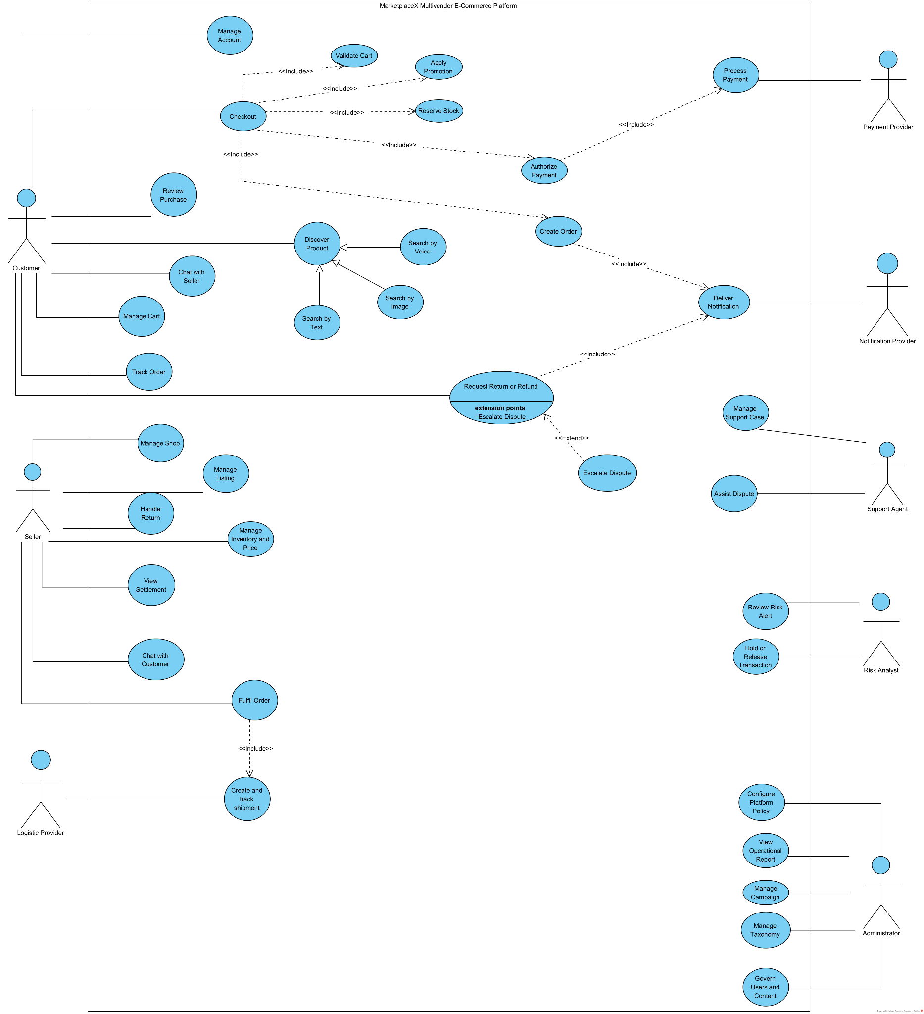
Figure 1 MarketplaceX Use Case Diagram

6.1 Drawing Specification
Create one system boundary named MarketplaceX Multivendor E Commerce Platform. Place Customer and Seller on the left; Administrator, Support Agent and Risk Analyst on the right; Payment Provider, Logistics Provider and Notification Provider below as secondary actors.
Actor | Associate With
Customer | Manage Account; Discover Product; Manage Cart; Checkout; Track Order; Request Return or Refund; Review Purchase; Chat
Seller | Manage Shop; Manage Listing; Manage Inventory and Price; Fulfil Order; Handle Return; View Settlement
Administrator | Manage Taxonomy; Manage Campaign; Govern Users and Content
Support Agent | Manage Support Case; Assist Dispute
Risk Analyst | Review Risk Alert; Hold or Release Transaction
External providers | Process Payment; Create and Track Shipment; Deliver Notification

Use <<include>> from Checkout to Validate Cart, Apply Promotion, Reserve Stock, Authorize Payment and Create Order. Use <<extend>> from Request Return or Refund to Escalate Dispute when normal seller resolution fails. Model Search by Text, Search by Voice and Search by Image as specializations of Discover Product.

6 Detailed Use Cases for Customer Purchase

UC01 Discover Product
Field | Specification
Primary actor | Customer; guest access is permitted for browsing
Preconditions | Catalogue index available; locale and market resolved
Trigger | Customer enters text, voice or image, or opens a category
Main flow | Normalize query; detect intent and filters; retrieve candidates; apply policy; rank; build facets; return results; record impression
Alternatives | No result suggests relaxation; image failure falls back to text; personalization unavailable uses generic ranking
Postconditions | No commercial state changes; trace and analytics events exist

UC02 Checkout
Field | Specification
Primary actor | Authenticated Customer
Preconditions | Selected cart items, deliverable address and active offers
Main flow | Load cart; reprice; validate limits; evaluate vouchers; quote shipping; show consent; reserve stock and voucher; authorize payment; create child orders; publish confirmation; notify parties
Exceptions | Price changed; stock unavailable; voucher exhausted; address unsupported; payment pending or failed; duplicate submission
Success | One checkout group, consistent child orders, payment reference and reservation references
Failure | No captured money without an order; temporary holds are compensated

6 Detailed Use Cases for Seller and After Sales

UC03 Publish Listing
Field | Specification
Actor | Verified Seller
Input | Category, title, attributes, variants, price, stock, media and logistics data
Validation | Required attributes, prohibited terms, image policy, variant uniqueness, price range and shipping feasibility
Outcome | Draft, pending moderation, active, rejected or suspended listing with reason and audit history

UC04 Fulfil Order
The seller accepts the order, confirms preparation, prints or receives a label, packs items, hands them to the authorized carrier and monitors pickup. The system prevents handover after cancellation, records package measurements, and creates an exception when carrier pickup misses the promised time.

UC05 Return Refund and Dispute
Stage | Rule and Evidence
Eligibility | Delivered item, return window, category rule and prior case checked
Request | Reason, requested remedy, item quantity, image or video evidence and customer statement
Seller response | Accept, propose alternative or reject with reason before deadline
Return logistics | Label, pickup or drop-off, tracking and inspection result
Refund | Amount calculated from captured payment, discounts, partial quantity and prior refunds
Dispute | Platform reviewer receives immutable timeline and evidence; decision is reason-coded

Use Case Quality Rule
Every use case must identify actor, trigger, preconditions, main success scenario, alternatives, failures, postconditions, business rules, permissions and auditable events. This prevents diagrams from becoming disconnected pictures.

7 Three Layer and Service Architecture
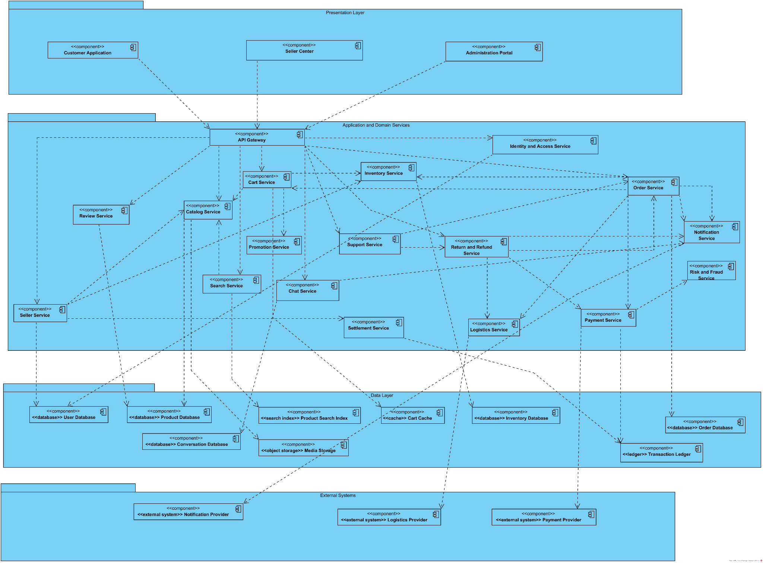

Figure 2 MarketplaceX Component Architecture

7.1 Drawing Specification
Draw three horizontal packages. Presentation contains Customer Web or App, Seller Center, Admin Console and API Gateway or Backend for Frontend. Application and Domain contains Identity, Catalogue, Search, Recommendation, Cart, Promotion, Checkout, Order, Inventory, Payment, Logistics, Review, Return Refund, Chat, Notification, Risk and Reporting services. Data and Integration contains service-owned databases, search index, cache, object storage, event broker, analytics warehouse and adapters for payment, carrier, email, SMS and push.

7.2 Mandatory Dependency Rules
- Clients call only gateway or BFF interfaces, never databases.
- A service owns its data and exposes versioned APIs or events; another service cannot write its tables.
- Synchronous calls are limited to decisions needed in the current response; notifications and analytics use events.
- External callbacks enter through verified adapters and are converted to internal commands or events.
- Reporting consumes replicated events and never runs heavy queries on transactional stores.

7 Component Catalogue and Interfaces
Component | Owns | Key Interfaces or Events
Identity | Account, role, credential metadata, device trust | authenticate; authorize; AccountRiskChanged
Catalogue | Product, category, attribute, variant, media reference | publishProduct; ProductChanged
Search | Search document and query trace | search; suggest; index ProductChanged
Cart | Versioned customer cart | getCart; changeItem; CartChanged
Promotion | Voucher, budget, rule, redemption hold | evaluate; reserve; commit; release
Checkout | Checkout attempt and orchestration state | quote; placeOrder; CheckoutTimedOut
Order | Order aggregate and history | createOrder; transition; OrderStatusChanged
Inventory | Available, reserved and committed quantity | reserve; commit; release; StockChanged
Payment | Payment intent, provider reference and refund | authorize; capture; refund; PaymentChanged
Logistics | Shipment, label, tracking timeline | quote; createShipment; TrackingChanged
Return Refund | Case, evidence, decision and refund calculation | openCase; decide; ReturnStatusChanged
Risk | Signals, rule result, hold and decision | evaluate; RiskDecisionMade

7.3 Contract Design
Commands carry requestId, actorId, timestamp, schemaVersion and correlationId. Mutating endpoints accept an idempotency key. Events carry eventId, aggregateId, aggregateVersion, occurredAt and producer. Consumers store processed event identifiers or use an inbox so redelivery is safe.

7 API Event and Integration Standards

7.4 Synchronous API Rules
Concern | Required Convention
Resource naming | Stable nouns and explicit subresources; business actions are commands with clear names
Versioning | Compatible additions within a major version; breaking changes require migration and retirement plan
Idempotency | Every externally retried mutation accepts a scoped idempotency key and returns the original outcome
Concurrency | Mutable resources expose version or ETag; stale updates return conflict instead of overwriting
Errors | Machine-readable code, safe message, field errors, correlation id and retry guidance
Pagination | Cursor-based pagination for changing datasets; stable sort key and maximum page size
Security | Authenticated principal, resource authorization, schema validation, rate limit and audit metadata

7.5 Event Governance
Domain events describe completed facts rather than instructions. Schemas are registered, owned and backward compatible. Producers never silently change the meaning of an existing field. Personally identifiable information is excluded unless a documented consumer purpose requires it. Consumers define maximum acceptable lag, retry policy, dead-letter ownership and replay procedure.

7.6 External Partner Adapter
Each payment or logistics provider is isolated behind a canonical internal interface. The adapter translates provider status values, validates signatures, normalizes timestamps and stores the unmodified provider reference. Provider-specific retry rules remain inside the adapter so OrderService and CheckoutService do not contain vendor conditions.

8 Logical Data and Information Model
[INSERT VISUAL PARADIGM DOMAIN CLASS OR ER DIAGRAM HERE]
Figure 3 MarketplaceX Logical Data Model

8.1 Entities and Cardinalities
Entity | Key Relationships and Constraints
Customer | 1..* Address; 0..1 active Cart; many Order and Case records
Seller and Shop | Seller 1..* Shop; Shop 1..* Offer and SettlementEntry
Product and Variant | Product 1..* Variant; category defines attribute schema
Offer and Inventory | Offer identifies shop plus variant; one stock ledger per fulfilment location
CheckoutGroup and Order | One group creates 1..* shop orders; each order has 1..* OrderItem
Payment | CheckoutGroup 1..* PaymentAttempt; captured amount bounds refunds
Shipment | Order 0..* Shipment; shipment has ordered TrackingEvent records
Voucher | Campaign defines rule and budget; Redemption references customer and order
ReturnCase | References order items, evidence, decision, return shipment and refund
AuditEvent | Actor, action, target, reason, before/after digest and correlation id

8.2 Integrity and Retention
Monetary values use integer minor units plus currency. Quantities never become negative. Mutable operational tables use optimistic version numbers. Order snapshots preserve product title, variant, price and seller terms as purchased. Personal and financial records have purpose-based retention; analytics receives pseudonymous identifiers when direct identity is unnecessary.

8 Localization Data Governance and Audit

8.3 Localization Model
Customer-visible catalogue fields separate canonical values from locale-specific display text. Search normalization supports Vietnamese with and without diacritics, localized units, currency display and synonym dictionaries. Dates are stored in UTC and rendered in the user's time zone. Address models are country-specific and validated by versioned rules rather than one global free-text format.

8.4 Master and Transaction Data
Data Class | System of Record | Consistency Expectation
Category and attributes | Catalogue governance | Versioned publication; historical listings retain schema reference
Product content | Catalogue service | Moderated source; search index eventually consistent
Offer price and stock | Offer and Inventory services | Revalidated during checkout; cache is non-authoritative
Order and payment | Order and Payment services | Strong local transaction plus reconciled cross-service events
Tracking | Logistics service with provider evidence | Ordered timeline; staleness is visible
Analytics event | Event pipeline and warehouse | Append-only, schema-versioned and quality monitored

8.5 Audit Evidence
An audit record includes who acted, the authenticated role, purpose, target, time, correlation identifier, reason code and a digest of material before-and-after values. Audit storage is append-only for application users. Sensitive payloads are referenced rather than copied when duplication would expand privacy risk.

9 Checkout Sequence Diagram
[INSERT VISUAL PARADIGM CHECKOUT SEQUENCE DIAGRAM HERE]
Figure 4 Checkout and Payment Sequence

9.1 Lifelines
Customer, CustomerApp, CheckoutService, CartService, PromotionService, LogisticsService, InventoryService, RiskService, PaymentService, PaymentProvider, OrderService, EventBroker and NotificationService.

9.2 Message Order
- CustomerApp -> CheckoutService: quote(checkoutRequest).
- CheckoutService -> CartService: getSelectedItems(cartId, version).
- CheckoutService -> PromotionService: evaluate(items, customer, vouchers).
- CheckoutService -> LogisticsService: quote(address, shopPackages).
- CheckoutService --> CustomerApp: quote with expiry and quoteHash.
- Customer confirms; app sends placeOrder(request, idempotencyKey, quoteHash).
- CheckoutService -> InventoryService: reserve(items, attemptId, ttl).
- CheckoutService -> PromotionService: reserve(redemptions, attemptId, ttl).
- CheckoutService -> RiskService: evaluateCheckout(context).
- alt approved: CheckoutService -> PaymentService: authorize(amount, paymentToken, attemptId).
- PaymentService -> PaymentProvider: authorize; provider returns pending or authorized.
- Payment callback -> PaymentService: verified status; PaymentService publishes PaymentAuthorized.
- CheckoutService -> OrderService: createOrders(snapshot, references).
- OrderService publishes OrderCreated; Inventory and Promotion commit reservations.
- NotificationService consumes OrderCreated and sends confirmation.
- alt failure or timeout: release inventory and voucher; void payment authorization when required.

9 Return Refund and Dispute Sequence
[INSERT VISUAL PARADIGM RETURN REFUND SEQUENCE DIAGRAM HERE]
Figure 5 Return Refund and Dispute Sequence

9.3 Lifelines and Fragments
Use Customer, CustomerApp, ReturnRefundService, OrderService, PolicyService, SellerCenter, LogisticsService, PaymentService, SupportConsole and AuditService. Show alt fragments for eligible versus ineligible request, seller accepts versus disputes, and inspection passes versus fails.

9.4 Core Messages
- Customer submits openCase(orderItem, reason, remedy, evidence).
- ReturnRefundService obtains immutable order snapshot and delivery time.
- PolicyService evaluates category, deadline, quantity and prior cases.
- Eligible case is created and seller response deadline scheduled.
- SellerCenter receives case; seller accepts, proposes or rejects.
- If physical return is required, LogisticsService creates return shipment.
- Tracking and inspection events update the case timeline.
- ReturnRefundService calculates refundable amount and calls PaymentService.refund with idempotency key.
- Payment provider callback confirms refund; case becomes Refunded.
- If contested, SupportConsole receives evidence bundle and records a reason-coded decision.
- AuditService records every privileged read and decision.

9 Order Lifecycle State Model
[INSERT VISUAL PARADIGM ORDER STATE MACHINE HERE]
Figure 6 Order State Machine

9.5 States
State | Meaning | Permitted Next States
Draft | Checkout attempt exists but commerce is not committed | PendingPayment; Cancelled
PendingPayment | Reservations held; payment unresolved | Confirmed; PaymentFailed; Cancelled
Confirmed | Payment condition satisfied and order accepted | Preparing; Cancelled
Preparing | Seller is packing | ReadyToShip; CancelRequested
ReadyToShip | Package awaits carrier handover | Shipped; CancelRequested
Shipped | Carrier has custody | Delivered; DeliveryException; ReturnRequested
Delivered | Delivery evidence recorded | Completed; ReturnRequested; Disputed
Completed | Settlement may be released | ReturnRequested only if policy permits
Cancelled | Terminal commercial cancellation | No normal transition
ReturnRequested | After-sales case is active | Returned; Rejected; Refunded

Add guards such as [paymentAuthorized], [beforeHandover], [deliveryEvidenceValid] and [withinReturnWindow]. Add entry actions for audit event publication and notification. Never draw a direct transition that bypasses commercial controls, such as PendingPayment to Shipped.

10 Search Recommendation and Ranking Design

10.1 Query Pipeline
- Language and locale detection; normalization and spelling correction.
- Intent classification for product, shop, order-help or unsafe query.
- Entity extraction for category, brand, attributes, price and location.
- Candidate retrieval from lexical index, vector index and sponsored eligibility set.
- Policy filtering for market, restricted items, stock and account eligibility.
- Learning-to-rank or weighted scoring; diversity and seller-quality constraints.
- Facet construction, explanation labels and experiment assignment.

10.2 Scoring Model
Score = 0.55 * lexical_relevance
+ 0.20 * semantic_similarity
+ 0.10 * offer_quality
+ 0.08 * seller_quality
+ 0.05 * delivery_fit
+ 0.02 * freshness
Hard constraints: market, policy, variant availability and selected price range.
Sponsored eligibility and organic relevance should be measured separately. The interface clearly labels sponsored placements. Business features must be bounded so a poorly matched product cannot outrank a strongly relevant product solely because of sales volume.

10.3 Recommendation Safety
Recommendation uses consented behavioral signals, suppresses recently purchased or hidden items, applies frequency caps and provides reset or opt-out controls. Model and feature versions are logged. Offline metrics such as NDCG and recall are combined with online guardrails for complaint rate, seller concentration and latency.

11 Security Privacy and Fraud Controls
Threat | Control Set | Evidence
Account takeover | MFA, device risk, rate limit, breached-password block, session rotation | Authentication and device events
Broken authorization | Central policy decision, resource ownership check, deny by default | Authorization test matrix
Injection and XSS | Parameterized queries, context encoding, CSP, validated file processing | SAST, DAST and security tests
Payment callback forgery | mTLS or signature, timestamp window, replay cache, provider reconciliation | Callback verification log
Voucher abuse | Per-account and device graph limits, reservation token, budget ledger | Risk decision and redemption ledger
Seller or product fraud | Verification, content moderation, anomaly detection, delayed settlement | Case and decision audit
Sensitive data exposure | Classification, encryption, tokenization, masking and least privilege | Data-flow and access review
Malicious upload | Type sniffing, size limit, malware scan, isolated transform and signed URL | Object scan status

11.1 Privacy Engineering
The design applies purpose limitation, collection minimization, retention schedules and access logging. Customer exports and deletion requests are orchestrated across service-owned data. Legal holds override normal deletion through an auditable policy decision. Analytics identifiers are separated from direct identity, and sensitive seller or support screens mask data until a justified action requires temporary reveal.

11.2 Threat Modeling Boundary
Trust boundaries exist at the client, gateway, service-to-service network, event broker, administrative tools and every external provider. A data-flow diagram should annotate authentication, encryption, data classification and rate limits at each boundary.

12 Scalability Reliability and Operations

12.1 Scaling Strategy
Workload | Primary Strategy | Failure Behavior
Browse and search | CDN, cache, horizontally scaled query nodes, partitioned index | Serve stale-safe facets or generic ranking
Catalogue update | Transactional write plus outbox event; asynchronous indexing | Product page is source of truth while index catches up
Cart | Partition by customer; optimistic version; short cache | Retry conflict without losing items
Checkout | Idempotent orchestration, bounded retries and saga compensation | Pending state with reconciliation, never blind success
Order events | Partition by order id to preserve per-order ordering | Dead-letter and replay with deduplication
Analytics | Append events to warehouse pipeline | Backlog tolerated without blocking transactions

12.2 Reliability Patterns
- Timeout, retry with jitter, circuit breaker and bulkhead around external providers.
- Transactional outbox for database change plus event publication.
- Inbox or processed-event ledger for idempotent event consumers.
- Reconciliation jobs compare platform records with payment and logistics statements.
- Backups are tested through restoration; recovery objectives are defined per data class.

12.3 Observability
Logs are structured and avoid secrets. Metrics cover request rate, error rate, latency, saturation, queue lag and business invariants. Distributed traces propagate correlation identifiers through synchronous calls and event metadata. Alerts are tied to user impact and runbooks, not raw infrastructure noise.

Optional Deployment Diagram
For an extra Visual Paradigm diagram, draw clients -> CDN/WAF -> load balancer -> API gateway -> services on two availability zones; include cache, service databases, search cluster, object storage, event broker, observability platform and external payment/logistics providers.

12 Flash Sale Settlement and Incident Operations

12.4 Flash Sale Capacity Protection
Risk Point | Design Control
Traffic burst | CDN waiting room, gateway rate limit, autoscaling warm-up and feature degradation plan
Hot product | Partition-aware counter, reservation queue, per-customer quantity limit and short reservation TTL
Voucher budget | Atomic budget ledger and reservation token; never count client display as redemption
Duplicate tap | Checkout idempotency key bound to customer and selected cart version
Price change | Signed quote hash with expiry; server reprice returns explicit changed-item response
Downstream slowdown | Bounded concurrency, circuit breaker and pending workflow rather than unlimited retry

12.5 Settlement and Reconciliation
A double-entry marketplace ledger records customer payment, seller payable, platform fee, shipping subsidy, voucher funding, refund and adjustment as balanced entries. SettlementService releases the net seller payable only after delivery and the applicable hold period. Daily reconciliation compares internal payment attempts and refunds with provider statements; unmatched records become owned investigation cases instead of silent balance corrections.

12.6 Incident Management
Operational incidents are classified by customer and financial impact. The incident commander coordinates containment, communication and recovery. High-risk switches can disable a payment method, voucher campaign, carrier or recommendation source without redeployment. After recovery, the team produces a blameless timeline, identifies the failed control, assigns corrective actions and verifies them through tests or monitoring.

12.7 Capacity and Recovery Evidence
Before major campaigns, teams run load tests using realistic search-to-checkout ratios, validate stock and voucher hot keys, rehearse provider failure, restore backups and confirm dashboards. Recovery objectives are specified separately for transactional ledgers, catalogue, search index and analytics because their acceptable loss and restoration sequence differ.

13 Python Prototype and Demonstration
The executable prototype validates two design ideas: all search modalities produce a common query that the same SearchService can rank, and checkout totals are recalculated on the server from price, quantity, discounts and shipping. The catalogue contains twelve representative products with price, rating, sales, stock and a small artificial image vector.
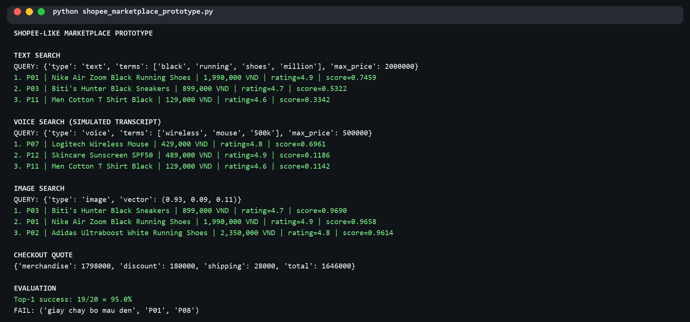
Figure 7 Prototype execution for text voice image and checkout quotation

13.1 Demonstrated Results
Scenario | Top Result or Total | Observation
Text: black running shoes under 2 million | Nike Air Zoom Black Running Shoes | Price ceiling applied before ranking
Voice transcript: wireless mouse under 500k | Logitech Wireless Mouse | Voice reuses text pipeline
Image vector similar to running shoes | Biti's Hunter Black Sneakers | Cosine similarity plus quality score
Two Biti's shoes with two vouchers | 1,646,000 VND | Server total includes 28,000 shipping

The automated text set produces 19 correct top results from 20 queries, or 95.0 percent. The deliberate Vietnamese query without translation fails, showing that a realistic platform needs Vietnamese normalization, synonyms and multilingual semantic retrieval. Image vectors and voice input are simulations; they validate interfaces, not model accuracy.

14 Test Strategy and Acceptance
Level | Purpose | Representative Tests
Unit | Business calculation and guard | Voucher cap, refund bound, state transition, ranking score
Contract | Provider and service schema compatibility | Payment callback signature; event schema version
Integration | Database, broker, cache and adapter behavior | Outbox publication; stock reservation expiry
End to end | Critical user journeys | Search to checkout; delivery to review; return to refund
Architecture | Dependency and ownership rules | Presentation cannot access repository; no cross-service table write
Security | Abuse and control effectiveness | Authorization matrix, replay, upload, rate limit and secrets
Performance | Latency and capacity under realistic mix | Flash-sale burst, search load and queue backlog
Resilience | Correctness under failure | Provider timeout, duplicate callback, broker redelivery, zone loss
Accessibility | Operability for diverse users | Keyboard, focus, labels, contrast and screen reader

14.1 Release Gates
- No open critical security finding or unowned high-risk defect.
- Checkout invariants pass under duplicate, delayed and reordered events.
- Performance targets pass with production-like data volume.
- Rollback and feature-disable procedures are rehearsed.
- Dashboards, alerts, runbooks and ownership are active before traffic migration.

14 Requirements Traceability and Risk Register

14.2 Traceability Sample
Requirement | Use Case or Component | Test Evidence
FR03 multimodal search | UC01; Query, Search and Ranking services | Text, voice and image ranking tests
FR10 checkout validation | UC02; Checkout service | Changed price, invalid address and expired quote
FR12 stock reservation | Checkout sequence; Inventory service | Duplicate attempt and expiry compensation
FR13 payment | Payment service and provider adapter | Signed callback, replay and reconciliation
FR17 return | UC05; Return Refund service | Eligibility, partial quantity and deadline
NFR reliability | Outbox, inbox, saga and reconciliation | Fault injection and event replay

14.3 Principal Risks
Risk | Impact | Mitigation
Oversell during campaign | Cancellation and trust loss | Atomic reservation, hot-key protection, quantity limit
Duplicate payment callback | Duplicate order or accounting error | Idempotency and unique provider reference
Search bias toward large sellers | Reduced marketplace diversity | Bounded quality features and concentration metrics
Fraud rule false positive | Legitimate customer blocked | Review queue, explanation, appeal and rule monitoring
Carrier event delay | Incorrect customer promise | Staleness flag, polling fallback and reconciliation
Sensitive support access | Privacy and insider risk | Purpose binding, masking, approval and audit

15 Conclusion
MarketplaceX is designed as a governed multivendor commerce platform rather than a monolithic online shop. The analysis covers participants, commercial rules, customer and seller journeys, service ownership, transactional consistency, search intelligence, payment and logistics integration, after-sales handling, security, privacy, scalability and operations. The central design principle is to choose consistency according to business risk: search and analytics can tolerate controlled delay, while stock, money, vouchers and order transitions require idempotent and auditable coordination.
The design is intentionally implementable in stages. A modular monolith can first preserve the same bounded responsibilities and interfaces; services can be extracted when scale, ownership or deployment independence justifies the operational cost. The prototype proves the common-query and pricing concepts, while the requirements and acceptance tests define what a production implementation must add.

15.1 Visual Paradigm Completion Checklist
Figure | Required Checks Before Export
Use Case | Actors outside boundary; include, extend and generalization arrows point correctly; no component names
Component | Three layers visible; interfaces and service-owned stores; no UI-to-database dependency
Data Model | Primary keys, foreign keys, multiplicities, money fields and snapshots included
Checkout Sequence | Lifelines, activation bars, return messages, approved and failure alt fragments, compensation path
Return Sequence | Eligibility, seller decision, logistics, inspection, refund and dispute fragments
State Machine | Initial and final nodes, guarded transitions, cancellation and return paths

15.2 Glossary
Term | Meaning in This Design
Aggregate | A consistency boundary whose changes are validated and committed together
BFF | Backend for Frontend tailored to customer, seller or administrator clients
Idempotency | Repeated processing of the same request produces one durable business outcome
Outbox | Transactional record used to publish a database change as a reliable event
Saga | A multi-service workflow coordinated through steps and compensating actions
SLO | A measurable service-level objective for availability, latency or correctness

15.3 Minimum Submission Package
The submission should include this report, the Visual Paradigm project, exported diagram images, Python prototype, sample data, a README with execution commands, the recorded prototype output and a short mapping from each required task to the corresponding report section. Diagram names and method names should remain consistent with the final code.

References
- ISO/IEC 25010:2023, Systems and software Quality Requirements and Evaluation product quality model, https://www.iso.org/standard/78176.html.
- OWASP Application Security Verification Standard 5.0.0, https://owasp.org/projects/asvs.
- PCI Security Standards Council, PCI DSS v4.0.1, https://www.pcisecuritystandards.org/standards/pci-dss/.
- W3C, Web Content Accessibility Guidelines WCAG 2.2, https://www.w3.org/TR/WCAG22/.
- Information Systems Analysis and Design Assignment 06 brief and supplied reference report.

