

Requirement & Design Specification
Restaurant Reservation Management System (RRMS)
Version: 1.0

Group 6
HE180039 - Đinh Gia Nam
HE186945 - Lê Mạnh Hùng
HE194555 - Nguyễn Đăng Hùng

MỤC LỤC
I. Overview 3
1. User Requirements 3
1.1 Actors 3
1.2 Use Cases 3
a. Diagram(s) 3
b. Descriptions 4
2. Overall Functionalities 6
2.1 Screens Flow 6
2.2 Screen Descriptions 9
2.3 Screen Authorization 11
System High Level Design 12
3.1 Database Design 12
a. Database Schema 12
b. Table Descriptions 12
II. Requirement Specifications (OPTIONAL) 15
1. Common Functions 15
1.1 UC1_ Login 15
1.2 UC2_ Register 15
1.3 UC3_Employee Manage 16
1.4 UC4_Table Manage 17
1.5 UC5_Booking Manager 18
1.6 UC6_Guest Manage 19
1.7 UC7_FeedBacks Manage 20
1.8 UC8_Direct booking 20
1.9 UC9_Booking requests 21
1.10 UC10_Booking table 22
1.11 UC11_History 24
III. Design Specifications 24
IV. Appendix 35
1. Assumptions & Dependencies 35
2. Limitations & Exclusions 35
3. Business Rules 35

I. Overview
The Restaurant Reservation Management Database project is a web application used to manage restaurant reservations. The project was developed using Java JDK 17 and NetBeans 17, deployed on Apache Tomcat 10.1.x, and uses Microsoft SQL Server 2022 as the database system, with SQL Server Management Studio (SSMS) 2020 for database management. The system was developed to optimize and improve restaurant reservation management.

1. User Requirements

1.1 Actors
# | Actor | Description
1 | Admin | The system administrator has the highest level of authority. They are responsible for managing platform data including all CRUD functionality for: Employees, Tables, and Guests (including account locking/unlocking). Admins can view the entire booking history and feedback to monitor activity.
2 | Receptionist | The receptionist is responsible for daily operations. They have the authority to handle guest reservation requests (Approve/Cancel/Complete), make walk-in reservations for walk-in guests, and monitor table status (Available/Occupied) on the table map.
3 | Guest | Customers use the system to search for available tables and make online bookings. They can manage their personal information, view their booking history, cancel pending orders, and submit feedback/ratings after completing their meal.

1.2 Use Cases

a. Diagram(s)

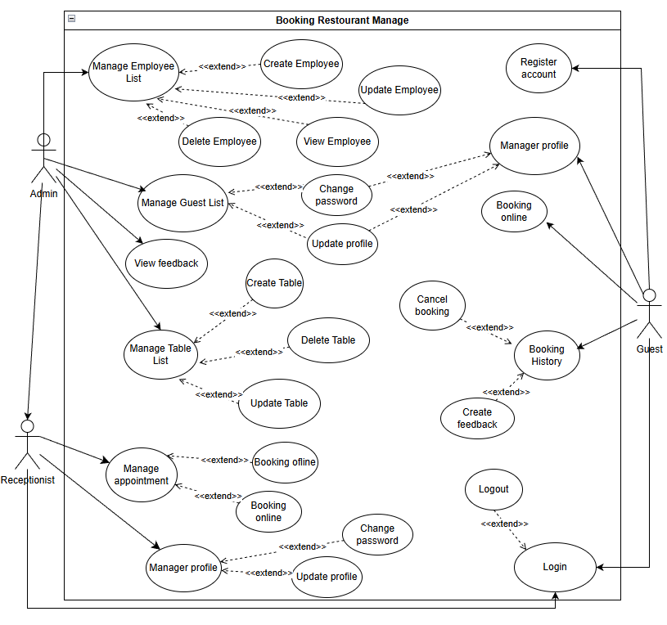

b. Descriptions

ID | Feature | Use Case | Use Case Description
01 | Admin | Manage Employee List | View the list of employees.
02 |  | Create Employee | Create a new employee account.
03 |  | Update Employee | Edit existing employee information.
04 |  | Delete Employee | Delete or Deactivate (Soft delete) an employee.
05 |  | Manage Table List | View list of tables and their current status.
06 |  | Create Table | Add a new table to the restaurant layout.
07 |  | Update Table | Edit table name or capacity.
08 |  | Delete Table | Remove a table from the system.
09 |  | Manage Guest List | Add, edit, delete, view guest information.
10 |  | View Feedback | View all customer feedbacks and ratings.
11 |  | View Booking History | View all booking history of the restaurant.
12 | Reception | Manage Booking Requests | View list of "Pending" bookings. Confirm or Reject requests.
13 |  | Walk-in Booking | Create a direct booking for guests at the restaurant (Offline).
14 |  | Update Booking Status | Mark a booking as "Completed" (Done) or "Cancelled".
15 |  | View Table Map | View real-time status of tables (Available/Occupied) on specific date/time.
16 | Guest | Register Account | Create a new account to use the system.
17 |  | Login | Login to the system using username and password.
18 |  | Logout | Log out of the system.
19 |  | Manage Profile | View and manage personal profile information.
20 |  | Update Profile | Edit personal profile information.
21 |  | Change Password | Change account password for security.
22 |  | Search Table | Check table availability by Date and Time.
23 |  | Booking Online | Book an available table.
24 |  | View Booking History | View list of past and upcoming bookings.
25 |  | Cancel Booking | Cancel a "Pending" or "Confirmed" booking.
26 |  | Create Feedback | Rate and write a review for a "Completed" booking.

2. Overall Functionalities

2.1 Screens Flow
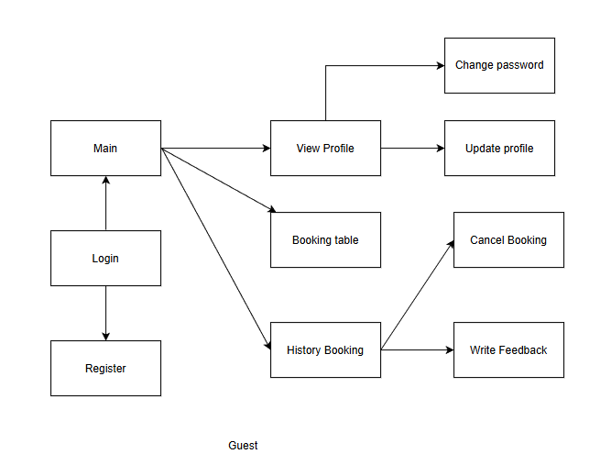
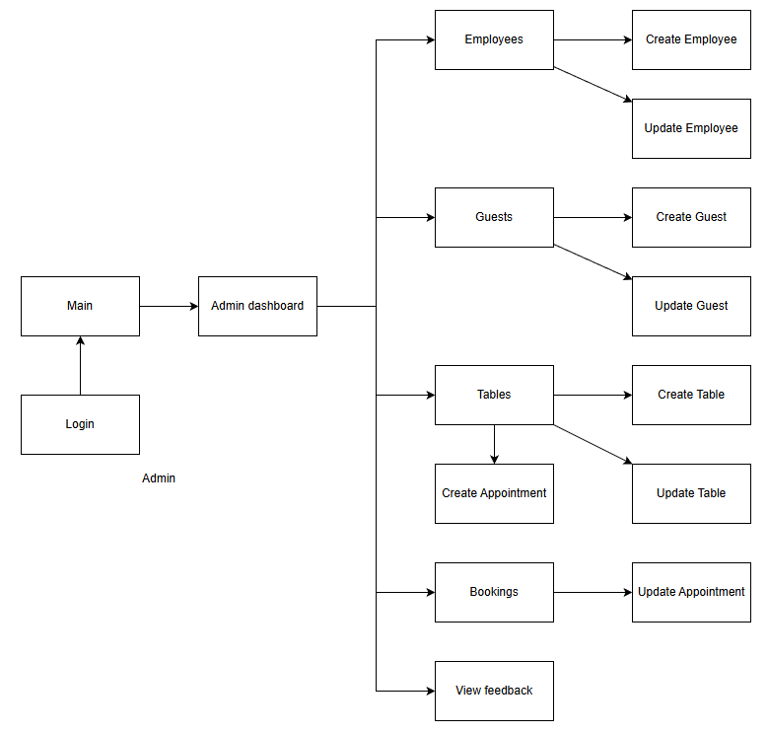

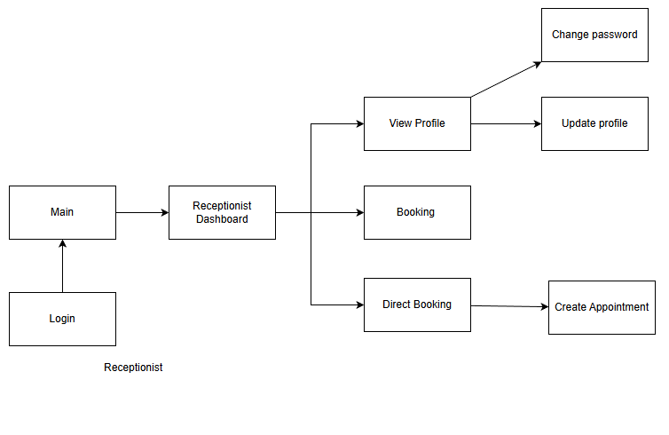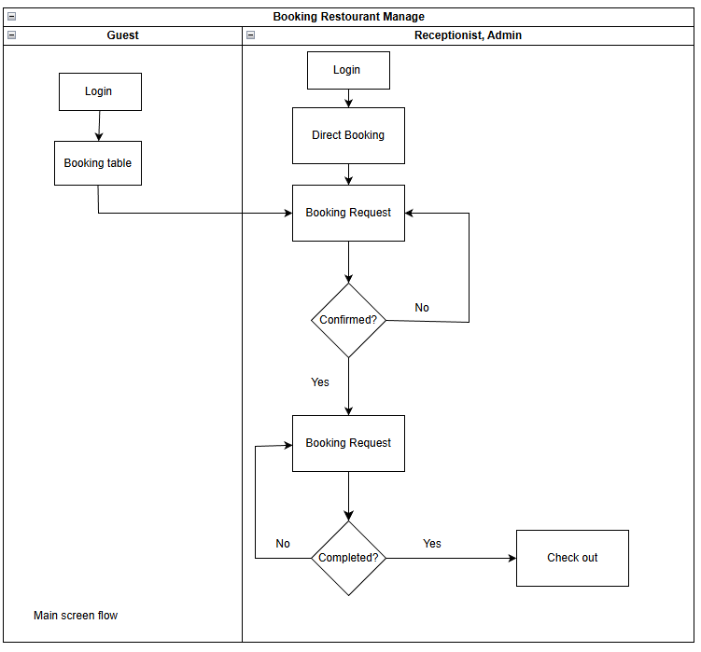

2.2 Screen Descriptions

NO | Feature | Screen | Description
1 | Staff Login | Log in | This page allows User to enter username and password to login
2 | Guest Login | Log in | This page allows guest to enter username and password to login
3 | Register Account | Register | This page allows guest to create a new account
4 | Manage Profile | Profile | This page allows user to view and manage personal information
5 | Update Profile | Update Profile | This page allows user to update personal information
6 | Change Password | Change Password | This page allows user to change account password
7 | Booking Online | Booking | This page allows guest to book a table online
8 | Cancel Booking | Booking Detail | This page allows guest to cancel an existing booking
9 | Create Feedback | Feedback | This page allows guest to create feedback about services
10 | Manage Feedback List | Feedback List | This page allows guest to view their feedback list
11 | View Feedback | Feedback List | This page allows admin to view feedback from guests
12 | Manage Employee List | Employee Management | This page allows admin to manage employee information
13 | Manage Table List | Table Management | This page allows receptionist to manage restaurant tables

2.3 Screen Authorization

NO | Screen | Admin | Receptionist | Guest
1 | Log in | X | X | X
2 | Home | X | X | X
3 | Manage Employee List | X
4 | Manage Guest List | X
5 | View Feedback | X
6 | Manage Table List |  | X
7 | Booking Online |  |  | X
8 | Manage Profile |  |  | X

System High Level Design

3.1 Database Design

Database Schema
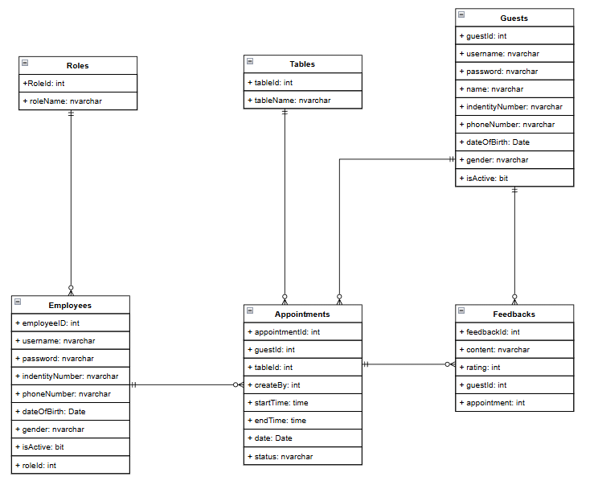

b. Table Descriptions
No | Table | Description
01 | Roles | - Manages role information with fields for RoleID and RoleName.  - Primary keys: RoleID
02 | Employees | - Manages employee accounts with fields for EmployeeID, Username, Password, IdentityNumber, PhoneNumber, DateOfBirth, Gender, IsActive, and RoleID.  - Primary keys: EmployeeID
03 | Guests | Stores guest information with fields for GuestID, Username, Password, Name, IdentityNumber, PhoneNumber, DateOfBirth, Gender, and IsActive.  Primary keys: GuestID
04 | Tables | - Stores table information with fields for TableID and TableName.  - Primary keys: TableID
05 | Appointments | - Manages appointment schedules with fields for AppointmentID, GuestID, TableID, CreatedBy, StartTime, EndTime, Date, and Status.  - Primary keys: AppointmentID
06 | Feedbacks | - Stores customer feedback with fields for FeedbackID, Content, Rating, GuestID, and AppointmentID.  - Primary keys: FeedbackID

4. Class diagram,
4.1. 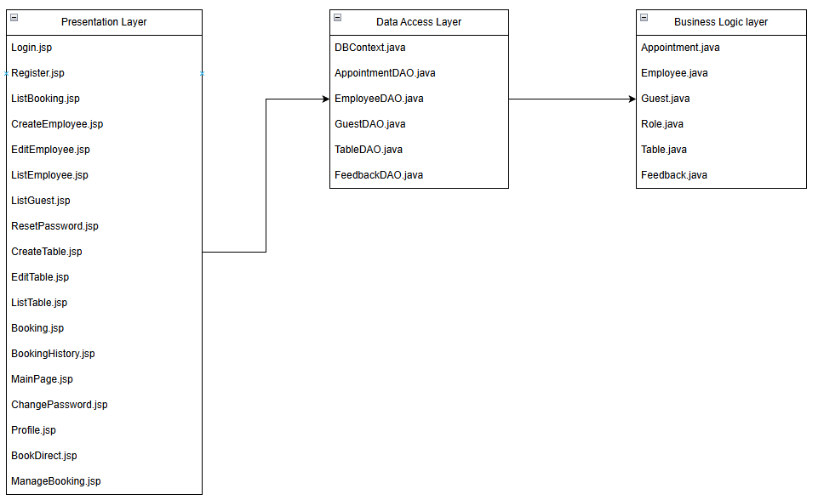

4.2. Class diagram
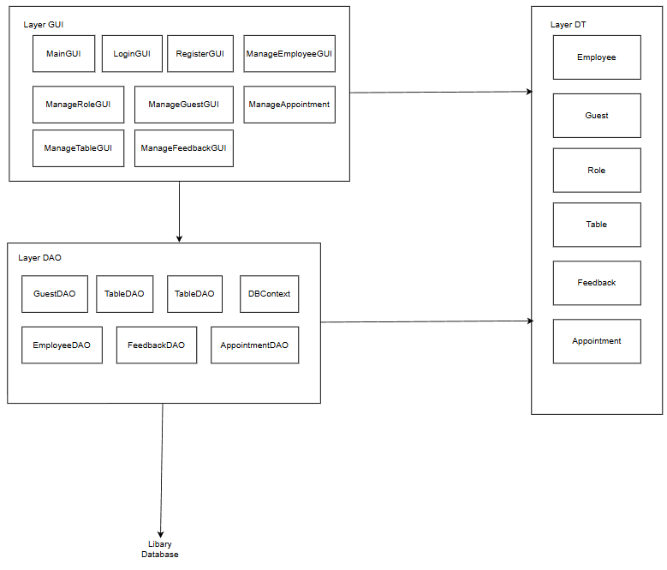

II. Requirement Specifications (OPTIONAL)

1. Common Functions

1.1 UC1_ Login
ID and Name: | UC-1_ User Login
Created By: |  | Date Created:
Primary Actor: | User (Admin/Staff/Guest) | Secondary Actors:
Description: | This use case describes the process of authenticating a user by verifying their account password and validating a captcha code.
Trigger: | User attempts to log in.
Preconditions: | PRE-1: User has an existing account.
Postconditions: | POST-1: User is logged into the system and can access authorized functionalities.
Normal Flow: | - User enters an account and password.  - System verifies credentials.  - If valid, user is logged in; otherwise, an error message is displayed
Alternative Flows:
Exceptions:
Priority: | High
Frequency of Use: | Frequently used by all users.
Business Rules:
Other Information: | N/A
Assumptions: | N/A

1.2 UC2_ Register
ID and Name: | User Register
Created By: |  | Date Created:
Primary Actor: | User (Admin/Staff/Guest) | Secondary Actors:
Description: | This use case register user by fill all box text
Trigger: | User attempts to register
Preconditions: | User does not have an account.
Postconditions:
- The user selects the Register function.
- The system displays the registration form.
- The user enters all valid information The user clicks Register/Submit.
- The system checks the data (Complete, Correct format, No duplicate accounts)
- The system saves the user's information to the database.
- The system notifies that registration was successful.
- The user is then redirected to the Login or Home page.

Alternative Flows:
Exceptions: | EX-1: Database connection error.
Priority: | High
Frequency of Use: | Frequently used by all users.
Business Rules:
Other Information: | N/A
Assumptions: | N/A

1.3 UC3_Employee Manage
a. Functional Description
ID and Name: | Employee Manage
Created By: |  | Date Created:
Primary Actor: | Admin | Secondary Actors: | None
Description: | As an administrator, I want to manage information, including adding, updating, viewing, and deleting records.
Trigger: | Admin clicks on the "Employees" button in the HomePage Screen
Preconditions: | Admin must be logged in to access the customer management functionalities.
Postconditions: | Customer information is added, updated, viewed, or deleted as per the admin's actions.
Normal Flow: | - Admin clicks on the "Employees" button.  - The system displays a list of all employees.  - Admin can choose to add a new employee by clicking "Add Employee”.  - Admin fills in the customer details and clicks "Create Employee” to create or clicks “Cancel” to cancel.  - The system saves the new employee information and displays it in the list.  - Admin can select an existing employee to update by clicking "Edit".  - Admin updates the employee details and clicks "Save Changes".  - The system saves the updated employee information and updates the list.  - Admin can delete a employee by selecting them and clicking "Delete" and clicking “Yes”  - The system deletes the employee and removes them from the list.
Alternative Flows: | N/A
Exceptions: | N/A
Priority: | High
Frequency of Use: | Usually
Other Information: | N/A
Assumptions: | N/A

1.4 UC4_Table Manage

ID and Name: | Table Manage
Created By: |  | Date Created:
Primary Actor: | Admin | Secondary Actors: | None
Description: | As an admin, I want to manage booking information, including adding, updating, viewing, deleting, and order table records.
Trigger: | Admin clicks on the "Tables" button in the Admin Dashboard Screen.
Preconditions: | Admin must be logged in to access the order management functionalities.
Postconditions: | Tables information is added, updated, viewed, or deleted as per the admin's actions
Normal Flow: | - Admin clicks on the "Tables" button.  - The system displays a list of all tables.  - Admin can check table by choose time then clicking “Check”  - Admin can book table by choose “Book” and fill the order then clicking “Confirm”  - Admin can choose to add a new table by clicking "Add Table".  - Admin fills in the order details and clicks "Save Table".  - The system saves the new table information and displays it in the list.  - Admin can select an existing table to update by clicking "Edit".  - Admin updates the order details and clicks "Update".  - The system saves the updated table information and updates the list.  - Admin can delete a table by selecting it and clicking "Delete” then clicking “Yes”
Alternative Flows: | N/A
Exceptions: | N/A
Priority: | High
Frequency of Use: | Frequent
Other Information: | N/A
Assumptions: | N/A

1.5 UC5_Booking Manager
a. Functional Description

ID and Name: | Booking Manager
Created By: |  | Date Created:
Primary Actor: | Admin | Secondary Actors: | none
Description: | As an admin, I want to manage booking information updating, viewing booking records.
Trigger: | Admin clicks on the "Booking" button in the Admin Dashboard Screen.
Preconditions: | Admin must be logged in to access the booking management functionalities.
Postconditions: | Booking information is updated, viewed as per the admin's actions.
Normal Flow: | - Admin clicks on the “Booking" button.  - The system displays a list of all booking history..  - Admin can choose action by clicking "V" or “X” icon to reject or accept the booking  - Admin can choose action by clicking “Done" or “Cancel” to update the table status.  - The system saves the new booking information and displays it in the list.
Alternative Flows: | If the admin clicks "Cancel" during the add or update process, the system will discard the changes booking list without saving.
Exceptions: | N/A
Priority: | High
Frequency of Use: | Usually
Other Information: | N/A
Assumptions: | Admin has the necessary permissions to manage booking information.  The system is operational and able to process database transactions.

1.6 UC6_Guest Manage
a. Functional Description
ID and Name: | UC-5_ Guest Manage
Created By: |  | Date Created:
Primary Actor: | Admin | Secondary Actors: | None
Description: | As an administrator, I want to manage guest information, including adding, updating, viewing, and deleting records.
Trigger: | Admin clicks on the "Guests" button in the HomePage Screen
Preconditions: | Admin must be logged in to access the customer management functionalities.
Postconditions: | Customer information is added, updated, viewed, or deleted as per the admin's actions.
Normal Flow: | - Admin clicks on the "Guests" button.  - The system displays a list of all customers.  - Admin can choose to add a new customer by clicking "Add Guests".  - Admin fills in the customer details and clicks "Create Guest” to create guest or “Cancel” to cancel.  - The system saves the new customer information and displays it in the list.  - Admin can select an existing guest to change password by clicking "Edit" icon. Fill new password then click “Update password” or “Cancel”.  - Admin can lock or unlock a by selecting them and clicking “Lock“ icon and clicking “Yes”or “No”
Alternative Flows: | N/A
Exceptions: | N/A
Priority: | High
Frequency of Use: | Usually
Other Information: | N/A
Assumptions: | N/A

1.7 UC7_FeedBacks Manage

ID and Name: | FeedBacks Manage
Created By: |  | Date Created:
Primary Actor: | Admin | Secondary Actors: | none
Description: | As an admin, I want to view list of feedback
Trigger: | Admin clicks on the "Feedbacks" button in the Admin Dashboard Screen
Preconditions: | Admin must be logged in to access the Feedbacks.
Postconditions: | Staff viewed list of feedback
Normal Flow: | - Admin clicks on the "Feedback" button.  - The system displays a list of all Feedbacks.
Alternative Flows: | NA
Exceptions: | NA
Priority: | High
Frequency of Use: | Usually
Other Information: | N/A
Assumptions: | N/A

1.8 UC8_Direct booking

ID and Name: | Direct booking
Created By: |  | Date Created:
Primary Actor: | Staff | Secondary Actors: | none
Description: | As a Staff, I want to manage reservation information, including adding, updating, viewing, deleting, and resetting reservation status.
Trigger: | Staff clicks on the "Direct Booking" button in Staff Dashboard Screen.
Preconditions: | Staff must be logged in and have appropriate permissions to manage booking information.
Postconditions: | Booking information is added, updated, viewed, or deleted according to staff's actions.
Normal Flow: | - Staff clicks on the "Direct Booking" button.  - The system displays a list of all table.  - Staff can check table by choose time then click “Refresh map status” to see list of table status.  - Staff can book table by choose table and fill the order then clicking “Confirm booking” or “Cancel”
Alternative Flows: | If the admin clicks "Cancel" during the add or update process, the system will discard the changes and return to the table map without saving.
Exceptions:
Priority: | High
Frequency of Use: | Usually
Other Information: | N/A
Assumptions: | N/A

1.9 UC9_Booking requests

ID and Name: | Booking requests
Created By: |  | Date Created:
Primary Actor: | Staff | Secondary Actors: | None
Description: | As a staff, I want to manage reservation information updating, viewing, deleting, and resetting reservation status.
Trigger: | Staff clicks on the "Booking requests" button in the main menu.
Preconditions: | Staff must be logged in and have appropriate permissions to access Dashboard.
Postconditions: | Staff has managed records and viewed top-selling staff information as required.
Normal Flow: | - Staff clicks on the "Booking equest" button.  - The system displays a list of all guest booking  - Staff can reject or accept by clicking “Complete” or “Cancel”.
Alternative Flows: | If the staff clicks "Cancel" during the add or update process, the system will discard the changes and return to the dashboard without saving.
Exceptions:
Priority: | High
Frequency of Use: | Usually
Other Information: | N/A
Assumptions: | N/A

1.10 UC10_Booking table

ID and Name: | Direct booking
Created By: |  | Date Created:
Primary Actor: | Guest | Secondary Actors: | none
Description: | As a guest, I would like to see the reservation status for my chosen time slot.
Trigger: | Guest clicks on the "Booking Table" button in Dashboard Screen.
Preconditions: | Guest must be logged in and have appropriate permissions
Postconditions: | Booking table see the reservation status for chosen time slot.
Normal Flow: | - Guest clicks on the "Booking table" button.  - Guest can check table by choose date and time then click “Check Availability” to see list of table status.  - Guest can book table by choose one table and clicking “Book Now” then click “Yes” or “No”
Alternative Flows:
Exceptions:
Priority: | High
Frequency of Use: | Usually
Other Information: | N/A
Assumptions: | N/A

1.11 UC11_History

ID and Name: | History
Created By: |  | Date Created:
Primary Actor: | Guest | Secondary Actors: | none
Description: | As a guest, I would like to see the list of my history booking to updating, viewing, deleting my order
Trigger: | Guest clicks on the "History" button in Dashboard Screen.
Preconditions: | Guest must be logged in and have appropriate permissions
Postconditions: | History see the list of my history booking.
Normal Flow: | - Guest clicks on the "History" button.  - Guest can see list of table booking  - Guest can confirm book table by choose table and clicking “Cancel” then choose “Yes” or “No”
Alternative Flows:
Exceptions:
Priority: | High
Frequency of Use: | Usually
Other Information: | N/A
Assumptions: | N/A

III. Design Specifications
1.1 User logs in with the designated account
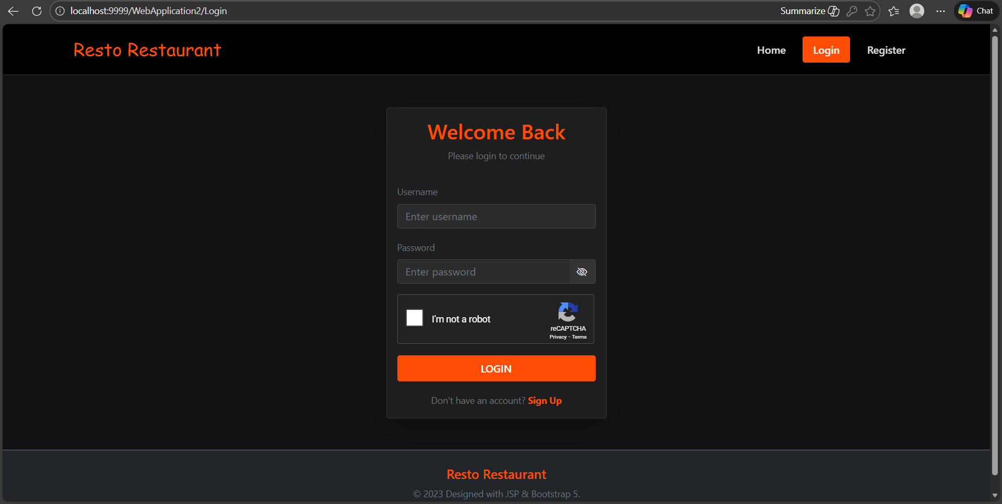
Field Name | Field Type | Description
User name | Text Box | This is for user to input user name for logging in
Password | Password Box | This is for user to input password for logging in
Captcha | Button | This is for user to input password for validating a captcha
Login | Button | User clicks to authenticate him/herself into the system with provided email/user name & password
Sign up | Button | If user do not have account, click to Sign up

1.1.1 User not check capcha
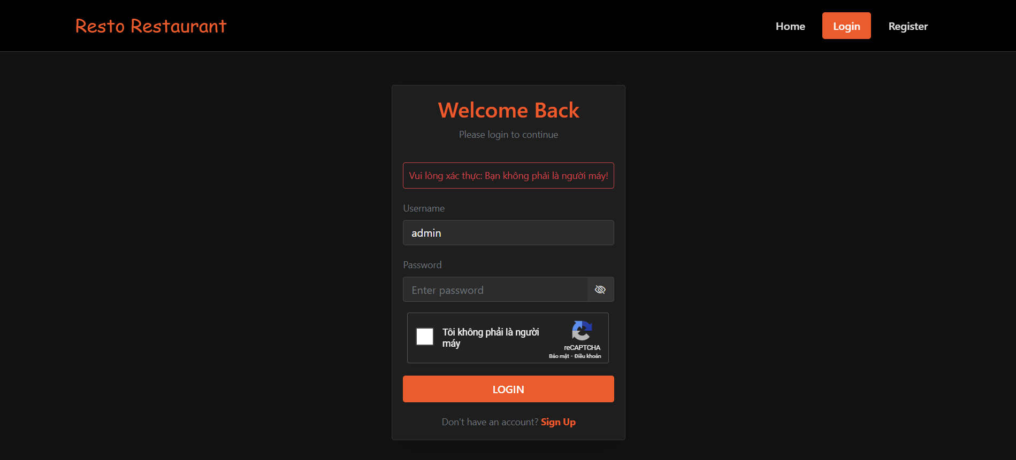
1.1.3 User input wrong password
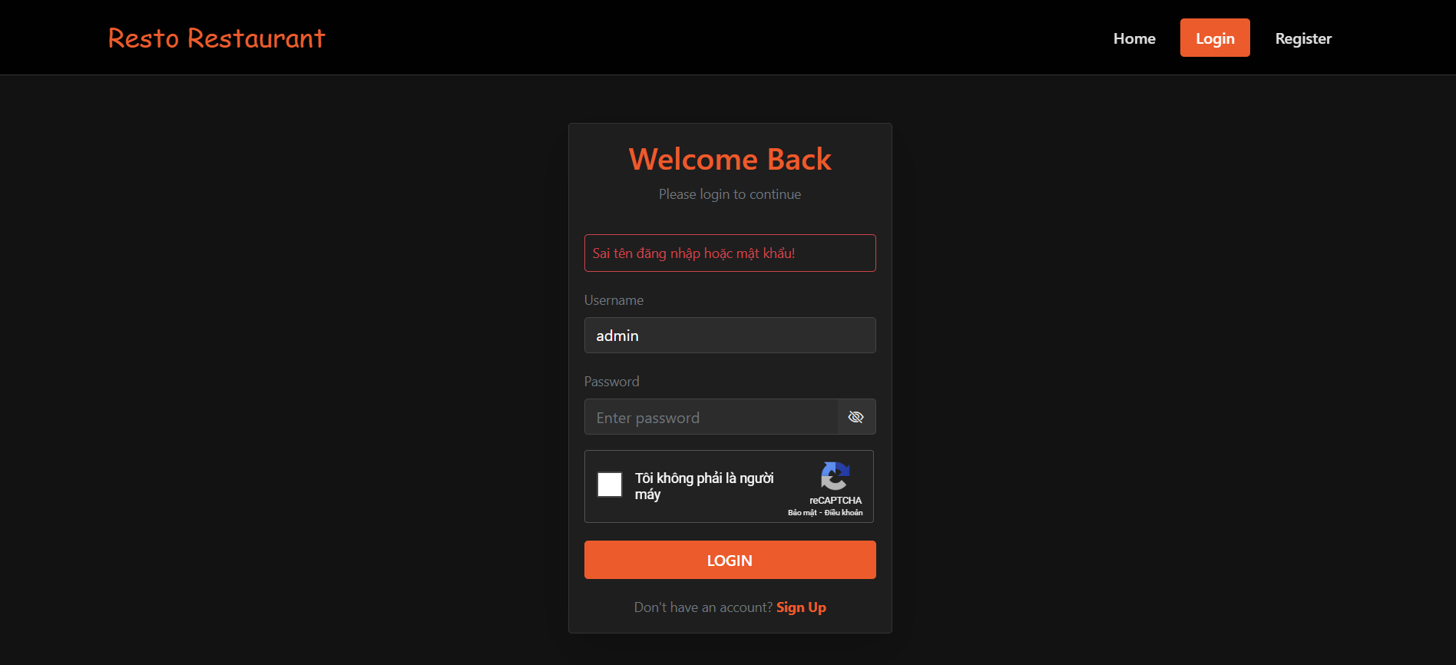
1.2 User(guest) register
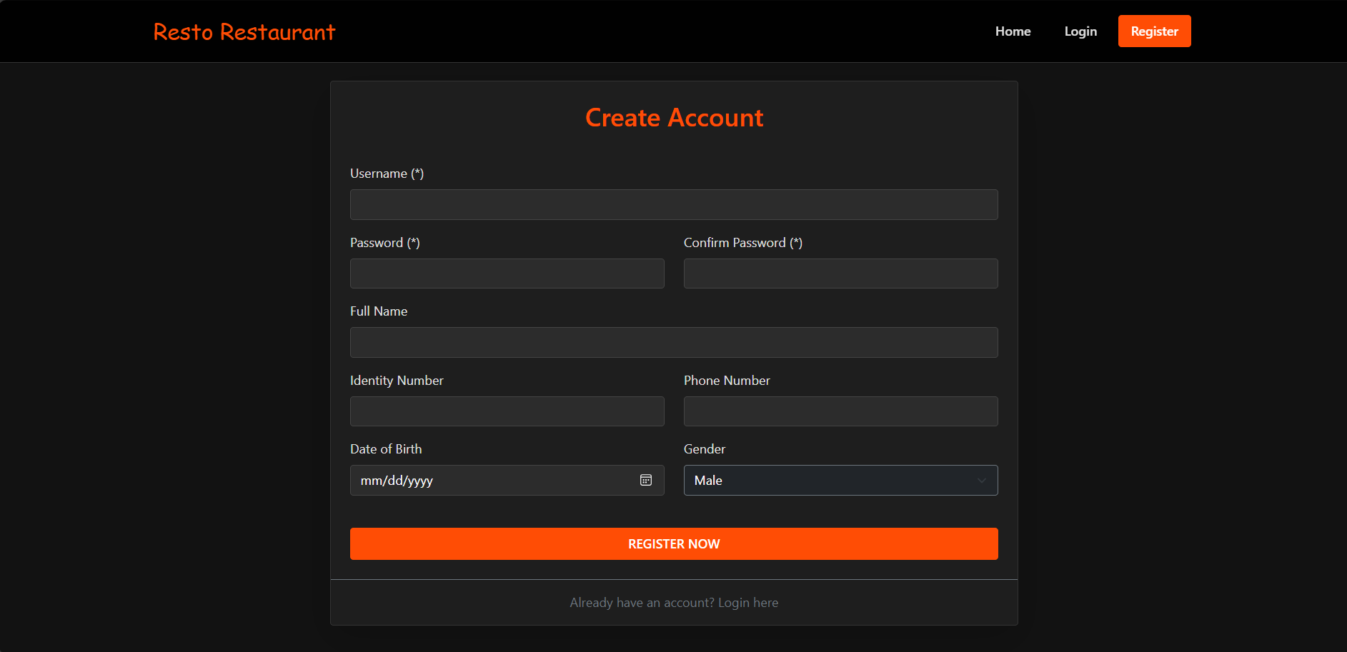

Field Name | Field Type | Description
User name | Text Box | This is for user to input user name
Password | Password Box | This is for user to input password
Confirm password | Password Box | This is for user to input confirm password
Full name | Text Box | This is for user to input full name
Identity Number | Text Box | This is for user to input identity
Phone Number | Text Box | This is for user to input phone number
Date of birth | DoB | This is for user register dob
Gender | Choice | This is for user to input gender
Register now | Button | This is for user register
Sign up | Button | If user have account, click to “Login here”

2.1 User(admin) screen after logging in
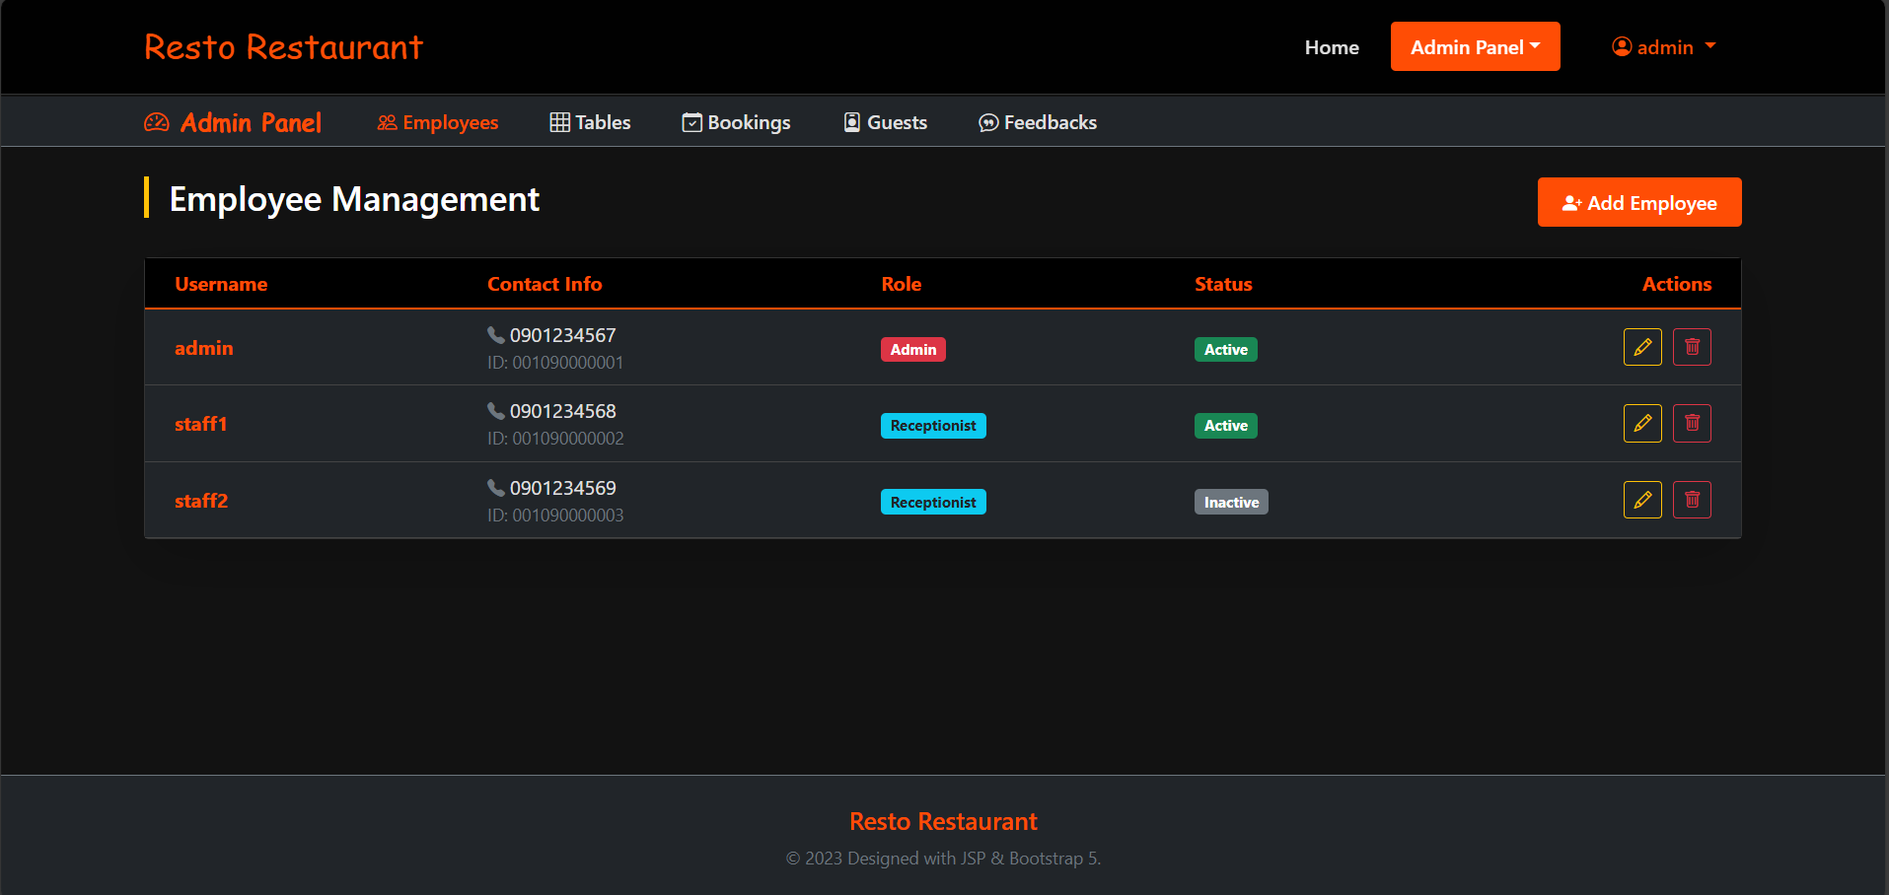
2.2 User(Employee) screen update profile
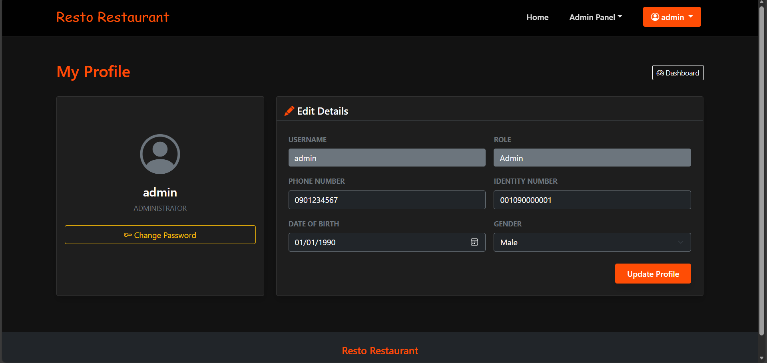

2.3 User(Guest) screen update profile
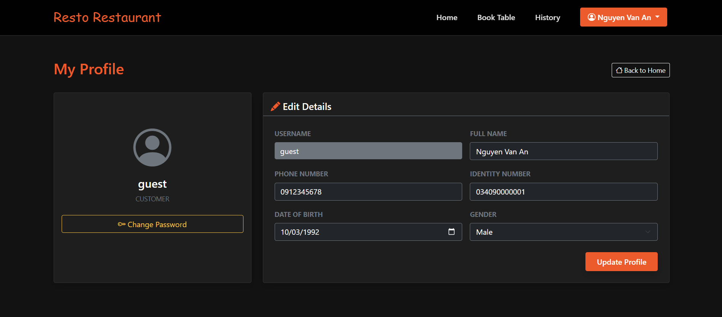
2.4 User screen change password
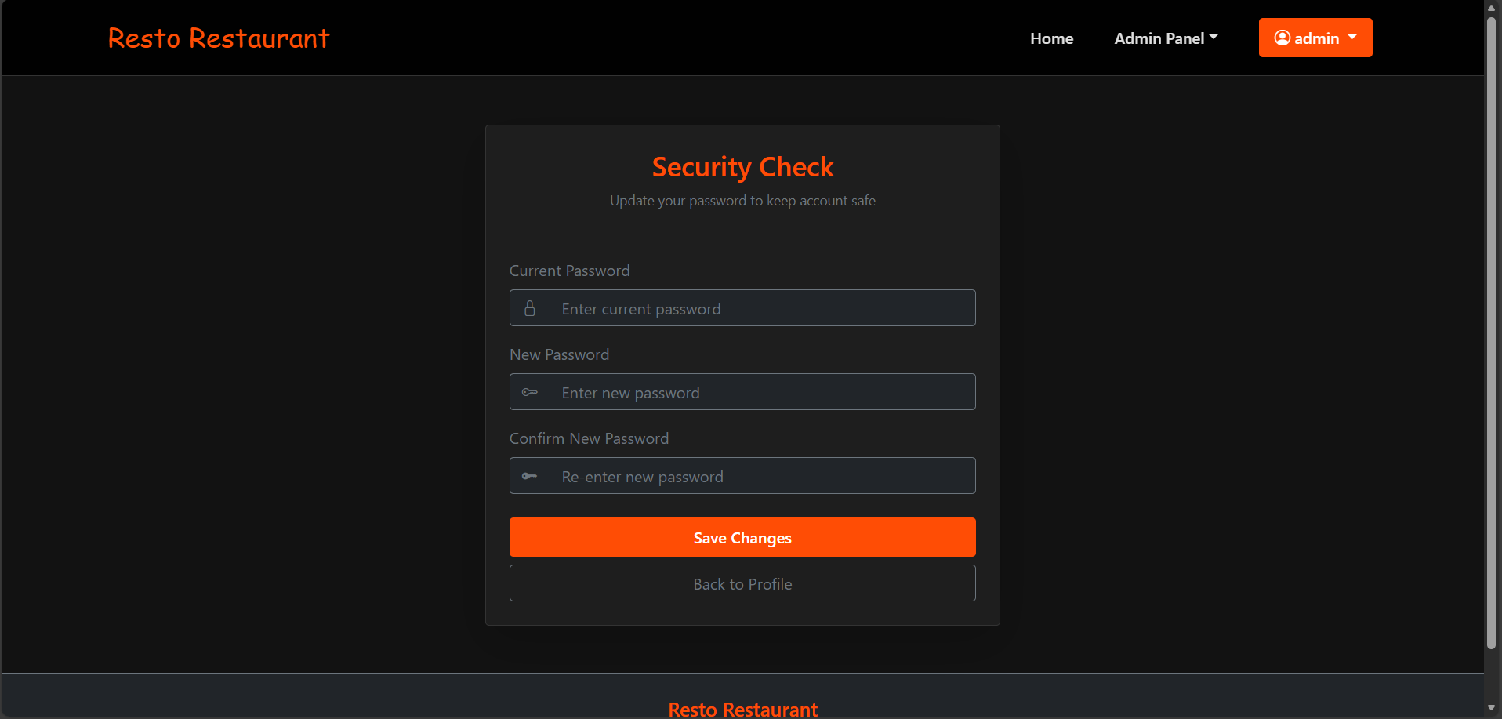
3.1 Employees manage(admin)


Field Name | Field Type | Description
Add Employee | Button | This is for admin add employee
Edit | Button | This is for admin edit employee
Delete | Button | This is for admin delete employee

3.1.1 Add employee(admin)
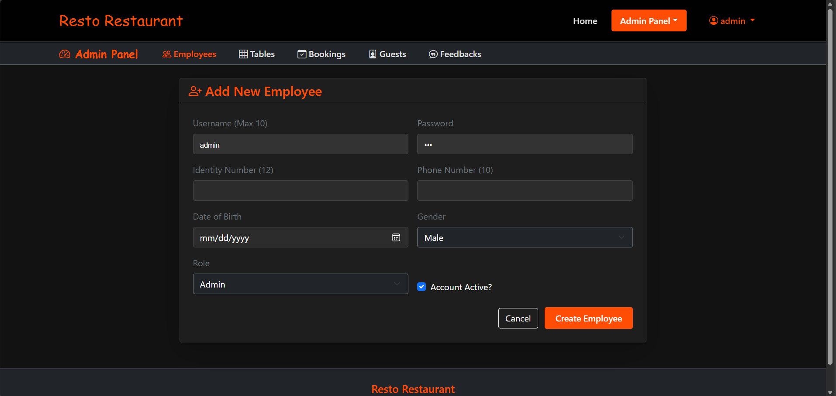

3.2 Table manage(admin)
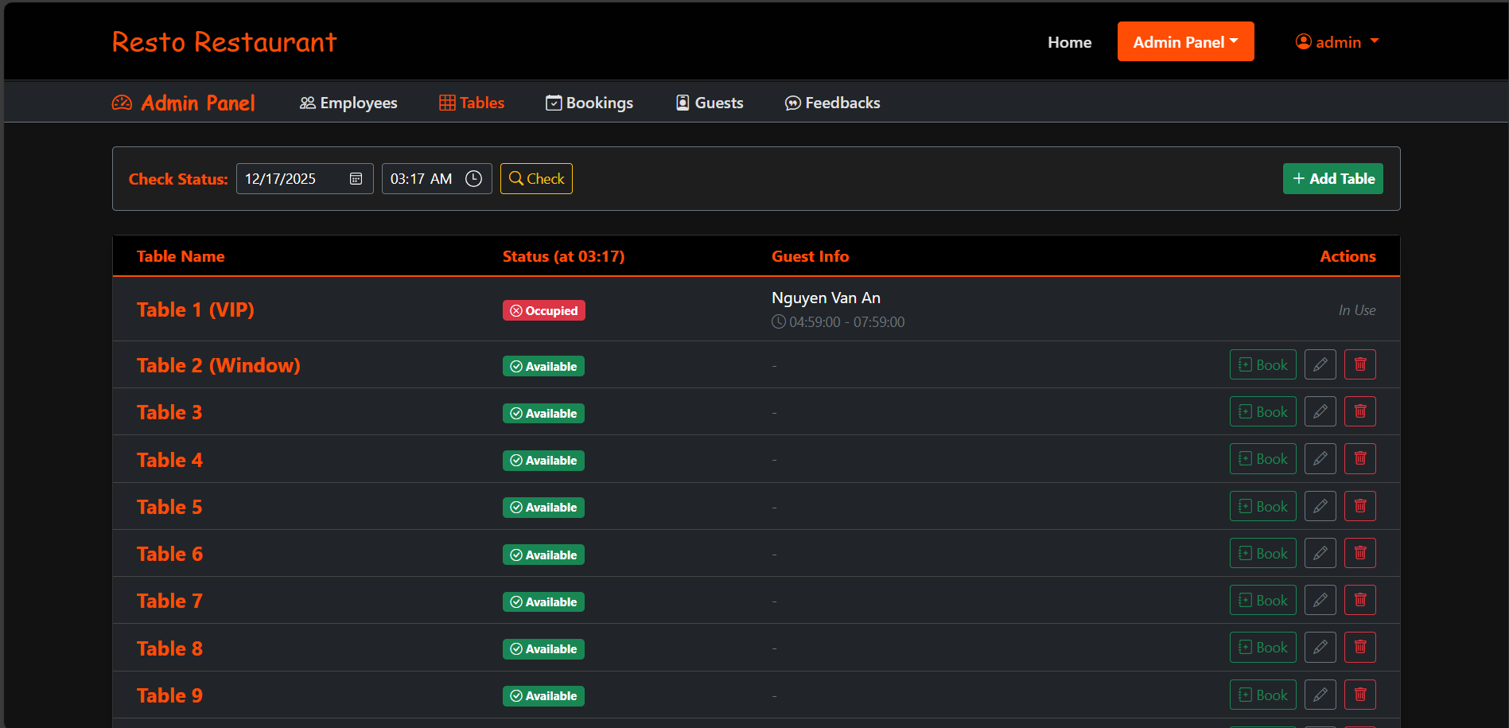

Field Name | Field Type | Description
Add Table | Button | This is for admin add table
Check | Button | This is for admin check table status
Book | Button | This is for admin booking
Edit | Button | This is for admin edit table
Delete | Button | This is for admin delete table.

3.2.1 Add table(admin)
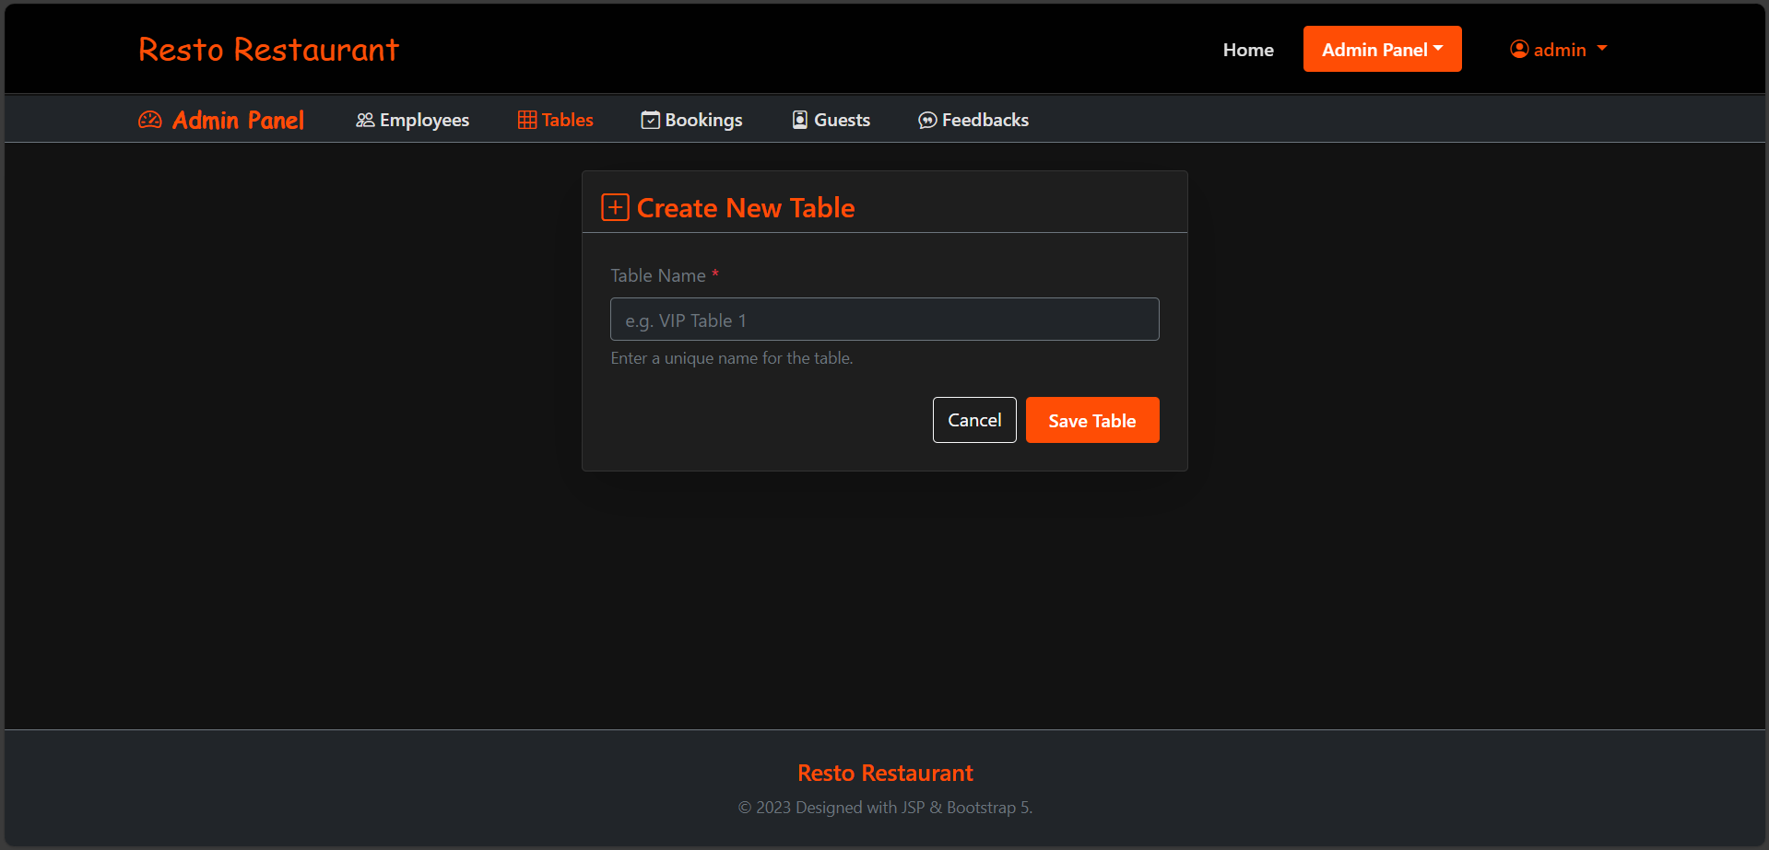
3.3 Booking(admin)
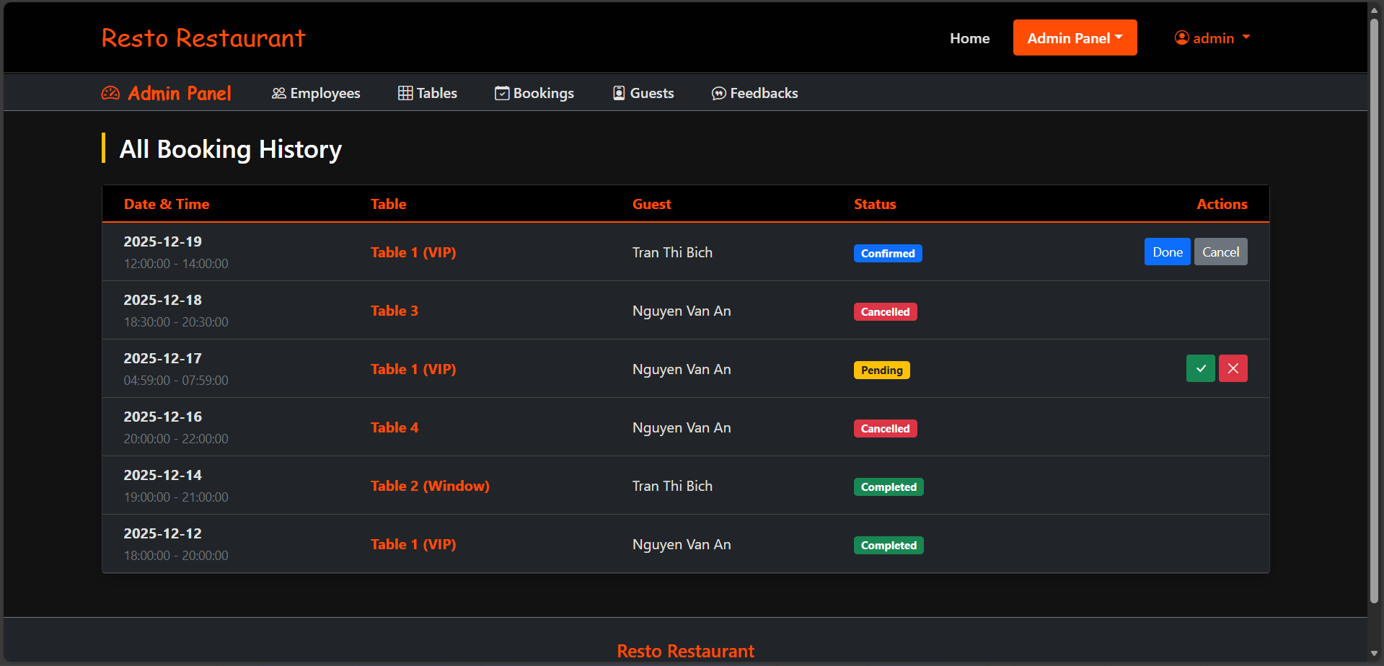

Field Name | Field Type | Description
V | Button | This is for admin confirm booking
X | Button | This is for admin reject booking
Done | Button | This is for admin done booking
Cancel | Button | This is for admin cancel booking

3.3.1 Update status button complete or Cancel(Admin)


3.4 Guest(admin)
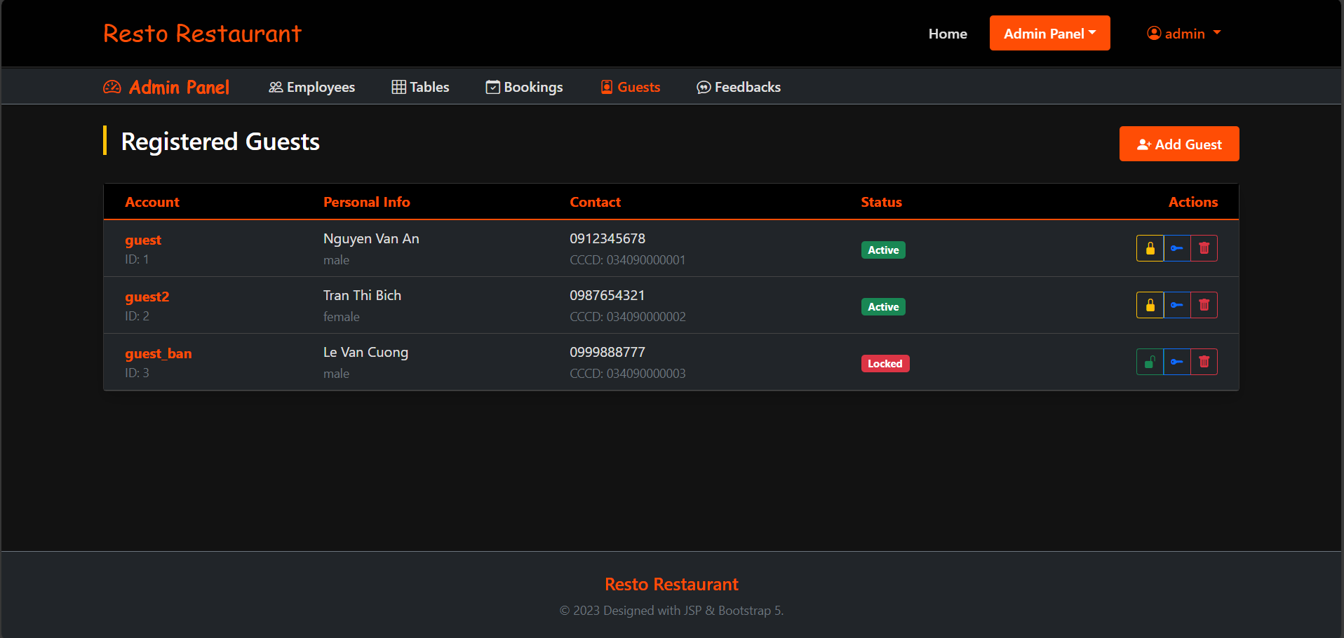

Field Name | Field Type | Description
Add guest | Button | This is for admin add guest
Lock | Button | This is for admin lock/unlock guest
Change password | Button | This is for admin change password for guest
Delete | Button | This is for admin delete guest

3.4.1 Add guest(admin)
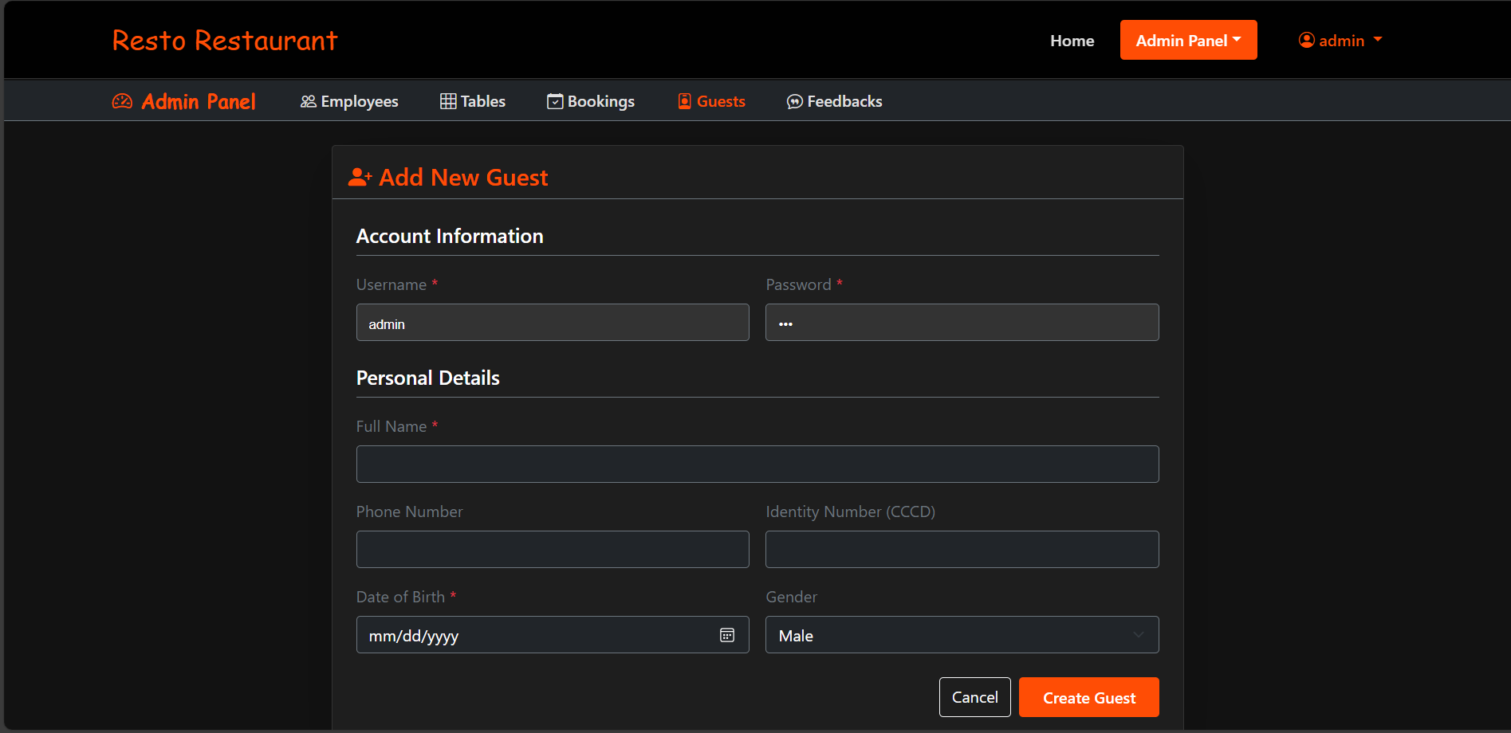
3.4.2 Reset password guest(admin)
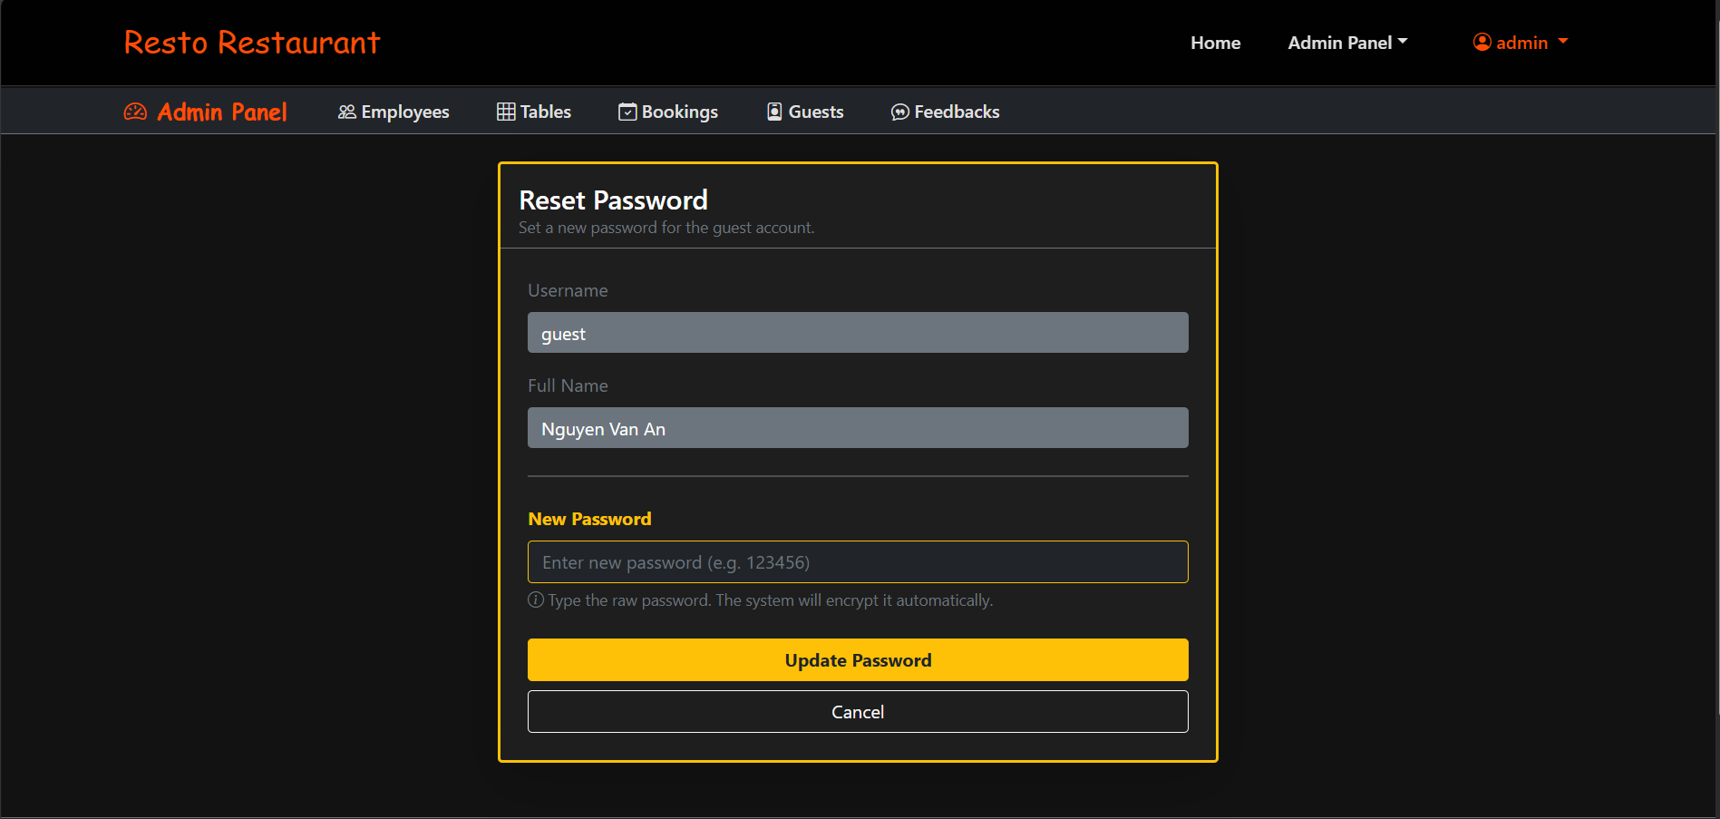
3.4.3 Change active guest(admin)
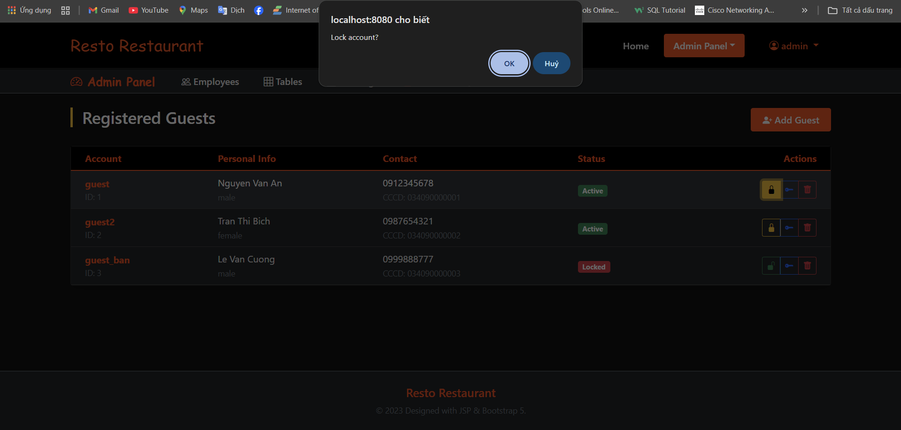
3.5 View Feedback(Admin)
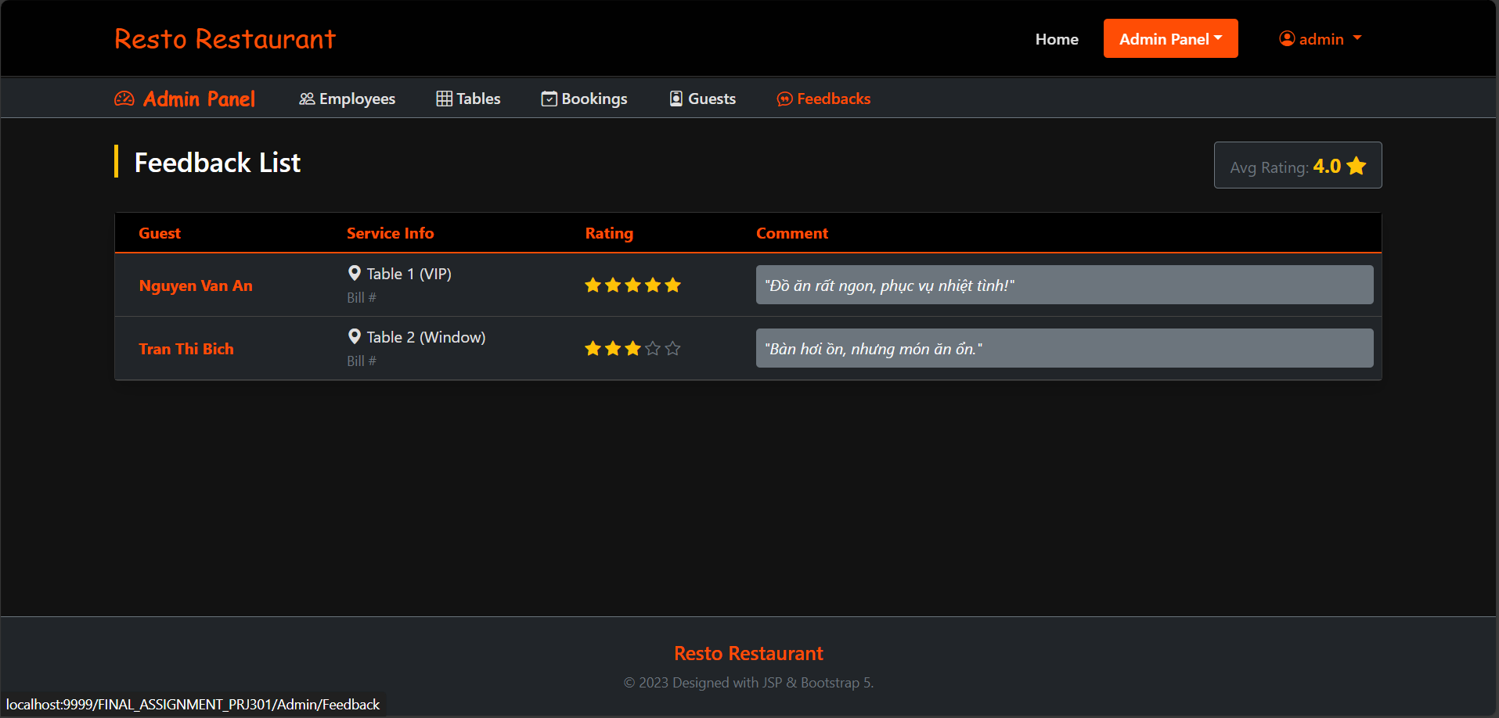

4.1 Direct Booking Map(Staff)
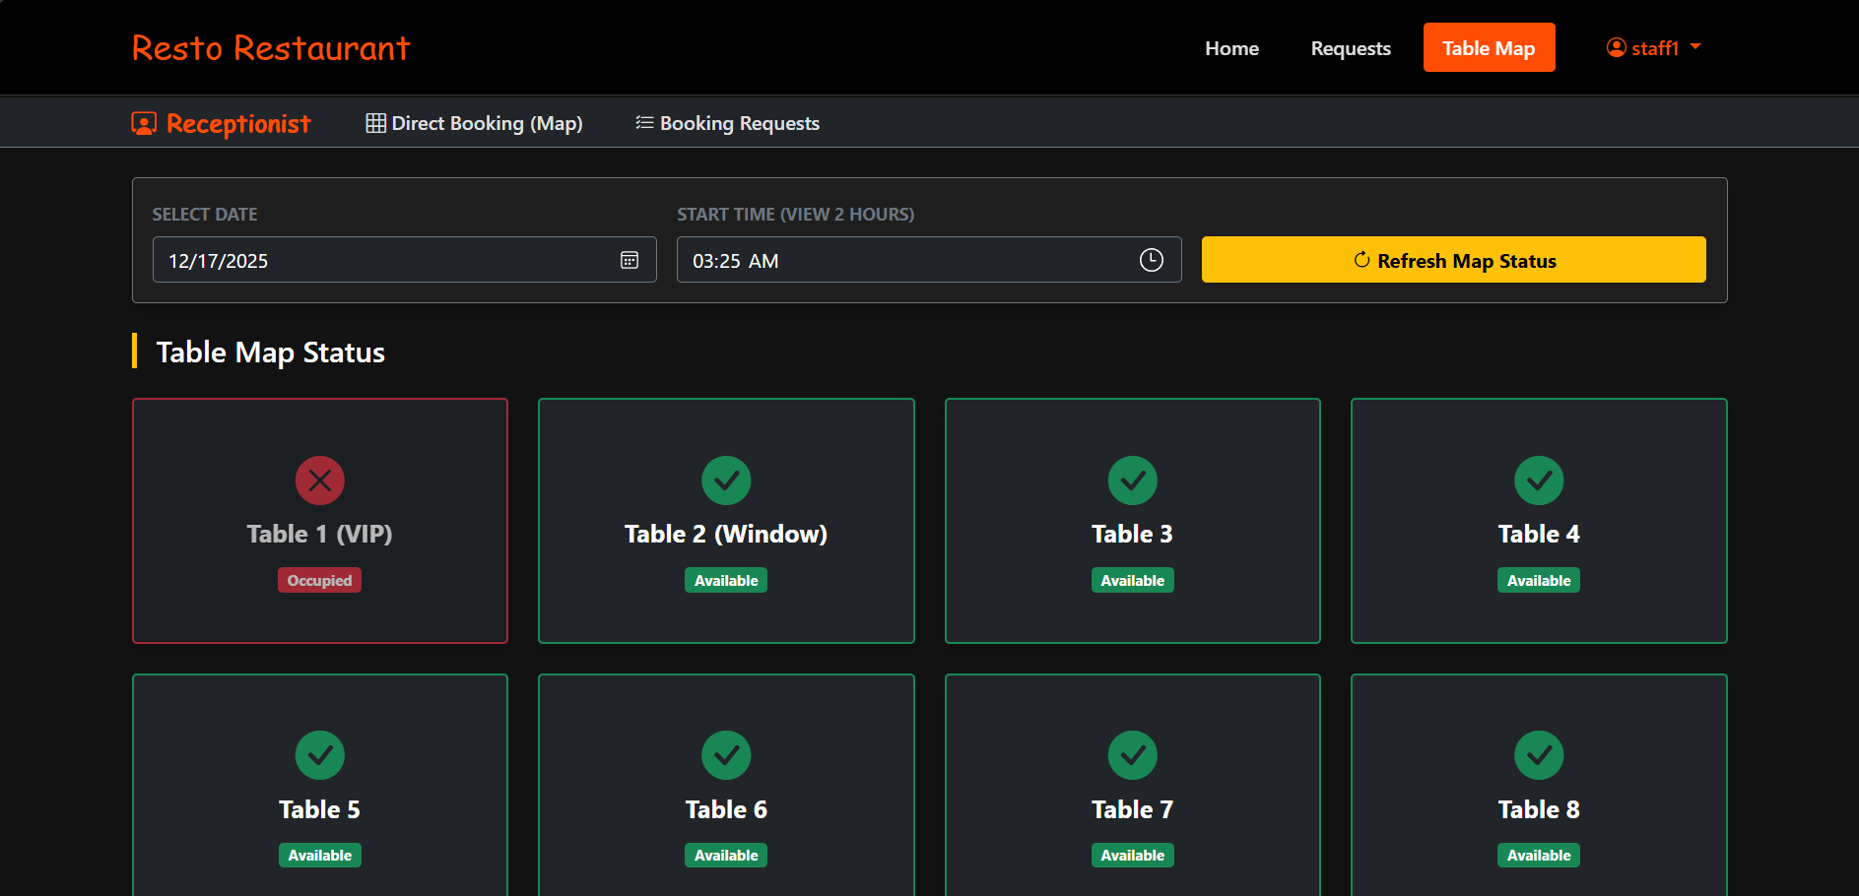
4.1.1 Booking offline(staff)
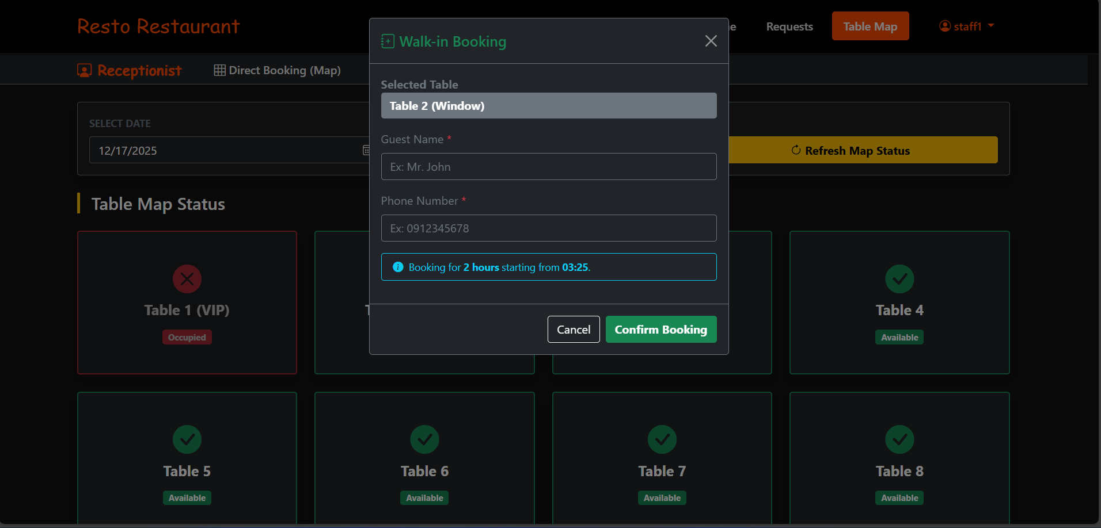
4.2 Booking request(staff)
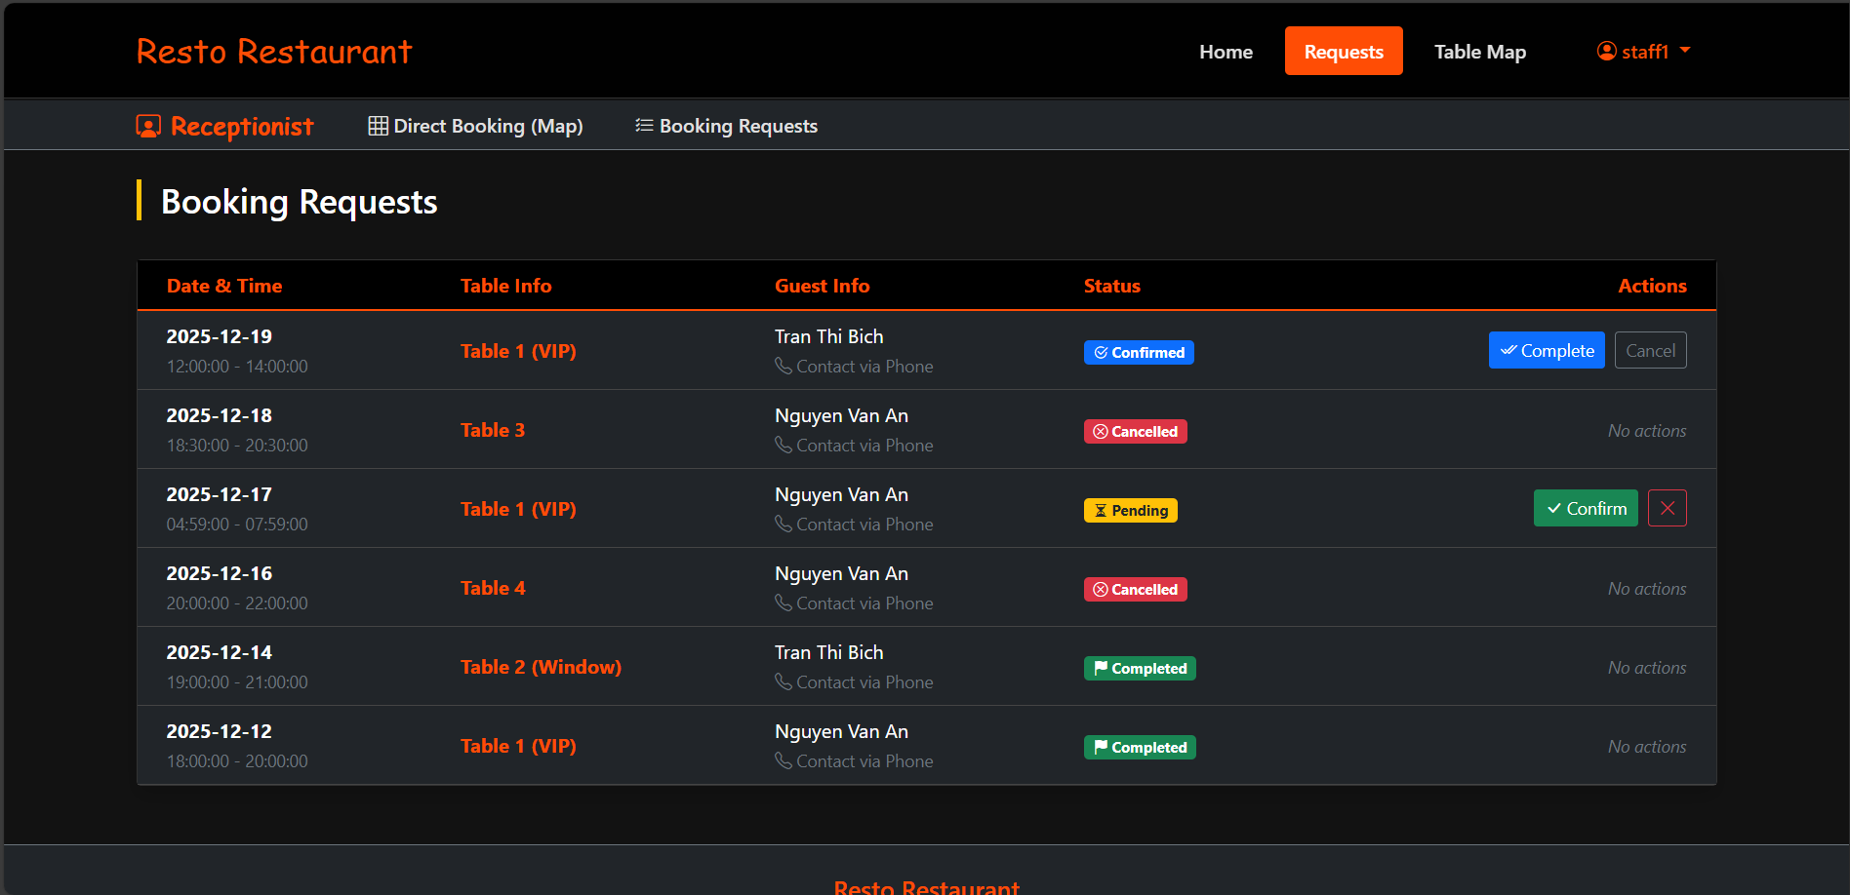
4.2.1 Update status button complete or Cancel(Staff)


5.1 Book a Table(guest)
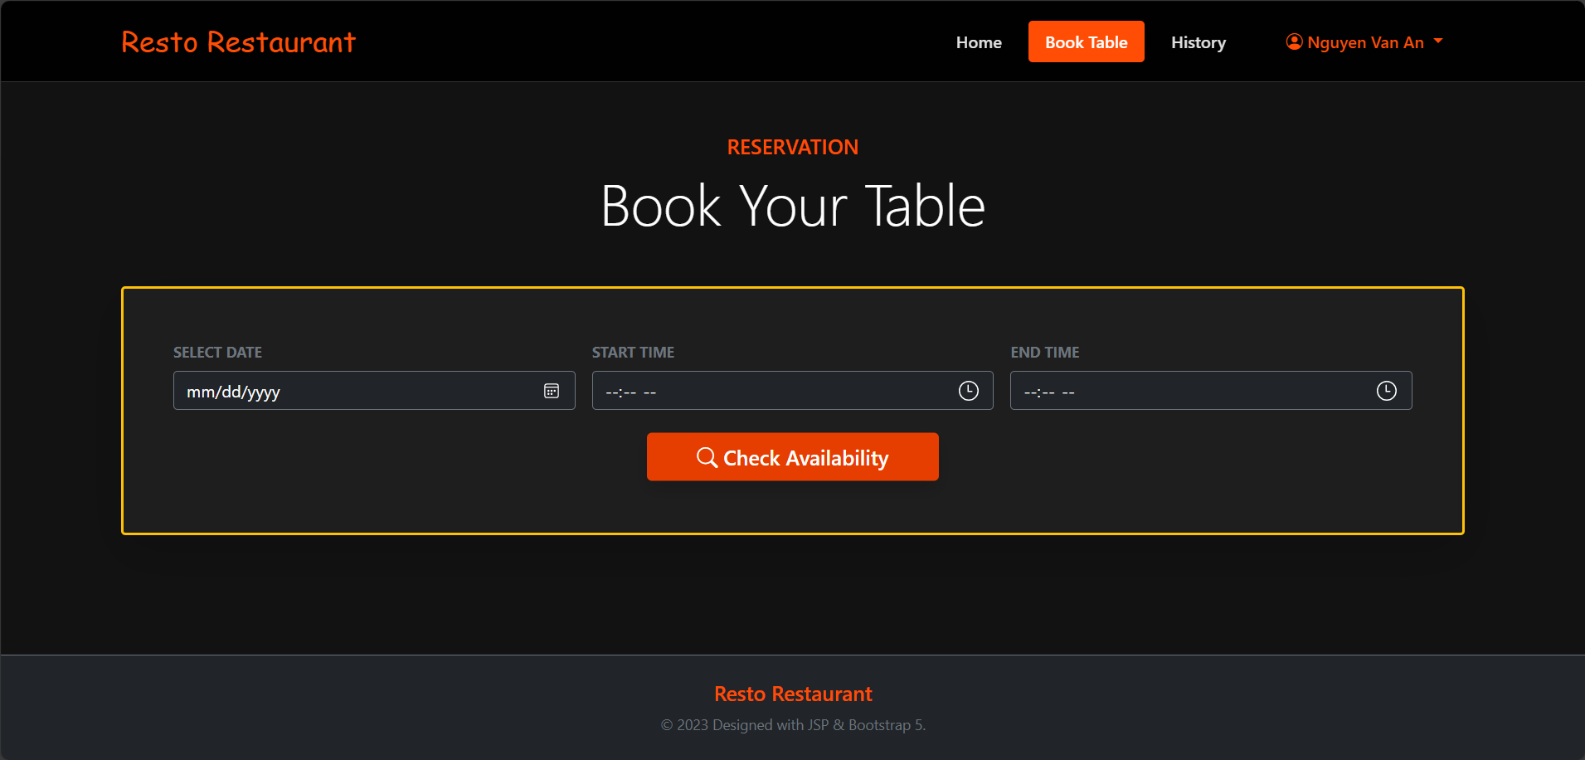
5.2 View History(guest)
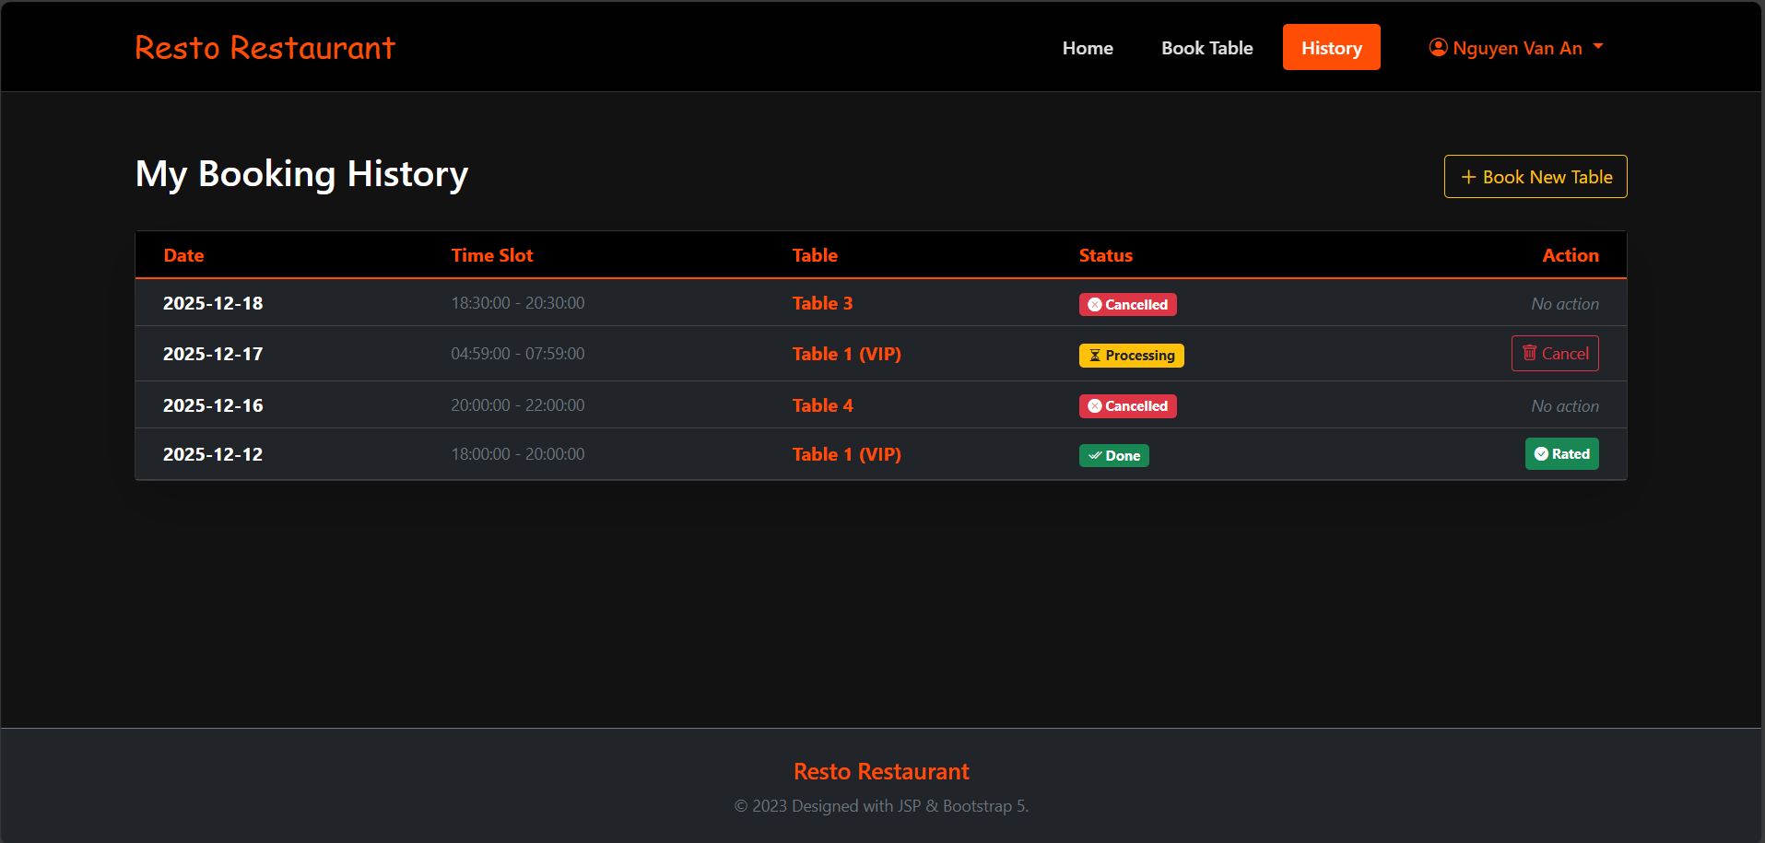

5.2.1 Rate and Feedback(guest)
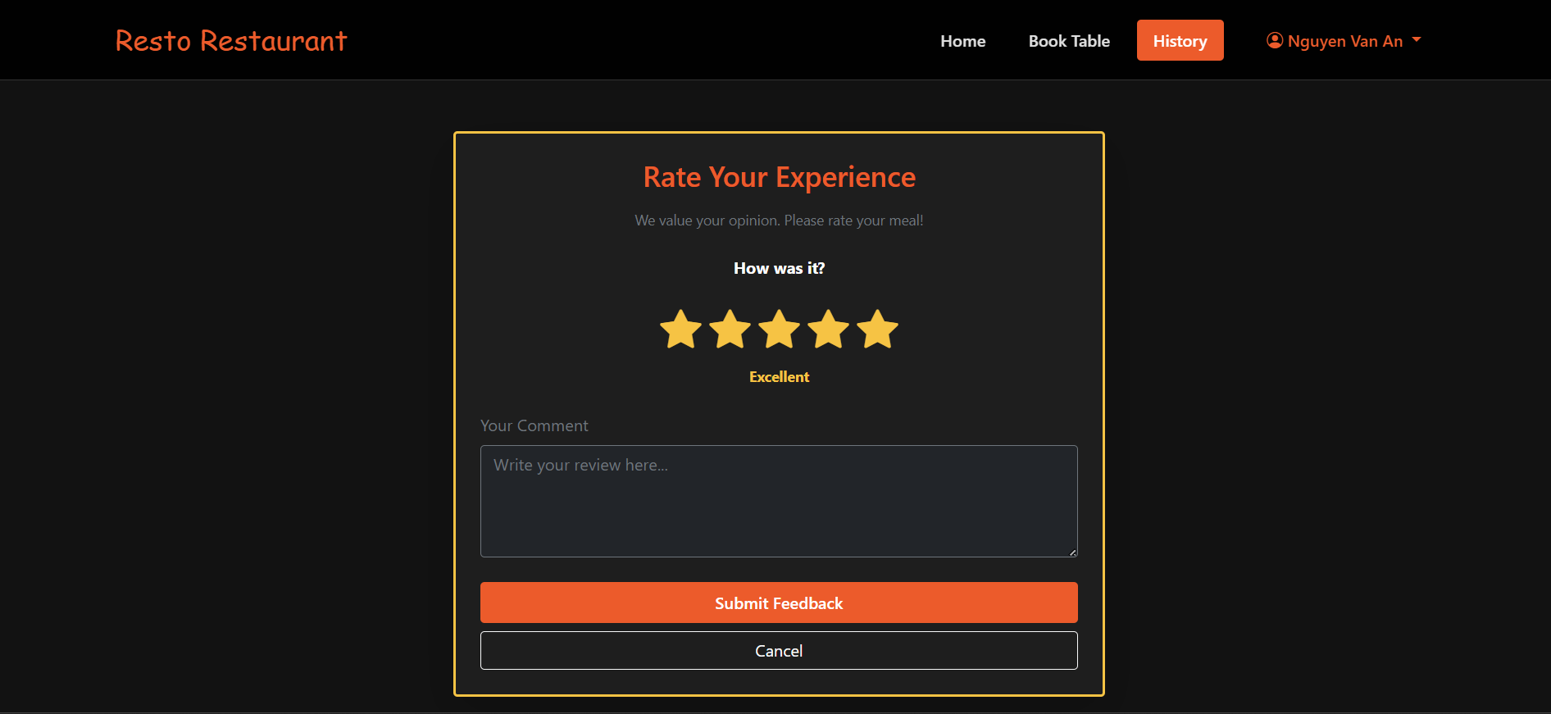

IV. Appendix

1. Assumptions & Dependencies
AS-1: The system will be used within the organization's internal network.
DE-1: Users have basic knowledge of using Windows applications.

2. Limitations & Exclusions
L-E : The system will not support mobile platforms in the current version.

3. Business Rules
BR- 1: Default admin account: Username is “admin” and password is “123”
BR- 2: Default staff account: Username is “staff1” and password is “123”
BR- 3: Default staff account: Username is “staff2” and password is “123”
BR- 4: Default guest account: Username is “guest” and password is “123”
BR- 5: Default guest account: Username is “guest2” and password is “123”
BR- 6: Default guest account: Username is “guest_ban” and password is “123”

Group 6 - WORKS
HE180039 - Đinh Gia Nam(35%)
HE186945 - Lê Mạnh Hùng(30%)
HE194555 - Nguyễn Đăng Hùng(35%)

