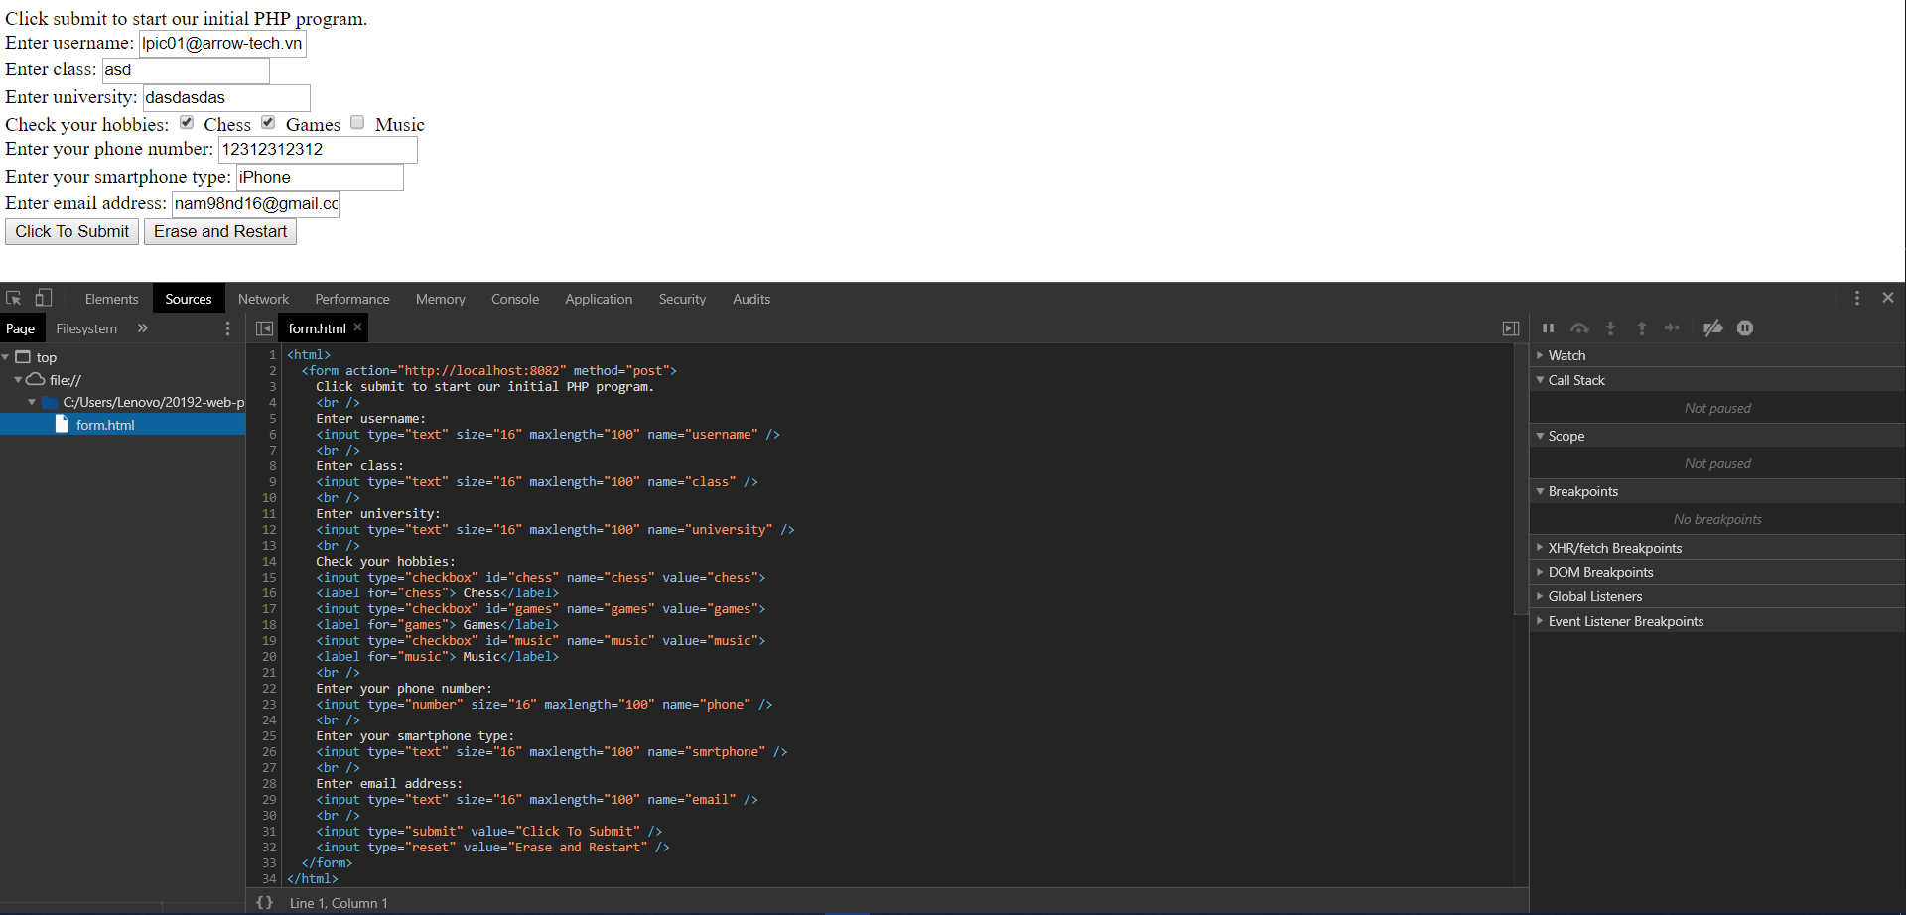
Figure 1. Input.html file opened with DOM Inspector
As we can see, Chrome provides an inspector helping us investigate currently displayed page in html format.
------------------------------------------------------------------------------------------------------------------------------------------
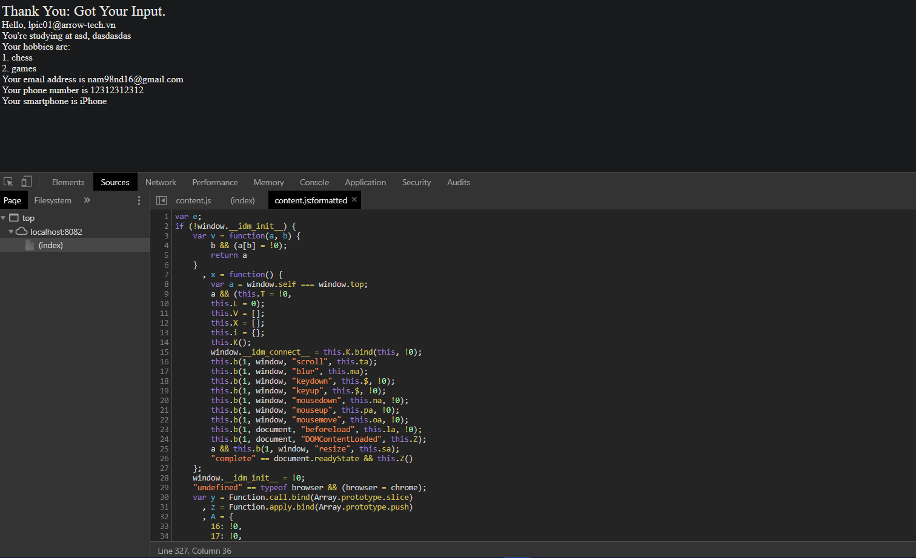
Figure 2. handleInput.php file ran on default server with DOM inspector

As we can see, Chrome automatically convert php source code to javascript source code.

