**Step 1: Create Kinesis Data Stream**

1. Go to **Kinesis > Data Streams**
2. Click **Create data stream**
3. Example name: namrata-stream
4. Choose the default settings and create

**Step 2: Create Kinesis Firehose Delivery Stream**

1. Go to **Kinesis > Delivery streams**
2. Click **Create delivery stream**
3. Choose:
   * **Source**: Kinesis Data Stream
   * **Destination**: Amazon S3
4. Set:
   * Source stream: namrata-stream
   * Destination bucket: megaproject-bin
5. (Optional) Enable **Dynamic Partitioning** if using it, and configure with metadata extraction.
6. Create the Firehose stream

**Step 3: Use Kinesis Data Generator (KDG)**

1. Go to Kinesis Data Generator
2. Login via Cognito

Git hub link – for genereate cognito user :https://awslabs.github.io/amazon-kinesis-data-generator/web/help.html

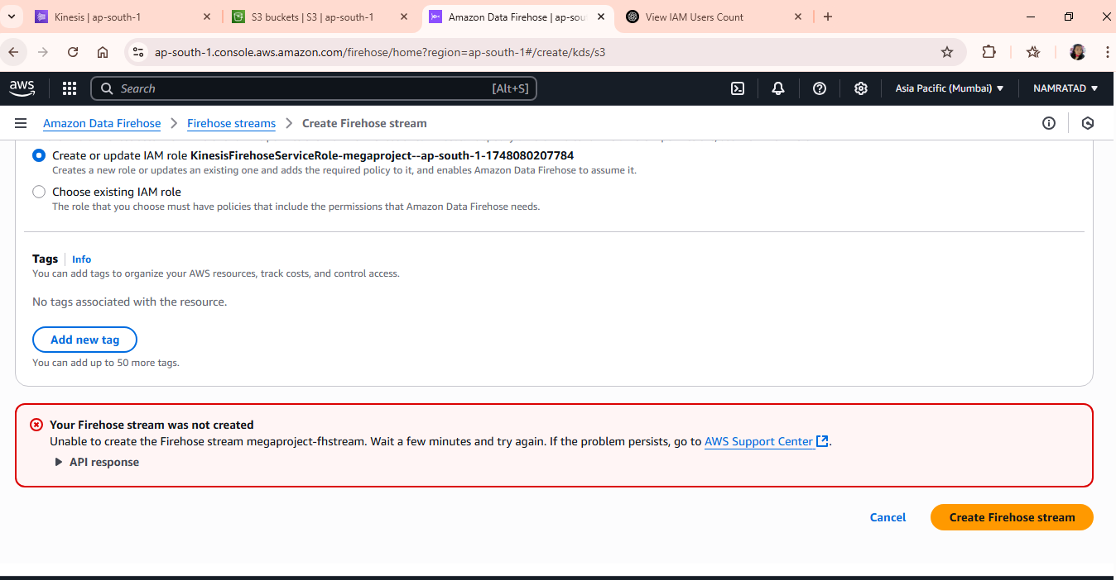

Use this template as test data:

{

"sensorId": "s128",

"temperature": 78,

"timestamp": "2025-05-25T16:25:00Z",

"deviceType": "thermometer"

}

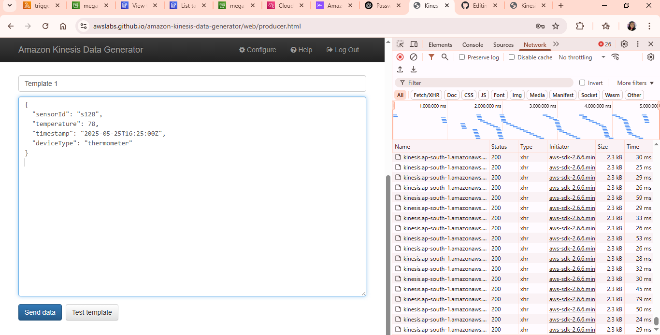

Next >>

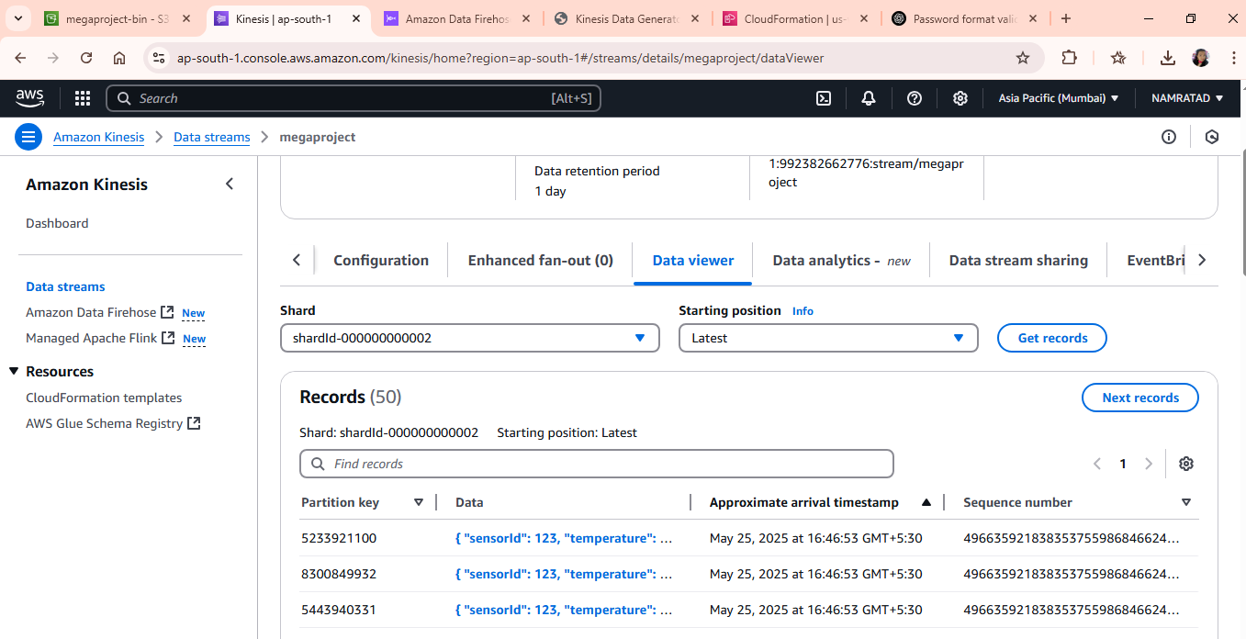

**Step 4: Create an S3 Bucket**

1. Go to **S3 > Create bucket**
2. Example bucket name: megaproject-bin
3. Uncheck "Block all public access" if needed for testing (not recommended for production)
4. Create the bucket

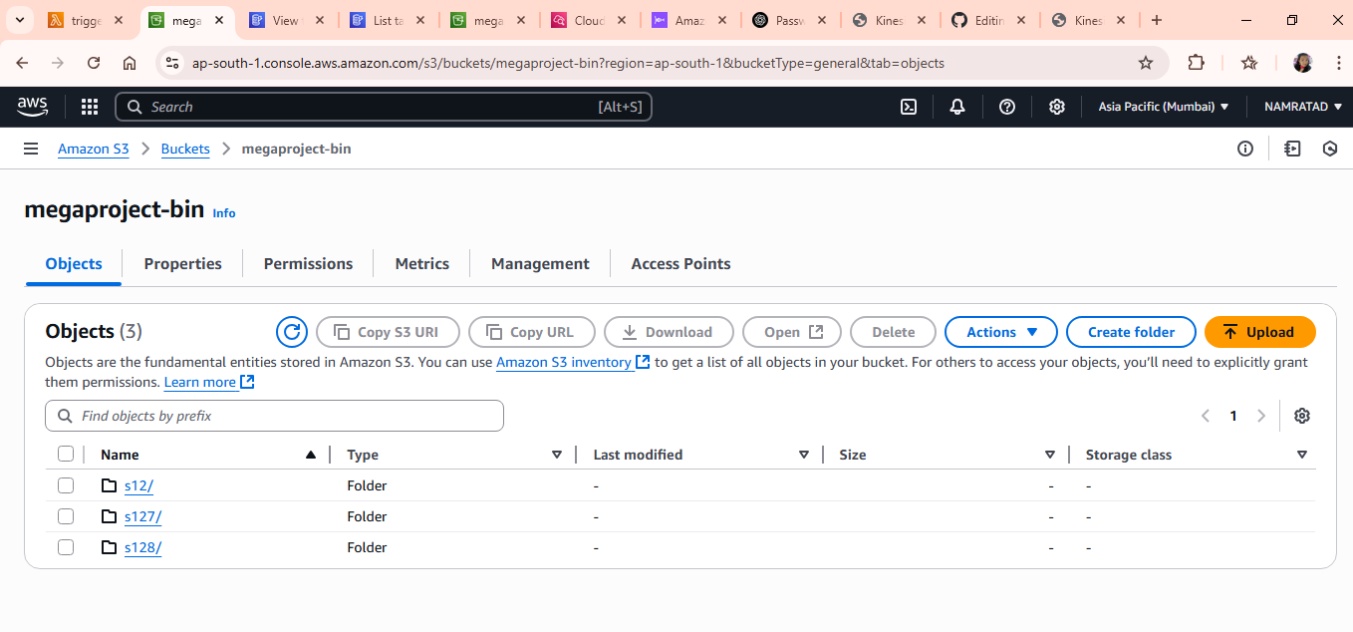

**Step 5: Create Lambda Function (S3 Trigger)**

1. Go to **Lambda > Create function**
2. Runtime: **Python 3.9**
3. Use inline or upload lambda_function.py (from this repo)
4. Set Environment Variable:
   * DYNAMODB_TABLE = namratadb
5. In **Permissions**, ensure Lambda's IAM role has:
   * s3:GetObject
   * dynamodb:PutItem
6. Add a trigger:
   * **Source**: S3
   * **Bucket**: megaproject-bin
   * **Event**: PUT (Object created)

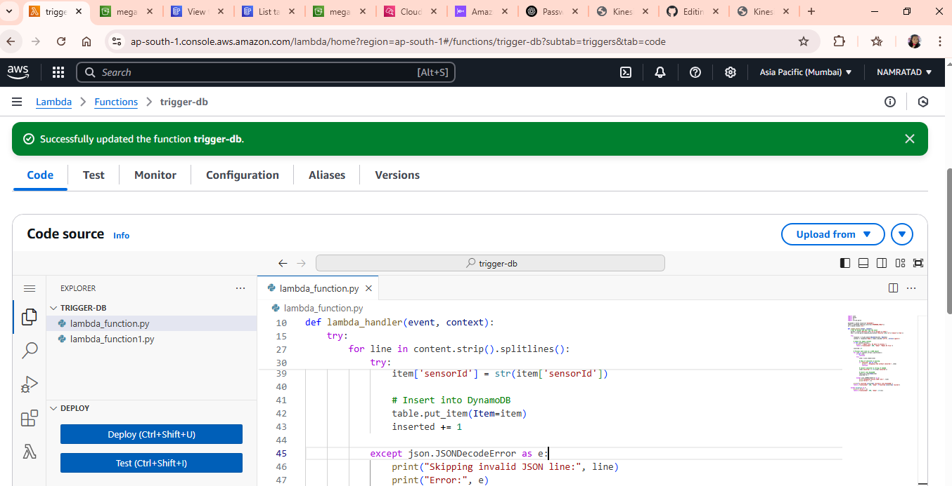

**Step 6: Set Up DynamoDB Table**

1. Go to the **AWS Console > DynamoDB**.
2. Create a new table:
   * **Table name**: namratadb (or your preferred name)
   * **Partition key**: sensorId
   * **Type**: String
3. Leave all other settings as default and create the table.

**Step 7: Test the Full Flow**

1. Send sample data from the **Kinesis Data Generator**
2. Wait for the Firehose to deliver to **S3**
3. Lambda will trigger and insert data into **DynamoDB**

Check logs in **CloudWatch** and records in **DynamoDB** to confirm.

