Task 1: Create a directory named test_dir
Command:
mkdir test_dir
ls
Screenshot:
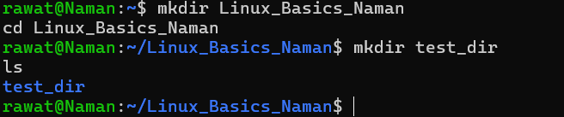
Explanation: mkdir creates a new directory. ls lists the current folder so we can confirm test_dir now exists.

Task 2: Create an empty file example.txt inside test_dir
Command:
touch test_dir/example.txt
ls test_dir
Screenshot:
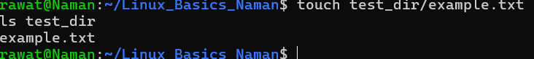
Explanation: touch creates an empty file when it does not already exist. The path test_dir/example.txt places it inside test_dir.

Task 3: Rename example.txt to renamed_example.txt
Command:
mv test_dir/example.txt test_dir/renamed_example.txt
ls test_dir
Screenshot:
Explanation: mv (move) renames a file when source and destination are in the same directory. ls confirms the new name.

Task 4: Display /etc/passwd using cat
Command:
cat /etc/passwd
Screenshot:
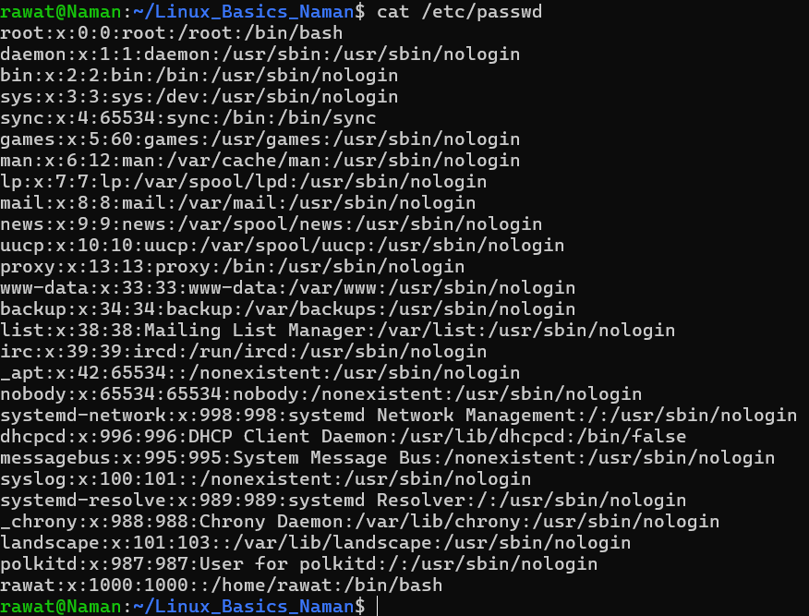
Explanation: cat prints the entire file to the terminal. /etc/passwd stores one line per user account (username, UID, GID, home directory, shell).

Task 5: Display the first 5 lines using head
Command:
head -n 5 /etc/passwd
Screenshot:
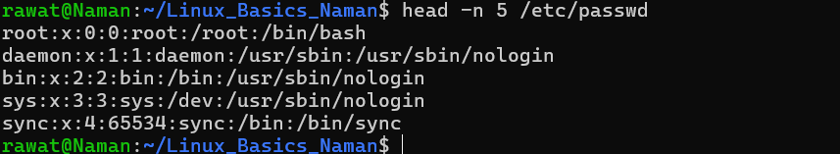
Explanation: head shows the beginning of a file. The -n 5 option limits the output to 5 lines.

Task 6: Display the last 5 lines using tail
Command:
tail -n 5 /etc/passwd
Screenshot:
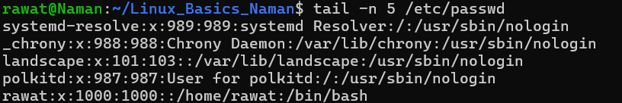
Explanation: tail shows the end of a file. The -n 5 option limits the output to 5 lines.

Task 7: Find lines containing "root" using grep
Command:
grep root /etc/passwd
Screenshot:
Explanation: grep searches for a pattern and prints every matching line. Here it finds all lines in /etc/passwd that contain the word root.

Task 8: Compress test_dir into test_dir.zip
Command:
zip -r test_dir.zip test_dir
ls -l test_dir.zip
Screenshot:
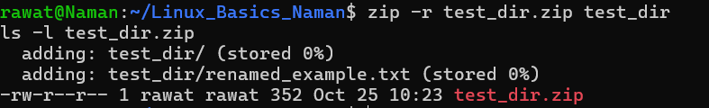
Explanation: zip creates an archive. The -r option includes the directory recursively (all files inside it). ls -l shows the archive was created.

Task 9: Unzip test_dir.zip into unzipped_dir
Command:
unzip test_dir.zip -d unzipped_dir
ls -R unzipped_dir
Screenshot:
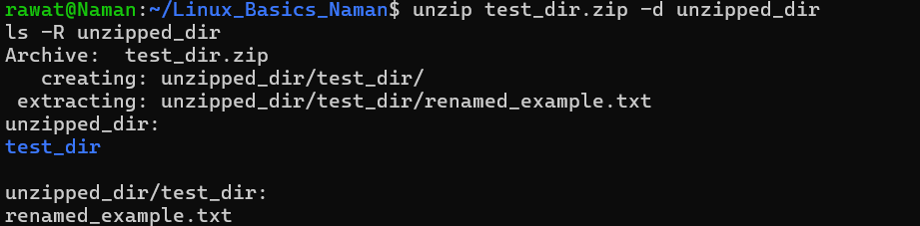
Explanation: unzip extracts the archive. The -d option sets the destination directory (created automatically). ls -R lists the extracted contents recursively.

Task 10: Download a file using wget
Command:
wget https://www.gutenberg.org/robots.txt -O sample.txt
ls -l sample.txt
Screenshot:
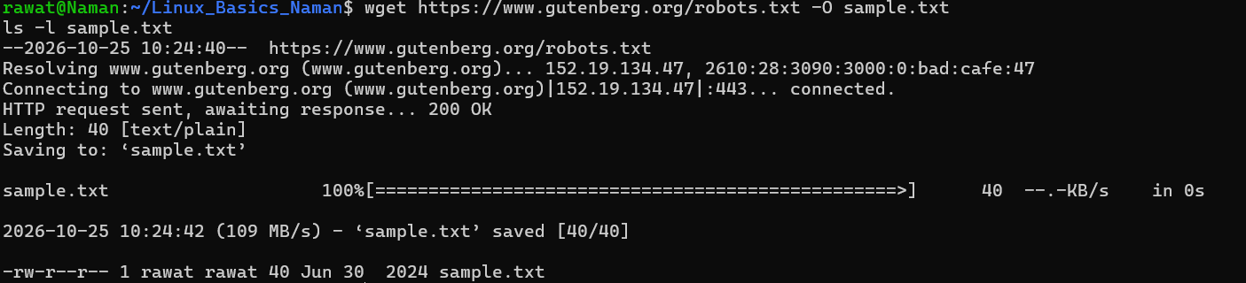
Explanation: wget downloads a file from a URL and saves it in the current directory. The -O option saves it under the name sample.txt. The output shows HTTP 200 OK, meaning the download succeeded.

Task 11: Make secure.txt read-only for everyone
Command:
touch secure.txt
ls -l secure.txt
chmod 444 secure.txt
ls -l secure.txt
Screenshot:
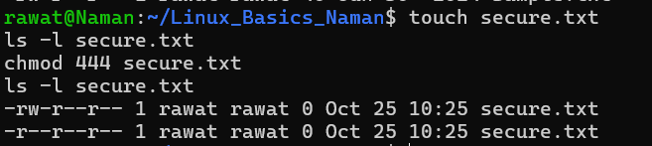
Explanation: chmod changes permissions. 444 means read (4) for owner, group and others, with no write or execute. ls -l shows the change from -rw-r--r-- to -r--r--r--.

Task 12: Set the environment variable MY_VAR
Command:
export MY_VAR="Hello, Linux!"
echo $MY_VAR
printenv MY_VAR
Screenshot:
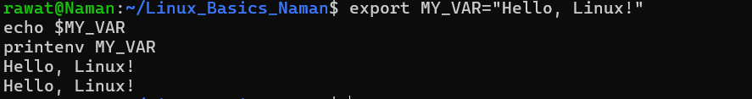
Explanation: export creates an environment variable that child processes can also see. echo $MY_VAR and printenv MY_VAR confirm its value. The variable lasts only for the current terminal session.

