# EXAM 1

**1. See the Employess**

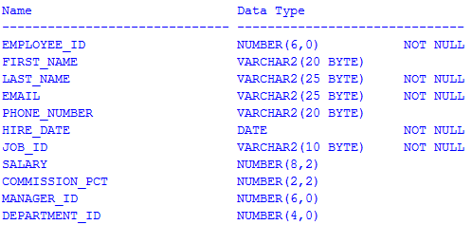

Which two SQL statements would execute successfully? (Choose two.)

A. **UPDATE** employees

SET salary = salary+10

**WHERE** **TO_CHAR**(HIRE_DATE,'yyyy')>'1995'

B. **SELECT** *

**FROM** employees

**WHERE** **TO_CHAR**(HIRE_DATE,'mon dd yy')='jan 13 93';

C. **UPDATE** employees

SET salary = salary+10

**WHERE** HIRE_DATE > **TO_DATE**(**SUBSTR**('01-JAN-200',8));

D. **SELECT** **TO_CHAR**(HIRE_DATE,'dd/month')

**FROM** employees

**WHERE** HIRE_DATE **IN** (**TO_DATE**('JAN 13 93',**TO_DATE**('JUL 01 98'));

-> OK

**2.** **Which three statements are true regarding subqueries? (Choose three.)**

A. Subqueries can contain GROUP BY and ORDER BY clauses

B. Main query and subquery can get data from different tables

C. Main query and subquery must get data from the same tables

D. Subqueries can contain ORDER BY but not the GROUP BY clause

E. Only one column or expression can be compared between the main query and subquery

F. Multiple columns or expressions can be compared between the main query and subquery

-> OK

**3. See the Departments**

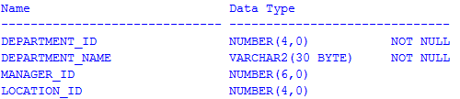

You want to update the MANAGER_ID column to NULL for all the DEPARTMENTS, where LOCATION_ID has NULL in the DEPARTMENTS table. Which SQL statement will accomplish the task?

A. **UPDATE** departments

SET manager_id = **NULL**

**WHERE** location_id = **NULL**;

B. **UPDATE** departments

SET manager_id = **NULL**

**WHERE** location_id **IS** **NULL**;

C. **UPDATE** departments

SET manager_id = **TO_NUMBER**(**NULL**)

**WHERE** location_id = **TO_NUMBER**(**NULL**);

D. **UPDATE** departments

SET manager_id = **TO_NUMBER**(' ',9999)

**WHERE** location_id **IS** **NULL**;

-> OK

**4. See the Departments**



NEW_DEPARTMENTS is a new table with the columns DEPT_ID, DEPT_NAME and MAN_ID, LOC_ID that have the same data types and size as the corresponding columns in the DEPARTMENTS table.

Evaluate the following INSERT SQL statement:



The INSERT statement fails when executed. What could be the reason?

A. The VALUES clause cannot be used in an INSERT with a subquery

B. Column names in the NEW_DEPARTMENTS and DEPARTMENTS tables do not match

C. The WHERE clause cannot be used in a subquery embedded in an INSERT statement

D. The total number of columns in the NEW_DEPARTMENTS table does not match the total number of columns in the DEPARTMENTS table

-> OK

**5. See the Employess**



You need to generate a list of all employee last name with their commission_pct from the Employees table. Those employee who do not have a commission_pct should appear last in the list. Which two queries would achieve the required result? (Choose two.)

A. **SELECT** employees.last_name,employees.commission_pct

**FROM** employees

**ORDER** **BY** commission_pct DESC;

B. **SELECT** employees.last_name,employees.commission_pct

**FROM** employees

**ORDER** **BY** commission_pct;

C. **SELECT** employees.last_name,employees.commission_pct

**FROM** employees

**ORDER** **BY** commission_pct NULLS LAST;

D. **SELECT** employees.last_name,employees.commission_pct

**FROM** employees

**ORDER** **BY** employees.last_name,employees.commission_pct

-> OK

**6. See**



What would be the outcome?

A. 16

B. 100

C. 160

D. 200

E. 150

-> OK

**7. See**

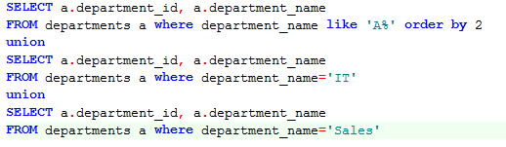

Which statement is true regarding the outcome of the above query?

A. It executes successfully and displays rows in the descending order of DEPARTMENT_NAME

B. It produces an error because positional notation cannot be used in the ORDER BY clause with SET operators

C. It executes successfully but ignores the ORDER BY clause because it is not located at the end of the compound statement

D. It produces an error because the ORDER BY clause should appear only at the end of a

compound query-that is, with the last SELECT statement

-> OK

**8. Which two statements are true regarding views? (Choose two.)**

A. A subquery that defines a view cannot include the GROUP BY clause

B. A view is created with the subquery having the DISTINCT keyword can be updated

C. A view that is created with the “with read only” keyword cannot be updated

D. The number of aliases must match the number of selected columns

-> OK

**9. Evaluate the following SQL statements:**

**select** astock MaCK,aqty **from** customers **where** acustaccount='058C000001'

**union** **all**

**select** astock,aqty Qty **from** customers **where** acustaccount='058C000001' Which ORDER BY clauses are valid for the above query? (Choose all that apply.)

A. **ORDER** **BY** 2,1

B. **ORDER** **BY** MACK

C. **ORDER** **BY** astock,QTY

D. **ORDER** **BY** "MACK"

E. **ORDER** **BY** QTY

-> OK

**10. See the following:**



You need to generate a list of stock that name is ordered to ascending

Which ORDER BY clauses are valid for the above query?

A. **select** astock ,aqty **from** Customers **where** acustaccount='058C000001'

**union** **all**

**select** 'Total' astock, **sum**(aqty) aqty **from** Customers **where** acustaccount='058C000001'

**order** **by** astock

B. **select** astock ,aqty **from** Customers **where** acustaccount='058C000001'

**order** **by** astock

**union** **all**

**select** 'Total' astock, **sum**(aqty) aqty **from** Customers **where** acustaccount='058C000001'

C. **select** 1, astock ,aqty **from** Customers **where** acustaccount='058C000001'

**union** **all**

**select** 2, 'Total' astock, **sum**(aqty) aqty **from** Customers **where** acustaccount='058C000001'

**order** **by** 1,astock

* Câu C mới đúng. Vì nếu chọn câu A thì khi em order by theo astock thì dòn select ‘Total’ nó sẽ bị nên đầu, anh ví dụ 1 câu select nó sẽ bị như thế 