**EXAM 3**

1. **See the tTEMP table**

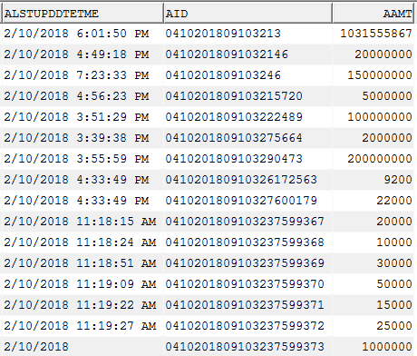

Write a **best query** to display all information that is updated on 02-Oct-2018

1. **There are three tables: tTableA, tTableB, tTableC**



Write **best query** to insert data from tTableA, tTableB, tTableC into tTableD

1. **Which SQL command performs best (results is very large)**



1. Select * from temployees where aempid in (select aempid from tdepartments);
2. Select * from temployees a where exists (select 1 from tdepartments b where a.aempid =b.aempid);
3. Select distinct a.* from temployees a, tdepartments b where a.aempid = b.aempid;
4. **In this practice, you examine and write executable statements.**

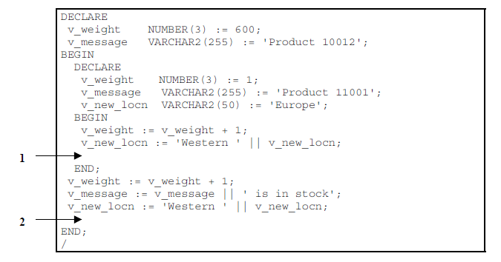

Evaluate the preceding PL/SQL block and determine the data type and value of each of the following variables, according to the rules of scoping.

a) The value of v_weight at position 1 is:

b) The value of v_new_locn at position 1 is:

c) The value of v_weight at position 2 is:

d) The value of v_message at position 2 is:

e) The value of v_new_locn at position 2 is:

1. **See tDepartments table**



Declare a cursour c_dept to retrieve adepid and adepname for those departments with adepid less than 100. Order by adepid

1. See temployees table



In the executable section, get all information from the temployees table by v_aempname. Display selected information about employee. The sample output is as followes:

Employee ID: 1 Employee Name: Joseph

1. See tEmployees table:



1. In the declarative section, declare two variable: v_aempname of type tEmployees.aempname and v_aempsal of tEmployees.aempsal. Initialize the latter to 1500.
2. In the executable section, retrieve the names of employees whose salaries are equal to the values in v_aempsal.

* If the salary entered returns only one row, insert into the tMessage table the employee’s name and the salary amount.

Note: Do not use explicit cursors.

* If the salary entered does not return any rows, handle the exception with an appropriate exception handler and insert the tMessage the message “No employee with salary of <salary>.”
* If the salary entered returns multiple rows, handle the exception with an appropriate exception handler and insert into the tMessage table the message “More than one employee with a salary of <salary>.”

1. See tRegions table:



1. Create procedure sptregions_i to insert information according to template.
2. Create and execute an anonymous block to invoke the sptregions_i procedure with parameter value.
3. Drop the sptregions_i procedure by issuing the following command.
4. Rename sptregions_i to sptregions_insert.