Systems Analysis and Design
Comprehensive Laboratory MIDTERM Examination Section A
Student Scholarship Monitoring and Academic Compliance System
Name: Natalie C. Amado Student ID: M-006899
Program and year: BSIT-3A Date: OCT. 20, 2026

1. Problem Statement
The Scholarship Office currently manages scholarship requirements using spreadsheets, emails, and paper grade records. This process can result in duplicate semester submissions, unverified academic records, missed deadlines, inconsistent scholarship decisions, and difficulty tracking submission status. The proposed Student Scholarship Monitoring and Academic Compliance System will provide a browser-based platform where scholars can submit academic summaries and evidence, while scholarship staff verify records, evaluate compliance with scholarship policies, and record renewal decisions. The Registrar remains the official source of grades, and the system will not modify official grades or release scholarship payments.

2. Problem, Cause, and Effect
ID | Problem | Cause | Effect
PCE01 | Duplicate submissions | Manual spreadsheet recording | Confusing or repeated records
PCE02 | Unverified grades | Evidence checked manually | Unreliable evaluation results
PCE03 | Missed deadlines | No centralized deadline monitoring | Late submissions and possible deficiencies
PCE04 | Inconsistent decisions | Policies applied inconsistently | Unfair or incorrect renewal decisions

3. Scope and Exclusions
In scope:
- User login and role-based access for scholars and scholarship staff.
- Scholar registration and scholarship program assignment.
- Semester academic summary submission and grade-document reference.
- Duplicate prevention and deadline validation.
- Verification, return for correction, and resubmission.
- Compliance evaluation using stored scholarship policy thresholds.
- Renewal decisions and reasons.
- Dashboard totals, searching, filtering, and history tracking.
Out of scope:
- Direct integration with the Registrar's system.
- Editing official grades or releasing scholarship payments.
- SMS notifications and machine-learning evaluation.
- A complete scholarship appeals workflow.

4. Development Tasks
ID | Development task
DT01 | Gather requirements and design the use case diagram, ERD, and database structure.
DT02 | Create the website interface and authentication for scholars and staff.
DT03 | Implement submissions, verification, policy evaluation, and renewal decisions.
DT04 | Implement dashboards, access policies, testing, documentation, and deployment or local setup.

5. Risks and Responses
ID | Risk | Response
RSK01 | Unauthorized users may access another scholar's records. | Enforce database access policies and test unauthorized access.
RSK02 | Incorrect policy thresholds may produce wrong compliance results. | Store thresholds in program records and test boundary values.

A2. Stakeholders and Elicitation (4 points)

1. Stakeholders and Actual Actors
ID | Stakeholder | Role | Actual actor?
ST01 | Scholar | Submits academic summaries and views submission status. | Yes
ST02 | Scholarship Staff | Registers scholars, verifies evidence, evaluates compliance, and records renewal decisions. | Yes
ST03 | Scholarship Office Management | Uses reports to monitor compliance and program performance. | Not a direct actor unless given system access
ST04 | Registrar | Maintains official grades and provides evidence staff verify. | No direct actor; no integration is included

Actual actors: Scholar and Scholarship Staff. They directly interact with the system within the defined scope.

2. Elicitation Questions
- How do staff currently verify the authenticity and completeness of submitted grade documents?
- How are submission deadlines communicated, monitored, and handled when a scholar submits late?
- What policy exceptions, if any, are allowed, and who has the authority to approve them?
- What information should scholars be allowed to view, edit, or resubmit after submitting academic summaries?
- What access permissions should scholars and staff have when viewing, verifying, or changing records?
- What reports and summary information does management need to monitor submissions, compliance, deficiencies, and renewal decisions?

A3. Requirements and Business Rules (10 points)

1. Functional Requirements
ID | Functional requirement
FR01 | The system shall authenticate users and enforce separate Scholar and Scholarship Staff permissions.
FR02 | The system shall allow staff to register scholars and assign each scholar to a persisted Merit Scholar or Community Scholar program.
FR03 | The system shall allow scholars to submit academic year, semester, GWA, enrolled units, failed subjects, incomplete grades, dropped subjects, and a grade-document reference.
FR04 | The system shall record submission timestamps, validate input values, and reject duplicate submissions for the same scholar, academic year, and semester.
FR05 | The system shall allow staff to mark submissions Verified or Returned and require a reason when returning a submission.
FR06 | The system shall allow scholars to correct and resubmit returned submissions, changing their verification status back to Pending.
FR07 | The system shall evaluate only verified submissions using thresholds stored in the scholar's assigned program.
FR08 | The system shall display Compliant or With Deficiency and identify every failed policy condition.
FR09 | The system shall allow staff to record an Approved or Held renewal decision with notes, preventing approval unless the evaluation is Compliant.
FR10 | The system shall display dashboard totals and support searching by scholar name or student ID and filtering by program or compliance result.

2. Non-Functional Requirements
ID | Requirement | Measurement
NFR01 | Security | Protected database operations enforce role-based access; unauthorized attempts must be denied in TC08.
NFR02 | Performance | Dashboard totals and search results should load within 3 seconds under agreed test conditions.
NFR03 | Data integrity | Duplicate submissions and invalid GWA, unit, or count values are rejected by validation and database constraints where applicable.
NFR04 | Reliability and auditability | Saved records remain after refresh; verification, evaluation, and renewal changes retain actor, timestamp, and history.

Note: These are proposed measurable targets for the MVP.

3. Business Rules
ID | Business rule
BR01 | Merit Scholar requires GWA 1.00–1.75, at least 18 units, zero failed subjects, zero incomplete grades, zero dropped subjects, and a grade-document reference.
BR02 | Community Scholar requires GWA 1.00–2.25, at least 15 units, zero failed subjects, zero incomplete grades, no more than one dropped subject, and a grade-document reference.
BR03 | A submission cannot be evaluated for final compliance until staff verify its supporting evidence.
BR04 | A scholar may have only one submission for each academic year and semester.
BR05 | The deadline is October 30, 2026, at 5:00 PM Philippine time. Exactly at the deadline is on time; after it is late.
BR06 | Only Scholarship Staff may record renewal decisions. Approval is allowed only when the evaluation is Compliant; a deficient result may be Held but not Approved.

Additional validation: GWA must be 1.00–5.00 inclusive. Enrolled units and failed, incomplete, and dropped counts must be nonnegative integers. Smaller GWA values represent better performance.
Status distinction: Submission status (Pending, Verified, Returned), compliance result (Compliant, With Deficiency), and renewal decision (Approved, Held) are separate. Verified does not automatically mean Compliant or Approved.

A4. UML Use Case Modeling (8 points)

1. Use Case Diagram (PlantUML source)
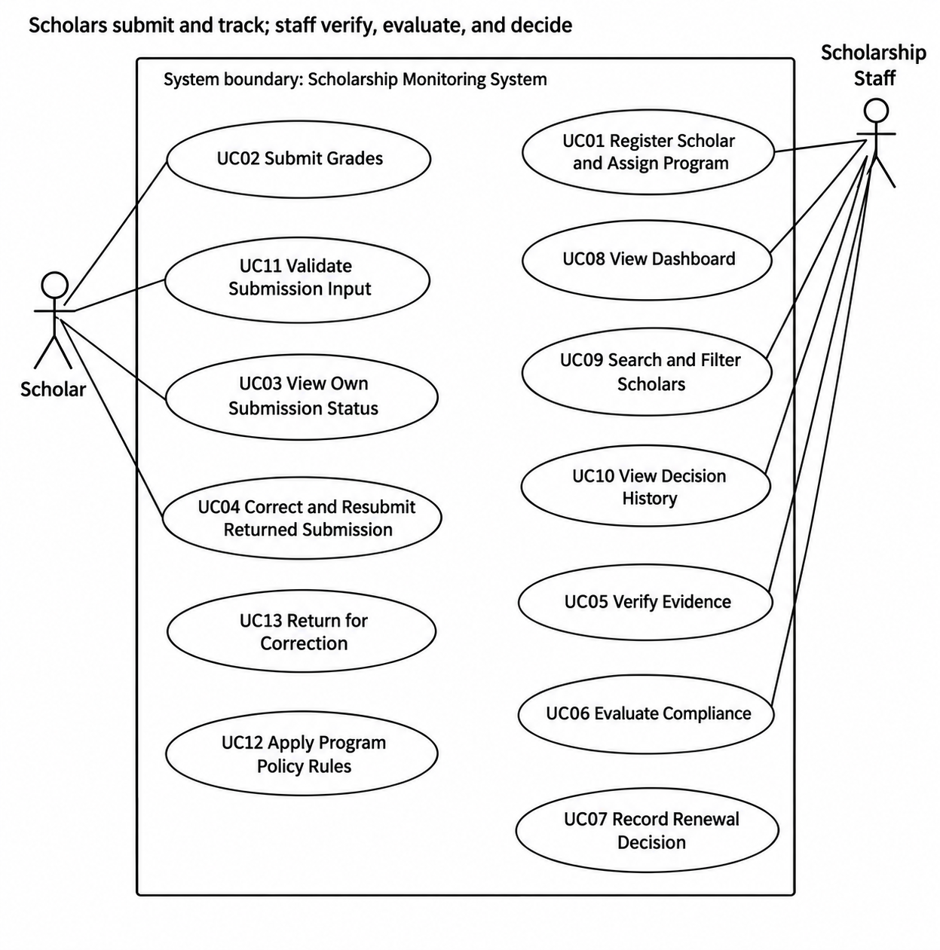

2. Relationship Justifications
Include 1 — UC02 Submit Grades includes UC11 Validate Submission. Validation is mandatory on every submission; the system checks required fields, valid values, and duplicate semester records.
Include 2 — UC07 Evaluate Compliance includes UC08 Check Policy Thresholds. Checking the assigned program's stored thresholds is required during evaluation.
Extend — UC12 Return Submission for Correction extends UC06 Verify Evidence. Returning is conditional and occurs when evidence is missing, incomplete, or unacceptable.
Arrow direction: include points from the main use case to the included use case; extend points from the conditional extending use case to the base use case.

A5. Detailed Use Cases and Data Design (8 points)

1. UC02 — Submit Grades
Field | Description
Use case ID | UC02
Primary actor | Scholar
Trigger | The scholar selects the option to submit semester grades.
Preconditions | The scholar is authenticated, has an assigned program, and is viewing their own account.
Postcondition | A valid submission is saved with timestamp and Pending verification status. Invalid or duplicate submissions are not saved.
Linked requirements | FR01, FR03, FR04, FR06
Linked business rules | BR03, BR04, BR05

Main flow:
- The scholar logs in to the system.
- The scholar opens the grade submission form.
- The system displays the assigned scholarship program.
- The scholar selects the academic year and semester.
- The scholar enters GWA, enrolled units, failed subjects, incomplete grades, and dropped subjects.
- The scholar provides the grade-document reference.
- The system validates required fields, allowed values, and uniqueness.
- The system records the timestamp and checks the deadline.
- The system saves the submission as Pending verification.
- The system displays confirmation and submission status.
Alternative and exception flows:
- A1 — Returned submission: The scholar corrects and resubmits it. Status returns to Pending verification and history is retained.
- E1 — Invalid input: Invalid GWA or unit/count values trigger an error and are not saved.
- E2 — Duplicate submission: A duplicate for the same scholar, academic year, and semester is rejected.
- E3 — Missing evidence reference: The system requires the grade-document reference before accepting the submission.
- E4 — Late submission: The timestamp is recorded and the late condition is considered during evaluation.
- E5 — Unauthorized access: A scholar attempting to access another scholar's record is denied.

2. UC07 — Evaluate Compliance
Field | Description
Use case ID | UC07
Primary actor | Scholarship Staff
Trigger | Staff select a verified submission for evaluation.
Preconditions | Staff are authenticated; the submission exists, evidence is Verified, and a program is assigned.
Postcondition | The evaluation result, failed checks, reasons, actor, and timestamp are saved.
Linked requirements | FR01, FR02, FR07, FR08, FR09
Linked business rules | BR01, BR02, BR03, BR05, BR06

Main flow:
- Staff log in.
- Staff open the dashboard and select a submission.
- The system confirms the submission is Verified.
- The system retrieves the assigned program and stored policy thresholds.
- The system checks GWA, units, failed subjects, incomplete grades, dropped subjects, evidence, and deadline.
- The system records each policy check.
- If all conditions pass, the result is Compliant.
- If any condition fails, the result is With Deficiency and reasons are listed.
- The system saves evaluation, staff identity, timestamp, and history.
- Staff explicitly record Approved for a Compliant evaluation or Held for a deficient evaluation.
- The system saves the decision and notes and displays the updated record.
Alternative and exception flows:
- A1 — Compliant: Staff may record Approved or Held.
- A2 — Deficient: The system lists each failed condition; staff may record Held but cannot approve.
- E1 — Pending verification: Evaluation and approval are blocked until evidence is verified.
- E2 — Returned submission: The scholar must correct and resubmit before verification and evaluation.
- E3 — Missing policy assignment: Evaluation is blocked until staff assign a valid program.
- E4 — Unauthorized action: A scholar attempting to evaluate a record or change a renewal decision is denied.

3. Entity Relationship Diagram (ERD)
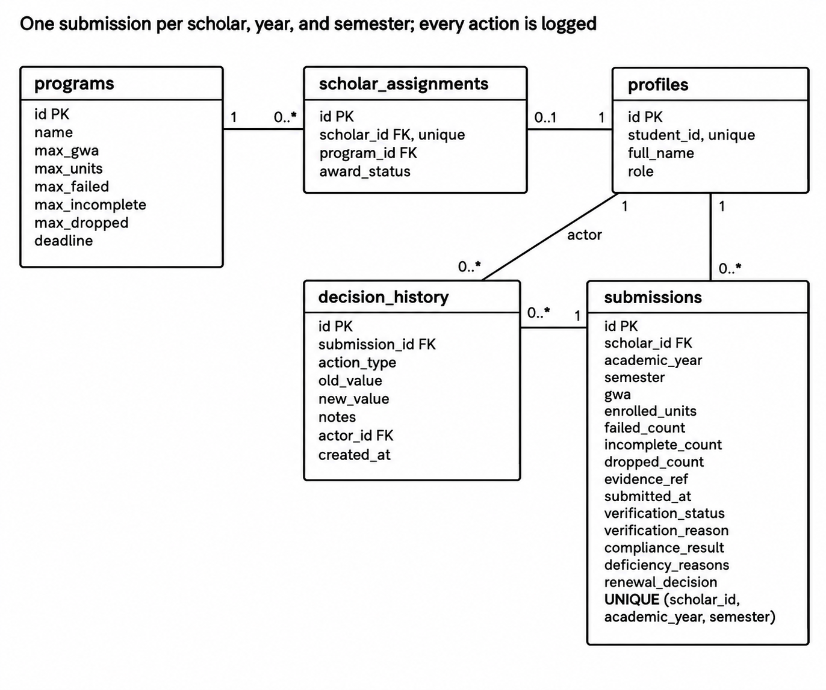

ERD Design Notes
- USER_PROFILE stores user identity and role; authentication credentials are handled by Supabase Auth.
- SCHOLARSHIP_PROGRAM stores thresholds for Merit Scholar and Community Scholar.
- SCHOLAR_ASSIGNMENT connects a scholar to a scholarship program; SEMESTER_SUBMISSION stores academic summaries and current statuses.
- VERIFICATION_HISTORY, EVALUATION_HISTORY, and RENEWAL_HISTORY preserve past actions.
- Enforce uniqueness on (assignment_id, academic_year, semester).
- Database policies must prevent scholars from reading or changing other scholars' records and from performing staff-only actions.

A6. Traceability (4 points)
The matrix connects requirements to actors, use cases, business rules, planned screen/functions, and tests. Screen/function entries are implementation targets, not claims that the application has already been implemented or tested.
FR ID | Actor | Use case | BR ID | Screen/function | Test and expected result
FR01 | Scholar, Staff | UC01 | BR06 | login.html; js/auth.js; database policies | TC08: Cross-scholar access and scholar verification are denied.
FR03 | Scholar | UC02 | BR03, BR04 | submission.html; js/submission.js | TC07: Invalid GWA, negative counts, and duplicate semester submissions are rejected.
FR05 | Staff | UC06 | BR03 | verification.html; js/verification.js | TC09: Return with reason; resubmission returns to Pending and history remains.
FR07 | Staff | UC07 | BR01, BR02, BR03, BR05 | evaluation.html; js/evaluation.js | TC01–TC06: Results and reasons match program policy; unverified records are blocked.

Planned Requirements Not Yet Implemented or Verified
- FR09: Save renewal decisions and block approval for deficient submissions.
- FR10: Verify dashboard totals, search, and filters.
- NFR04: Verify history persists after refresh.
- Database security: Verify role isolation and duplicate prevention are enforced at database level.

Test Case Reference
Test ID | Expected result
TC01 | A01 is Compliant at the GWA and deadline boundaries.
TC02 | A02 is With Deficiency because its GWA exceeds the Merit limit.
TC03 | A03 is Compliant because Community Scholar permits one dropped subject.
TC04 | A04 identifies insufficient units and an incomplete grade.
TC05 | A05 identifies the failed subject and late submission.
TC06 | A06 cannot be evaluated or approved until evidence is verified.
TC07 | Duplicate submissions and invalid inputs are rejected.
TC08 | Unauthorized cross-scholar access and scholar verification attempts are denied.
TC09 | Correction/resubmission returns the record to Pending while preserving history.
TC10 | Staff can approve compliant and hold deficient records; scholars cannot change renewal decisions.

