# Frontend Mentor - Four card feature section solution

This is a solution to the [Four card feature section challenge on Frontend Mentor](https://www.frontendmentor.io/challenges/four-card-feature-section-weK1eFYK). Frontend Mentor challenges help you improve your coding skills by building realistic projects.

## Table of contents

- Overview

- The challenge

- Screenshot

- Links

- My process

- Built with

- What I learned

- Continued development

- Useful resources

- Author

- Acknowledgments

## Overview

### The challenge

Users should be able to:

- View the optimal layout for the site depending on their device's screen size

### Screenshot

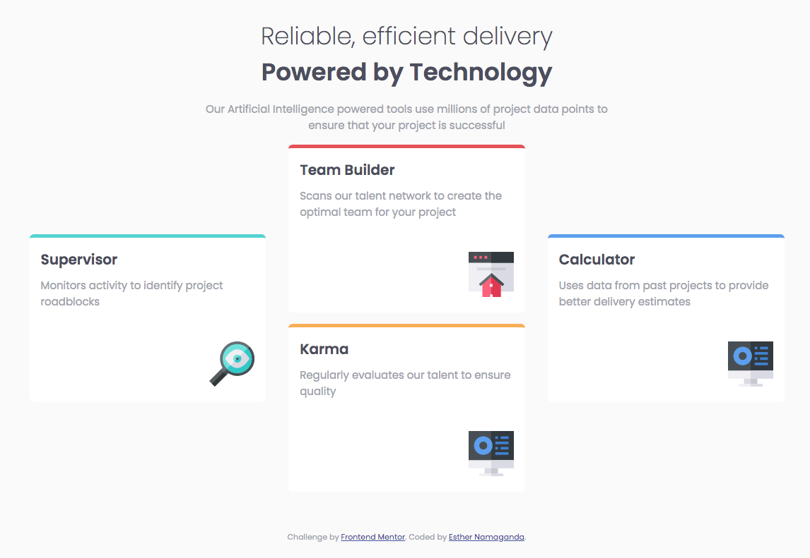

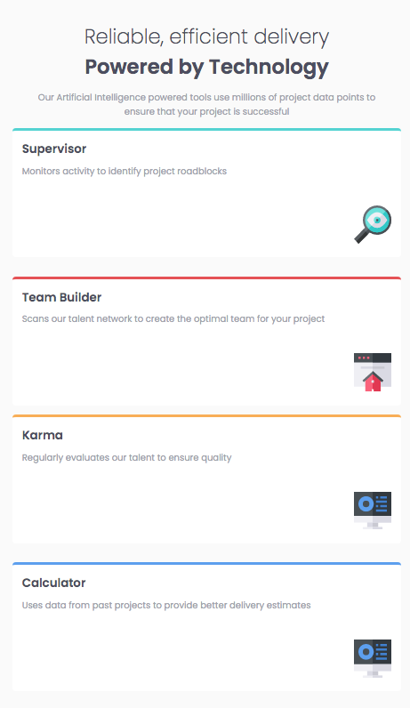

### Links

- Solution URL: https://namaganda-esther.github.io/Frontend-Mentor-four-card-feature--Challenge/

- Live Site URL: https://namaganda-esther.github.io/Frontend-Mentor-four-card-feature--Challenge/

## My process

### Built with

- Semantic HTML5 markup

- CSS custom properties

- Flex

- CSS Grid

### What I learned

I learnt how to use grid and flex. It’s been a good experience in css. Things become easy when you know what to do to have a certain result.

To see how you can add code snippets, see below:

```css

.container{

display: grid;

grid-template-columns: 1fr 1fr 1fr;

}

```

### Continued development

I want to continue learning how to use the flex and grid attributes in css. And how to create the div tags to make it easy to use them.

### Useful resources

- w3Schools helped know learn more about the grid and flex css elements to help me align the elements.

Codepen was also a good resource.

Geeks for geeks is a good resource

## Author

- Website - [Esther Namaganda]

- Frontend Mentor - [@namaganda-esther]

(https://www.frontendmentor.io/profile/namaganda-esther)

- Twitter - @prudence_esther

## Acknowledgments

I give credit to mr coder on youtube, was having difficulties between flex and grid. But he made things easy.