# Frontend Mentor - Product preview card component solution

This is a solution to the [Product preview card component challenge on Frontend Mentor](https://www.frontendmentor.io/challenges/product-preview-card-component-GO7UmttRfa). Frontend Mentor challenges help you improve your coding skills by building realistic projects.

## Table of contents

- Overview

- The challenge

- Screenshot

- Links

- My process

- Built with

- What I learned

- Continued development

- Useful resources

- Author

- Acknowledgments

## Overview

### The challenge

Users should be able to:

- View the optimal layout depending on their device's screen size

- See hover and focus states for interactive elements

### Screenshot

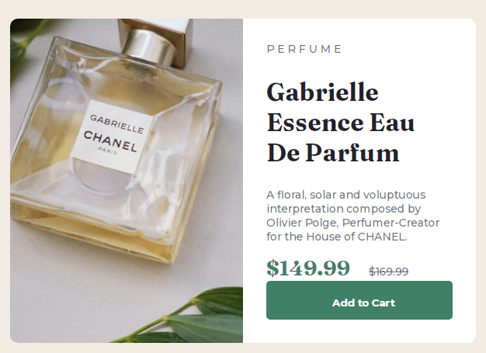

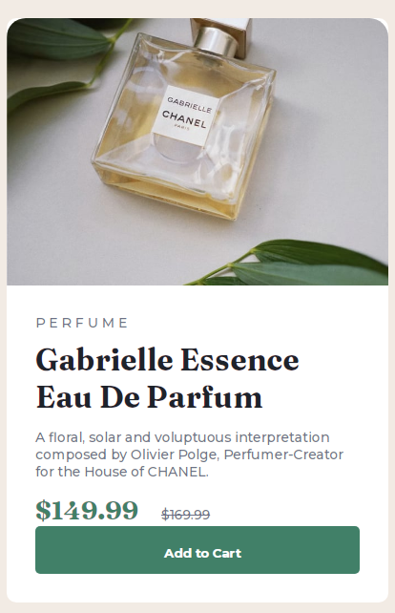

### Links

- Solution URL: [solution](https://github.com/namaganda-esther/Frontend-MentorProduct-preview-card-component)

- Live Site URL: [link](https://namaganda-esther.github.io/Frontend-MentorProduct-preview-card-component/)

## My process

### Built with

- Semantic HTML5 markup

- CSS custom properties

- Flexbox

- CSS Grid

### What I learned

I learnt that using section tag saves you a lot and can easily group content on a page.

Also using flex in CSS has opened my eyes a lot to what it can do.

html

‘’’<section>

</section>

CSS

’’display: flex;

### Continued development

I want to focus on how to lay out a page, looking forward to more projects like this.

### Useful resources

W3S was a great resource, I used some YouTube.

## Author

- Website – Esther Namaganda

- Frontend Mentor - @namaganda-esther <https://www.frontendmentor.io/profile/namaganda-esther>

- Twitter - @orudence_esther

## Acknowledgments

This GitHub account was very helpful. https://github.com/maudlinmandrake/product-preview-card-component