This is a basic C# .NET Windows Forms application. To open the software, start with the “Comapp” I provided in the ZIP file. The application includes several operations. When you click the "Basic" button, a new window opens where you can connect to a port. You can use buttons to connect or disconnect from the port.

I also provided additional interfaces for knob control and axle simulation.

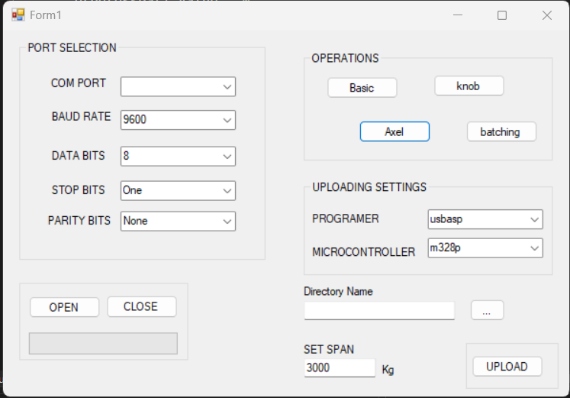

Interface of the complete software

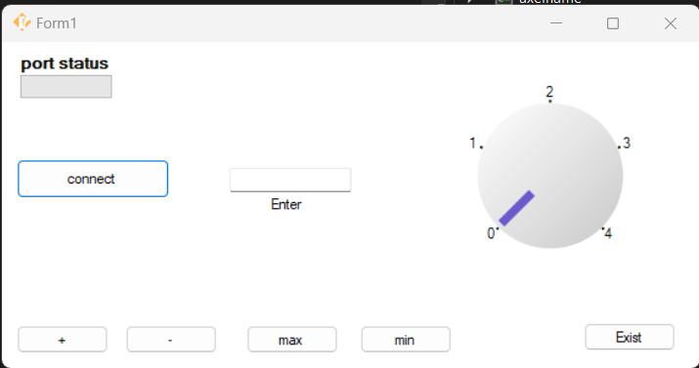

“ Basic” interface

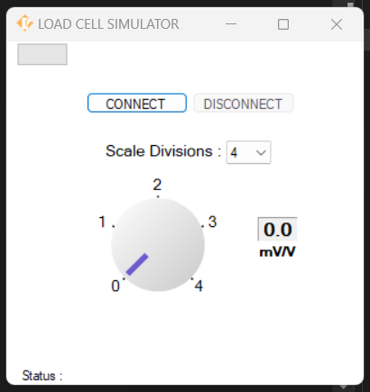l

Knob interface

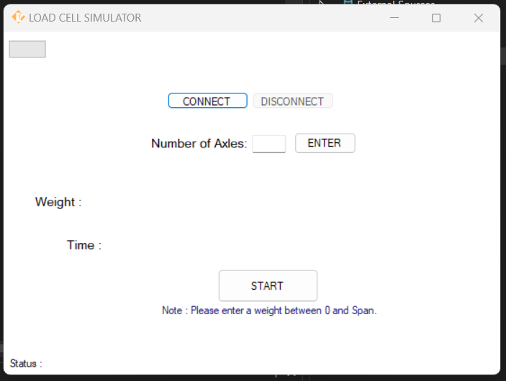

Axel interface

