|  |
| --- |
| **Browns Engineering and Construction (Pvt) Ltd** |
| Project Management System (Web & Mobile Application) |
| **For Home Connection Division** |
|  |
|  |
|  |

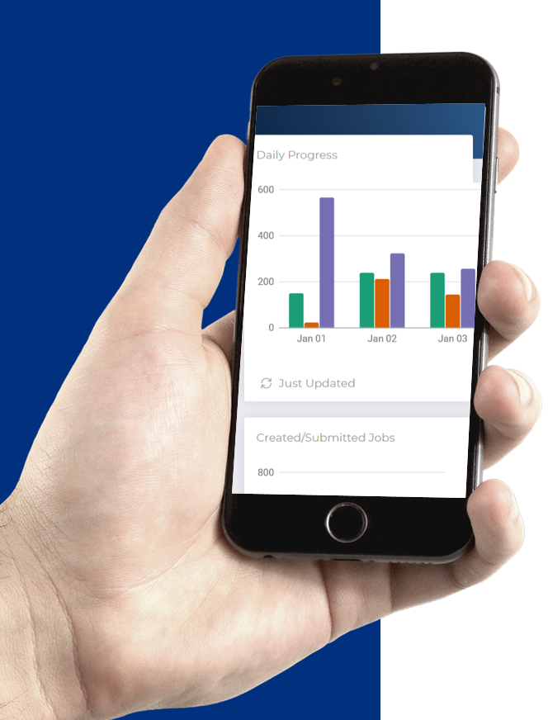

|  |
| --- |
|  |

# Project Details

|  |  |  |  |
| --- | --- | --- | --- |
| **Project Name** | Project Management System - Web & Mobile Application | | |
| **Project Manager** | Nuwan Wijesinghe | | |
| **Start Date** | **8th July 2020** | **Completion Date** |  |

# Revision History

|  |  |  |  |  |
| --- | --- | --- | --- | --- |
| **Version** | **Status (Draft or Approved)** | **Date** | **Author/Editor** | **Details of changes** |
| 1.0 | Draft | 05/03/2014 | Namal | Initial document |
|  |  |  |  |  |
|  |  |  |  |  |
|  |  |  |  |  |
|  |  |  |  |  |
|  |  |  |  |  |

Table of Contents

1. Introduction 3

1.1 Background 3

1.2 Aim 3

2. Requirements of a new web based system 3

3. Proposed Solution 3

4. Business Case 4

5. Risks 4

6. Requirements 5

6.1. Functional Requirements 5

Web Application 5

Mobile Application 12

System constraints 19

6.1. Non Functional Requirements 19

# Introduction

## Background

This document is prepared for the purpose of implementing a new web & mobile application for the home connection division at browns engineering and construction.

## Aim

The aim is to develop a mobile and web solution that will enhance the effectiveness of handling the service orders, measuring the performances of the team, and collecting the essential data to create invoices for SLT.

# Requirements of a new web based system

At this moment, the work order handling process is done manually and there is no system involvement for the process. Currently, that process is done by collecting manual data and updating the excel sheets accordingly. It seems that the manual process cannot continue when processes are expanded.

The new system should be implemented in accordance to keep a smooth business process and manage work orders, trace problems in the process and measure the performance and the productivity of the project.

# Proposed Solution

It is proposed to develop a mobile and web application for the work orders management process. The mobile application is mainly based on the android platform and a staging application will be maintained mobile data. The mobile application will be used to upload images and data which are related to work orders. Users will be able to use the mobile application online and offline at any time and any place.

* Any changes or enhancements which are not explicitly defined in this document will be discouraged at this phase and handled under a Change Request process, and will be logged and maintained separately.

# Business Case

* The company will be able to discontinue the manual service order handling process
* Usage of mobile computing devices with Android open source platform is getting increased in a sophisticated rate in today’s marketplace, therefore providing a mobile solution will be an optimum method to the field employees.
* Service order status will be recorded to the system without a delay. Therefore the company will be able to get information about service orders details and status.
* Time saving and increase the efficiency of home connection division
* The company will be able to get valuable reports using the system such as material usage, Progress, Performance, etc.
* The users tend to use mobile applications rather than using the manual process.
* The users will be more careful using the mobile and web application and will minimize errors.

# Risks

* N/A

# Requirements

## Functional Requirements

### 6.1.1 Web Application

|  |  |  |
| --- | --- | --- |
| **Functional Requirement ID** | **Use Case** | **Description** |
| **FR1** | Authentication | 1. The login credentials should be approved by an administrator. 2. The administrator should have facilitated to Create, Read, Update, Delete users from the system. 3. The administrator will be assigned the default password which can be changed after the user logged in. 4. The user name and password validations should be there. 5. System should have limited the number of failed login attempts per user. If it is exceeded, the user should be locked. 6. The system should facilitate sending an email to the administrator if they are locked or when forget the password. |
| **FR2** | Authorization | 1. Once the user login to the system through user credentials, the users can only access the resources of the system according to their levels. There are five user levels as below,  * Administrator * OMC user * RBU user * Field Team * Quality Checker  1. The administrator should have permission to assign the user level and resources to the users. 2. Role-based permission method should be used. |
| **FR3** | Upload Dataset to the System | 1. System should upload the CSV file which is downloaded by SLT portal. It should be filtered and the system should only record the below data.  * Service Order NO * Received Date * Circuit Number * RTOM * LEA * ORDER TYPE * TASK NAME * Customer Name * Customer Contact NO * Customer Address * FTTH Package * DP * Loop * PHONE CLASS * Description  1. Once CSV uploaded, all service orders should be waiting until approved by the uploaded user. 2. If there are duplicated SODs, the system should review duplicated SODs. If they are reconstructions, the system should backup old data and replace it with new data with SLT details. 3. Once CSV uploaded successfully, all uploaded details should display in the OMC To-do list according to the related user. 4. The temporary SOD details list should be deleted once CSV successfully uploaded. 5. Above SOD details can be changed later. The system should be able to update details manually. 6. The customer details also can be changed later. The system should be able to update details manually. |
| **FR4** | Workgroups and RBU details | 1. There should be three workgroups,  * OMC - Operations Management Center * RBU - Regional Business Unit * Team - Field team  1. There should have 7 RBUs initially as  * NC & NEP * WPS * NWP * CEN & UVA * SUB & SP * WPC * WPN |
| **FR5** | Operations at OMC when SOD assigned | 1. The uploaded SODs should be filtered according to the related user. 2. The SOD should be completed within 7 days. The system should maintain the aging of all SODs. 3. The SOD’s color should be changed as follows,  * If remaining more 3 days, the color is green * If remaining less than 3 days, the color is yellow * If remaining less than 0 days, the color is red  1. The system should have the facility to filter SODs by all general details such as SO Number, Circuit number, Received date, RTOM, Order Type, Task Name, Customer Name, FTTH Package, Age, DP, and Loop 2. The system should be able to monitor all details of the service orders 3. Appointment date may have to insert into the system according to the request of the client. The system should have the facility to add the Appointment date if any. 4. Some SODs have to return SLT due to many reasons. The system should be able to return to the SLT with common reasons with a description. 5. The SLT Rejected details should be recorded. 6. When SODs are uploaded, those could be able to assign related RBU with a description. 7. Assigned SOD history with details should be maintained by the system 8. The SODs may have to wait at OMC Level due to many reasons. Those are could be able to assign related RBU with descriptions. 9. The held SOD details should be maintained. 10. The Work order aging should be monitored. 11. The system should maintain rejected SOD by RBU level. |
| **FR6** | Operations at OMC when SOD rejected | 1. The rejected SODs should be filtered by all general details such as SO Number, Circuit number, Received date, RTOM, Order Type, Task Name, Customer Name, FTTH Package, Age, DP, and Loop. 2. Once SOD is rejected, it may able have to reassign to a RBU again. OMC user should have permission to reassign to a related RBU with the description 3. Rejected details should be clearly including essential details such as rejected by, Reject reason, description. 4. If the service order updated to the SLT portal as rejected SOD, the system should remove it from the rejected list. 5. When a service order assigned to a RBU, the system should remove it from the rejected list |
| **FR7** | Operations at OMC when SOD held | 1. Held SODs by all general details such as SO Number, Circuit number, Received date, RTOM, Order Type, Task Name, Customer Name, FTTH Package, Age, DP, and Loop. 2. Once SOD is held, it may able have to reassign to a RBU again. OMC users should have permission to reassign to a related RBU with the description. 3. When a service order assigned to a RBU, the system should remove it from the hold list. 4. Once SOD is held, it may have a chance to reject the SLT. The system should reject with description. 5. When a service order rejects, the system should remove it from the hold list. |
| **FR8** | Operations at OMC when SOD completed | 1. The OMC should have all information about completed SODs by field teams. 2. The system should maintain QC status at the OMC level. 3. OMC should have information about total aging, Completed teams, and other related details. 4. Job Data of the completed task should be displayed at the OMC level. 5. OMC should have permission to change QC Status as Pass, Fail, Not done with description. 6. When QC review is completed, SOD should update by OMC user at the SLT Web portal. Those SODs should rejected from the completed list. 7. Once SODs submit to the SLT, all records should be recorded. |
| **FR9** | QC review at OMC level | 1. The OMC user should maintain the records of QC review by the teams 2. The OMC user should review the QC which is done by the teams and, should maintain the status and records of the QC. |
| **FR10** | Operations at RBU when SOD assigned | 1. The related SODs should be listed when the RBU users logged into the system. 2. The system should maintain all related details of the SOD including OMC Description, and assigned person. 3. When SODs are assigned to RBU, those could be able to assign to a related field team with a description (description is optional). 4. If a service order assigned to a team, the system should remove it from the to-do list of RBU. 5. The system should be able to reject SODs to OMC when required with the common reasons and description. 6. If a service order rejected, the system should remove it from the to-do list. 7. The system should be able to hold SODs at the RBU level when required with the common reason and description. 8. If a service order in a hold state, the system should remove it from the to-do list. 9. The system should have the facility to add the Appointment date at the RBU level (if any). 10. The system should be recorded team assigned SOD details with OMC and RBU Descriptions, Appointment Date, Started Time 11. If SODs are not started yet by the assigned team, RBU should be able to take back from the assigned team and reassign to a suitable team. |
| **FR11** | Operations at RBU when SOD is Rejected | 1. The rejected SODs should filtered by all general details such as SO Number, Circuit number, Received date, RTOM, Order Type, Task Name, Customer Name, FTTH Package, Age, DP and Loop. 2. The rejected details should be recorded clearly including rejected by, reject reason, description and other related details. |
| **FR12** | Operations at RBU when SOD is Hold | 1. The held SODs should be filtered by all general details such as SO Number, Circuit number, Received date, RTOM, Order Type, Task Name, Customer Name, FTTH Package, Age, DP, and Loop. 2. Once SOD is held, it may able have to reassign to a team again. RBU users should have permission to reassign to a related team with the description. 3. When a service order assigned to a team, the system should remove it from the hold list. 4. Once SOD is held, it may have a chance to reject the OMC. The system should reject with description. 5. When a service order rejects, the system should remove it from the hold list. |
| **FR13** | Operations at RBU when SOD is completed | 1. The completed SODs should be filtered by all general details such as SO Number, Circuit number, Received date, RTOM, Order Type, Task Name, Customer Name, FTTH Package, Age, DP, and Loop. 2. The RBU should have all information about completed jobs and job details by the field teams. 3. The QC status should be displayed at RBU level which is done by the field teams. 4. The RBU should have records about the total aging of a SOD and the team completed SODs. 5. The job data of the completed task should be displayed at the RBU level. |
| **FR14** | Operations at Field teams | 1. All material usage and job details are recorded at this level. 2. The assigned SODs of team level should be filtered by all general details such as SO Number, Circuit number, Received Date, RTOM, Order Type, Task Name, Customer Name, FTTH Package, Age, DP, and Loop. 3. Initially, the field team has two options as starting the job or reject the job. 4. If it is rejected, it should return to the related RBU and the rejected list should be recorded at the RBU. 5. The rejected list of field teams should also maintain. 6. If the job is started, the RBU should be noticed and should not allow it to get back from the team. 7. Once a job is done by the field team, it should be removed from the to-do list of the field team. 8. The completed list should be recorded with job details at the field team level. 9. While the job is doing, the following details should be recorded by the field team.  * **SLT details**   + The team should select DP is changed or not. If changed, the user should input DP and Loop to the system. (DP and Loop will be a text field)   + Optical power ONT value should input by the user. (this value is numeric and less than zero) * **Serial Details**   In this section below details should be inserted,   * + ONT serial – (text field)   + STB serial - (text field)   + TP serial - (text field) * **Pole Details**   + In this section, the connection type should be selected. It may have two options as with poles or without poles.   + If with poles option is selected, the user has to insert the number of poles and the pole type, and the serial number.   Pole types are,   * 5.6m PLC * 6.7m PLC * 8m PLC * **Accessories**   In this section below details should be inserted,   * + DW-CH –> (Numeric value)   + DW-LH –> (Numeric value)   + DW-RT –> (Numeric value) * **Indoor Cabling**   In this section below details should be inserted,   * + DW-IW –> (Numeric value)   + DW-CAT5 –> (Numeric value) * **Other Cabling**   In this section below details should be inserted,   * + F1 –> (Numeric value)   + H1-CASING –> (Numeric value)   + H1-CONDUIT –> (Numeric value)   + G1 –> (Numeric value) * **Other Accessories**   In this section below details should be inserted,   * + E1 –> (Numeric value)   + E2 –> (Numeric value)   + E4 –> (Numeric value) * **Service Type**   There are three option and one option should be selected as follows   * + CPE-ONT   + CPE-ONT-1STB   + CPE-ONT-2STB * **QC Done**   The user should select QC done or not by the field team   * **Team Details**   There are two types of teams   * + Browns Team   + Sub-Contractor   + If they are Browns team system, let them insert up to 3 names of the team into the system.   + If they are Sub-contractor let them insert one name into the system. (names are text fields) * **Description**   The team should insert if any remarks. (Text field) |
| **FR15** | Report: Job details | 1. The system should have the facility to generate the report of all jobs as a CSV/PDF file. 2. The Workgroup, Group details, Status, and age should be monitored while getting the reports. 3. The system should have filtered from Started time, Completed time, and submitted time by date range. 4. The job details should be filtered by Time, Workgroup, and Status. |
| **FR16** | Report: Material Usage Summary | 1. The system should have the facility to generate the report of material details as a CSV/PDF file. 2. The report section should have features to filter by date range and workgroup. 3. The report should filter by an individual or multiple materials to get an idea about material consumption. |

* Any changes or enhancements which are not explicitly defined in this document will be discouraged at this phase and handled under a Change Request process, and will be logged and maintained separately.

### 6.1.2 Mobile Application

Gathering the requirements from the HC division.

### 6.1.3 System constraints

N/A

## Non Functional Requirements

|  |  |
| --- | --- |
|  | **Description** |
| **NFR1** | The system must provide user level security to authorized personnel to restrict access for making revisions and entering information. |
| **NFR2** | The system must provide categorized access and permissions based on specific users/groups. |
| **NFR3** | The system should be able to provide accountability of records such as created/ modified user with created/modified date. |

* Any changes or enhancements which are not explicitly defined in this document will be discouraged at this phase and handled under a Change Request process, and will be logged and maintained separately.