**Mini Project Report on**



**LIBRARY MANAGEMENT SYSTEM**



**Submitted in partial fulfillment of the requirement for the award of the degree of**

**BACHELOR OF TECHNOLOGY**

**IN**

**COMPUTER SCIENCE & ENGINEERING**

**Submitted by:**

**Naman Gupta**  **2018951**

***Under the Mentorship of***

**Meenakshi Maindola**

**Assistant Professor**



**Department of Computer Science and Engineering**

**Graphic Era (Deemed to be University)**

**Dehradun, Uttarakhand**

**January 2023**



**CANDIDATE’S DECLARATION**

I hereby certify that the work which is being presented in the project report entitled **“Library Management System”** in partial fulfillment of the requirements for the award of the Degree of Bachelor of Technology in Computer Science and Engineeringof the Graphic Era (Deemed to be University), Dehradun shall be carried out by the under the mentorship of **Meenakshi Maindola, Assistant Professor**, Department of Computer Science and Engineering, Graphic Era (Deemed to be University), Dehradun.

Naman Gupta 2018951 

**Table of Contents**

|  |  |  |
| --- | --- | --- |
| **Chapter No.** | **Description** | **Page No.** |
| Chapter 1 | Introduction | 1-2 |
| Chapter 2 | Literature Survey | 3-4 |
| Chapter 3 | Methodology | 5-6 |
| Chapter 4 | Result and Discussion | 7 |
| Chapter 5 | Conclusion and Future Work | 8 |
|  | References | 9 |

**Chapter 1**

**Introduction**

* 1. **Introduction**

A library management system is a piece of software that aids in managing a library's catalogue. This covers the administration of books, journals, and other resources. The programme can help with both the tracking of items that have been checked out and returned as well as the circulation of materials.

The system could offer a basic set of features, such as adding and updating members and books, depending on the needs of users. Additionally, this system can manage borrower transactions, check-in requirements, and more. All library information and transactions can be handled automatically by a library management system. All the tasks associated with library management software are intended to be organized. Additionally, this can offer details regarding the books in the library, their authors, library users, book borrowers, and library staff.

The creation of a library management system for a small library is detailed in this project report.

* 1. **Objective**

• The purpose of this Library Management System project is to monitor and regulate library transactions.

• It primarily focuses on the fundamental operations of a library, including the addition of new users, books, and information updates; searching for users and books; and offering the ability to borrow and return books.

• We can add new book records and retrieve information about books that are currently on hand at the library.

• We may preserve the students' records while providing the books to the kids.

• Students who return the borrowed books after the deadline will be assessed a late fee.

**1.3 System Module**

• **Recording of Book Information**: Each book's information should be entered into the system to give potential borrowers or students the book references they need.

• **Administrator Login**: To have primary access to the system and secure all information and transactions carried out within it, the school librarian will need to provide their email address and password for the admin login.

• **Users'/Borrowers' Login**: To access this, you'll also need the email address and password that users or students provided when they signed up for the system. Their login credentials—their email and password—will be used to access the system and request or borrow books.

• **Book Monitoring and Updates**: The system ought to keep track of the borrower's information and the number of books taken out. Additionally, these records must be updateable after the books are received.

• **Inspect and Verify Information**: The administrator may view and verify the books that have been checked out as well as the identity of the students that did so. In addition to viewing information about the books they have borrowed and returned, students can also view their borrowing transactions.

• **Information on Borrowing:** The information on borrowing should include key facts about the borrowers and the books that each borrower has borrowed. Both, the day the book was borrowed and the day it was returned should be noted in this information.

• **Records of Borrowing**: These will keep track of every transaction performed and be kept on file for future use as a reference for significant issues.

**Chapter 2**

**Literature Survey**

**2.1 Integrated library management system**

In ODL institutions a Library Management System has been developed to automate, administer, and take care of the whole functioning of a library. Library management systems have undergone ongoing improvements, including the use of smart cards for application login, RFID-enabled smart libraries for cataloguing and material circulation, centralized databases, smart cards for user identification, theft detection statistics and reporting web-based modules, etc. (BGIL, 2017). The goal is to streamline library procedures to save money and time.

Since its inception in the 1970s, the automated library system (ALS) has experienced several significant improvements. The conceptual distinctions between the ALS and the integrated library system (ILS) reflect these modifications (Kinner, 2009). Uzomba, Oyebola, and Izuchukwu (2015) noted that since libraries all over the world have realized the need to transition from their manual practices into integrated systems and networked operations, the significance of integrated systems in library activities like cataloguing, circulation, acquisition, and serials management is no longer in question. A well-built corporate resource management system that can adapt and meet the demands and needs of users is an integrated library system.

Müller (2011) states that when selecting ILS software, libraries must consider both the system's performance and efficiency as well as its inherent flexibility to quickly adapt to changing customer demands and needs. Consequently, it is necessary to intentionally continue to enhance these systems.

**2.2 Topic Modelling**

According to Liu et al. (2016), a topic model is a type of probabilistic generative model that has recently gained significant traction in the field of computer science with an emphasis on text mining and information retrieval. Latent semantic indexing (LSI) (Deerwester et al., 1990) is the source of a topic model, and it served as the framework for its creation. However, LSI is not a probabilistic model, and as a result, it is not a true topic model. Hofmann's proposed probabilistic latent semantic analysis (PLSA), which is a true topic model and is based on LSI (Hofmann, 2001). Latent Dirichlet allocation (LDA), which was introduced by Blei et al. in 2003 and was published after PLSA, is the extension of PLSA and is an even more comprehensive probabilistic generative model. A rising variety of probabilistic models are being developed today that use LDA in conjunction with certain goals.

All the topic models discussed above were first developed for unsupervised topic discovery in a corpus of documents in the text analysis community.

**Chapter 3**

**Methodology**

C++ programming was used to create this library management system. The system was made to be simple to use and comprehend. To facilitate future modifications, the system was created to be modular.

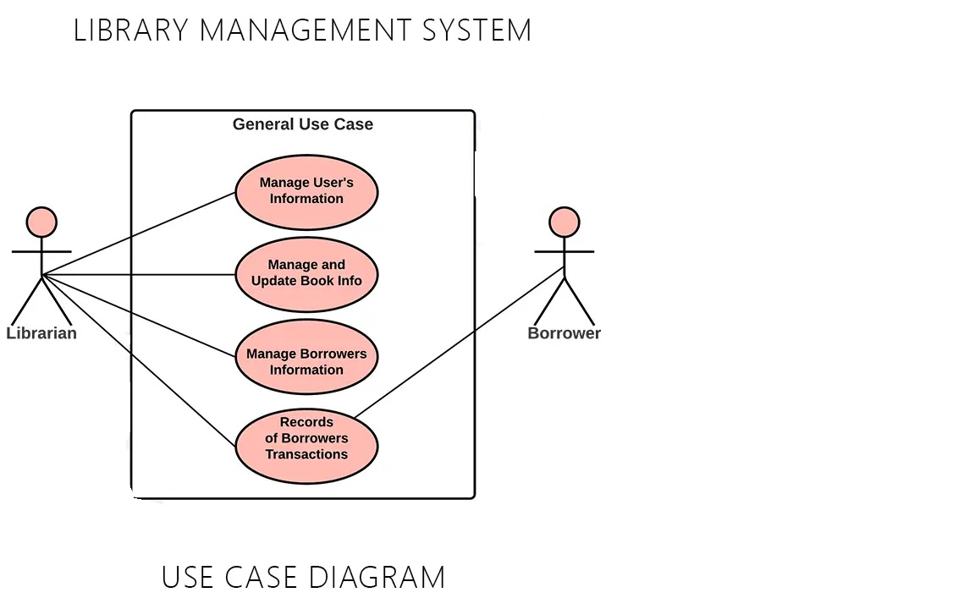

Utilizing the concepts of object-oriented programming, the system was created. The system's architecture as well as the interactions between various classes and objects were represented using class diagrams and sequence diagrams. Data was stored and retrieved using data structures like arrays. To support the system's functionalities, algorithms like search and sorting algorithms were created and used.

In this system, we inquire as to whether the user wishes to issue or deposit a book, among other things. We provide him access to different categories in our system where the books are stored, if he wants to issue a book. Additionally, there are many books available under the categories, allowing the user to select the book he wants to issue. Now, he can choose a book from the available alternatives, and the book will be registered in his name.

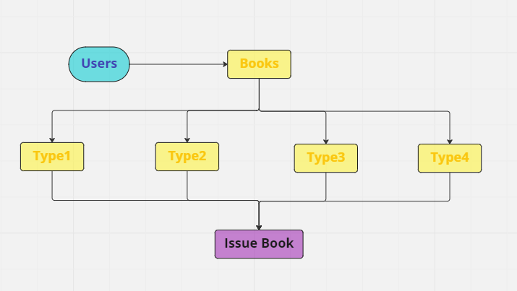

**Chapter 4**

**Result and Discussion**

**4.1 Library Management System as an outcome/result**

The system makes use of object-oriented programming principles and is developed using the C++ programming language. The system contains a validation system that makes sure the user enters the right data and is user-friendly and simple to use. A test of the system revealed that it is operating properly.

Users can quickly issue books, find books using our program's many pre-defined categories, and return books they have already borrowed.

**4.2 Skills Learned**

• **C++ Programming:** Writing code for this project required the usage of the popular, potent programming language C++, which is used to create a wide variety of software applications.

• **Object Oriented Programming:** To represent books, authors, and users in the project, classes and objects would need to be created, and their behavior would need to be implemented.

• **File Handling:** To store and retrieve data on books, authors, and users, the project included reading and writing data to files.

• **System Development and Testing:** The project involved planning and carrying out the project using software development, as well as testing the system to make sure it is functioning properly.

• **Algorithm design and problem solving:** Designing algorithms to implement different system features and resolving issues that can crop up during development are both required for the project.

**Chapter 5**

**Conclusion and Future Work**

It has been observed that this method will aid in time management as well as informational productivity. In other words, topic modelling should be used to undertake topic extraction for well-informed decisions rather than flicking through already borrowed books (or tons of pages) for hours or even days.

Users can now participate in and experience brand-new search methods on upcoming library management systems that are helpful for fundamental tasks like categorization, novelty detection, summarization, similarity, and pertinent judgements.

**References**

[1] www.udemy.com

[2] scholar.google.com

[3] www.wikipedia.com

[4] www.w3school.com