PROJECT · AI AGENT WORKFLOW
Canada Restaurant WhatsApp AI Ordering Assistant
An AI agent that runs a restaurant's WhatsApp ordering line end to end: greets the customer, takes the order, checks real stock, calculates tax, quotes a pickup time, and knows when to hand off to a person.
n8n WhatsApp Business API Google Gemini LangChain Agent Google Sheets

Overview
I built an AI agent that runs a restaurant's entire WhatsApp ordering line. A customer texts the number the way they'd text a friend, and the agent takes it from there: greets them, walks through the order, checks real stock, adds tax, quotes a pickup time, and answers questions about hours or payment. No app. No menu to tap through. Just a conversation.
The part I care about most isn't the WhatsApp integration. It's that the restaurant's actual policies, what's in stock, what things cost, when the kitchen is open, when to hand a customer off to a person, all live in one place: the agent's instructions, written in plain language. I didn't hand-code a decision tree for every possible thing a customer might say. The agent reads the rules and decides, turn by turn, which tool it actually needs.

Architecture
Every message goes through the same three steps before the agent even sees it. A webhook catches it, a filter drops anything that isn't plain text (a photo, a voice note, a reaction, a sticker), and what's left reaches the AI Agent node. That filter isn't just tidiness: the system prompt only knows how to handle typed commands, so a voice note or a thumbs-up reaction would otherwise still trigger a full model call the agent has no real instructions for, wasting an API call and most likely confusing the customer with a reply that doesn't fit what they sent. From there the agent isn't working alone: it pulls in a language model to reason, a memory buffer to keep track of the conversation so far, four Google Sheets tools for live business data, and an email tool that notifies the restaurant once an order's confirmed, then hands its finished reply back to WhatsApp.
WhatsApp Trigger → Only Text Messages → AI Agent → Send Message
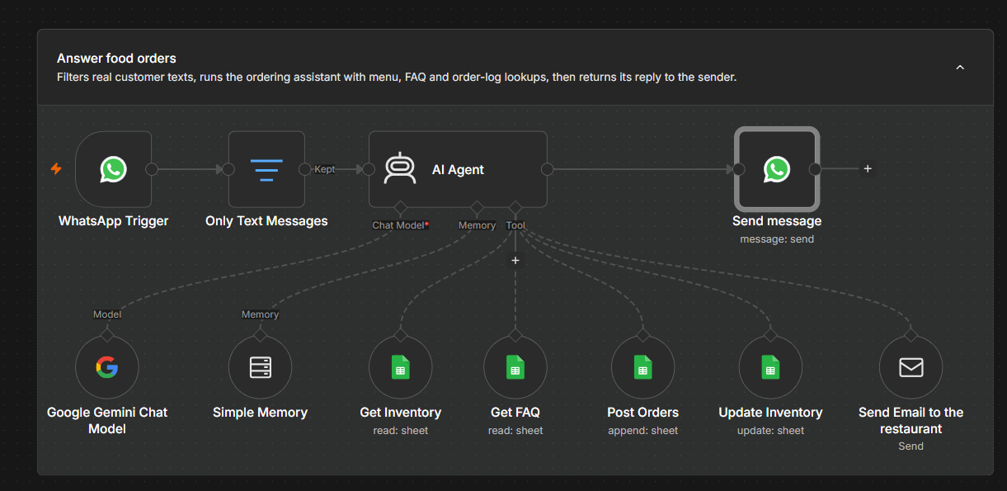
The current canvas. The top row is the message path. Everything hanging off the AI Agent below it, labeled Chat Model, Memory, and Tool, is n8n's UI name for what its own engine calls the ai_languageModel, ai_memory, and ai_tool connection types. Send Email to the restaurant, on the far right, is the newest addition.

What the Agent Reaches For
Six resources are wired to the agent. It decides on its own, each turn, which ones the conversation actually needs.
Google Gemini Chat Model  Does the actual reasoning and writes what the customer reads. | Simple Memory  Remembers the last ten messages for that phone number, so the agent doesn't ask for a name twice mid-order.
Get Inventory & Get FAQ  Two read-only Sheets lookups. Stock counts and store hours live in the spreadsheet, not buried in the prompt. | Post Orders  Writes the confirmed order back to Sheets. The model fills in the customer, items, and totals; the workflow itself generates the order ID, phone number, and timestamp, and the agent quotes that returned ID back to the customer rather than inventing one.
Update Inventory  Writes the new stock count for one item at a time. The agent calls it once per line item after confirming, and flips an item to Out of Stock itself when a count hits zero. | Send Email to the restaurant  Emails a copy of the confirmed order to the restaurant's inbox. The agent writes the subject and summary itself, from the same order details it just used to confirm and log everything else.

Business Rules
The agent's system prompt reads like a policy document. It enforces seven things consistently:
01 Order intake — Collects a name and items one at a time, checks each one against actual stock instead of a plain available/unavailable flag, and lets the customer keep adding to the order before confirming.
02 Pricing — Adds up the subtotal, applies 13% tax, and returns a total. The same math runs whether someone asks “how much is my order” or the agent is writing the final confirmation.
03 Pickup timing — 20 to 30 minutes for 5 items or fewer, 40 to 50 minutes for 6 to 9, and 50 minutes to an hour for 10 or more, counted from when the order actually went in.
04 Hours and delivery scope — Knows when the restaurant is closed, and sends delivery requests to Uber Eats instead of trying to take them itself.
05 Escalation — A cancellation or a change doesn't get handled by the bot. It gets the restaurant's contact number, +1 (555) 143-4597. That's deliberate, not a gap.
06 Inventory sync — Once an order is confirmed, the agent writes each item's new stock count back individually and marks it Out of Stock the moment a count hits zero. Declined or rejected items never touch the sheet at all.
07 Order notification — After logging the order, the agent emails the restaurant once with the customer, items, and total, so staff have a written copy even if no one's watching WhatsApp right then.

Menu & Policies
Everything below comes straight from the two Sheets tabs the agent actually reads from, Inventory and FAQ, as they stood when I pulled this together.
ITEM | PRICE | STOCK | STATUS
Veg Thali | $14.99 | 10 | Available
Chicken Thali | $17.99 | 15 | Available
Mutton Thali | $18.99 | 12 | Available
Fish Curry Meal | $12.99 | 8 | Available
Egg Curry Meal | $10.99 | 20 | Available
Extra Rice | $6.99 | 0 | Out of Stock
The FAQ tab is what the agent quotes from when someone asks about hours, delivery, or payment, instead of any of that being written into the prompt:
QUESTION | ANSWER
What are your opening hours? | We are open daily from 11:00 AM to 10:00 PM.
Do you offer home delivery? | Yes, with the assistance of Uber Eats.
What is your refund policy? | Refunds are only available for canceled orders before preparation starts.
Do you have vegetarian options? | Yes, we serve a variety of vegetarian thalis and meals.
How can I place an order? | You can order via WhatsApp for hassle-free pickup at no extra cost.
Do you accept online payments? | No, we only accept VISA, Mastercard, or cash upon pickup.
Worth flagging honestly: the FAQ tab was updated since the first pass, and it's closer to the truth now but not all the way there. Delivery lines up with the system prompt today, both say Uber Eats handles it, and the same goes for order placement and refunds. Hours still don't: the FAQ says open daily from 11:00 AM to 10:00 PM, while the system prompt runs on 12pm to 10pm, Tuesday through Sunday, closed Mondays. And the payment answer contradicts itself on its own terms, it opens with "No" to online payments, then lists VISA and Mastercard, which are online payment methods; that reads like a wording slip in the sheet rather than a real policy, but it's the kind of thing a customer would notice.

Business & Customer Impact
The mechanics are one thing. Here's what they actually change for the people on either end of the conversation.
For the business  • Stock never goes stale in the customer's eyes. The agent checks the Inventory tab before confirming, so it stops selling Extra Rice the moment the count hits zero instead of relying on someone remembering to update a paper menu.  • Every order lands in the same sheet, in the same shape, with tax and totals already worked out. No one has to re-key an order from a WhatsApp thread at the end of a shift.  • Policy questions that used to pull a staff member away from the line now get answered instantly and the same way every time, straight from the FAQ tab.  • Cancellations and changes still route to a person by design, so nothing gets refunded or reversed without someone actually looking at it first.  • Photos, voice notes, and reactions get filtered out before they ever reach the model, so the restaurant isn't paying for API calls the agent can't actually act on. | For the customer  • No app to download and no hold music. Ordering is a WhatsApp conversation, the way most people already message a restaurant.  • The price they're quoted, tax included, is the price that gets logged with the order, not a rough estimate they confirm later.  • A pickup time comes back right away, scaled to how big the order actually is, instead of the same generic answer for everyone.  • Questions about hours, delivery, or payment get answered on the spot, any time the restaurant's WhatsApp line is being watched.

Live Demo
Here's a real order once inventory sync and the email step were both wired up correctly: five Chicken Thali, marked spicy, with a request for disposable cutlery.
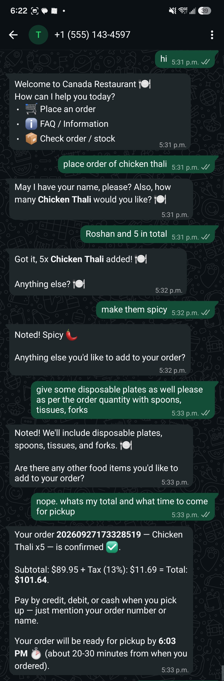
The agent takes the order, notes the special requests, and works out $89.95 subtotal, $11.69 tax, $101.64 total, ready by 6:03 PM.
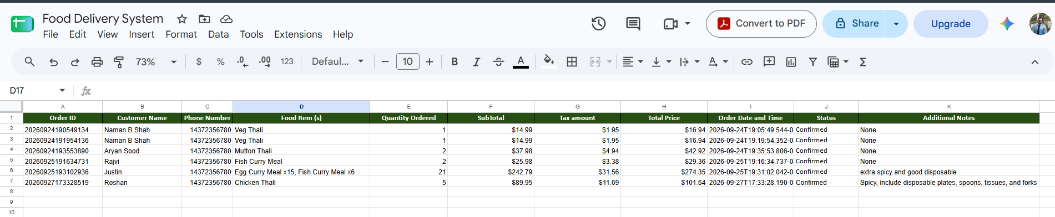
The same order lands in the Orders sheet, order ID and totals matching the chat exactly, alongside every earlier order this workflow has logged.
Chicken Thali: 15 in stock → order for 5 confirmed → 10 in stock
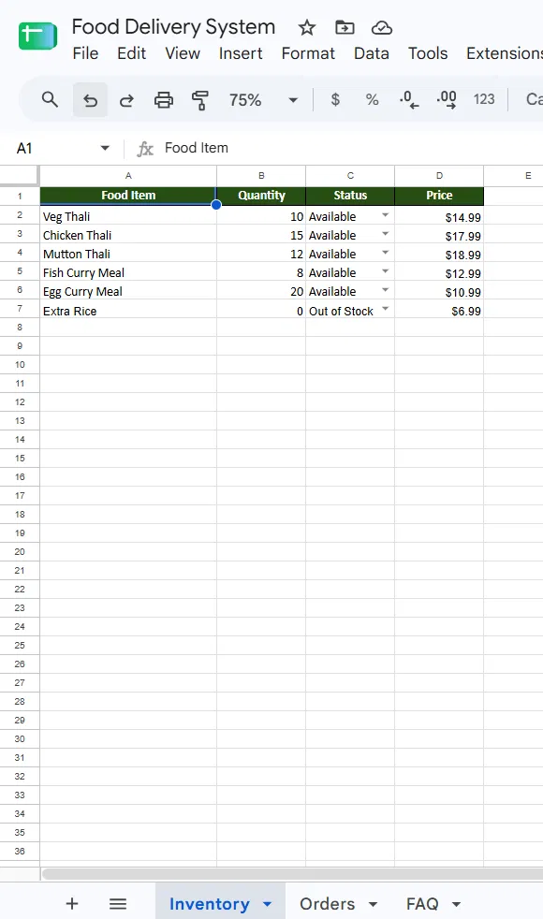
Inventory before the order: 15 Chicken Thali.
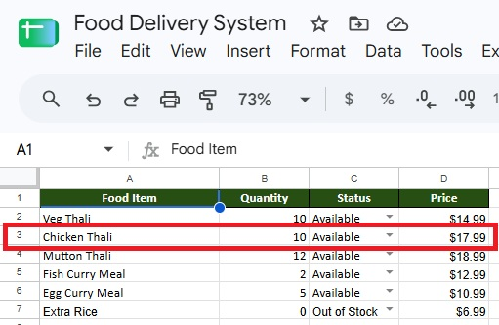
Inventory right after: 10, still Available since it didn't hit zero. Update Inventory decremented the exact quantity ordered, on its own.
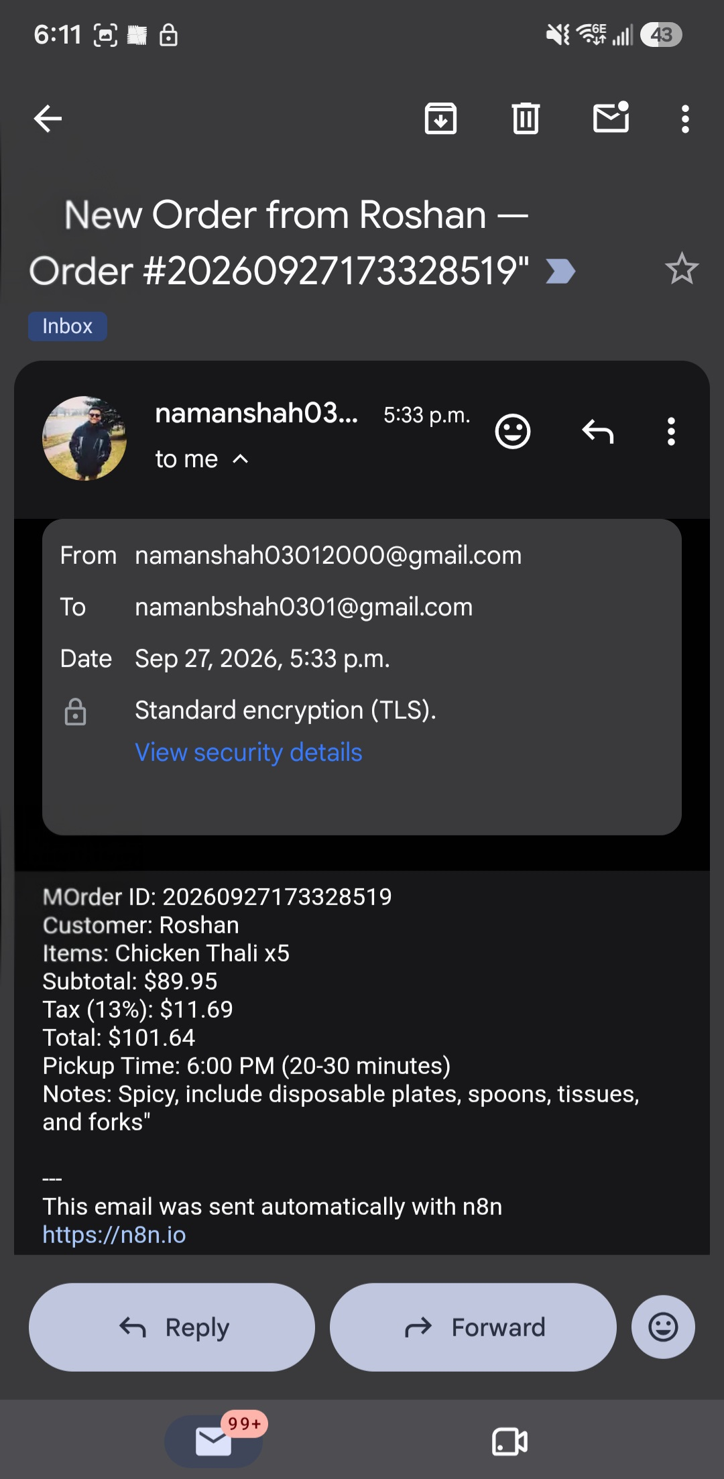
The restaurant's inbox, seconds later: same order ID, same customer, same totals, sent by Send Email to the restaurant without anyone touching the sheet or the chat.
A smaller, single-item order from an earlier test, to check the standard flow still holds up outside the multi-item case above: one Veg Thali, no special requests.
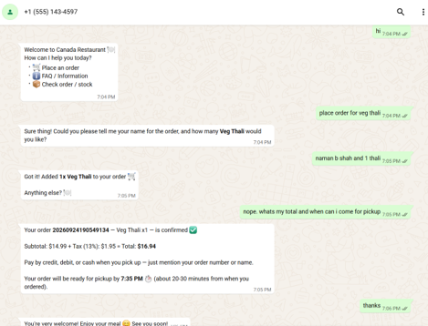
Name and quantity collected in one exchange, order confirmed at $14.99 subtotal, $1.95 tax, $16.94 total, ready by 7:35 PM.
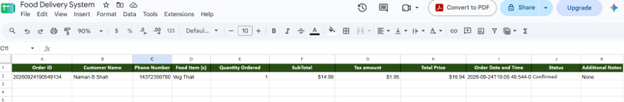
Same order ID, same totals, logged with an empty Additional Notes field since none was given, and Status already reading Confirmed.

Tech Stack
n8n (orchestration) WhatsApp Business API Google Gemini 3.6 Flash (Google AI Studio API) LangChain Agent Google Sheets Buffer window memory SMTP email notifications

What This Demonstrates
What this actually proves, I think, is less about WhatsApp and more about knowing where to trust a language model and where not to. The order ID, the phone number, the timestamp: none of that comes from the model. It's generated by the workflow directly, because an LLM is a good judge of what a customer wants and a poor source for a number that has to be exactly right every single time.
The rest, reading the rules, calling the right tool, writing a coherent reply, is exactly what the model is good at. Splitting the work that way, instead of asking one system to do everything, is the actual design decision here.
A second pass through my own rules caught things the first draft missed: an instruction telling the model to invent its own order ID when the workflow already generates one, a status value that could never actually occur because only confirmed orders ever reach the sheet, another status borrowed from a delivery flow this bot doesn't run. None of it broke the demo. All of it would have caused real confusion once someone other than me was reading the sheet.
A third pass added the notification step. The email to the restaurant is written by the model, not a fixed template, because by the time an order's confirmed the agent already has the customer's name, items, and total sitting in context, it just needed somewhere to put them.
Built as part of the AI Builder program, on n8n's stock WhatsApp ordering template, extended with stock-quantity checks, tax handling, multi-item orders, and session memory over several iterations.

