**Assignment: Client-Server Communication**

**Part 2**

Q1

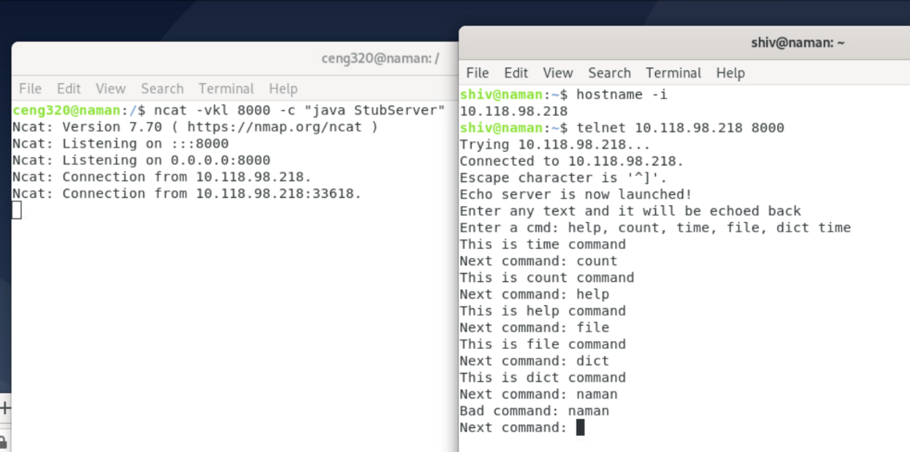

Q2

A and C are already answered in the screenshot of Part3.

B.

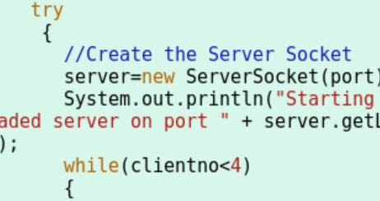

D. 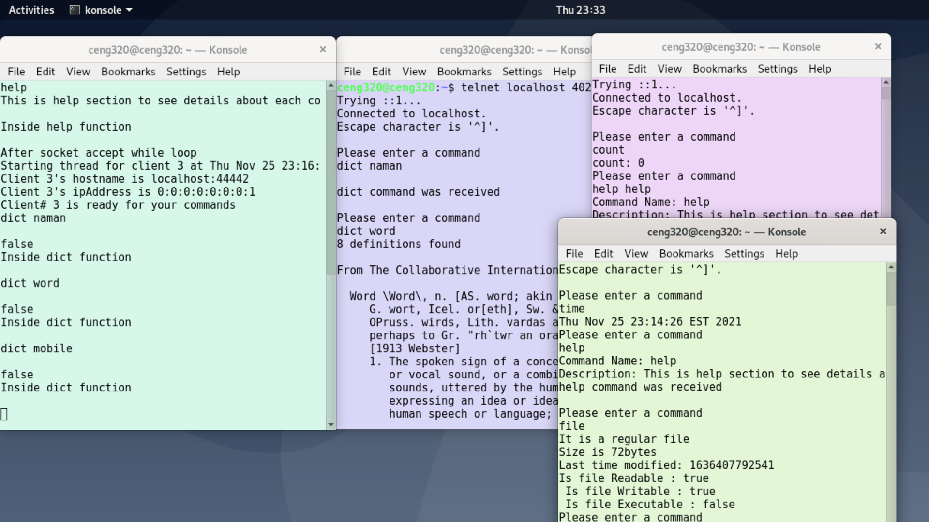

E.

If I connect with the 4th terminal then it will connect but it will not ask to enter a command since it won't satisfy the while loop as mentioned in B. If I quit one of the clients then the 4th terminal will ask the user to enter a command

**Part 3**

The below screenshot shows how different commands are running on the different clients such as help, count, dict, file, and time

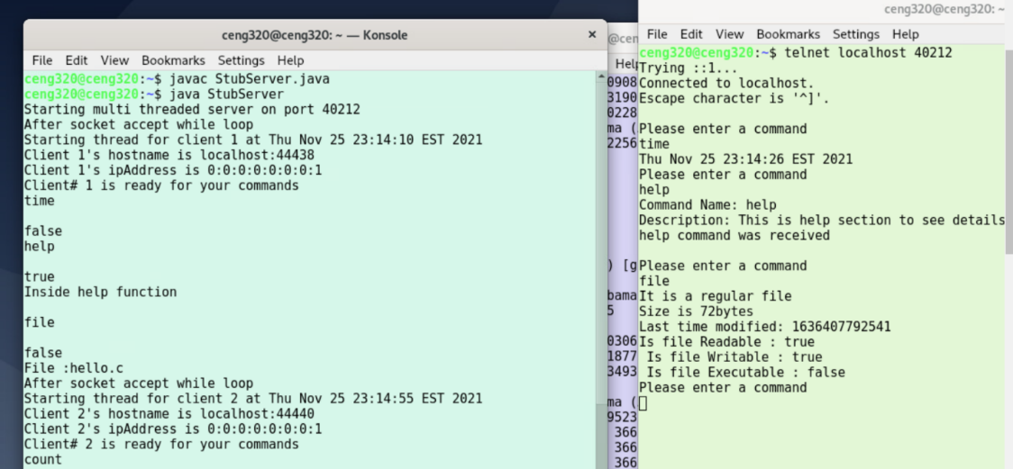

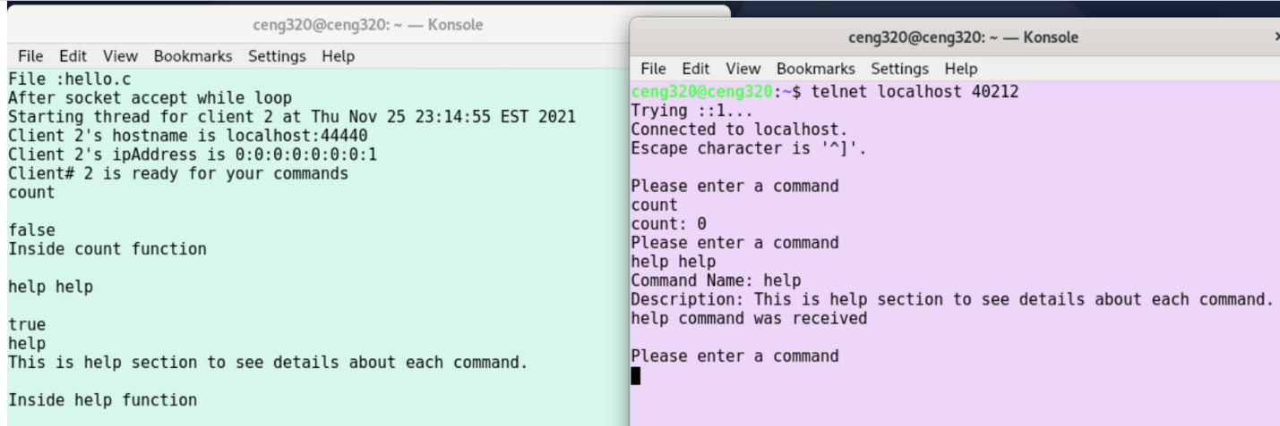

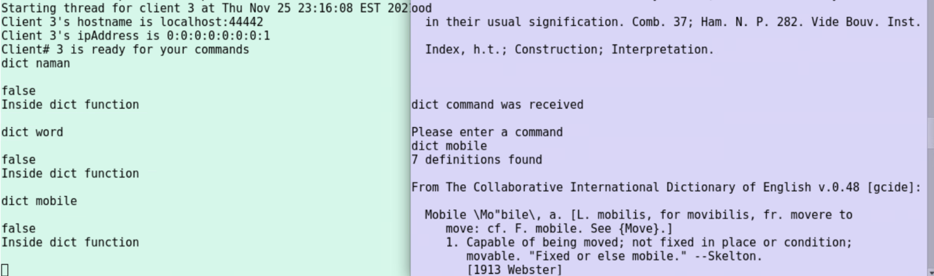

**Status Report**

* I have been able to successfully implement all questions of part 3 and part 2 which includes running server and client on multiple terminals and implementing the mentioned functions such as file, help, dict, and count. One of the questions where I face technical problems was to understand how multithreading was working between client and server but with the help of recordings, use of some internet resources, and notes provided by the professor I was able to understand that concept clearly although it took me a lot of time.