# Practical 1

## AIM: Introduction to android and create a “custom message application”. It will show custom message in the middle of black screen with yellow background.

SourceCode:

Java File/s:

MainActivity.java

package com.example.myapplication5;

import androidx.appcompat.app.AppCompatActivity; import android.os.Bundle;

public class MainActivity extends AppCompatActivity {

@Override

protected void onCreate(Bundle savedInstanceState) { super.onCreate(savedInstanceState); setContentView(R.layout.activity_main);

}

}

Layout File/s:

Activity_main.xml

*<?*xml version="1.0" encoding="utf-8"*?>*

<androidx.constraintlayout.widget.ConstraintLayout xmlns:android=["http://schemas.android.com/](http://schemas.android.com/apk/res/android)a[pk/res/android"](http://schemas.android.com/apk/res/android)

xmlns:app=["http://sc](http://schemas.android.com/apk/res-auto)h[emas.android.com/apk/res-auto"](http://schemas.android.com/apk/res-auto) xmlns:t[ools="ht](http://schemas.android.com/tools)tp:/[/sc](http://schemas.android.com/tools)he[mas.android.com/tools"](http://schemas.android.com/tools) android:layout_width="match_parent" android:layout_height="match_parent" android:background="@android:color/holo_orange_light" tools:context=".MainActivity">

<TextView android:layout_width="wrap_content" android:layout_height="wrap_content" android:text="Hello World!" android:textSize="20sp"

app:layout_constraintBottom_toBottomOf="parent" app:layout_constraintLeft_toLeftOf="parent" app:layout_constraintRight_toRightOf="parent" app:layout_constraintTop_toTopOf="parent" />

</androidx.constraintlayout.widget.ConstraintLayout>

Output:

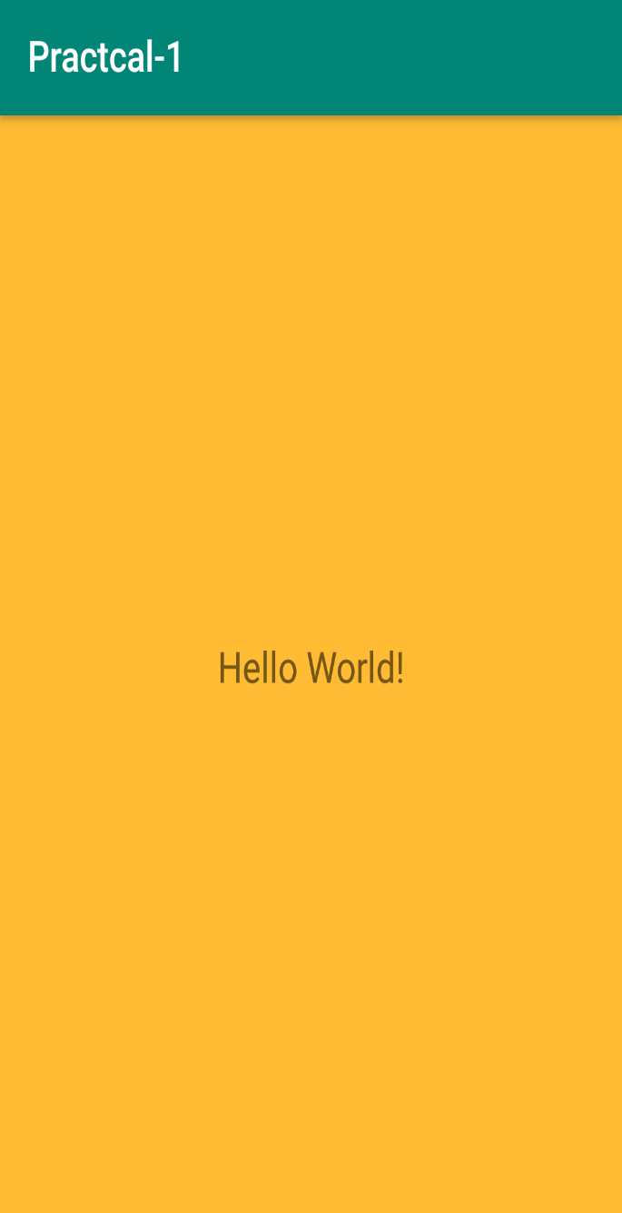

# Practical 2

## AIM: Create an android application to calculate the sum and display answer in toast message

Source Code:

Java File/s:

MainActivity.java

package com.example.pract_2;

import androidx.appcompat.app.AppCompatActivity; import android.os.Bundle;

import android.view.View; import android.widget.Button; import android.widget.EditText; import android.widget.Toast;

public class MainActivity extends AppCompatActivity { EditText number1;

EditText number2; Button add_button; int ans =0;

@Override

protected void onCreate(Bundle savedInstanceState) { super.onCreate(savedInstanceState); setContentView(R.layout.activity_main);

number1 = findViewById(R.id.editText_first_no); number2 = findViewById(R.id.editText_second_no); add_button = findViewById(R.id.add_button);

// used to create on click listener

if (!(number1.getText().toString().isEmpty() && number2.getText().toString().isEmpty())) {

add_button.setOnClickListener(new View.OnClickListener() { @Override

public void onClick(View v) {

// num1 or num2 double type

// get data which is in edittext, convert it to string

// using parse Double convert it to Double type

double num1 = Double.parseDouble(number1.getText().toString()); double num2 = Double.parseDouble(number2.getText().toString());

// add both number and store it to sum double sum = num1 + num2;

//Displaying Toast with Hello Javatpoint message Toast.makeText(getApplicationContext(), "sum: " + sum,

Toast.LENGTH_SHORT).show();

}

});

}

}

}

Layout File/s:

Main_activity.xml

<?xml version="1.0" encoding="utf-8"?>

<androidx.constraintlayout.widget.ConstraintLayout xmlns:andr[oid="htt](http://schemas.android.com/apk/res/android)p:/[/sc](http://schemas.android.com/apk/res/android)he[mas.android.com/apk/res/android"](http://schemas.android.com/apk/res/android)

xmlns:app=["http://sc](http://schemas.android.com/apk/res-auto)h[emas.android.com/apk/res-auto"](http://schemas.android.com/apk/res-auto) xmlns:t[ools="ht](http://schemas.android.com/tools)tp:/[/sc](http://schemas.android.com/tools)he[mas.android.com/tools"](http://schemas.android.com/tools) android:layout_width="match_parent" android:layout_height="match_parent" tools:context=".MainActivity">

<TextView android:id="@+id/textView_1" android:layout_width="wrap_content" android:layout_height="wrap_content" android:text="Number 1:" android:textSize="20sp"

app:layout_constraintBottom_toBottomOf="parent" app:layout_constraintEnd_toEndOf="parent" app:layout_constraintHorizontal_bias="0.227" app:layout_constraintStart_toStartOf="parent" app:layout_constraintTop_toTopOf="parent" app:layout_constraintVertical_bias="0.203" />

<EditText android:id="@+id/editText_first_no" android:layout_width="154dp" android:layout_height="71dp" android:hint="Enter Number 1:" android:inputType="number"

app:layout_constraintBottom_toBottomOf="parent" app:layout_constraintEnd_toEndOf="parent" app:layout_constraintHorizontal_bias="0.787" app:layout_constraintStart_toStartOf="parent" app:layout_constraintTop_toTopOf="parent" app:layout_constraintVertical_bias="0.171" />

<TextView android:id="@+id/textView_2" android:layout_width="wrap_content"

android:layout_height="wrap_content" android:text="Number 2:" android:textSize="20sp"

app:layout_constraintBottom_toBottomOf="parent" app:layout_constraintEnd_toEndOf="parent" app:layout_constraintHorizontal_bias="0.226" app:layout_constraintStart_toStartOf="parent" app:layout_constraintTop_toTopOf="parent" app:layout_constraintVertical_bias="0.411" />

<EditText android:id="@+id/editText_second_no" android:layout_width="157dp" android:layout_height="65dp" android:hint="Enter Number 2:" android:inputType="number"

app:layout_constraintBottom_toBottomOf="parent" app:layout_constraintEnd_toEndOf="parent" app:layout_constraintHorizontal_bias="0.787" app:layout_constraintStart_toStartOf="parent" app:layout_constraintTop_toTopOf="parent" app:layout_constraintVertical_bias="0.393" />

<Button

android:id="@+id/add_button" android:layout_width="95dp" android:layout_height="59dp" android:text="Button" app:layout_constraintBottom_toBottomOf="parent" app:layout_constraintEnd_toEndOf="parent" app:layout_constraintHorizontal_bias="0.498" app:layout_constraintStart_toStartOf="parent" app:layout_constraintTop_toTopOf="parent" app:layout_constraintVertical_bias="0.672" />

</androidx.constraintlayout.widget.ConstraintLayout>

Output:

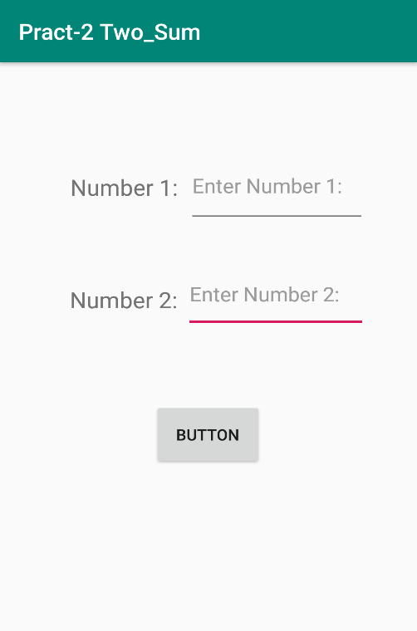

# Practical 3

## AIM: Create an application that will display Toast (Message) on specific interval of time.

Source Code:

Java File/s:

MainActivity.java

package com.example.pract_3;

import androidx.appcompat.app.AppCompatActivity; import android.os.Bundle;

import android.widget.Chronometer; import android.widget.Toast;

public class MainActivity extends AppCompatActivity { Chronometer c;

int i = 0;

int duration = 10; @Override

protected void onCreate (Bundle savedInstanceState){ super.onCreate(savedInstanceState); setContentView(R.layout.activity_main);

c = (Chronometer) findViewById(R.id.chronometer1); c.start();

c.setOnChronometerTickListener(new Chronometer.OnChronometerTickListener()

{

@Override

public void onChronometerTick(Chronometer arg0) { i++;

if (i >= duration) {

Toast.makeText(getApplicationContext(), "Message" + (i / 10), Toast.LENGTH_LONG).show();

duration = duration + 10;

}

}

});

}

}

MainActivity.xml

*<?*xml version="1.0" encoding="utf-8"*?>*<RelativeLayoutxmlns:android="http://schemas.android.com/apk/res/android"  
xmlns:app="http://schemas.android.com/apk/res-auto"  
xmlns:tools="http://schemas.android.com/tools"  
android:layout_width="match_parent"  
android:layout_height="match_parent"  
  
>  
  
<TextView  
android:id="@+id/tv"  
android:layout_width="match_parent"  
android:layout_height="wrap_content"  
 android:textAppearance="@android:style/TextAppearance.DeviceDefault.Medium" />  
  
<Chronometer  
android:id="@+id/cnm"  
android:layout_width="wrap_content"  
android:layout_height="wrap_content"  
android:layout_centerHorizontal="true"  
android:layout_centerVertical="true"  
android:format="Timer : %s"/>  
  
</RelativeLayout>

Layout File/s:

Activity_main.xml

*<?*xml version="1.0" encoding="utf-8"*?>*<RelativeLayoutxmlns:android="http://schemas.android.com/apk/res/android"  
xmlns:app="http://schemas.android.com/apk/res-auto"  
xmlns:tools="http://schemas.android.com/tools"  
android:layout_width="match_parent"  
android:layout_height="match_parent"  
  
>  
  
<TextView  
android:id="@+id/tv"  
android:layout_width="match_parent"  
android:layout_height="wrap_content"  
 android:textAppearance="@android:style/TextAppearance.DeviceDefault.Medium" />  
  
<Chronometer  
android:id="@+id/cnm"  
android:layout_width="wrap_content"  
android:layout_height="wrap_content"  
android:layout_centerHorizontal="true"  
android:layout_centerVertical="true"  
android:format="Timer : %s"/>  
  
</RelativeLayout>

Output:

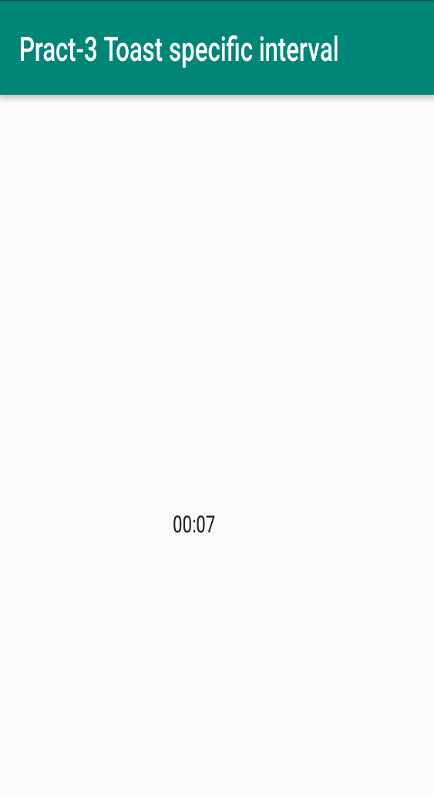

# Practical 4

## AIM: Create a temperature converter Application. (Fahrenheit-Celsius).

Source Code:

Java File/s:

Main_activity.java

package com.example.pract_4;

import android.os.Bundle; import android.view.View; import android.widget.Button; import android.widget.EditText;

import android.widget.AdapterView; import android.widget.ArrayAdapter; import android.widget.Spinner; import android.widget.TextView; import android.widget.Toast;

import androidx.appcompat.app.AppCompatActivity;

public class MainActivity extends AppCompatActivity implements AdapterView.OnItemSelectedListener {

EditText number1; Button add_button; TextView textview; String[] c ={"a"}; double num1,f;

String[] users = {"C","F"}; @Override

protected void onCreate(Bundle savedInstanceState) { super.onCreate(savedInstanceState); setContentView(R.layout.activity_main);

Spinner spin = (Spinner) findViewById(R.id.spinner1); ArrayAdapter<String> adapter = new ArrayAdapter<String>(this,

android.R.layout.simple_spinner_item, users);

adapter.setDropDownViewResource(android.R.layout.simple_spinner_dropdown_item); spin.setAdapter(adapter);

spin.setOnItemSelectedListener(this); number1 = findViewById(R.id.edit_text);

add_button = findViewById(R.id.button_convert); textview = findViewById(R.id.textView2);

// used to create on click listener

//if (!(number1.getText().toString().isEmpty())) { add_button.setOnClickListener(new View.OnClickListener() {

@Override

public void onClick(View v) {

if(c[0].equals("F")){

num1 = Double.parseDouble(number1.getText().toString()); double f = (num1 - 32) * 5 / 9; textview.setText(String.format("Celsius :%.2f", f)); Toast.makeText(getApplicationContext(), "F: " + f,

Toast.LENGTH_SHORT).show();

}

else{

num1 = Double.parseDouble(number1.getText().toString()); double f = (num1 * 9/5) + 32; textview.setText(String.format("Fahrenheit :%.2f", f)); Toast.makeText(getApplicationContext(), "C: " + num1,

Toast.LENGTH_SHORT).show();

}

}

});

// }

}

@Override

public void onItemSelected(AdapterView<?> arg0, View arg1, int position,long id) { c[0]=users[position];

}

@Override

public void onNothingSelected(AdapterView<?> arg0) {

// TODO - Custom Code

}

}

Layout File/s:

Activity_main.xml

<?xml version="1.0" encoding="utf-8"?>

<androidx.constraintlayout.widget.ConstraintLayout xmlns:andr[oid="htt](http://schemas.android.com/apk/res/android)p:/[/sc](http://schemas.android.com/apk/res/android)he[mas.android.com/apk/res/android"](http://schemas.android.com/apk/res/android)

xmlns:app=["http://sc](http://schemas.android.com/apk/res-auto)h[emas.android.com/apk/res-auto"](http://schemas.android.com/apk/res-auto) xmlns:t[ools="ht](http://schemas.android.com/tools)tp:/[/sc](http://schemas.android.com/tools)he[mas.android.com/tools"](http://schemas.android.com/tools) android:layout_width="match_parent" android:layout_height="match_parent" tools:context=".MainActivity">

<EditText android:id="@+id/edit_text" android:layout_width="185dp" android:layout_height="46dp" android:layout_marginEnd="112dp"

android:layout_marginRight="112dp" app:layout_constraintBottom_toBottomOf="parent"

app:layout_constraintEnd_toEndOf="parent" app:layout_constraintHorizontal_bias="0.264" app:layout_constraintLeft_toLeftOf="parent" app:layout_constraintRight_toRightOf="parent" app:layout_constraintTop_toTopOf="parent" app:layout_constraintVertical_bias="0.321" />

<TextView android:id="@+id/textView" android:layout_width="wrap_content"

android:layout_height="wrap_content" app:layout_constraintBottom_toBottomOf="parent" app:layout_constraintHorizontal_bias="0.414" app:layout_constraintLeft_toLeftOf="parent" app:layout_constraintRight_toRightOf="parent" app:layout_constraintTop_toTopOf="parent" app:layout_constraintVertical_bias="0.131" />

<Spinner android:id="@+id/spinner1"

android:layout_width="wrap_content" android:layout_height="wrap_content" android:autofillHints="Select" app:layout_constraintBottom_toBottomOf="parent" app:layout_constraintEnd_toEndOf="parent" app:layout_constraintHorizontal_bias="0.887" app:layout_constraintStart_toStartOf="parent" app:layout_constraintTop_toTopOf="parent"

app:layout_constraintVertical_bias="0.342" />

<Button

android:id="@+id/button_convert" android:layout_width="wrap_content" android:layout_height="wrap_content" android:text="Convert" android:background="@color/button" app:layout_constraintBottom_toBottomOf="parent" app:layout_constraintEnd_toEndOf="parent" app:layout_constraintStart_toStartOf="parent"

app:layout_constraintTop_toTopOf="parent" />

<TextView android:id="@+id/textView2" android:layout_width="203dp" android:layout_height="67dp" android:textSize="20sp"

app:layout_constraintBottom_toBottomOf="parent" app:layout_constraintEnd_toEndOf="parent" app:layout_constraintHorizontal_bias="0.482" app:layout_constraintStart_toStartOf="parent" app:layout_constraintTop_toTopOf="parent"

</androidx.constraintlayout.widget.ConstraintLayout>

/>

app:layout_constraintVertical_bias="0.671"

Output:

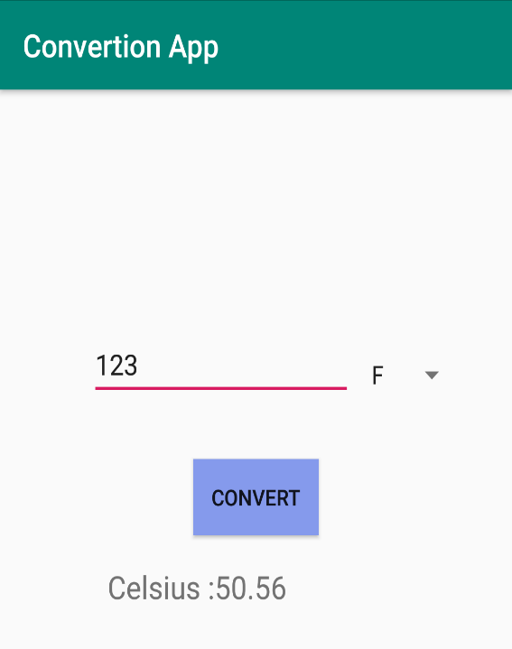

# Practical 5

## AIM: Create a login application with following features:

1. **Successful Login message in Text-View with Green background if Username & password iscorrect.**
2. **Failure message in Text-View with Red background if Username or password is incorrect.**
3. **Disable Login Button after three wrong loginattempts.**
4. **Close application if user selects CancelButton.**

Source Code: Java File/s:

Main_activity.java

package com.example.login;

import androidx.appcompat.app.AppCompatActivity; import android.content.Intent;

import android.graphics.Color; import android.os.Bundle; import android.view.View; import android.widget.Button; import android.widget.EditText;

import android.widget.TextView; import android.widget.Toast;

public class MainActivity extends AppCompatActivity { EditText Username;

EditText Password; int count=3;

Buttonbutton_login;

TextViewRegister;

DatabaseHelperdb;

@Override

protected void onCreate(Bundle savedInstanceState) { super.onCreate(savedInstanceState); setContentView(R.layout.activity_main);

db = new DatabaseHelper(this);

Username = (EditText)findViewById(R.id.Username); Password = (EditText)findViewById(R.id.Password); button_login = (Button)findViewById(R.id.button_login); Register = (TextView)findViewById(R.id.Register);

Register.setOnClickListener(new View.OnClickListener() { @Override

public void onClick(View view) {

Intent register = new Intent(MainActivity.this,RegisterActivity.class); startActivity(register);

}

});

button_login.setOnClickListener(new View.OnClickListener() { @Override

public void onClick(View view) {

String user = Username.getText().toString()

.trim();

String pass = Password.getText().toString().trim(); TextView incorrect;

TextView attempts = (TextView)findViewById(R.id.textView2); TextView lim = (TextView)findViewById(R.id.textView3); Button logbtn;

Button closeapp = (Button)findViewById(R.id.closeapp); Boolean res = db.checkUser(user,pass);

if(res==true){

Toast toast = Toast.makeText(MainActivity.this,"Successfully logged in

:)",Toast.LENGTH_SHORT);

view =toast.getView(); view.setBackgroundColor(Color.rgb(0,170,0)); TextView toastMessage = (TextView)

toast.getView().findViewById(android.R.id.message); toastMessage.setTextColor(Color.BLACK); toast.show();

} else {

lim.setVisibility(View.VISIBLE); attempts.setVisibility(View.VISIBLE); lim.setBackgroundColor(Color.RED); count--; lim.setText(Integer.toString(count));

incorrect =(TextView)findViewById(R.id.incorrect); incorrect.setVisibility(View.VISIBLE); if(count==0){

logbtn = (Button)findViewById(R.id.button_login); logbtn.setText("Disabled"); logbtn.setEnabled(false);

}

closeapp.setOnClickListener(new View.OnClickListener() { @Override

public void onClick(View view) { finish();

System.exit(0);

}

}

});

}

});

}

}

Database_Helper.java package com.example.login;

import android.content.ContentValues; import android.content.Context; importandroid.database.Cursor;

import android.database.sqlite.SQLiteDatabase; import android.database.sqlite.SQLiteOpenHelper;

import androidx.annotation.Nullable;

public class DatabaseHelper extends SQLiteOpenHelper { public static final String DATABASE_NAME = "register.db"; public static final String TABLE_NAME = "register_user"; public static final String COL1_NAME ="ID";

public static final String COL2_NAME = "username"; public static final String COL3_NAME = "password";

public DatabaseHelper(Context context) { super(context, DATABASE_NAME, null, 1);

}

@Override

public void onCreate(SQLiteDatabase sqLiteDatabase) { sqLiteDatabase.execSQL("CREATE TABLE register_user (ID INTEGER PRIMARY

KEY AUTOINCREMENT,username TEXT,password TEXT)");

}

@Override

public void onUpgrade(SQLiteDatabase sqLiteDatabase, int i, int i1) { sqLiteDatabase.execSQL("drop table if exists " + TABLE_NAME); onCreate(sqLiteDatabase);

}

public long addUser(String user,String password){ SQLiteDatabase db = this.getWritableDatabase(); ContentValues contentValues = new ContentValues(); contentValues.put("username",user); contentValues.put("password",password);

long res = db.insert("register_user",null,contentValues); db.close();

return res;

}

public boolean checkUser(String username,String password){ String[] columns = { COL1_NAME };

SQLiteDatabase db = getReadableDatabase();

String selection = COL2_NAME + "=?" + " and " + COL3_NAME + "=?"; String[] selectionArgs = { username, password };

Cursor cursor = db.query(TABLE_NAME,columns,selection,selectionArgs,null,null,null);

int count = cursor.getCount(); cursor.close();

db.close(); if(count>0){

return true;

} else {

return false;

}

}

}

Register_Activity.java package com.example.login;

import androidx.appcompat.app.AppCompatActivity; import android.content.Intent;

import android.os.Bundle;

import android.view.View; import android.widget.Button; import android.widget.EditText; import android.widget.TextView; import android.widget.Toast;

public class RegisterActivity extends AppCompatActivity { DatabaseHelper db;

EditText Username; EditText Password; EditText Cnf_Password; Button Register; TextView ViewLogin;

@Override

protected void onCreate(Bundle savedInstanceState) { super.onCreate(savedInstanceState); setContentView(R.layout.activity_register);

db = new DatabaseHelper(this);

Username = (EditText)findViewById(R.id.Username); Password = (EditText)findViewById(R.id.Password); Cnf_Password = (EditText)findViewById(R.id.Cnf_Password); Register = (Button)findViewById(R.id.button_register); ViewLogin = (TextView)findViewById(R.id.Login);

ViewLogin.setOnClickListener(new View.OnClickListener() { @Override

public void onClick(View view) {

Intent login = new Intent(RegisterActivity.this,MainActivity.class); startActivity(login);

}

});

Register.setOnClickListener(new View.OnClickListener() { @Override

public void onClick(View view) {

String user = Username.getText().toString()

.trim();

String pass = Password.getText().toString().trim();

String cnf_pass = Cnf_Password.getText().toString().trim();

if(pass.equals(cnf_pass)){

Long val = db.addUser(user,pass); if(val>0){

Toast.makeText(RegisterActivity.this,"Registration successful",Toast.LENGTH_SHORT).show();

Intent movToLogin = new Intent(RegisterActivity.this,MainActivity.class); startActivity(movToLogin);

} else {

Toast.makeText(RegisterActivity.this,"Register error!!",Toast.LENGTH_SHORT).show();

}

} else {

Toast.makeText(RegisterActivity.this,"Password is not matching",Toast.LENGTH_SHORT).show();

}

}

});

}

}

Layout File/s:

Activity_register.xml

<?xml version="1.0" encoding="utf-8"?>

<LinearLayout xmlns:android=["http://schemas.android.com/](http://schemas.android.com/apk/res/android)a[pk/res/android"](http://schemas.android.com/apk/res/android) xmlns:app=["http://sc](http://schemas.android.com/apk/res-auto)h[emas.android.com/apk/res-auto"](http://schemas.android.com/apk/res-auto) xmlns:t[ools="ht](http://schemas.android.com/tools)tp:/[/sc](http://schemas.android.com/tools)he[mas.android.com/tools"](http://schemas.android.com/tools) android:layout_width="match_parent"

android:background="#384AAA" android:orientation="vertical" android:gravity="center_horizontal" android:layout_height="match_parent" tools:context=".RegisterActivity">

<ImageView android:layout_width="wrap_content"

android:layout_height="127dp" android:src="@drawable/logo" android:layout_marginTop="50dp">

</ImageView>

<EditText android:id="@+id/Username" android:layout_width="190dp" android:layout_height="45dp" android:layout_marginTop="10dp"

android:drawableLeft="@drawable/username" android:textColorHint="#161414" android:textColor="#171414" android:background="#ffff" android:hint="@string/username" />

<EditText android:id="@+id/Password" android:layout_width="190dp" android:layout_height="55dp"

android:drawableLeft="@drawable/password" android:textColorHint="#161414" android:textColor="#171414" android:background="#ffff" android:layout_marginTop="25dp" android:hint="@string/password" />

<EditText android:id="@+id/Cnf_Password" android:layout_width="190dp" android:layout_height="55dp" android:textColor="#171414"

android:drawableLeft="@drawable/password" android:textColorHint="#161414" android:background="#ffff" android:layout_marginTop="25dp" android:hint="@string/conf_password" />

<Button

android:id="@+id/button_register" android:layout_width="wrap_content" android:layout_height="40dp" android:background="#2198F3" android:layout_marginTop="20dp" android:text="@string/getRegistered"/>

<LinearLayout android:layout_width="wrap_content" android:layout_height="wrap_content" android:layout_marginTop="15dp" android:orientation="horizontal">

<TextView android:layout_width="wrap_content" android:layout_height="35dp" android:textColor="#ffff" android:textSize="20sp" android:text="@string/already_registered">

</TextView>

<TextView android:id="@+id/Login"

android:layout_width="wrap_content" android:textColor="#ffff" android:layout_height="35dp" android:paddingLeft="10dp" android:textSize="25sp" android:textStyle="bold" android:text="@string/thenlogin">

</TextView>

</LinearLayout>

</LinearLayout>

Activity_main.xml

<?xml version="1.0" encoding="utf-8"?>

<LinearLayout xmlns:android=["http://schemas.android.com/](http://schemas.android.com/apk/res/android)a[pk/res/android"](http://schemas.android.com/apk/res/android) xmlns:app=["http://sc](http://schemas.android.com/apk/res-auto)h[emas.android.com/apk/res-auto"](http://schemas.android.com/apk/res-auto) xmlns:t[ools="ht](http://schemas.android.com/tools)tp:/[/sc](http://schemas.android.com/tools)he[mas.android.com/tools"](http://schemas.android.com/tools) android:layout_width="match_parent" android:layout_height="match_parent" android:gravity="center_horizontal"

android:orientation="vertical" tools:context=".MainActivity" android:background="@drawable/img_background">

<ImageView android:layout_width="wrap_content" android:layout_height="127dp" android:src="@drawable/logo" android:layout_marginTop="50dp">

</ImageView>

<EditText android:id="@+id/Username" android:layout_width="190dp" android:layout_height="45dp" android:layout_marginTop="10dp"

android:drawableLeft="@drawable/username" android:textColorHint="#ffff" android:hint="@string/username" />

<EditText android:id="@+id/Password" android:layout_width="190dp" android:layout_height="55dp"

android:drawableLeft="@drawable/password" android:textColorHint="#ffff" android:layout_marginTop="25dp" android:hint="@string/password" />

<TextView android:id="@+id/incorrect" android:layout_width="200dp" android:layout_marginTop="20dp" android:layout_height="25dp" android:textColor="#ffff"

android:layout_marginBottom="15dp" android:textAlignment="center" android:background="#FF1818" android:text="Incorrect credentials!" android:visibility="gone" />

<LinearLayout android:layout_width="wrap_content" android:layout_height="wrap_content" android:orientation="horizontal">

<TextView android:layout_width="wrap_content" android:layout_height="wrap_content" android:text="Attempts Left:" android:id="@+id/textView2" android:visibility="gone" android:layout_alignParentLeft="true" android:layout_alignParentStart="true" android:textSize="25dp" />

<TextView android:layout_width="50dp" android:layout_height="wrap_content" android:text="New Text" android:textAlignment="center" android:id="@+id/textView3" android:visibility="gone" android:textSize="25dp"

/>

</LinearLayout>

<LinearLayout android:layout_width="wrap_content" android:layout_height="wrap_content" android:orientation="horizontal">

<Button

android:id="@+id/button_login" android:layout_width="wrap_content" android:layout_height="40dp" android:background="#ffff" android:textColor="#171212" android:layout_marginTop="20dp" android:text="@string/login"/>

<Button

android:layout_width="wrap_content" android:layout_height="40dp" android:id="@+id/closeapp" android:background="#ffff" android:layout_marginLeft="30dp" android:textColor="#171212" android:layout_marginTop="20dp" android:text="Cancel">

</Button>

</LinearLayout>

<LinearLayout android:layout_width="wrap_content" android:layout_height="wrap_content" android:layout_marginTop="15dp" android:orientation="horizontal">

<TextView android:layout_width="wrap_content" android:layout_height="35dp" android:textColor="#ffff" android:textSize="20sp" android:text="@string/not_registered">

</TextView>

<TextView android:id="@+id/Register"

android:layout_width="wrap_content" android:textColor="#ffff" android:layout_height="35dp" android:paddingLeft="10dp" android:textSize="25sp" android:textStyle="bold" android:text="@string/register">

</TextView>

</LinearLayout>

</LinearLayout>

Output:

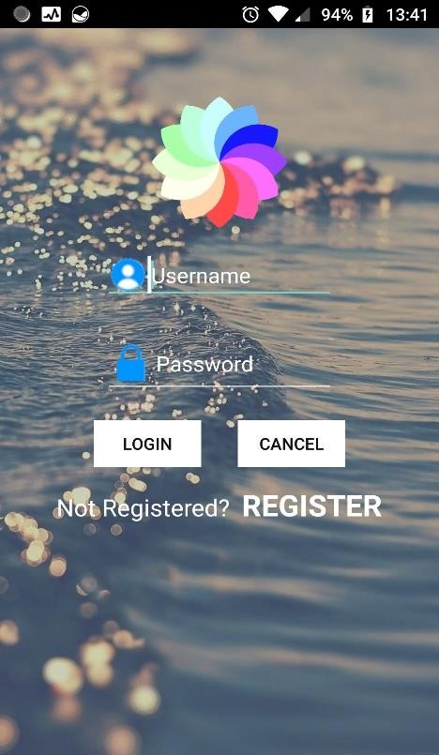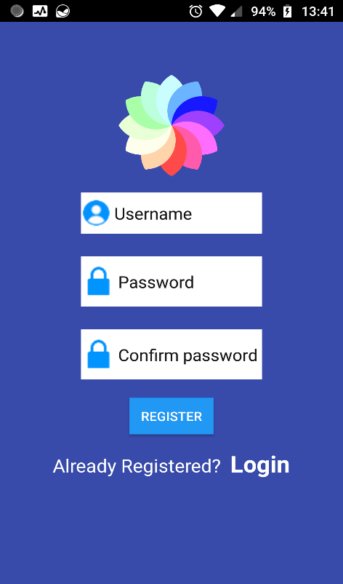

# Practical 6

## AIM: Create an application which turns ON or OFF Torch/Flashlight of Camera.

Source Code:

Java File/s:

Main_activity.java package

com.example.practical6; import androidx.annotation.Require sApi; import androidx.appcompat.app.Ale rtDialog;

import androidx.appcompat.app.AppCompat Activity; import android.content.Context;

import android.content.DialogInterfa ce; import android.content.pm.Package Manager;

import android.hardware.camera2.CameraAccessE xception; import android.hardware.camera2.CameraManager

;

import android.os

.Build; import android.os

.Bundle; import

android.widget.Compoun dButton; import android.widget.ToggleBu tton;

@RequiresApi(api = Build.VERSION_CODES.LOLLIPOP)

public class MainActivity extends AppCompatActivity {

private CameraManager mCameraManager; private String mCameraId;

private ToggleButton toggleButton; @RequiresApi(api =

Build.VERSION_CODES.LOLLIPOP)

@Override

protected void onCreate(Bundle savedInstanceState) { super.onCreate(savedInstanceState)

;

setContentView(R.layout.activity_ main);

boolean isFlashAvailable = getApplicationContext().getPackageManager()

.hasSystemFeature(PackageManager.FEATURE_CAM ERA_FLASH);

if (!isFlashAvailable) { showNoFlashError();

}

mCameraManager = (CameraManager) getSystemService(Context.CAMERA_SERVICE); try {

mCameraId = mCameraManager.getCameraIdList()[0];

} catch

(CameraAccessExcep tion e) { e.printStackTrace();

}

toggleButton = findViewById(R.id.toggleButton); toggleButton.setOnCheckedChangeListener(new

CompoundButton.OnCheckedChangeListen er() { @RequiresApi(api = Build.VERSION_CODES.M)

@Override

public void onCheckedChanged(CompoundButton buttonView, boolean isChecked) { switchFlashLight(isChecked);

}

}

)

;

}

public void showNoFlashError() {

AlertDialog alert = new AlertDialog.Builder(this)

.create(); alert.setTitle("Oops! ");

alert.setMessage("Flash not available in this device..."); alert.setButton(DialogInterface.BUTTON_POSITIVE, "OK", new

DialogInterface.OnClickListener() {

public void onClick(DialogInterface dialog, int which) { finish();

}

}

)

;

alert.show();

}

Layout File/s:

Activity_main.xml

<?xml version="1.0" encoding="utf-8"?>

<androidx.constraintlayout.widget.ConstraintLayout xmlns:andr[oid="htt](http://schemas.android.com/apk/res/android)p://[schemas.android.com/apk/res/android"](http://schemas.android.com/apk/res/android) xmlns:t[ools="ht](http://schemas.android.com/tools)tp:/[/sc](http://schemas.android.com/tools)he[mas.android.com/tools"](http://schemas.android.com/tools) xmlns:app=["http://sc](http://schemas.android.com/apk/res-auto)h[emas.android.com/apk/res-auto"](http://schemas.android.com/apk/res-auto) android:layout_width="match_parent" android:layout_height="match_parent" tools:context=".MainActivity">

<TextView android:layout_width="wrap_content" android:layout_height="wrap_content"

app:layout_constraintBottom_toBottomOf="parent" app:layout_constraintHorizontal_bias="0.414" app:layout_constraintLeft_toLeftOf="parent" app:layout_constraintRight_toRightOf="parent" app:layout_constraintTop_toTopOf="parent" app:layout_constraintVertical_bias="0.131" />

<Spinner android:id="@+id/spinner1"

android:layout_width="wrap_content" android:layout_height="wrap_content" android:autofillHints="Select" app:layout_constraintBottom_toBottomOf="parent" app:layout_constraintEnd_toEndOf="parent" app:layout_constraintHorizontal_bias="0.603" app:layout_constraintStart_toStartOf="parent" app:layout_constraintTop_toTopOf="parent" app:layout_constraintVertical_bias="0.236" />

</androidx.constraintlayout.widget.ConstraintLayout>

Output:

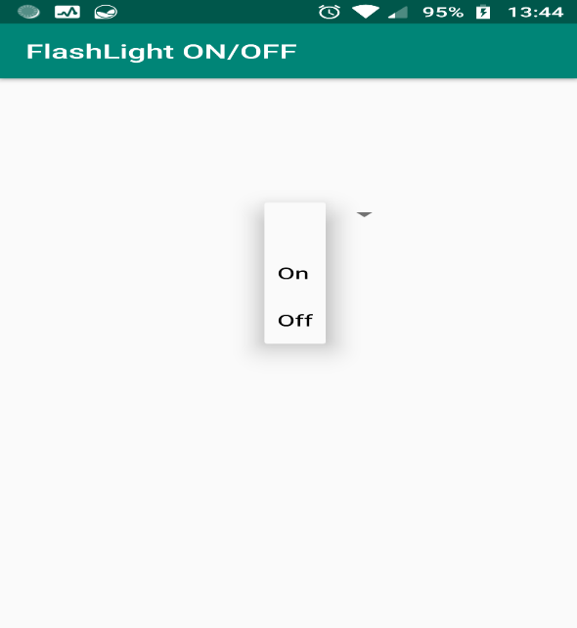

# Practical 7

## AIM: Create an application that will change the color of the screen, based on selected options from the menu.

Source Code:

Java File/s:

Main_activity.java

package com.example.pract_7;

import androidx.appcompat.app.AppCompatActivity; import androidx.core.content.ContextCompat;

import android.os.Bundle; import android.view.Menu; import android.view.MenuItem; import android.view.View; import android.widget.Toast;

public class MainActivity extends AppCompatActivity { @Override

protected void onCreate(Bundle savedInstanceState) { super.onCreate(savedInstanceState); setContentView(R.layout.*activity_main*);

}

@Override

public boolean onCreateOptionsMenu(Menu menu) { getMenuInflater().inflate(R.menu.*options_menu*, menu); return true;

}

@Override

public boolean onOptionsItemSelected(MenuItem item) { Toast.*makeText*(this, "Selected Item: " + item.getTitle(),

Toast.*LENGTH_SHORT*).show(); switch (item.getItemId()) {

case R.id.*search_item*:

View someView = findViewById(R.id.*main_layout*); View root = someView.getRootView();

root.setBackgroundColor(ContextCompat.*getColor*(this, R.color.*orange*)); return true;

case R.id.*upload_item*:

View someView1 = findViewById(R.id.*main_layout*); View root1 = someView1.getRootView();

root1.setBackgroundColor(ContextCompat.*getColor*(this, R.color.*color1*)); return true;

case R.id.*copy_item*:

View someView2 = findViewById(R.id.*main_layout*); View root2 = someView2.getRootView();

root2.setBackgroundColor(ContextCompat.*getColor*(this, R.color.*color2*)); return true;

case R.id.*print_item*:

View someView3 = findViewById(R.id.*main_layout*); View root3 = someView3.getRootView();

root3.setBackgroundColor(ContextCompat.*getColor*(this, R.color.*color3*)); return true;

default:

return super.onOptionsItemSelected(item);

}

}

}

Layout File/s:

option_menu.xml

*<?*xml version="1.0" encoding="utf-8"*?>*

<menu xmlns:android="[http://schemas.android.com/apk/res/android"](http://schemas.android.com/apk/res/android)>

<item android:id="@+id/search_item" android:title="Red" />

<item android:id="@+id/upload_item" android:title="Orange" />

<item android:id="@+id/copy_item" android:title="Blue" />

<item android:id="@+id/print_item" android:title="Green" />

</menu>

Activity_main.xml

*<?*xml version="1.0" encoding="utf-8"*?>*

<androidx.constraintlayout.widget.ConstraintLayout xmlns:andr[oid="htt](http://schemas.android.com/apk/res/android)p:/[/sc](http://schemas.android.com/apk/res/android)he[mas.android.com/apk/res/android"](http://schemas.android.com/apk/res/android)

xmlns:app=["http://sc](http://schemas.android.com/apk/res-auto)h[emas.android.com/apk/res-auto"](http://schemas.android.com/apk/res-auto) xmlns:t[ools="ht](http://schemas.android.com/tools)tp:/[/sc](http://schemas.android.com/tools)he[mas.android.com/tools"](http://schemas.android.com/tools) android:id="@+id/main_layout" android:layout_width="match_parent" android:layout_height="match_parent" tools:context=".MainActivity">

<TextView android:layout_width="wrap_content" android:layout_height="wrap_content" android:text="Hello World!"

app:layout_constraintBottom_toBottomOf="parent" app:layout_constraintLeft_toLeftOf="parent" app:layout_constraintRight_toRightOf="parent"

app:layout_constraintTop_toTopOf="parent" />

</androidx.constraintlayout.widget.ConstraintLayout>

Output:

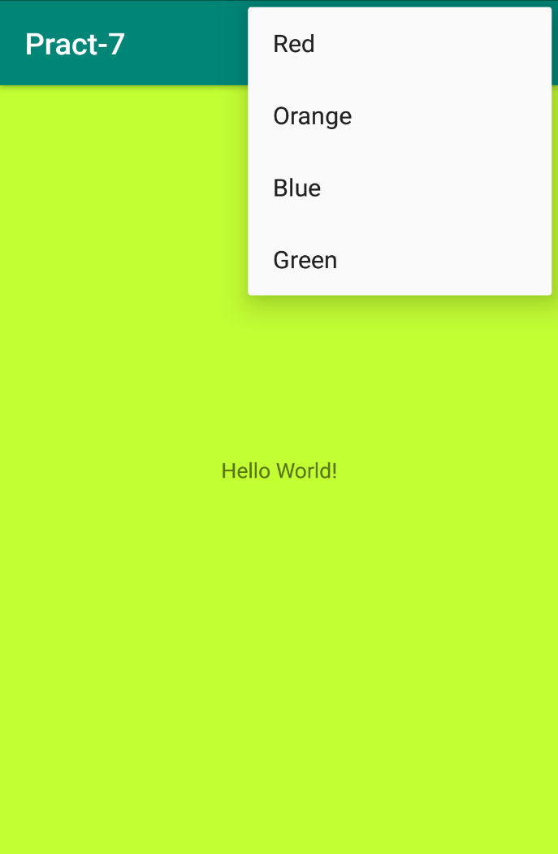

# Practical 8

## AIM: Create an application with the help of a fragment.

Source Code:

Java File/s: main.xml

package com.example.pract_8;

import androidx.appcompat.app.AppCompatActivity; import androidx.core.content.ContextCompat;

import android.os.Bundle; import android.view.Menu; import android.view.MenuItem; import android.view.View; import android.widget.Toast;

public class MainActivity extends AppCompatActivity { @Override

protected void onCreate(Bundle savedInstanceState) { super.onCreate(savedInstanceState);

setContentView(R.layout.*activity_main*);

}

@Override

public boolean onCreateOptionsMenu(Menu menu) { getMenuInflater().inflate(R.menu.*options_menu*, menu); return true;

}

@Override

public boolean onOptionsItemSelected(MenuItem item) { Toast.*makeText*(this, "Selected Item: " + item.getTitle(),

Toast.*LENGTH_SHORT*).show(); switch (item.getItemId()) {

case R.id.*search_item*:

View someView = findViewById(R.id.*main_layout*); View root = someView.getRootView();

root.setBackgroundColor(ContextCompat.*getColor*(this, R.color.*orange*)); return true;

case R.id.*upload_item*:

View someView1 = findViewById(R.id.*main_layout*); View root1 = someView1.getRootView();

|  |  |  |  |
| --- | --- | --- | --- |
| } | } | } | root1.setBackgroundColor(ContextCompat.*getColor*(this, R.color.*color1*)); return true;  case R.id.*copy_item*:  View someView2 = findViewById(R.id.*main_layout*); View root2 = someView2.getRootView();  root2.setBackgroundColor(ContextCompat.*getColor*(this, R.color.*color2*)); return true;  case R.id.*print_item*:  View someView3 = findViewById(R.id.*main_layout*); View root3 = someView3.getRootView();  root3.setBackgroundColor(ContextCompat.*getColor*(this, R.color.*color3*)); return true;  default:  return super.onOptionsItemSelected(item); |
|  | | | |

Layout File/s:

Activity_main.xml

*<?*xml version="1.0" encoding="utf-8"*?>*

<androidx.constraintlayout.widget.ConstraintLayout xmlns:andr[oid="htt](http://schemas.android.com/apk/res/android)p:/[/sc](http://schemas.android.com/apk/res/android)he[mas.android.com/apk/res/android"](http://schemas.android.com/apk/res/android)

xmlns:app=["http://sc](http://schemas.android.com/apk/res-auto)h[emas.android.com/apk/res-auto"](http://schemas.android.com/apk/res-auto) android:id="@+id/container" android:layout_width="match_parent" android:layout_height="match_parent" android:paddingTop="?attr/actionBarSize">

<com.google.android.material.bottomnavigation.BottomNavigationView android:id="@+id/nav_view"

android:layout_width="0dp" android:layout_height="wrap_content" android:layout_marginStart="0dp" android:layout_marginEnd="0dp" android:background="?android:attr/windowBackground" app:layout_constraintBottom_toBottomOf="parent" app:layout_constraintLeft_toLeftOf="parent" app:layout_constraintRight_toRightOf="parent" app:menu="@menu/bottom_nav_menu" />

<fragment android:id="@+id/nav_host_fragment"

android:name="androidx.navigation.fragment.NavHostFragment" android:layout_width="match_parent" android:layout_height="match_parent" app:defaultNavHost="true" app:layout_constraintBottom_toTopOf="@id/nav_view" app:layout_constraintLeft_toLeftOf="parent"

app:layout_constraintRight_toRightOf="parent" app:layout_constraintTop_toTopOf="parent" app:navGraph="@navigation/mobile_navigation" />

</androidx.constraintlayout.widget.ConstraintLayout>

Home_menu.xml

*<?*xml version="1.0" encoding="utf-8"*?>*

<androidx.constraintlayout.widget.ConstraintLayout xmlns:andr[oid="htt](http://schemas.android.com/apk/res/android)p:/[/sc](http://schemas.android.com/apk/res/android)he[mas.android.com/apk/res/android"](http://schemas.android.com/apk/res/android)

xmlns:app=["http://sc](http://schemas.android.com/apk/res-auto)h[emas.android.com/apk/res-auto"](http://schemas.android.com/apk/res-auto) android:layout_width="match_parent" android:layout_height="match_parent">

<TextView android:id="@+id/text_home" android:layout_width="match_parent" android:layout_height="wrap_content" android:layout_marginStart="8dp" android:layout_marginTop="8dp" android:layout_marginEnd="8dp" android:textAlignment="center" android:textSize="20sp"

app:layout_constraintEnd_toEndOf="parent" app:layout_constraintStart_toStartOf="parent" app:layout_constraintTop_toTopOf="parent" />

</androidx.constraintlayout.widget.ConstraintLayout>

Dashboard_menu.xml

*<?*xml version="1.0" encoding="utf-8"*?>*

<androidx.constraintlayout.widget.ConstraintLayout xmlns:andr[oid="htt](http://schemas.android.com/apk/res/android)p:/[/sc](http://schemas.android.com/apk/res/android)he[mas.android.com/apk/res/android"](http://schemas.android.com/apk/res/android)

xmlns:app=["http://sc](http://schemas.android.com/apk/res-auto)h[emas.android.com/apk/res-auto"](http://schemas.android.com/apk/res-auto) android:layout_width="match_parent" android:layout_height="match_parent">

<TextView android:id="@+id/text_dashboard" android:layout_width="match_parent" android:layout_height="wrap_content" android:layout_marginStart="8dp" android:layout_marginTop="8dp" android:layout_marginEnd="8dp" android:textAlignment="center" android:textSize="20sp"

app:layout_constraintEnd_toEndOf="parent" app:layout_constraintStart_toStartOf="parent"

app:layout_constraintTop_toTopOf="parent" />

</androidx.constraintlayout.widget.ConstraintLayout>

notify_menu.xml

*<?*xml version="1.0" encoding="utf-8"*?>*

<androidx.constraintlayout.widget.ConstraintLayout xmlns:andr[oid="htt](http://schemas.android.com/apk/res/android)p:/[/sc](http://schemas.android.com/apk/res/android)he[mas.android.com/apk/res/android"](http://schemas.android.com/apk/res/android)

xmlns:app=["http://sc](http://schemas.android.com/apk/res-auto)h[emas.android.com/apk/res-auto"](http://schemas.android.com/apk/res-auto) android:layout_width="match_parent" android:layout_height="match_parent">

<TextView android:id="@+id/text_notifications" android:layout_width="match_parent" android:layout_height="wrap_content" android:layout_marginStart="8dp" android:layout_marginTop="8dp" android:layout_marginEnd="8dp" android:textAlignment="center" android:textSize="20sp" app:layout_constraintEnd_toEndOf="parent" app:layout_constraintStart_toStartOf="parent"

app:layout_constraintTop_toTopOf="parent" />

</androidx.constraintlayout.widget.ConstraintLayout>

Output:

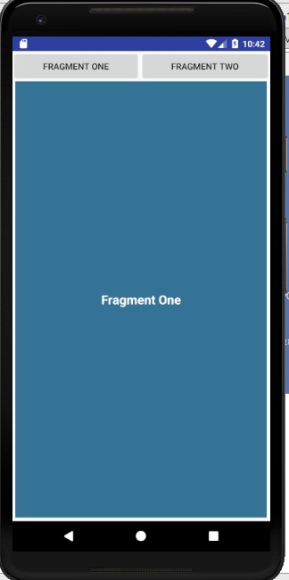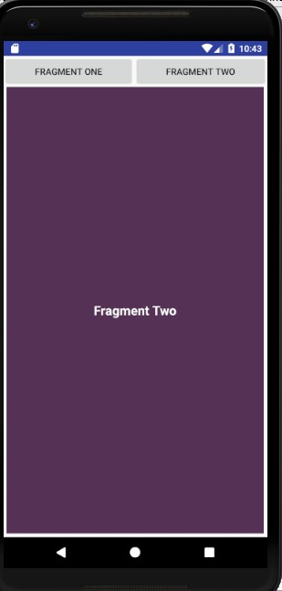

# PRACTICAL9

**AIM - Create an application with the help of web view.**

Activity_main.xml

## *<?*xml version="1.0" encoding="utf-8"*?>*

**<RelativeLayout xmlns:android="**[**http://schemas.android.com/apk/res/android**](http://schemas.android.com/apk/res/android)**" xmlns:app="**[**http://schemas.android.com/apk/res-auto"**](http://schemas.android.com/apk/res-auto) **xmlns:tools="**[**http://schemas.android.com/tools"**](http://schemas.android.com/tools) **android:layout_width="match_parent" android:layout_height="match_parent" tools:context="com.example.administrator.prac9_webview.MainActivity">**

**<TextView android:text="WebView" android:layout_width="wrap_content" android:layout_height="wrap_content"**

**android:id="@+id/textview" android:textSize="35dp" android:layout_alignParentTop="true" android:layout_centerHorizontal="true" />**

**<TextView android:id="@+id/textView"**

**android:layout_width="wrap_content" android:layout_height="wrap_content" android:layout_alignParentTop="true" android:layout_centerHorizontal="true" android:layout_marginTop="35dp" android:text="charusat website" android:textColor="#ff7aff24" android:textSize="35dp" />**

**<EditText android:id="@+id/editText"**

**android:layout_width="match_parent" android:layout_height="wrap_content" android:layout_alignParentStart="true" android:layout_below="@+id/textView" android:layout_marginTop="11dp" android:focusable="true" android:hint="Enter Text" android:textColorHighlight="#ff7eff15" android:textColorHint="#ffff25e6" />**

**<ImageView android:id="@+id/imageView" android:layout_width="wrap_content" android:layout_height="wrap_content"**

**android:layout_alignEnd="@+id/textView"android:layout_below="@+id/button"**

**android:src="@drawable/abc" />**

**<Button android:id="@+id/button"**

**android:layout_width="wrap_content" android:layout_height="wrap_content" android:layout_below="@+id/editText" android:layout_centerHorizontal="true" android:text="Enter" />**

**<WebView android:id="@+id/webView"**

**android:layout_width="match_parent" android:layout_height="wrap_content"android:layout_alignStart="@+id/textview"android:layout_marginBottom="0dp" android:layout_marginLeft="0dp" android:layout_marginRight="100dp" android:layout_marginTop="404dp" android:visibility="visible"/>**

**</RelativeLayout>**

**Mainactivity.java**

**package com.example.administrator.prac9_webview;**

**import android.support.v7.app.AppCompatActivity; import android.os.Bundle;**

**import android.view.View; importandroid.webkit.WebView;**

**import android.webkit.WebViewClient; import android.widget.Button;**

**import android.widget.EditText;**

**public class MainActivity extends AppCompatActivity**

**{**

**Button b1; EditText ed1;**

**private WebView wv1;**

**protected void onCreate(Bundle savedInstanceState)**

**{**

**super.onCreate(savedInstanceState); setContentView(R.layout.*activity_main*);**

**b1=(Button)findViewById(R.id.*button*); ed1=(EditText)findViewById(R.id.*editText*);**

**wv1=(WebView)findViewById(R.id.*webView*); wv1.setWebViewClient(new MyBrowser());**

**b1.setOnClickListener(new View.OnClickListener() { @Override**

**public void onClick(View v) {**

**String url = ed1.getText().toString();**

**}**

**});**

**}**

**wv1.getSettings().setLoadsImagesAutomatically(true); wv1.getSettings().setJavaScriptEnabled(true); wv1.setScrollBarStyle(View.*SCROLLBARS_INSIDE_OVERLAY*); wv1.loadUrl(url);**

**private class MyBrowser extends WebViewClient { @Override**

**public boolean shouldOverrideUrlLoading(WebView view, String url) { view.loadUrl(url);**

**return true;**

**}**

**}**

**}**

Output

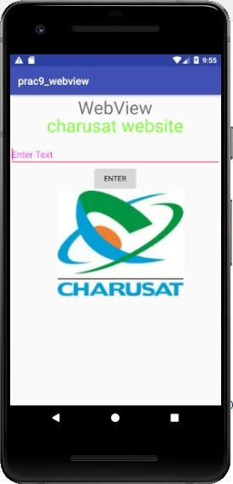

**AIM:**

**PRACTICAL 10**

## Create an application with the help of the database.

**CODE:**

**MainActivity.java:**

package com.example.admin1.saveandretrive;

import android.support.v7.app.AppCompatActivity; import android.os.Bundle;

import com.google.firebase.database.DatabaseReference; import com.google.firebase.database.FirebaseDatabase;

public class MainActivity extends AppCompatActivity { @Override

protected void onCreate(Bundle savedInstanceState) {

super.onCreate(savedInstanceState); setContentView(R.layout.*activity_main*);

FirebaseDatabase database = FirebaseDatabase.*getInstance*(); DatabaseReference myRef = database.getReference("message");

myRef.setValue("kem cho gujarat");

}

}

**Output:**

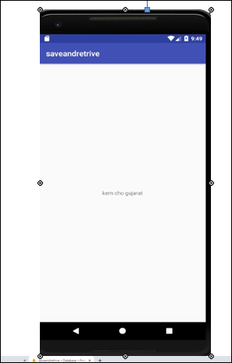

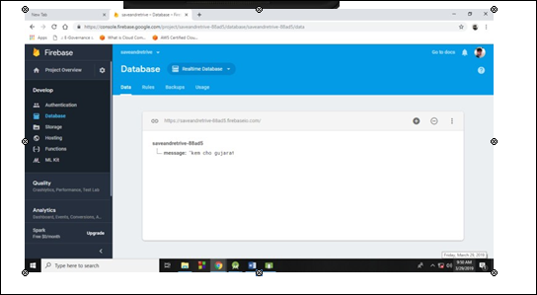

**PRACTICAL 11**

**AIM: Creating an application that provides Single Sign-on (SSO) with Chrome CustomTabs via the App-Auth library, and optionally push managed configuration to provide a user login hint.** [https://codelabs.developers.google.com/codelabs/signin/index.html?index=..%2F..index#0](https://codelabs.developers.google.com/codelabs/signin/index.html?index=..%2F..index&amp;0)Activity_main.xml

*<?*xml version="1.0" encoding="utf-8"*?>*

<android.support.constraint.ConstraintLayoutxmlns:andr[oid="htt](http://schemas.android.com/ap)p:/[/schemas.android.](http://schemas.android.com/ap)c[om/](http://schemas.android.com/ap)a[p](http://schemas.android.com/ap) k/res/android"

xmlns:app=["http://sche](http://schemas.android.com/apk/res-auto)m[as.android.com/apk/res-auto"](http://schemas.android.com/apk/res-auto) xmlns:t[ools="ht](http://schemas.android.com/tools)tp:/[/schemas.android.com/tool](http://schemas.android.com/tools)s" android:layout_width="match_parent" android:layout_height="match_parent" tools:context="com.example.app_1.signin_1.MainActivity">

<LinearLayout android:layout_width="wrap_content" android:layout_height="wrap_content" android:orientation="vertical" android:padding="2dip">

<com.google.android.gms.common.SignInButton android:id="@+id/sign_in_button" android:layout_width="wrap_content" android:layout_height="wrap_content" android:enabled="false" />

<Button android:id="@+id/sign_out_button" android:layout_width="wrap_content"android:layout_height="wrap_content"android:text="Sign Out" android:enabled="true"/>

<Button android:id="@+id/revoke_access_button" android:layout_width="wrap_content" android:layout_height="wrap_content" android:text="Revoke Access" android:enabled="true"/>

<TextView android:layout_width="wrap_content" android:layout_height="wrap_content" android:id="@+id/statuslabel" android:text="Status"/>

</LinearLayout>

</android.support.constraint.ConstraintLayout>

mainactivity.java

package com.google.codelabs.appauth;

import android.app.PendingIntent;

import android.app.admin.DevicePolicyManager; import android.content.BroadcastReceiver; import android.content.Context;

import android.content.Intent; import android.content.IntentFilter;

import android.content.RestrictionsManager; import android.net.Uri;

import android.os.AsyncTask; import android.os.Bundle;

import android.os.PersistableBundle; import android.os.UserManager;

import android.support.annotation.NonNull; import android.support.annotation.Nullable; import android.support.design.widget.Snackbar;

import android.support.v7.app.AppCompatActivity; import android.support.v7.widget.AppCompatButton; import android.support.v7.widget.AppCompatTextView; importandroid.text.TextUtils;

import android.util.Log; import android.view.View; importandroid.widget.Button;

import android.widget.ImageView; importandroid.widget.Toast;

importcom.squareup.picasso.Picasso;

importnet.openid.appauth.AuthState;

import net.openid.appauth.AuthorizationException; import net.openid.appauth.AuthorizationRequest; import net.openid.appauth.AuthorizationResponse; import net.openid.appauth.AuthorizationService;

import net.openid.appauth.AuthorizationServiceConfiguration; import net.openid.appauth.TokenResponse;

import org.json.JSONException; import org.json.JSONObject;

import java.util.HashMap; import java.util.Map;

import okhttp3.OkHttpClient; import okhttp3.Request; import okhttp3.Response;

import static com.google.codelabs.appauth.MainApplication.LOG_TAG;

public class MainActivity extends AppCompatActivity {

private static final String SHARED_PREFERENCES_NAME = "AuthStatePreference"; private static final String AUTH_STATE = "AUTH_STATE";

private static final String USED_INTENT = "USED_INTENT"; private static final String LOGIN_HINT = "login_hint";

MainApplication mMainApplication;

// state

AuthState mAuthState;

// views

AppCompatButton mAuthorize; AppCompatButton mMakeApiCall; AppCompatButton mSignOut; AppCompatTextView mGivenName; AppCompatTextView mFamilyName; AppCompatTextView mFullName; ImageView mProfileView;

// login hint

protected String mLoginHint;

// broadcast receiver for app restrictions changed broadcast BroadcastReceiver mRestrictionsReceiver;

@Override

protected void onCreate(Bundle savedInstanceState) { super.onCreate(savedInstanceState); setContentView(R.layout.activity_main);

mMainApplication = (MainApplication) getApplication(); mAuthorize = (AppCompatButton) findViewById(R.id.authorize);

mMakeApiCall = (AppCompatButton) findViewById(R.id.makeApiCall); mSignOut = (AppCompatButton) findViewById(R.id.signOut); mGivenName = (AppCompatTextView) findViewById(R.id.givenName); mFamilyName = (AppCompatTextView) findViewById(R.id.familyName); mFullName = (AppCompatTextView) findViewById(R.id.fullName); mProfileView = (ImageView) findViewById(R.id.profileImage);

enablePostAuthorizationFlows();

// wire click listeners

mAuthorize.setOnClickListener(new AuthorizeListener(this));

// Retrieve app restrictions and take appropriate action getAppRestrictions();

}

@Override

protected void onResume(){ super.onResume();

// Retrieve app restrictions and take appropriate action getAppRestrictions();

// Register a receiver for app restrictions changed broadcast registerRestrictionsReceiver();

@Override

protected void onStop(){ super.onStop();

// Unregister receiver for app restrictions changed broadcast unregisterReceiver(mRestrictionsReceiver);

}

@Override

protected void onNewIntent(Intent intent) { checkIntent(intent);

}

private void checkIntent(@Nullable Intent intent) { if (intent != null) {

String action = intent.getAction(); switch (action) {

case "com.google.codelabs.appauth.HANDLE_AUTHORIZATION_RESPONSE": if (!intent.hasExtra(USED_INTENT)){

handleAuthorizationResponse(intent); intent.putExtra(USED_INTENT,true);

}

break; default:

// do nothing

}

}

@Override

protected void onStart() { super.onStart(); checkIntent(getIntent());

// Register a receiver for app restrictions changed broadcast registerRestrictionsReceiver();

}

private void enablePostAuthorizationFlows() { mAuthState = restoreAuthState();

if (mAuthState != null && mAuthState.isAuthorized()) { if (mMakeApiCall.getVisibility() == View.GONE) { mMakeApiCall.setVisibility(View.VISIBLE);

mMakeApiCall.setOnClickListener(new MakeApiCallListener(this, mAuthState, new AuthorizationService(this)));

}

if (mSignOut.getVisibility() == View.GONE) { mSignOut.setVisibility(View.VISIBLE); mSignOut.setOnClickListener(new SignOutListener(this));

}

} else { mMakeApiCall.setVisibility(View.GONE); mSignOut.setVisibility(View.GONE);

}

}

/**

* Exchanges the code, for the {@link TokenResponse}.

*

* @paramintentrepresentsthe{@linkIntent}fromtheCustomTabsortheSystemBrowser.

*/

private void handleAuthorizationResponse(@NonNull Intent intent) { AuthorizationResponse response = AuthorizationResponse.fromIntent(intent); AuthorizationException error = AuthorizationException.fromIntent(intent); final AuthState authState = new AuthState(response, error);

if (response != null) {

Log.i(LOG_TAG, String.format("Handled Authorization Response %s ", authState.toJsonString()));

AuthorizationService service = new AuthorizationService(this); service.performTokenRequest(response.createTokenExchangeRequest(), new

AuthorizationService.TokenResponseCallback() { @Override

public void onTokenRequestCompleted(@Nullable TokenResponse tokenResponse, @Nullable AuthorizationException exception) {

if (exception != null) {

Log.w(LOG_TAG, "Token Exchange failed", exception);

} else {

if (tokenResponse != null) { authState.update(tokenResponse, exception); persistAuthState(authState);

Log.i(LOG_TAG, String.format("Token Response [ Access Token: %s, ID Token:

%s ]", tokenResponse.accessToken, tokenResponse.idToken));

}

}

}

});

}

}

private void persistAuthState(@NonNull AuthState authState) {

getSharedPreferences(SHARED_PREFERENCES_NAME, Context.MODE_PRIVATE).edit()

.putString(AUTH_STATE, authState.toJsonString())

.commit(); enablePostAuthorizationFlows();

}

private void clearAuthState() { getSharedPreferences(SHARED_PREFERENCES_NAME, Context.MODE_PRIVATE)

.edit()

.remove(AUTH_STATE)

.apply();

}

@Nullable

private AuthState restoreAuthState() {

String jsonString = getSharedPreferences(SHARED_PREFERENCES_NAME, Context.MODE_PRIVATE)

.getString(AUTH_STATE, null); if (!TextUtils.isEmpty(jsonString)) {

try {

return AuthState.fromJson(jsonString);

} catch (JSONException jsonException) {

// should never happen

}

}

return null;

}

/**

* Kicks off the authorizationflow.

*/

public static class AuthorizeListener implements Button.OnClickListener {

private final MainActivity mMainActivity;

public AuthorizeListener(@NonNull MainActivity mainActivity) { mMainActivity = mainActivity;

}

@Override

public void onClick(View view) {

AuthorizationServiceConfiguration serviceConfiguration = new AuthorizationServiceConfiguration(

Uri.parse("https://accounts.google.com/o/oauth2/v2/auth") /* auth endpoint */, Uri.parse("https://[www.googleapis.com/oauth2/v4/token")](http://www.googleapis.com/oauth2/v4/token) /* token endpoint */

);

AuthorizationService authorizationService = new AuthorizationService(view.getContext());

String clientId = "511828570984- fuprh0cm7665emlne3rnf9pk34kkn86s.apps.googleusercontent.com";

Uri redirectUri = Uri.parse("com.google.codelabs.appauth:/oauth2callback"); AuthorizationRequest.Builder builder = new AuthorizationRequest.Builder(

serviceConfiguration, clientId,

AuthorizationRequest.RESPONSE_TYPE_CODE, redirectUri

);

builder.setScopes("profile");

if(mMainActivity.getLoginHint() != null){

Map loginHintMap = new HashMap<String, String>(); loginHintMap.put(LOGIN_HINT,mMainActivity.getLoginHint()); builder.setAdditionalParameters(loginHintMap);

Log.i(LOG_TAG, String.format("login_hint: %s", mMainActivity.getLoginHint()));

}

AuthorizationRequest request = builder.build();

String action = "com.google.codelabs.appauth.HANDLE_AUTHORIZATION_RESPONSE";

Intent postAuthorizationIntent = new Intent(action);

PendingIntent pendingIntent = PendingIntent.getActivity(view.getContext(), request.hashCode(), postAuthorizationIntent,0);

authorizationService.performAuthorizationRequest(request, pendingIntent);

}

}

public static class SignOutListener implements Button.OnClickListener {

private final MainActivity mMainActivity;

public SignOutListener(@NonNull MainActivity mainActivity) { mMainActivity = mainActivity;

}

@Override

public void onClick(View view) { mMainActivity.mAuthState = null; mMainActivity.clearAuthState(); mMainActivity.enablePostAuthorizationFlows();

}

}

public static class MakeApiCallListener implements Button.OnClickListener {

private final MainActivity mMainActivity; private AuthState mAuthState;

private AuthorizationService mAuthorizationService;

public MakeApiCallListener(@NonNull MainActivity mainActivity, @NonNull AuthState authState, @NonNull AuthorizationService authorizationService) {

mMainActivity = mainActivity; mAuthState = authState;

mAuthorizationService = authorizationService;

}

@Override

public void onClick(View view) { mAuthState.performActionWithFreshTokens(mAuthorizationService, new

AuthState.AuthStateAction() { @Override

public void execute(@Nullable String accessToken, @Nullable String idToken, @Nullable AuthorizationException exception) {

new AsyncTask<String, Void, JSONObject>() { @Override

protected JSONObject doInBackground(String... tokens) { OkHttpClient client = new OkHttpClient();

Request request = new Request.Builder()

.url("https://[www.googleapis.com/oauth2/v3/userinfo")](http://www.googleapis.com/oauth2/v3/userinfo)

.addHeader("Authorization", String.format("Bearer %s", tokens[0]))

.build();

try {

Response response = client.newCall(request).execute(); String jsonBody = response.body().string();

Log.i(LOG_TAG, String.format("User Info Response %s", jsonBody)); return new JSONObject(jsonBody);

} catch (Exception exception) { Log.w(LOG_TAG, exception);

}

return null;

}

@Override

protected void onPostExecute(JSONObject userInfo) { if (userInfo != null) {

String fullName = userInfo.optString("name", null);

String givenName = userInfo.optString("given_name", null); String familyName = userInfo.optString("family_name", null); String imageUrl = userInfo.optString("picture", null);

if (!TextUtils.isEmpty(imageUrl)) { Picasso.with(mMainActivity)

.load(imageUrl)

.placeholder(R.drawable.ic_account_circle_black_48dp)

.into(mMainActivity.mProfileView);

}

if (!TextUtils.isEmpty(fullName)) { mMainActivity.mFullName.setText(fullName);

}

if (!TextUtils.isEmpty(givenName)) { mMainActivity.mGivenName.setText(givenName);

}

if (!TextUtils.isEmpty(familyName)) { mMainActivity.mFamilyName.setText(familyName);

}

String message;

if (userInfo.has("error")) {

message = String.format("%s [%s]", mMainActivity.getString(R.string.request_failed), userInfo.optString("error_description", "Nodescription"));

} else {

message = mMainActivity.getString(R.string.request_complete);

}

Snackbar.make(mMainActivity.mProfileView, message, Snackbar.LENGTH_SHORT)

.show();

}

}

}.execute(accessToken);

}

});

}

}

private void getAppRestrictions(){ RestrictionsManager restrictionsManager =

(RestrictionsManager) this

.getSystemService(Context.RESTRICTIONS_SERVICE);

Bundle appRestrictions = restrictionsManager.getApplicationRestrictions();

// Block user if KEY_RESTRICTIONS_PENDING is true, and save login hint if available if(!appRestrictions.isEmpty()){

if(appRestrictions.getBoolean(UserManager.

KEY_RESTRICTIONS_PENDING)!=true){

mLoginHint = appRestrictions.getString(LOGIN_HINT);

}

else { Toast.makeText(this,R.string.restrictions_pending_block_user,

Toast.LENGTH_LONG).show(); finish();

}

}

}

private void registerRestrictionsReceiver(){ IntentFilter restrictionsFilter =

new IntentFilter(Intent.ACTION_APPLICATION_RESTRICTIONS_CHANGED);

mRestrictionsReceiver = new BroadcastReceiver() { @Override

public void onReceive(Context context, Intent intent) { getAppRestrictions();

}

};

registerReceiver(mRestrictionsReceiver, restrictionsFilter);

}

public String getLoginHint(){ return mLoginHint;

}

}

## Output:

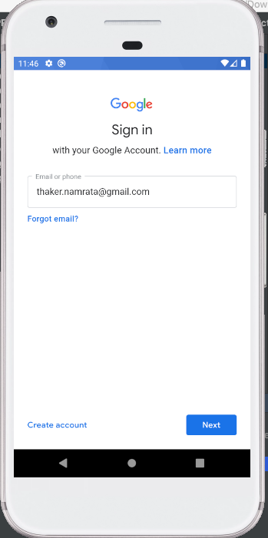

**PRACTICAL 12**

**AIM: Create an application to handle support voice interaction. Source Code:**

**Program: activity_main.xml**

<?xml version="1.0" encoding="utf-8"?>

<android.support.constraint.ConstraintLayout xmlns:android=["http://schemas.android.com/](http://schemas.android.com/apk/res/android)a[pk/res/android"](http://schemas.android.com/apk/res/android)

xmlns:app=["http://sc](http://schemas.android.com/apk/res-auto)h[emas.android.com/apk/res-auto"](http://schemas.android.com/apk/res-auto) xmlns:t[ools="ht](http://schemas.android.com/tools)tp:/[/schemas.android.com/tool](http://schemas.android.com/tools)s" android:layout_width="match_parent" android:layout_height="match_parent" tools:context="com.example.prac12.MainActivity">

<TextView

android:id="@+id/textView" android:layout_width="wrap_content" android:layout_height="wrap_content" android:layout_marginTop="168dp"

android:text="Wait till Question PopUP!!" android:textSize="24sp" app:layout_constraintHorizontal_bias="0.501" app:layout_constraintLeft_toLeftOf="parent" app:layout_constraintRight_toRightOf="parent" app:layout_constraintTop_toTopOf="parent" />

<TextView

android:id="@+id/textView1" android:layout_width="wrap_content" android:layout_height="wrap_content" android:layout_marginBottom="8dp" android:layout_marginEnd="8dp" android:layout_marginStart="8dp" android:layout_marginTop="8dp"

android:text="Speak your answer" android:textSize="24sp" app:layout_constraintBottom_toBottomOf="parent" app:layout_constraintEnd_toEndOf="parent" app:layout_constraintHorizontal_bias="0.501" app:layout_constraintStart_toStartOf="parent" app:layout_constraintTop_toBottomOf="@+id/textView" app:layout_constraintVertical_bias="0.171" />

</android.support.constraint.ConstraintLayout>

## Program: MainActivity.java

package com.example.prac12; import android.content.Intent;

import android.speech.RecognizerIntent;

import android.speech.tts.TextToSpeech;

import android.support.v7.app.AppCompatActivity; import android.os.Bundle;

import android.widget.TextView; import java.util.List;

import java.util.Locale;

public class MainActivity extends AppCompatActivity {

private TextToSpeech t1;

private final int REQUEST_SPEECH_RECOGNIZER = 3000; private TextView question, answer;

private final String mQuestion = "Who is the owner of this phone?"; private String mAnswer = "";

@Override

protected void onCreate(Bundle savedInstanceState) { super.onCreate(savedInstanceState);

setContentView(R.layout.activity_main);

question = (TextView) findViewById(R.id.textView); answer = (TextView) findViewById(R.id.textView1);

t1=new TextToSpeech(getApplicationContext(), new TextToSpeech.OnInitListener() { @Override

public void onInit(int status) { if(status != TextToSpeech.ERROR) {

t1.setLanguage(Locale.UK);

}

}

});

startSpeechRecognizer();

}

private void startSpeechRecognizer() {

Intent intent = new Intent (RecognizerIntent.ACTION_RECOGNIZE_SPEECH);

intent.putExtra(RecognizerIntent.EXTRA_LANGUAGE_MODEL, RecognizerIntent.LANGUAGE_MODEL_FREE_FORM);

intent.putExtra(RecognizerIntent.EXTRA_PROMPT, mQuestion); startActivityForResult(intent, REQUEST_SPEECH_RECOGNIZER);

}

@Override

protected void onActivityResult(int requestCode, int resultCode,

Intent data) { super.onActivityResult(requestCode, resultCode, data);

if (requestCode == REQUEST_SPEECH_RECOGNIZER) { if (resultCode == RESULT_OK) {

List<String> results = data.getStringArrayListExtra (RecognizerIntent.EXTRA_RESULTS);

mAnswer = results.get(0); question.setText(mQuestion); answer.setText(mAnswer);

if (mAnswer.toUpperCase().indexOf("SMIT") > -1) {

t1.speak("Great You are correct", TextToSpeech.QUEUE_FLUSH, null, "adfvsfgbrsgh");

}

else {

t1.speak("Wrong answer submit this phone to my owner Smit", TextToSpeech.QUEUE_FLUSH, null,"adfvsfgbrsgh");

}

}

}

}

@Override

public void onPause(){ if(t1 !=null){

t1.stop(); t1.shutdown();

}

super.onPause();

}

}

## Output:

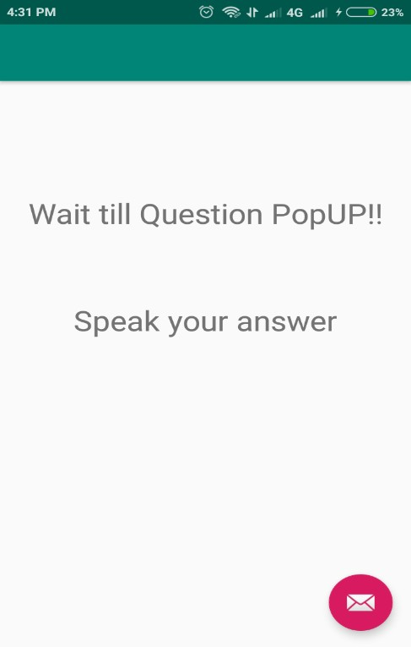

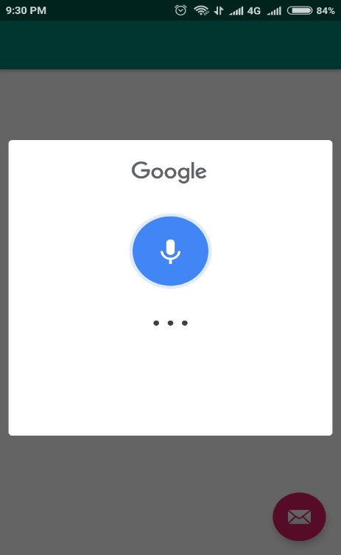

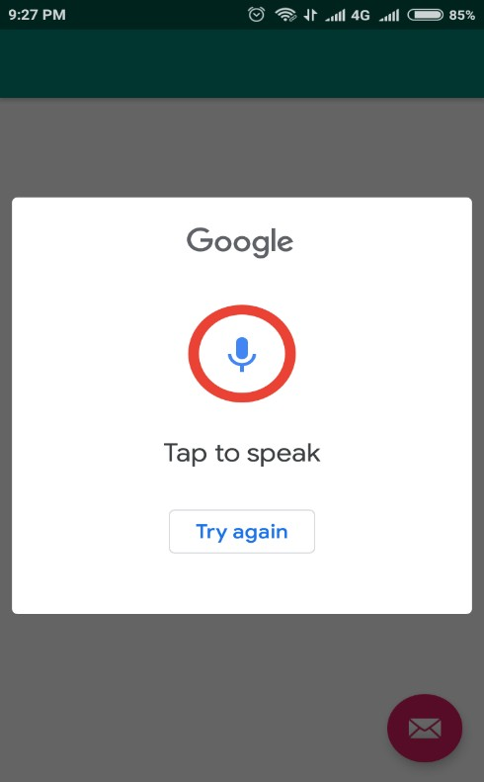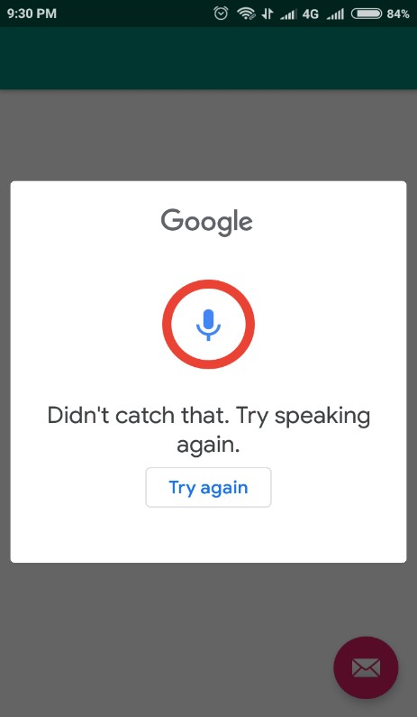

**PRACTICAL 13**

**AIM:Create an application to play video using the YouTube API in PIP mode. Source Code:**

**Program:activity_main.xml**

<?xml version="1.0" encoding="utf-8"?>

<RelativeLayout  
 xmlns:android="http://schemas.android.com/apk/res/android"  
 xmlns:app="http://schemas.android.com/apk/res-auto"  
 xmlns:tools="http://schemas.android.com/tools"  
 android:layout_width="match_parent"  
 android:layout_height="match_parent"  
 tools:context=".MainActivity">  
<VideoView  
 android:layout_width="match_parent"  
 android:layout_height="match_parent"  
 android:id="@+id/video"  
 android:layout_above="@id/pipbtn"/>  
<Button  
 android:layout_width="match_parent"  
 android:layout_height="wrap_content"  
 android:text="Enter PIP mode"  
 android:layout_alignParentBottom="true"  
 android:id="@+id/pipbtn"/>  
</RelativeLayout>

**Program:MainActivity.java**

package com.example.practical13;  
  
import androidx.appcompat.app.AppCompatActivity;  
  
import android.app.ActionBar;  
import android.app.Notification;  
import android.app.PictureInPictureParams;  
import android.drm.DrmStore;  
import android.graphics.Point;  
import android.net.Uri;  
import android.os.Bundle;  
import android.util.Rational;  
import android.view.Display;

public class MainActivity extends AppCompatActivity {

Button pipbtn;

String path = "/storage/DCIM/Camera/movie.mp4"; ActionBar actionBar;

VideoView video;

@Override

protected void onCreate(Bundle savedInstanceState) { super.onCreate(savedInstanceState); setContentView(R.layout.*activity_main*);

video = (VideoView)findViewById(R.id.*video*); actionBar = getActionBar();

MediaController mediaController= new MediaController(this); mediaController.setAnchorView(video); video.setMediaController(mediaController); video.setVideoURI(Uri.*parse*(path));

video.requestFocus(); video.start();

pipbtn = (Button)findViewById(R.id.*pipbtn*);

pipbtn.setOnClickListener(new View.OnClickListener() { @Override

public void onClick(View view) {

Display display = getWindowManager().getDefaultDisplay(); Point point = new Point();

display.getSize(point); int width = point.x;

int height = point.y;

Rational ratio = new Rational(width,height); PictureInPictureParams.Builder pip_builder = new

PictureInPictureParams.Builder(); pip_builder.setAspectRatio(ratio).build(); pipbtn.setVisibility(View.*INVISIBLE*); enterPictureInPictureMode(pip_builder.build());

}

});

}

}

## Output:

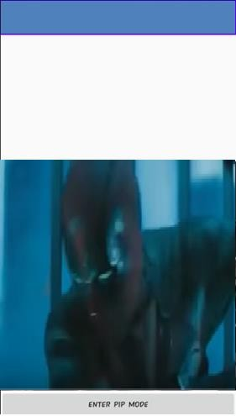 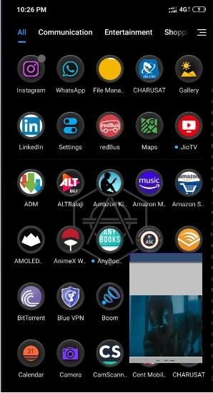

# PRACTICAL 14

## AIM: Create an application that uses the end-to-end process of training a machine learning model that can recognize handwritten characters images with TensorFlow and deploy it to an Android app.

Ref: [https://codelabs.developers.google.com/codelabs/digit-classifiertflite/index.html?index=..%2F..index#0](https://codelabs.developers.google.com/codelabs/digit-classifiertflite/index.html?index=..%2F..index&amp;0)

## Source Code:

**Program: activity_main.xml**

<?xml version="1.0" encoding="utf-8"?>

<RelativeLayout  
 xmlns:android="http://schemas.android.com/apk/res/android"  
 xmlns:app="http://schemas.android.com/apk/res-auto"  
 xmlns:tools="http://schemas.android.com/tools"  
 android:layout_width="match_parent"  
 android:layout_height="match_parent"  
 tools:context=".MainActivity">  
<VideoView  
 android:layout_width="match_parent"  
 android:layout_height="match_parent"  
 android:id="@+id/video"  
 android:layout_above="@id/pipbtn"/>  
<Button  
 android:layout_width="match_parent"  
 android:layout_height="wrap_content"  
 android:text="Enter PIP mode"  
 android:layout_alignParentBottom="true"  
 android:id="@+id/pipbtn"/>  
</RelativeLayout>

android:layout_width="match_parent" android:layout_height="match_parent" tools:context=".MainActivity">

<com.divyanshu.draw.widget.DrawView android:id="@+id/draw_view" android:layout_width="match_parent" android:layout_height="0dp" app:layout_constraintDimensionRatio="1:1" app:layout_constraintTop_toTopOf="parent"/>

<TextView android:id="@+id/predicted_text" android:textStyle="bold" android:layout_width="wrap_content" android:layout_height="wrap_content"

android:text="@string/prediction_text_placeholder" android:textSize="20sp" app:layout_constraintBottom_toTopOf="@id/clear_button" app:layout_constraintLeft_toLeftOf="parent" app:layout_constraintRight_toRightOf="parent" app:layout_constraintTop_toBottomOf="@id/draw_view"/>

<Button

android:id="@+id/clear_button" android:layout_width="wrap_content" android:layout_height="wrap_content" android:text="@string/clear_button_text" app:layout_constraintBottom_toBottomOf="parent" app:layout_constraintLeft_toLeftOf="parent" app:layout_constraintRight_toRightOf="parent"/>

</androidx.constraintlayout.widget.ConstraintLayout>

## Program: MainActivity.java

package org.tensorflow.lite.codelabs.digitclassifier

import android.annotation.SuppressLint import android.graphics.Color

import android.os.Bundle

import androidx.appcompat.app.AppCompatActivity import android.util.Log

import android.view.MotionEvent import android.widget.Button import android.widget.TextView

import com.divyanshu.draw.widget.DrawView class MainActivity : AppCompatActivity() {

private var drawView: DrawView? = null

private var clearButton: Button? = null

private var predictedTextView: TextView? = null private var digitClassifier = DigitClassifier(this)

@SuppressLint("ClickableViewAccessibility") override fun onCreate(savedInstanceState: Bundle?) { super.onCreate(savedInstanceState) setContentView(R.layout.activity_main)

// Setup view instances.

drawView = findViewById(R.id.draw_view) drawView?.setStrokeWidth(70.0f) drawView?.setColor(Color.WHITE) drawView?.setBackgroundColor(Color.BLACK) clearButton = findViewById(R.id.clear_button) predictedTextView = findViewById(R.id.predicted_text)

// Setup clear drawing button. clearButton?.setOnClickListener { drawView?.clearCanvas()

predictedTextView?.text = getString(R.string.prediction_text_placeholder)

}

// Setup classification trigger so that it classify after every stroke drew. drawView?.setOnTouchListener { _, event ->

// As we have interrupted DrawView's touch event,

// we first need to pass touch events through to the instance for the drawing to show up. drawView?.onTouchEvent(event)

// Then if user finished a touch event, run classification if (event.action == MotionEvent.ACTION_UP) { classifyDrawing()

}

true

}

// Setup digit classifier. digitClassifier

.initialize()

.addOnFailureListener { e -> Log.e(TAG, "Error to setting up digit classifier.", e) }

}

override fun onDestroy() {

// Sync DigitClassifier instance lifecycle with MainActivity lifecycle,

// and free up resources (e.g. TF Lite instance) once the activity is destroyed. digitClassifier.close()

super.onDestroy()

}

private fun classifyDrawing() {

val bitmap = drawView?.getBitmap()

if ((bitmap != null) && (digitClassifier.isInitialized)) { digitClassifier

.classifyAsync(bitmap)

.addOnSuccessListener { resultText -> predictedTextView?.text = resultText }

.addOnFailureListener { e -> predictedTextView?.text = getString( R.string.classification_error_message, e.localizedMessage

)

Log.e(TAG, "Error classifying drawing.", e)

}

}

}

companion object {

private const val TAG = "MainActivity"

}

}

## Output:

