CUSTOMER PURCHASE DATA
ANALYSIS AND PREPROCESSING
Yuvaintern Internship — Week 1 | Python for Machine Learning & Data Preprocessing

1. Introduction
Machine Learning projects commonly begin with raw data. Such data may contain missing values, duplicate records, categorical text and numerical features measured on different scales. Preprocessing improves data quality and makes a dataset more suitable for later analysis or machine-learning workflows. This project demonstrates a beginner-level preprocessing pipeline using a synthetic customer purchase dataset.

2. Objective
The objective is to load and inspect a CSV dataset, identify and handle missing values, remove duplicate rows, remove an identifier column, encode categorical features, normalize numerical features, visualize product-category counts and export a processed CSV.

3. Dataset Description
The dataset is synthetic and created for educational use only. It contains 30 unique customer records plus one intentionally repeated row (31 rows in total). The eight source columns are Customer_ID, Age, Gender, Annual_Income, Spending_Score, Purchase_Frequency, Product_Category and Membership_Status. Selected fields contain missing values so that imputation can be demonstrated. No real customer information is used.

4. Tools and Libraries
- Python — programming language used to implement the workflow.
- Pandas — CSV loading, inspection, duplicate removal and missing-value handling.
- NumPy — numerical computing dependency used in the data-analysis ecosystem.
- Matplotlib — creation of the product-category bar chart.
- Scikit-learn — MinMaxScaler for numerical feature scaling.
- VS Code — editor and terminal used to run the Python script.

5. Methodology
Data loading and inspection: Pandas reads the CSV. The script displays a preview, shape, data types, null counts and duplicate count.
Duplicate removal: Exact duplicate rows are removed with drop_duplicates() so a repeated record does not count twice.
Missing-value handling: Numerical columns are filled with their median. Categorical columns are filled with their most frequent value (mode).
Feature selection: Customer_ID is dropped because it is an identifier, not a meaningful measured feature for this demonstration.
Categorical encoding: Gender, Product_Category and Membership_Status are converted into separate binary indicator columns using one-hot encoding.
Normalization: Age, Annual_Income, Spending_Score and Purchase_Frequency are scaled to the 0–1 range using MinMaxScaler.
Exploratory visualization: A bar chart displays the number of customers in each product category.
Export: The final processed table, category graph and a text summary are saved in the output folder.

6. Execution Results (verified in the package build)
Check | Verified result
Original dataset | 31 rows × 8 columns
Duplicate rows detected | 1
Rows after duplicate removal | 30
Final processed dataset | 30 rows × 13 columns
Missing values in processed output | 0
Scaled numerical feature range | 0 to 1 (inclusive)
These are results from a test run performed while preparing this downloadable package. Run preprocess.py on your own computer and retain your own genuine VS Code screenshots for submission.

7. Visualization
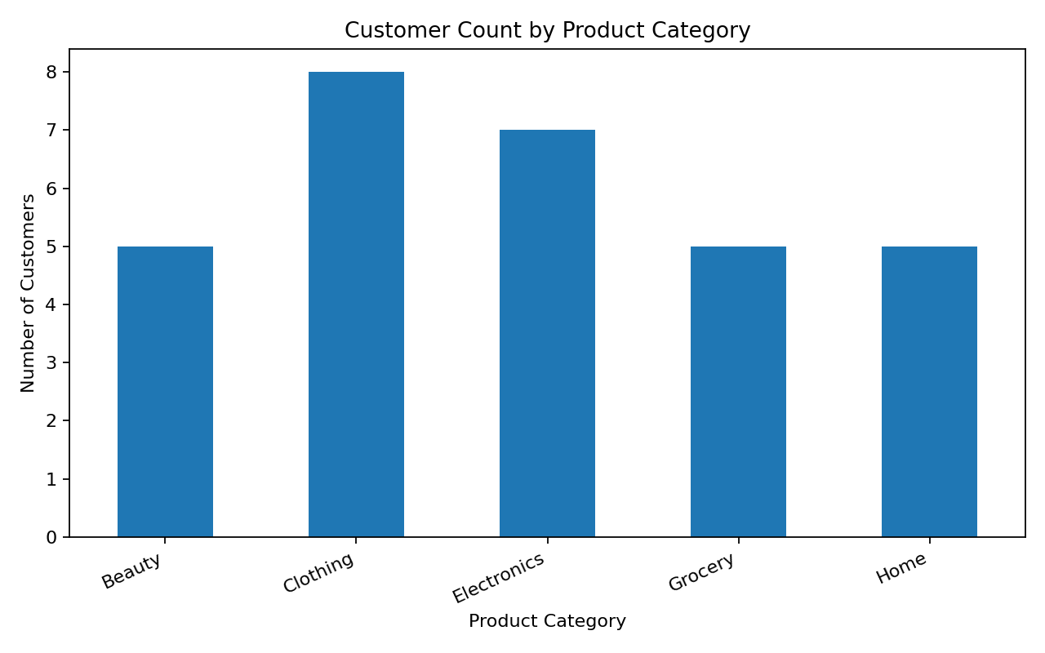

8. Conclusion
The project demonstrates a complete introductory preprocessing workflow. The duplicate record was removed, missing values were imputed, the identifier was excluded, categorical variables were encoded and numerical features were scaled. A category-distribution chart and cleaned CSV were generated. The resulting table is prepared for further learning and experimentation, but no prediction model is trained in this Week 1 project.

9. Limitations and Good Practice
The sample is small and synthetic, so it should not be used to draw conclusions about real customers. For a real predictive workflow, split data into training and test sets before fitting imputers, encoders or scalers; fit transformations on training data only and apply them to held-out data. A Scikit-learn Pipeline is a good next step when the student is ready.

10. Screenshots to Add Before Submission
(1) VS Code showing the project folder
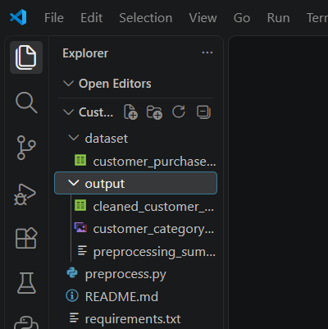
(2) terminal showing the command python preprocess.py and successful output
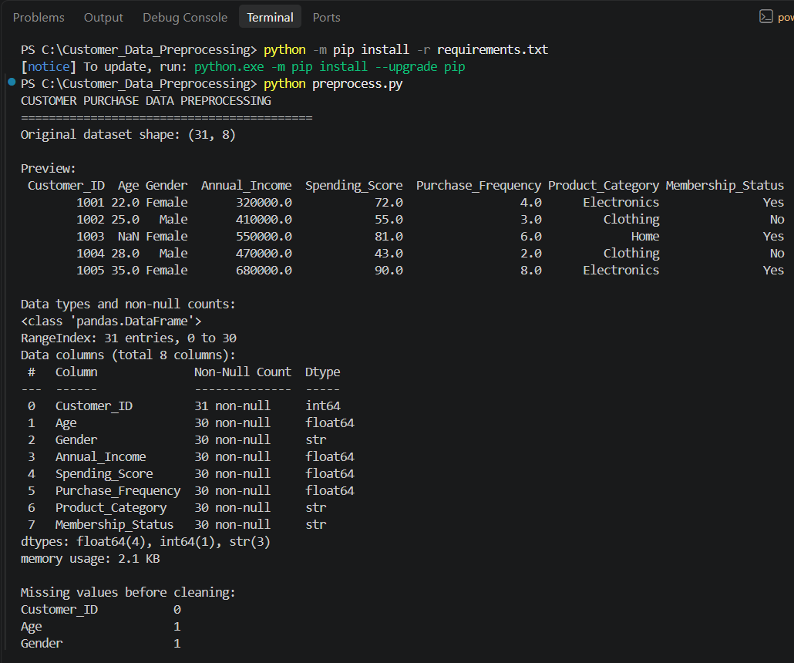
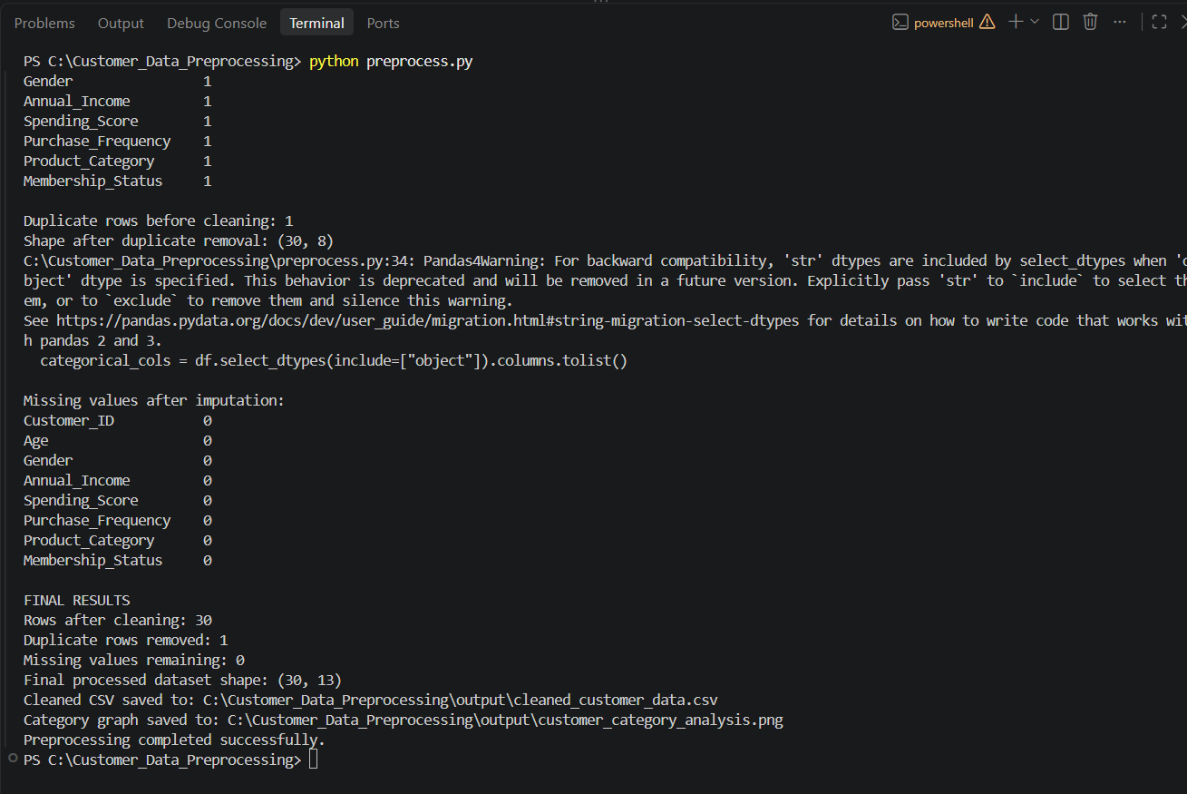
(3) the generated category graph .
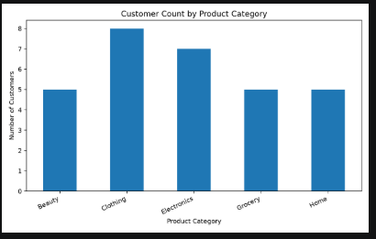

(4) the cleaned CSV opened in VS Code .


