YUVaintern – WEEK 2 PROJECT REPORT
Supervised Machine Learning Models

1. Project Summary
This project builds supervised machine learning models for two problem types: regression and classification. It uses Scikit-learn datasets and compares multiple algorithms with suitable evaluation metrics.

2. Objectives
- Understand supervised learning and the difference between regression and classification.
- Train Linear Regression, Logistic Regression, Decision Tree, Random Forest, and K-Nearest Neighbors models.
- Split labelled data into training and testing sets and generate predictions.
- Compare models using regression and classification performance metrics.
- Save charts, confusion matrix, and metric tables for documentation.

3. Tools and Libraries
Python, NumPy, Pandas, Matplotlib, and Scikit-learn. The project can be run locally in Visual Studio Code.

4. Datasets and Methodology
Regression uses the Scikit-learn Diabetes dataset. Classification uses the Scikit-learn Breast Cancer Wisconsin dataset. Both datasets are split into 80% training and 20% testing data with random_state=42. The classification split is stratified to preserve class proportions. StandardScaler is applied inside Pipelines for Logistic Regression and KNN, preventing the scaler from learning from the test set.
Regression algorithms: Linear Regression, Decision Tree Regressor, Random Forest Regressor, and KNN Regressor. Classification algorithms: Logistic Regression, Decision Tree Classifier, Random Forest Classifier, and KNN Classifier.

5. Evaluation Metrics
Regression: MAE (average absolute prediction error), RMSE (penalizes larger errors more strongly), and R-squared (variance explained). Classification: Accuracy, Precision, Recall, F1-score, and ROC-AUC. A confusion matrix is also generated for the best classifier by F1-score.

6. Results – Regression
The table below shows the measured results from the actual execution of train_models.py. Lower MAE/RMSE is generally better; a higher R-squared is better.
Model | MAE | RMSE | R² Score
Linear Regression | 42.7941 | 53.8534 | 0.4526
KNN | 42.7817 | 54.4933 | 0.4395
Random Forest | 44.3766 | 54.7235 | 0.4348
Decision Tree | 47.0454 | 59.7408 | 0.3264
In this execution, Linear Regression had the lowest RMSE (53.8534), narrowly ahead of KNN and Random Forest. The result indicates that model performance should be compared using test-set metrics rather than assuming a more complex model will always be better.
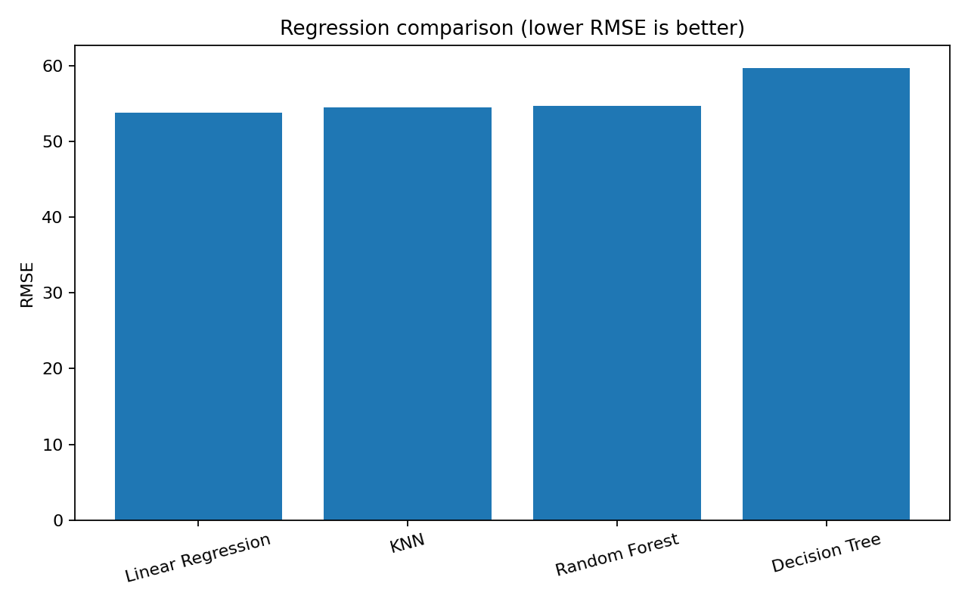
Figure 1. Regression model comparison using RMSE.

7. Results – Classification
Model | Accuracy | Precision | Recall | F1 | ROC-AUC
Logistic Regression | 0.9825 | 0.9861 | 0.9861 | 0.9861 | 0.9954
Random Forest | 0.9561 | 0.9589 | 0.9722 | 0.9655 | 0.9927
KNN | 0.9561 | 0.9589 | 0.9722 | 0.9655 | 0.9788
Decision Tree | 0.9386 | 0.9577 | 0.9444 | 0.9510 | 0.9342
Logistic Regression was the best classifier by F1-score in this run, with F1-score 0.9861, accuracy 0.9825, and ROC-AUC 0.9954.
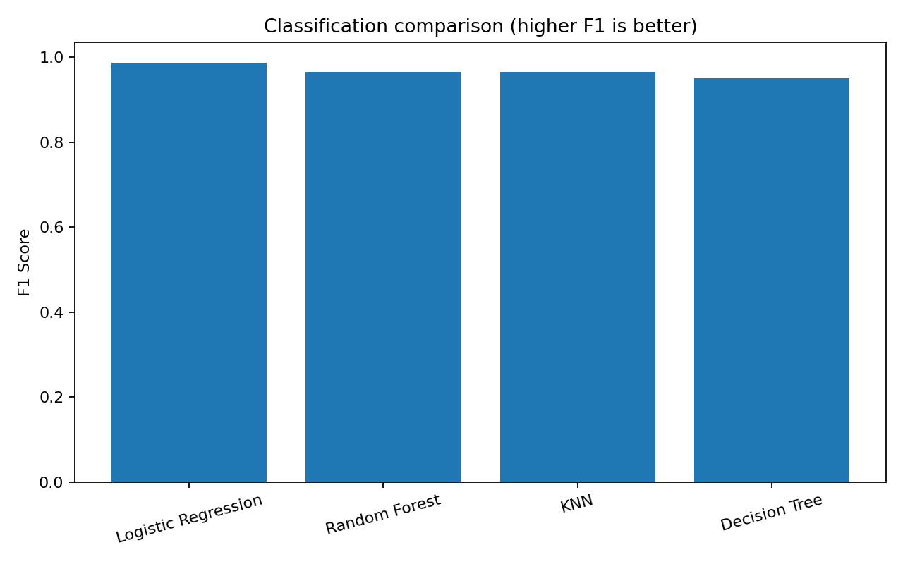
Figure 2. Classification model comparison using F1-score.
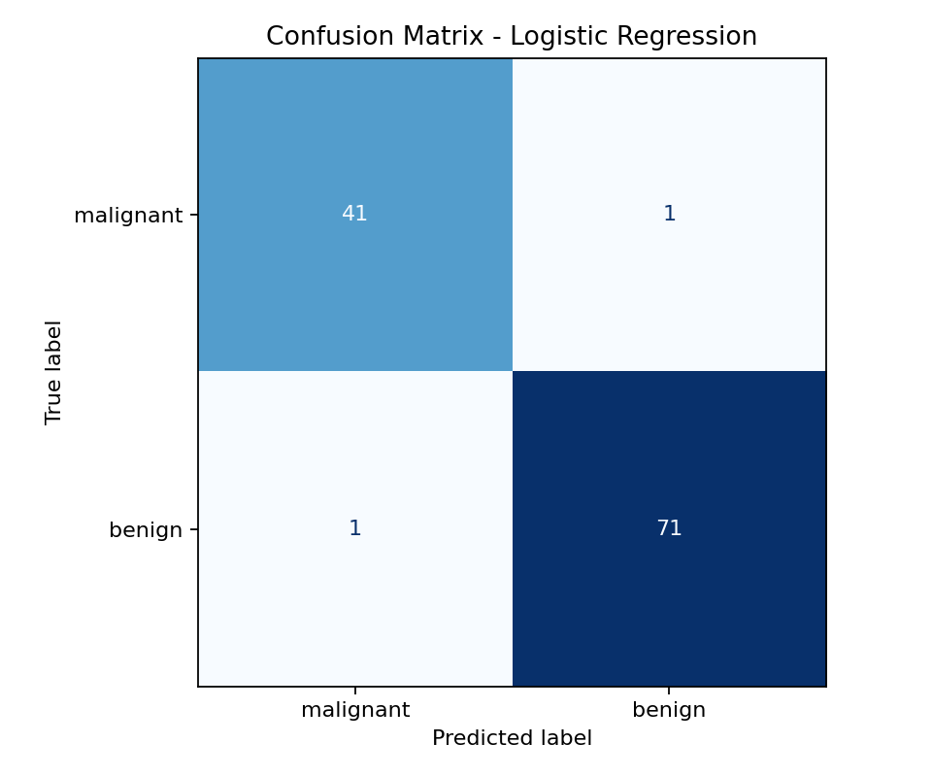
Figure 3. Confusion matrix for the best classification model.

8. Program Execution Evidence
The following capture was generated from the actual console output of running train_models.py. When preparing the final submission, the student should also run the project on their own computer and may add a personal VS Code screenshot if required by the evaluator.
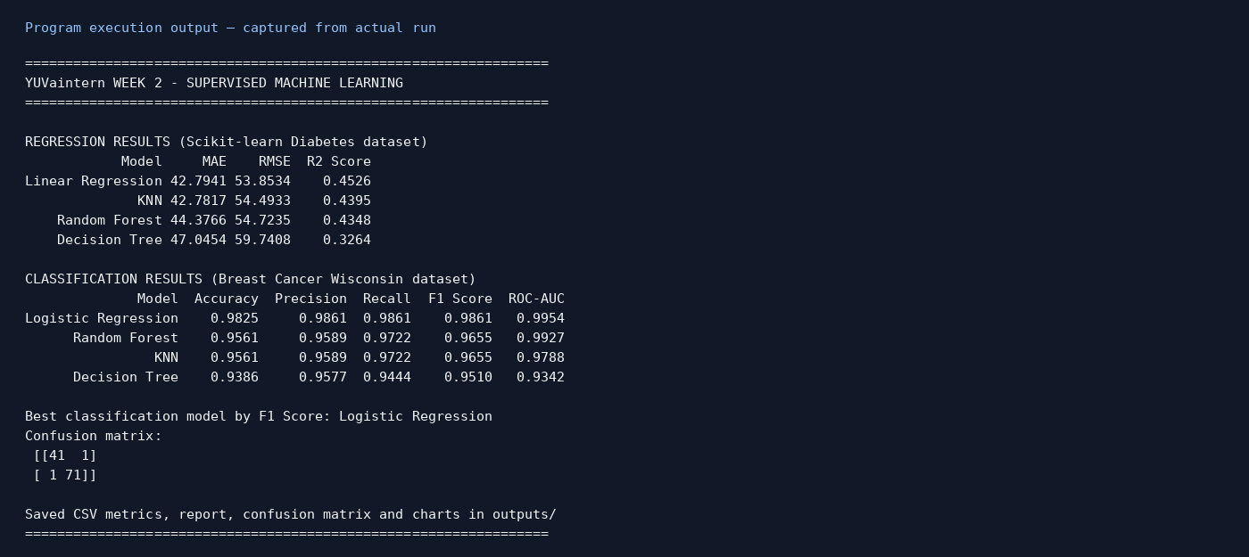
Figure 4. Actual program execution output capture.

9. Conclusion
The project successfully trained and evaluated multiple supervised learning algorithms for both regression and classification. Linear Regression produced the lowest RMSE for the selected regression test split, while Logistic Regression achieved the highest F1-score for classification. The experiment demonstrates the importance of selecting metrics according to the problem type, using a separate test set, and comparing models objectively. These results are specific to the chosen datasets, split, and model settings; they do not guarantee the same ranking on other data.

10. How to Run
- Open the extracted project folder in VS Code.
- Open Terminal > New Terminal.
- Run: python -m venv .venv
- Activate: .venv\\Scripts\\activate
- Install: pip install -r requirements.txt
- Execute: python train_models.py

