YUVaintern – WEEK 4 PROJECT REPORT
AI Project Deployment & Capstone
Iris Species Prediction API

1. Project Summary
This project demonstrates an end-to-end machine-learning workflow. It preprocesses the Iris dataset, trains and evaluates a classification model, saves the fitted pipeline using Joblib, and serves predictions through a Flask REST API.

2. Objectives
Understand data preparation, model training and testing, evaluation, model serialization, and prediction API development.

3. Tools and Libraries
Python, Pandas, NumPy, Scikit-learn, Joblib, Flask, Matplotlib and Visual Studio Code.

4. Dataset and Preprocessing
The public Iris dataset contains 150 observations, four numeric flower measurements and three species classes. The data is split into 80% training and 20% testing data using stratification and random_state=42. StandardScaler is included inside a Scikit-learn Pipeline so the same transformation is applied during training and prediction.

5. Model Training and Serialization
A RandomForestClassifier with 200 trees is trained inside the preprocessing pipeline. The complete fitted pipeline is saved as models/iris_model.joblib. This keeps preprocessing and prediction together.

6. Test-Set Evaluation
The following metrics were calculated on the held-out test set: accuracy = 0.9000, precision macro = 0.9024, recall macro = 0.9000, f1 macro = 0.8997. The confusion matrix and classification report are included in outputs.

7. Flask Prediction API
GET / provides API information, GET /health reports whether the model is loaded, and POST /predict accepts a JSON object with all four required features. It validates input and returns the predicted species and class probabilities.

8. Testing
test_app.py checks the home route, health route, valid prediction and missing input. Run: python -m unittest test_app.py.

9. How to Run
Create a virtual environment, activate it, install requirements, run python train_model.py, then run python app.py. The README contains the exact PowerShell commands and an example prediction request.

10. Limitations and Good Practice
This is a small educational example using a public dataset, not a high-stakes application. Load Joblib/Pickle files only from trusted sources. A production service would need authentication, HTTPS, logging, monitoring and deployment configuration.

12. Project Files
train_model.py – training and evaluation; app.py – Flask API; test_app.py – API tests; models/iris_model.joblib – serialized pipeline; outputs/ – metrics and confusion matrix; README.md – setup and usage.
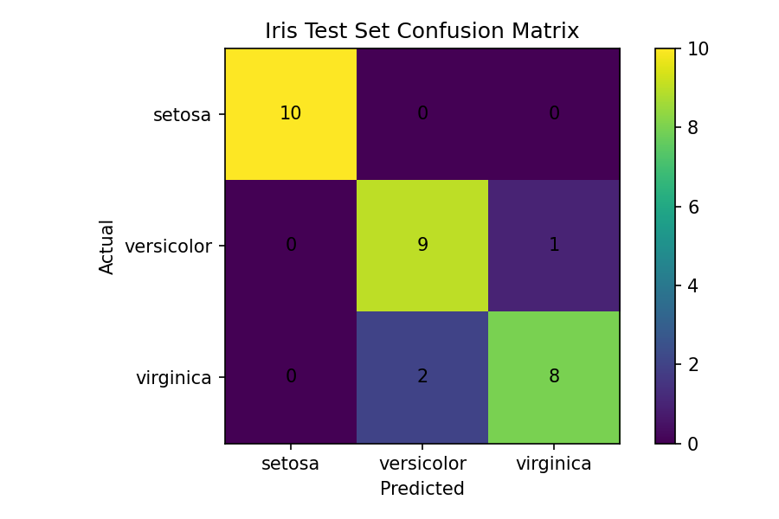
Figure 1. Confusion matrix for the held-out Iris test set.

13. Supporting screenshots
1. files and folders in vs code
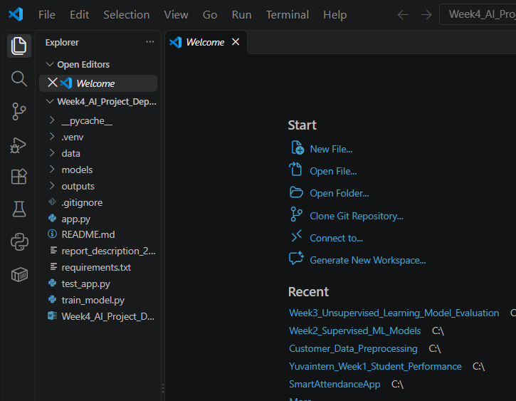
2. training ml model.
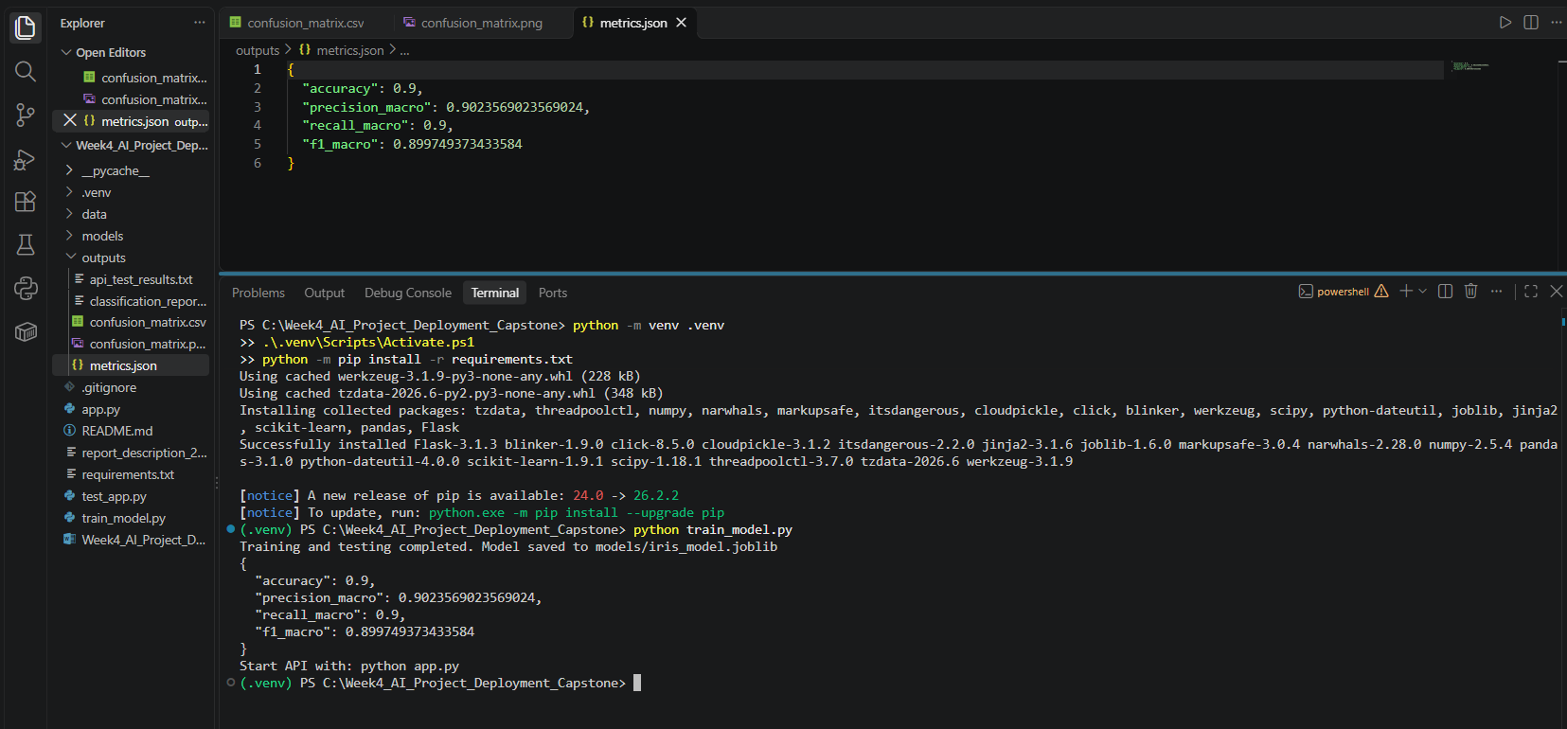
3. output of the project.
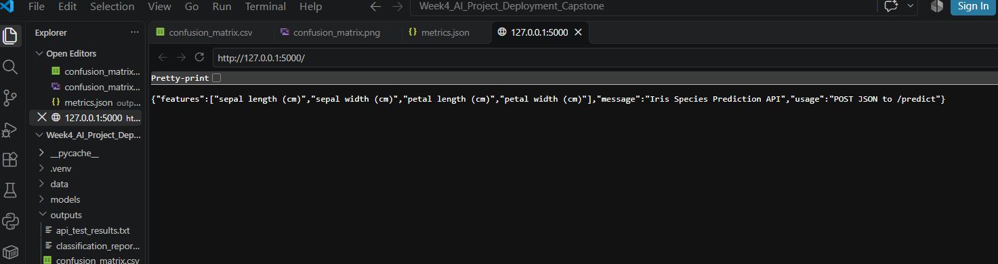
4. by providing information on iris flower.


