Structure of DNA

James Watson and Francis Crick discovered DNA double helical structure in 1953
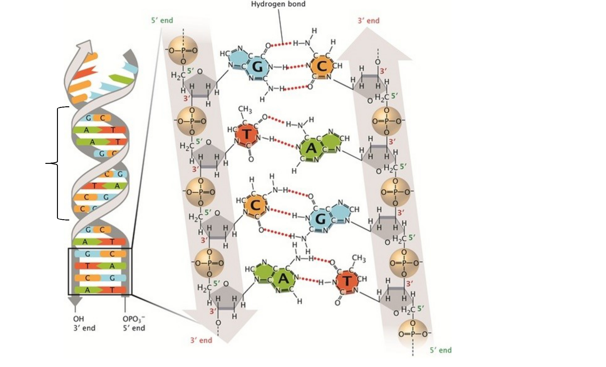

Complementary

AT

GC

Covalent bond

3.4 nm | Direction: 5’-3’ (convention)
3.4 nm |  | Anti-parallel
 | Backbone and ladder
 | Sequence: TAGCTTGA
 |  | Complementary?

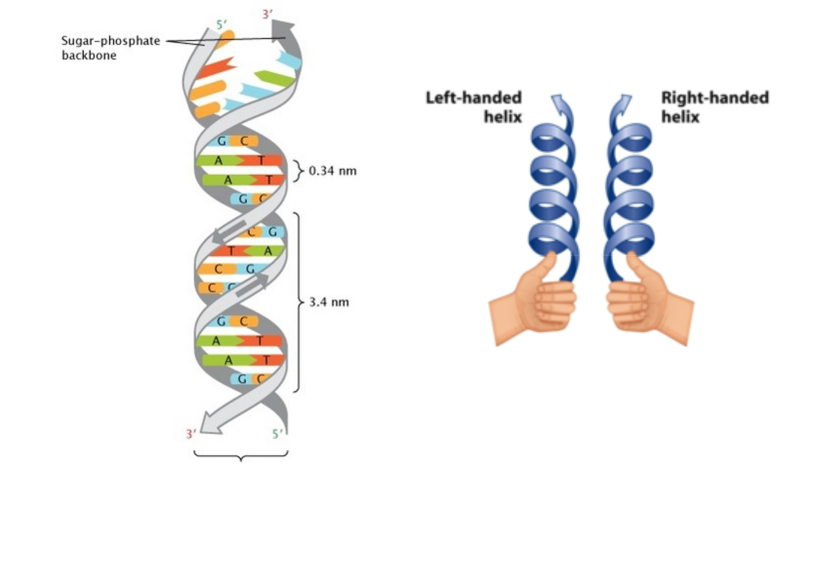

Types of DNA
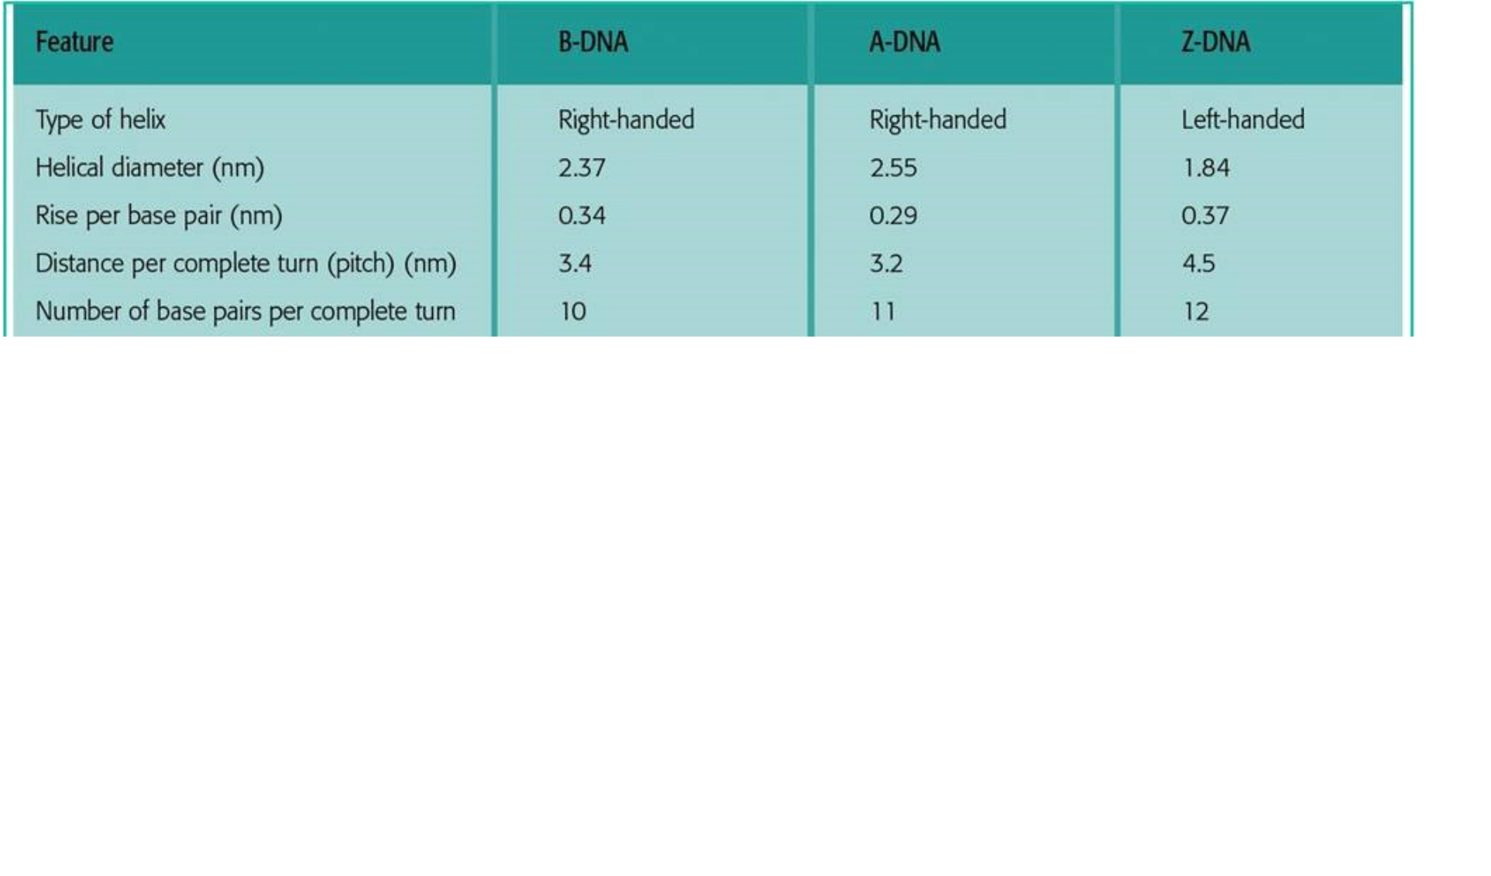

The most common form, present in most DNA is B-form. A small amount of the DNA in a cell exists in the Z form.
Structure of RNA
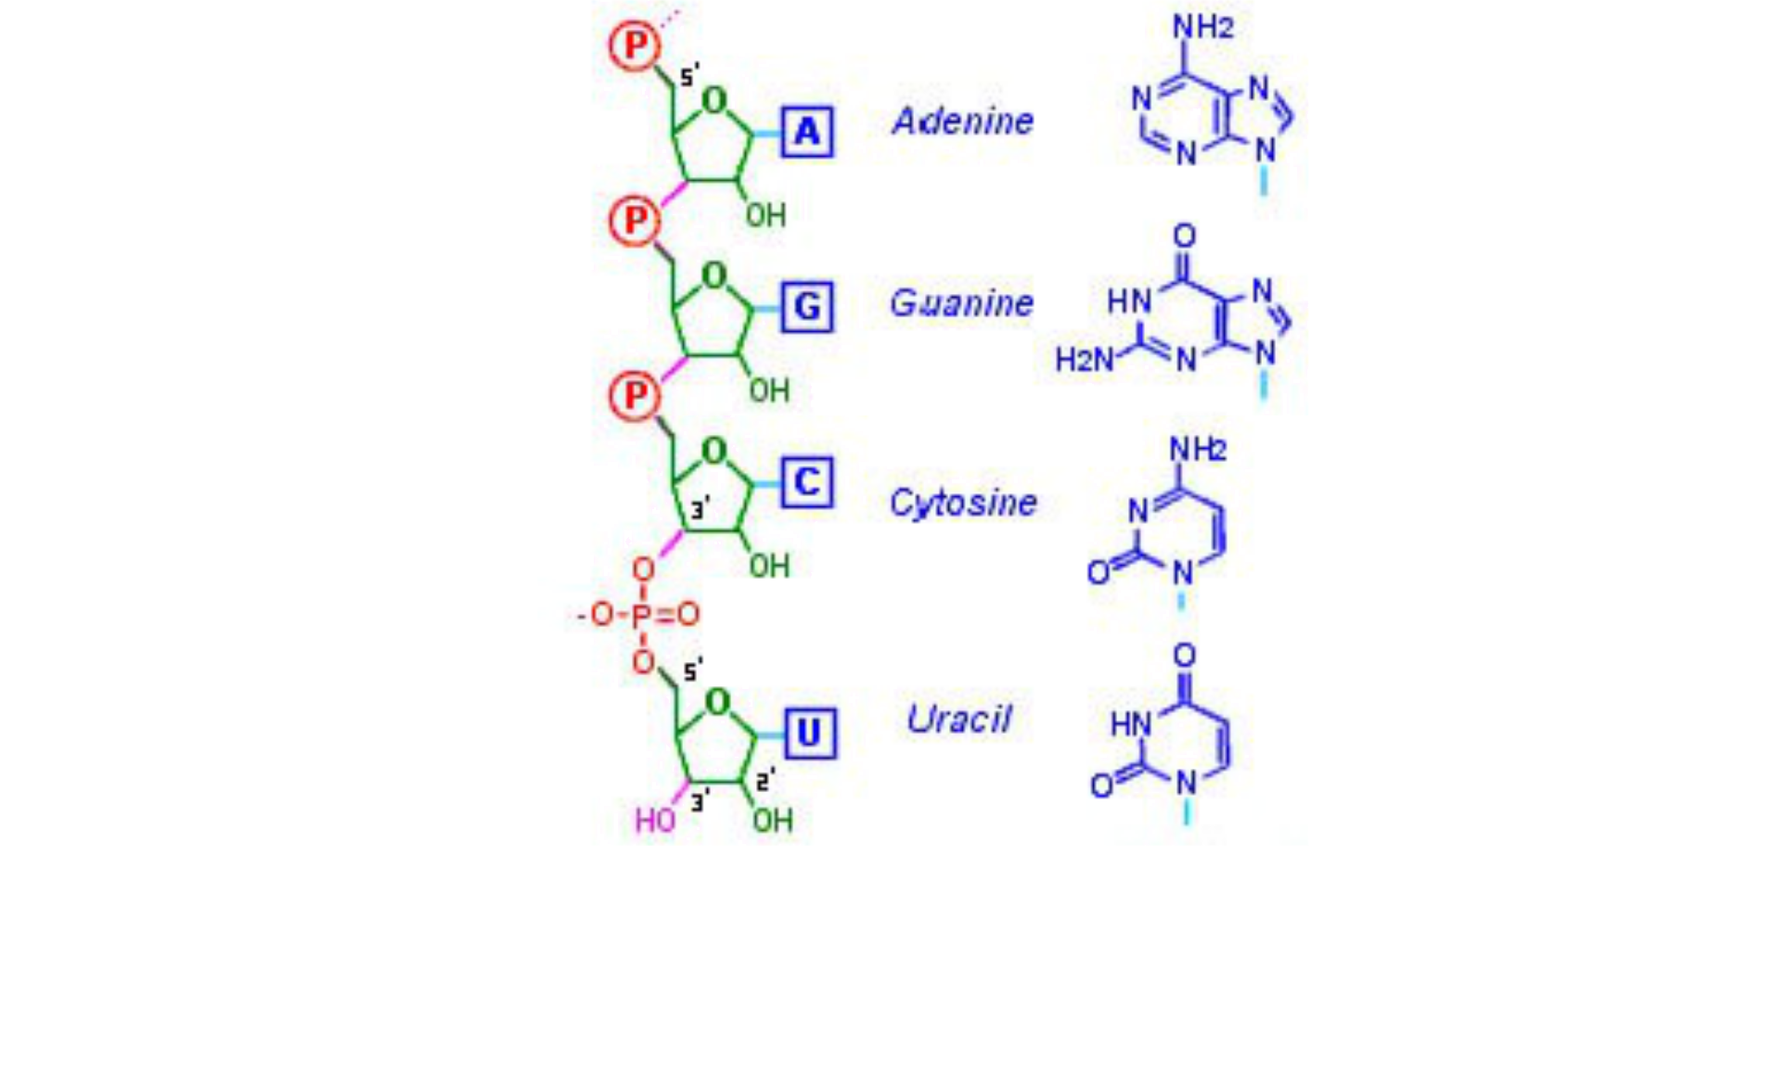
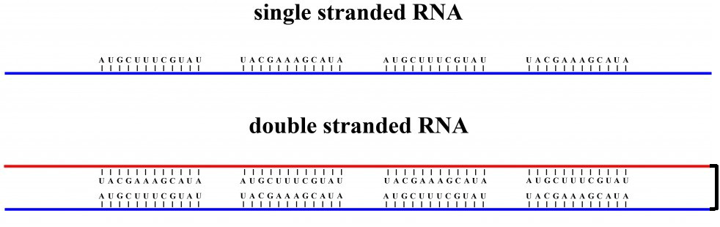


Molecular Biology

The biomolecules are molecules that are present in living organisms.

Examples of important biomolecules: Proteins, carbohydrates, lipids, and nucleic acids.

Molecular biology is the branch of biology that deals with the structure, function, and
DNA as a genetic materials (Fred Griffith, 1928)
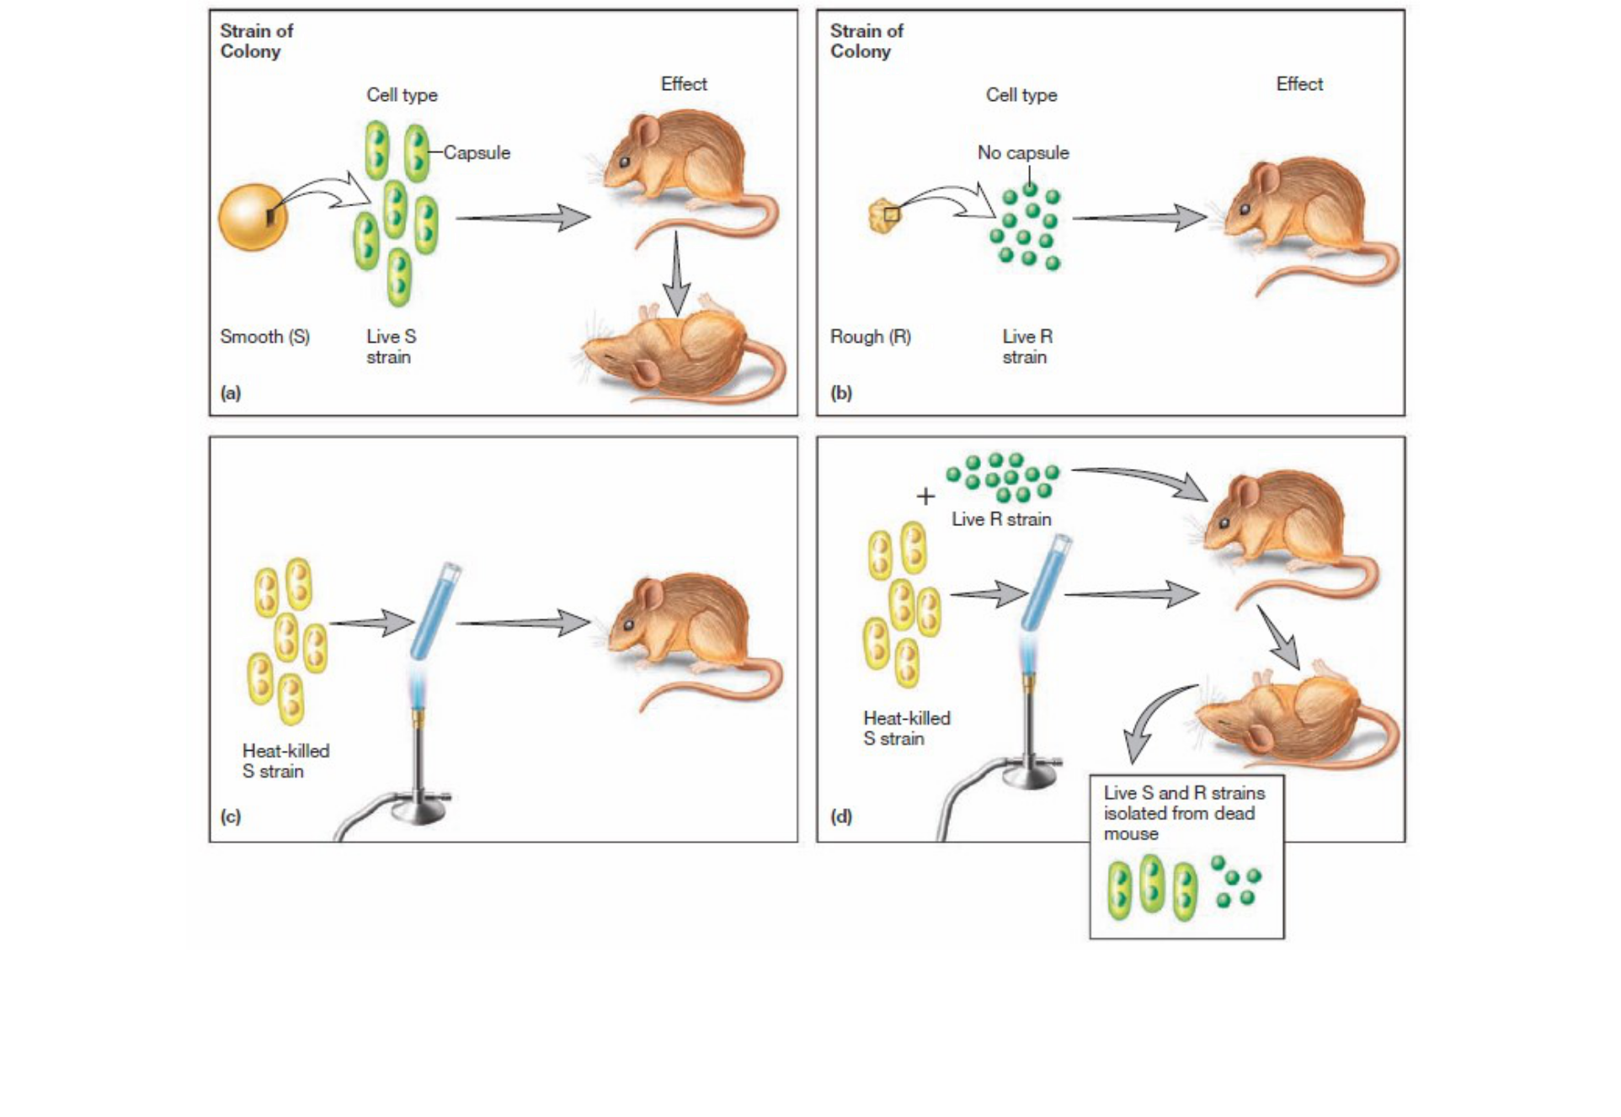

Griffith’s Transformation Experiments. (a) Mice died of pneumonia when injected with pathogenic strains of S pneumococci, which have a capsule and form smooth-looking colonies. (b) Mice survived when injected with a nonpathogenic strain of R pneumococci, which lacks a capsule and forms rough colonies. (c) Injection with heat-killed strains of S pneumococci had no effect. (d) Injection with a live R strain and a heat-killed S strain gave the mice pneumonia, and live S strain pneumococci could be isolated from the dead mice.

DNA as a genetic material

Although it is now hard to imagine, it was once thought that DNA was too simple a molecule to store genetic information. The early work of Fred Griffith in 1928 on the transfer of virulence in the pathogen Streptococcus pneumoniae, set the stage for research showing that DNA was indeed the genetic material.

Griffith found that if he boiled virulent bacteria and injected them into mice, the mice were not affected and no pneumococci could be recovered from the animals. When he injected a combination of killed virulent bacteria and a living non-virulent strain, the mice died; moreover, he could recover living virulent bacteria from the dead mice. Griffith called this change of non-virulent bacteria into virulent pathogens transformation.
 | Oswald Avery, C. M. MacLeod, and M. J.
/RNA/Protein | McCarty (1944)
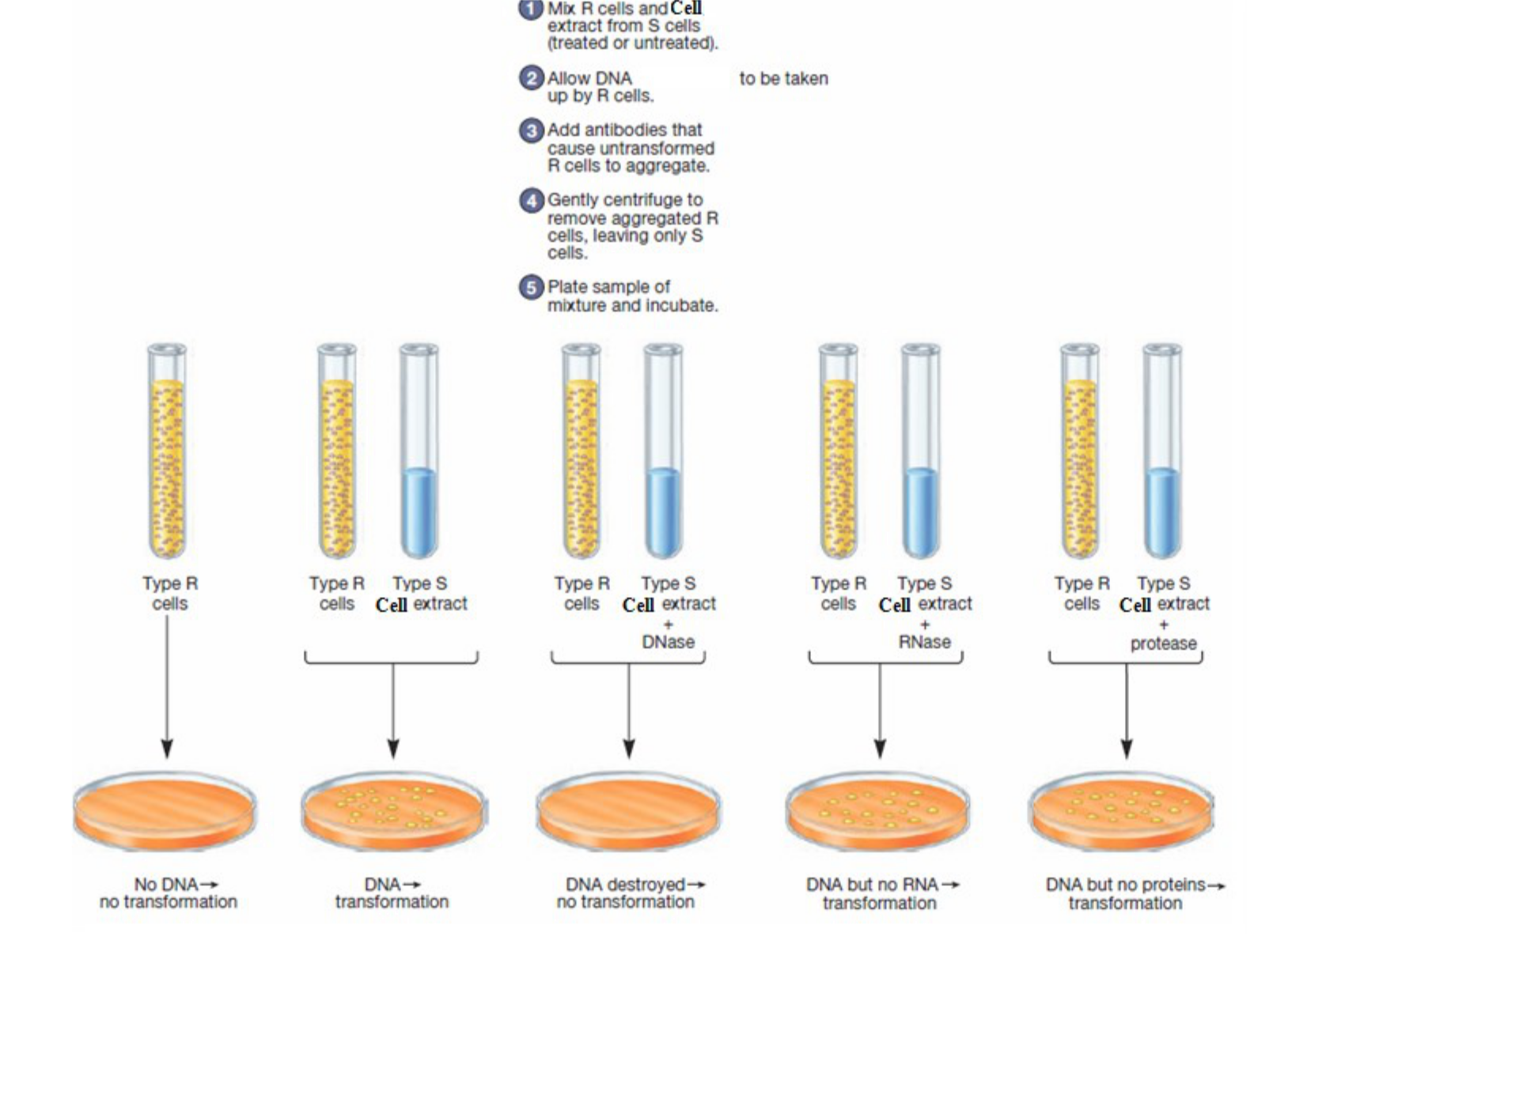

Antigen, antibody

DNase, RNase, Protease

Oswald Avery, C. M. MacLeod, and M. J. McCarty (1944) had shown that only DNA extracts from S cells caused transformation of R cells to S cells.To demonstrate that contaminating molecules in the DNA extract were not responsible for transformation, the DNA extract from S cells was treated with RNase, DNase, and protease and then mixed with R cells. Time was allowed for the DNA from S cells to be taken up by the R cells and expressed, transforming R cells into S cells.Then, antibodies (immune system proteins that recognize specific structures) that recognized R cells,but not S cells,were added to the mixture.The addition of antibodies caused the R cells (i.e., those R cells that had not been transformed) to aggregate.These aggregated R cells were removed from the mixture by gentle centrifugation.Thus, the only cells remaining in the mixture were cells that had been transformed and were now S cells.Only treatment of the DNA extract from S cells with DNase destroyed the ability of the extract to transform the R cells.

Oswald Avery and his colleagues then set out to discover which constituent in the heat-killed virulent pneumococci was responsible for Griffith’s transformation. These investigators selectively destroyed constituents in purified extracts of virulent pneumococci (S cells), using enzymes that would hydrolyze DNA, RNA, or protein. They then exposed nonvirulent

bacteria was blocked only if the DNA was destroyed, suggesting that DNA was carrying the information required for transformation. The publication of these studies by Avery, C. M. MacLeod, and M. J. McCarty in 1944 provided the first evidence that Griffith’s transforming principle was DNA and therefore that DNA carried genetic information.

