MONTH WISE Plots of the features

JAN

1:YearAvgI_HP(yearly avg of Irradiation over the horizontal plane)

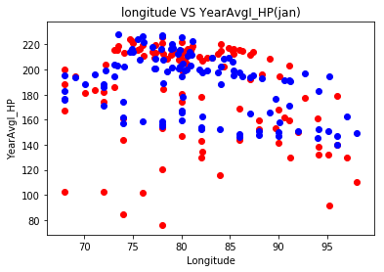

2:YearAvgI_IncP

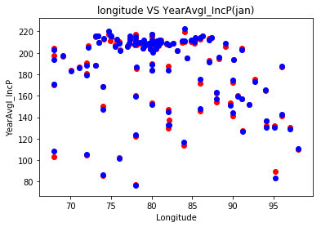

3:YearAvgI_B

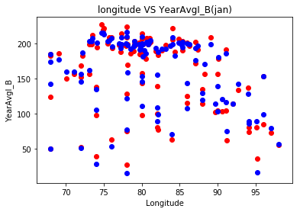

4: OptSlopeAngle

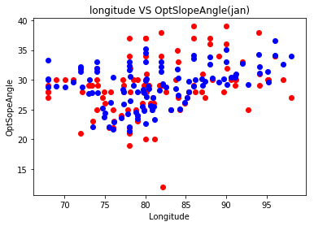

5: Ratio_D_G

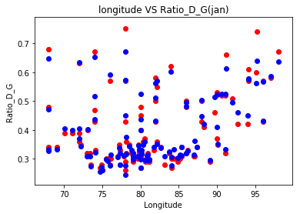

FEB

1:YearAvgI_HP(yearly avg of Irradiation over the horizontal plane)

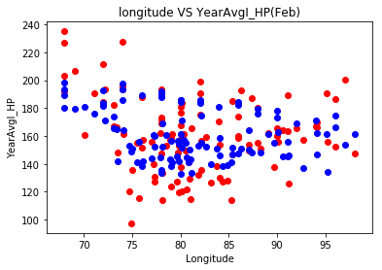

2:YearAvgI_IncP

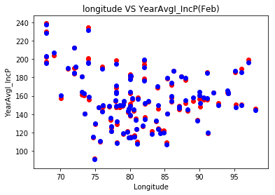

3:YearAvgI_B

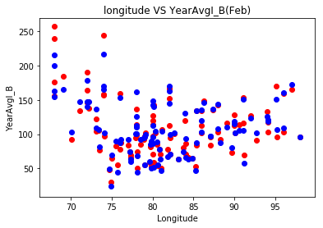

4: OptSlopeAngle

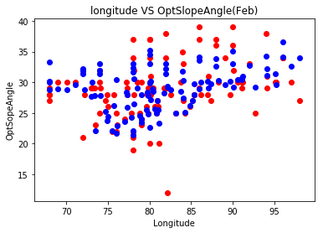

5: Ratio_D_G

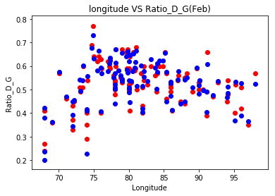

March

1:YearAvgI_HP(yearly avg of Irradiation over the horizontal plane)

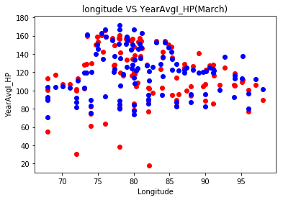

2:YearAvgI_IncP

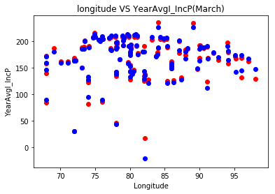

3:YearAvgI_B

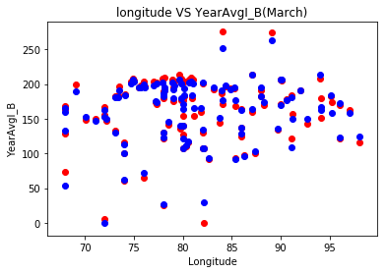

4: OptSlopeAngle

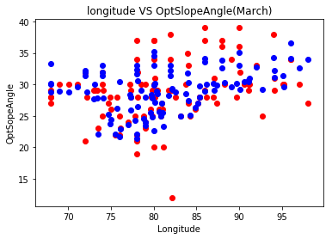

5: Ratio_D_G

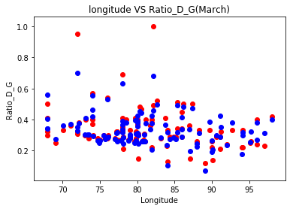

April

1:YearAvgI_HP(yearly avg of Irradiation over the horizontal plane)

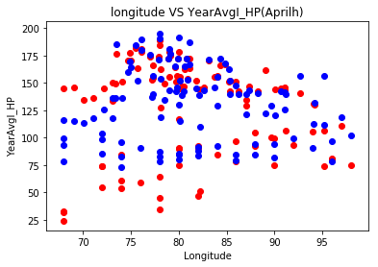

2:YearAvgI_IncP

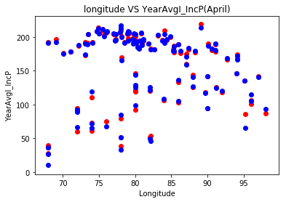

3:YearAvgI_B

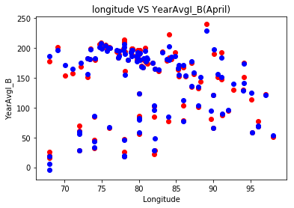

4: OptSlopeAngle

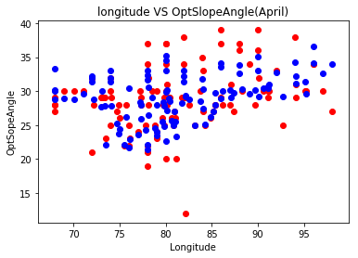

5: Ratio_D_G

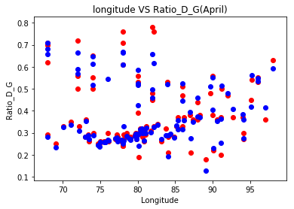

May

1:YearAvgI_HP(yearly avg of Irradiation over the horizontal plane)

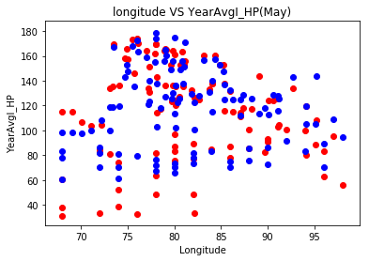

2:YearAvgI_IncP

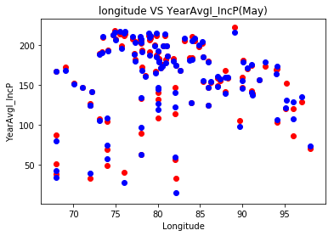

3:YearAvgI_B

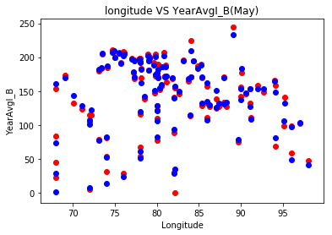

4: OptSlopeAngle

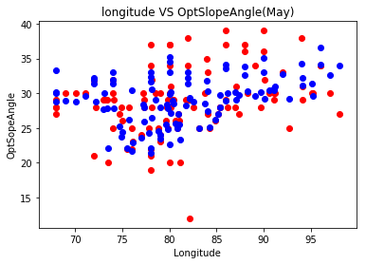

5: Ratio_D_G

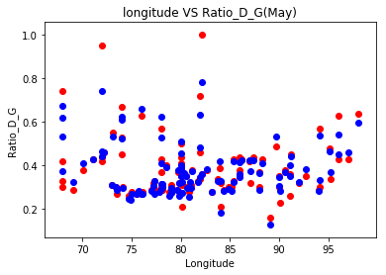

June

1:YearAvgI_HP(yearly avg of Irradiation over the horizontal plane)

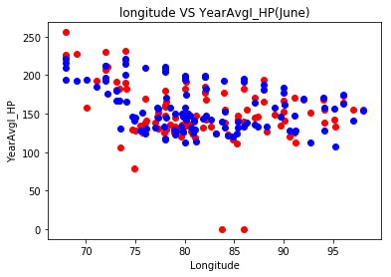

2:YearAvgI_IncP

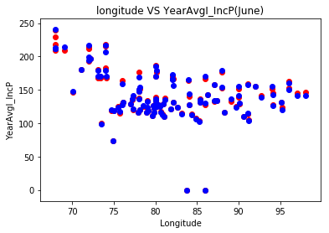

3:YearAvgI_B

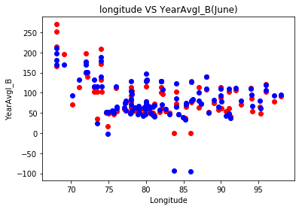

4: OptSlopeAngle

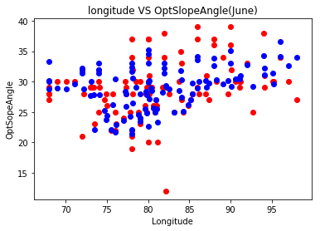

5: Ratio_D_G

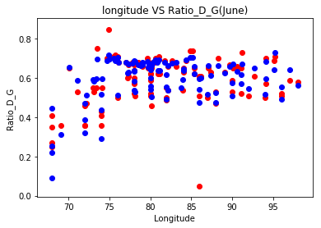

July

1:YearAvgI_HP(yearly avg of Irradiation over the horizontal plane)

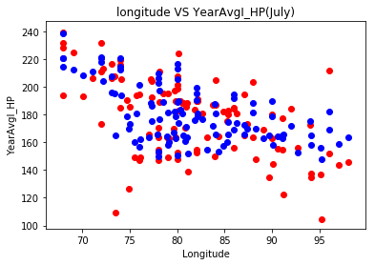

2:YearAvgI_IncP

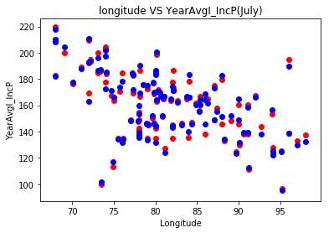

3:YearAvgI_B

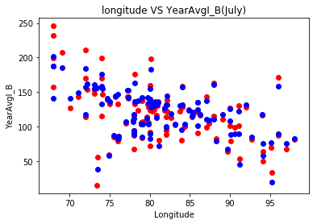

4: OptSlopeAngle

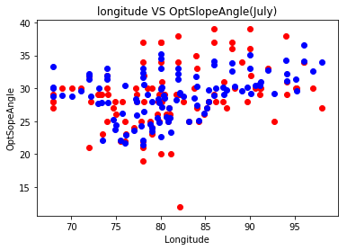

5: Ratio_D_G

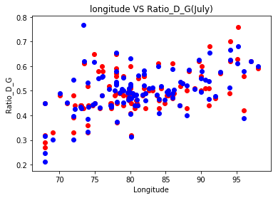

August

1:YearAvgI_HP(yearly avg of Irradiation over the horizontal plane)

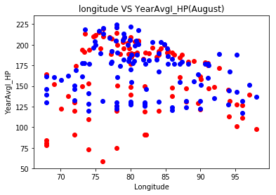

2:YearAvgI_IncP

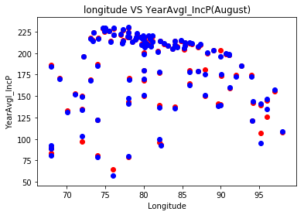

3:YearAvgI_B

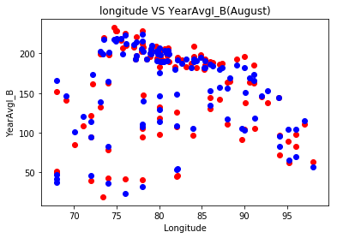

4: OptSlopeAngle

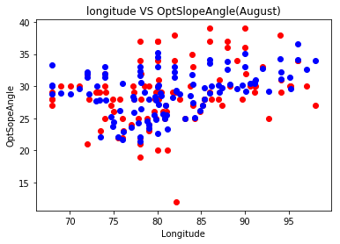

5: Ratio_D_G

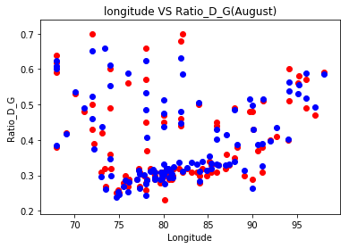

September

1:YearAvgI_HP(yearly avg of Irradiation over the horizontal plane)

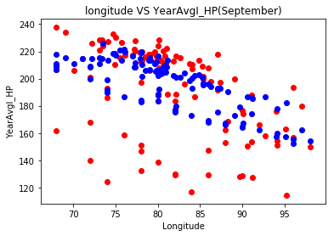

2:YearAvgI_IncP

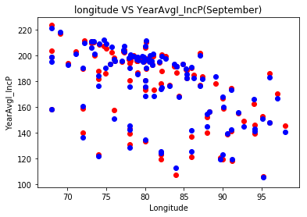

3:YearAvgI_B

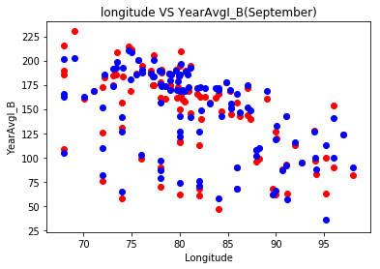

4: OptSlopeAngle

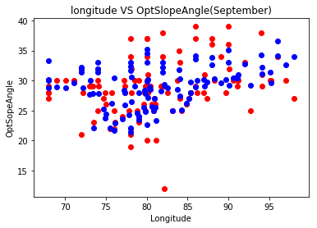

5: Ratio_D_G

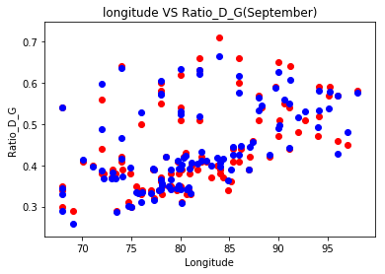

October

1:YearAvgI_HP(yearly avg of Irradiation over the horizontal plane)

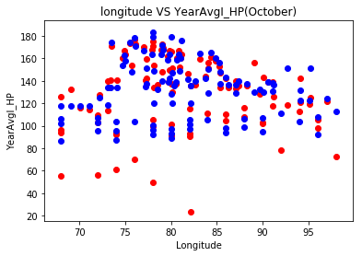

2:YearAvgI_IncP

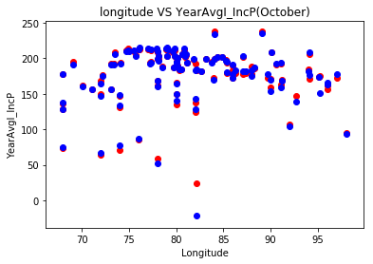

3:YearAvgI_B

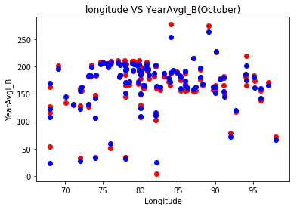

4: OptSlopeAngle

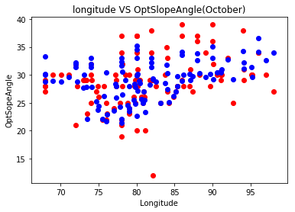

5: Ratio_D_G

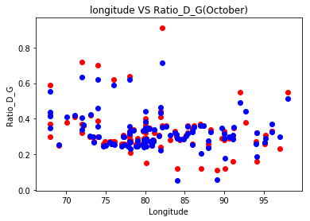

November

1:YearAvgI_HP(yearly avg of Irradiation over the horizontal plane)

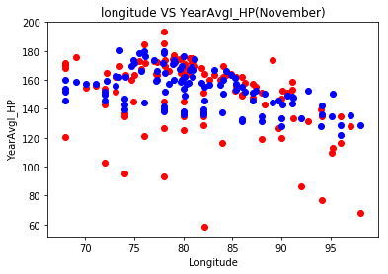

2:YearAvgI_IncP

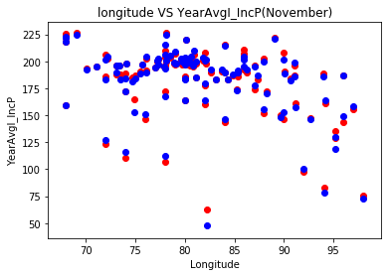

3:YearAvgI_B

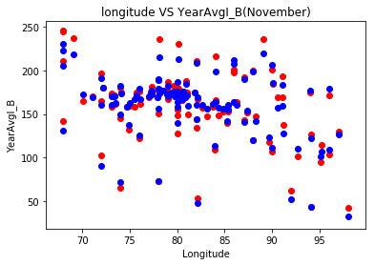

4: OptSlopeAngle

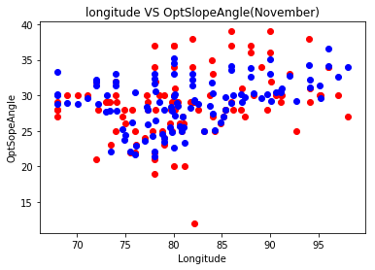

5: Ratio_D_G

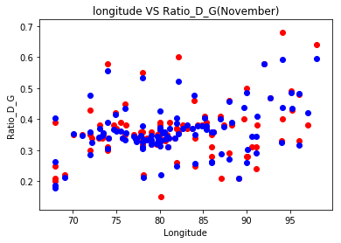

December

1:YearAvgI_HP(yearly avg of Irradiation over the horizontal plane)

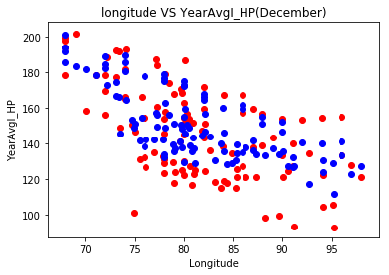

2:YearAvgI_IncP

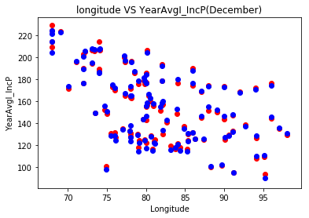

3:YearAvgI_B

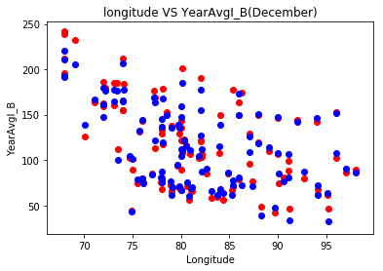

4: OptSlopeAngle

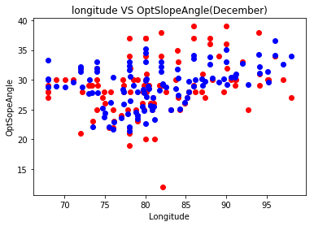

5: Ratio_D_G

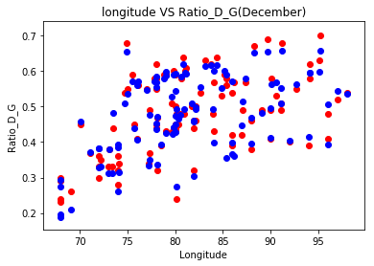

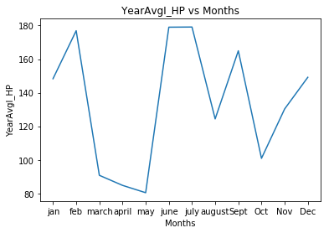

Region 2

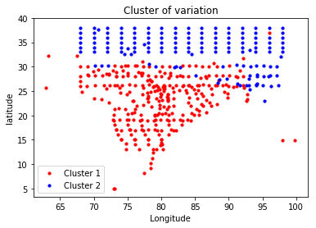

Region 1

