**LAB-2 Report**

**Instructor: Dr. Yang Gao  
Date: 13/12/2021**

**Naman Agarwal**

**UCID: 30138256**

**ENGO 629**

Contents

1

Task 1– Robust Least Square Implementation and Computation 2

1.1 Implement the Robust Least Square method based on influence-function (applying an influence-function of your choice). 2

1.2 Compute the solutions of the unknown parameters from the Robust Least Squares method using data provided in Lab 1. 3

ENGO 629 Data Results and Graphs 4

ENGO-625 Data Results and Graphs(For Remote Receiver) 7

Task 2 – Result Comparison and Analysis 10

Compare and analyze the unknown parameter solutions from the Standard Least-Squares method in Lab 1 and the Robust Least-Squares method. 10

ENGO-625 Data Results and Graphs( Between-Single-Receiver-Differenced Measurements using Remote and Base Station Data) 11

Final Conclusion 13

References 13

# Task 1– Robust Least Square Implementation and Computation

## Implement the Robust Least Square method based on influence-function (applying an influence-function of your choice).

I have implemented all the three Robust Least Squares(LS) methods/M-estimators discussed in the class(Gao, 2004). Following are the weight functions associated with the three methods.

Table : Weight Function of M-Estimators

|  |  |  |
| --- | --- | --- |
| Huber | Hampel | Andrew |
|  |  |  |
|  | | |

I have implemented M-estimators mentioned above using the following Iteratively Reweighted Least-Squares(IRLS) method(Medina et al., 2019)

Equation : IRLS Procedure

|  |  |
| --- | --- |
|  | |
| Step 1: | Update residuals: |
| Step 2: | Update Scale:  Where,  a normalizing constant (≈1.4815 to make MAD consistent with the usual parameters at Gaussian distributions) |
| Step 3: | Update Weights() using one of the weight functions described in Table 1 |
| Step 4: | Perform WLS: |
| Step 5: | **,**  wheredenote the maximum number of iterations of the iterative Gauss-Newton method and the convergence criteria |

## Compute the solutions of the unknown parameters from the Robust Least Squares method using data provided in Lab 1.

I have applied Robust LS methods on two different sets of data.

1. ENGO 629 Lab data
2. ENGO 625 Lab data

Following is the data description for both datasets.

Table : Data Description

|  |  |  |
| --- | --- | --- |
| Item | ENGO 629 | ENGO 625 |
| Data Type( Static or Kinematic) | Kinematic | Static |
| Sampling interval | 1Hz | 1Hz |
| No. of Receivers | One Trimble R8 Receiver | 1 Novatel Remote Receiver  1 Base Station Receiver |
| Data Quality | High Quality: All major errors are removed. | Low Quality: Ionospheric Error is present. Can perform in-between receiver single differencing to remove errors. |

Solutions and corresponding graphs are presented for both datasets. Comparison and Analysis is performed for the results obtained from both datasets.

### ENGO 629 Data Results and Graphs

Table : Tuning Constant Settings NO. 1 for each M-Estimator

|  |  |  |  |
| --- | --- | --- | --- |
| Tuning Constant Method | a | b | c |
| Huber | 1.5 | x | x |
| Hampel | 1.5 | 3.8 | 8.0 |
| Andrew | x | x | 2.1 |
| Kindly refer to Table 1 to understand how each constant is assigned to the weight functions | | | |

Table : RMSE(in m) results for ENGO 629 data

|  |  |  |  |  |  |
| --- | --- | --- | --- | --- | --- |
| RMSE(m)/Method | Least Squares | Weighted Least Squares | Huber Robust LS | Hampel Robust LS | Andrew Robust LS |
| Easting | 0.6797 | 0.6604 | 0.6931 | 0.6987 | 0.6798 |
| Northing | 1.4703 | 1.5016 | 1.4684 | 1.4685 | 1.4699 |
| Up | 1.9104 | 1.9265 | 1.9273 | 1.9346 | 1.9093 |
| 3d Error | 2.5047 | 2.5304 | 2.5202 | 2.5274 | 2.5036 |
| 2d Error | 1.6198 | 1.6404 | 1.6238 | 1.6262 | 1.6195 |
| Tuning Constant Setting No.1 (Table 3) has been used for Robust LS | | | | | |

Figure : East Error(in m) for ENGO-629 data

Figure : North Error(in m) for ENGO-629 Data

Figure : Up Error(in m) for ENGO-629 Data

Figure : 2D Error(in m) for ENGO-629 Data

Figure : 3D RMSE(in m) for ENGO-629 Data

### ENGO-625 Data Results and Graphs(For Remote Receiver)

Table : Tuning Constant Settings NO. 2 for each M-Estimator

|  |  |  |  |
| --- | --- | --- | --- |
| Tuning Constant Method | a | b | c |
| Huber | 1.0 | x | x |
| Hampel | 1.0 | 1.5 | 3.0 |
| Andrew | x | x | 0.9 |
| Kindly refer to Table 1 to understand how each constant is assigned to the weight functions | | | |

Table : RMSE(IN M) Results for ENGO 625 Data

|  |  |  |  |  |  |
| --- | --- | --- | --- | --- | --- |
| RMSE(m)/Method | Least Squares | Weighted Least Squares | Huber Robust LS | Hampel Robust LS | Andrew Robust LS |
| Easting | 1.5734 | 1.3470 | 1.6205 | 1.5967 | 1.5660 |
| Northing | 1.1120 | 0.5192 | 1.0492 | 1.0322 | 1.0469 |
| Up | 7.7219 | 7.2910 | 7.3934 | 7.2328 | 7.3939 |
| 3d Error | 7.9587 | 7.4326 | 7.7048 | 7.4785 | 7.6301 |
| 2d Error | 1.9267 | 1.4437 | 1.9305 | 1.9013 | 1.8837 |
| Tuning Constant Setting No.2 (Table 5) has been used for Robust LS | | | | | |

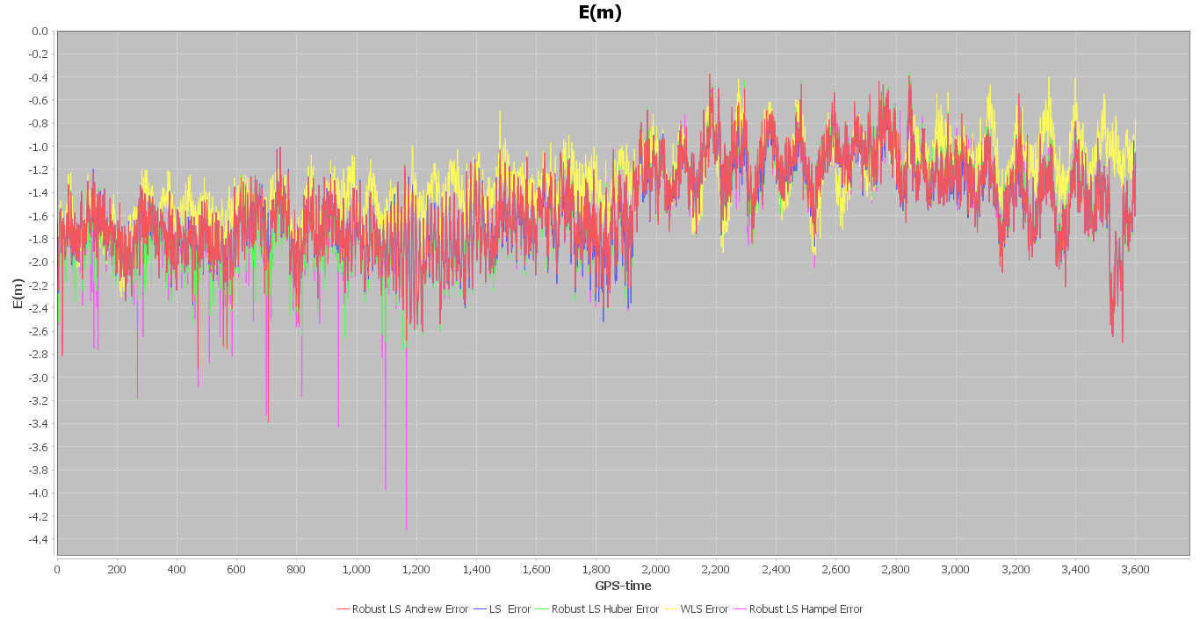

Figure : East Error(in m) for ENGO-625 Data

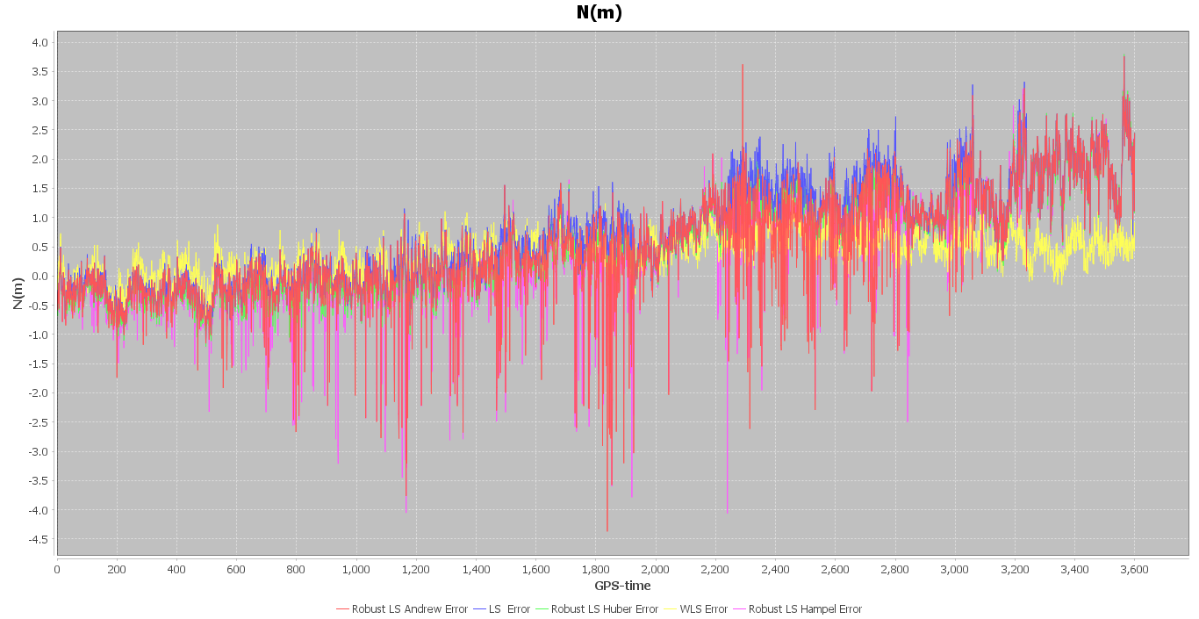

Figure : North Error(in m) for ENGO-625 Data

Figure : Up Error(in m) for ENGO-625 Data

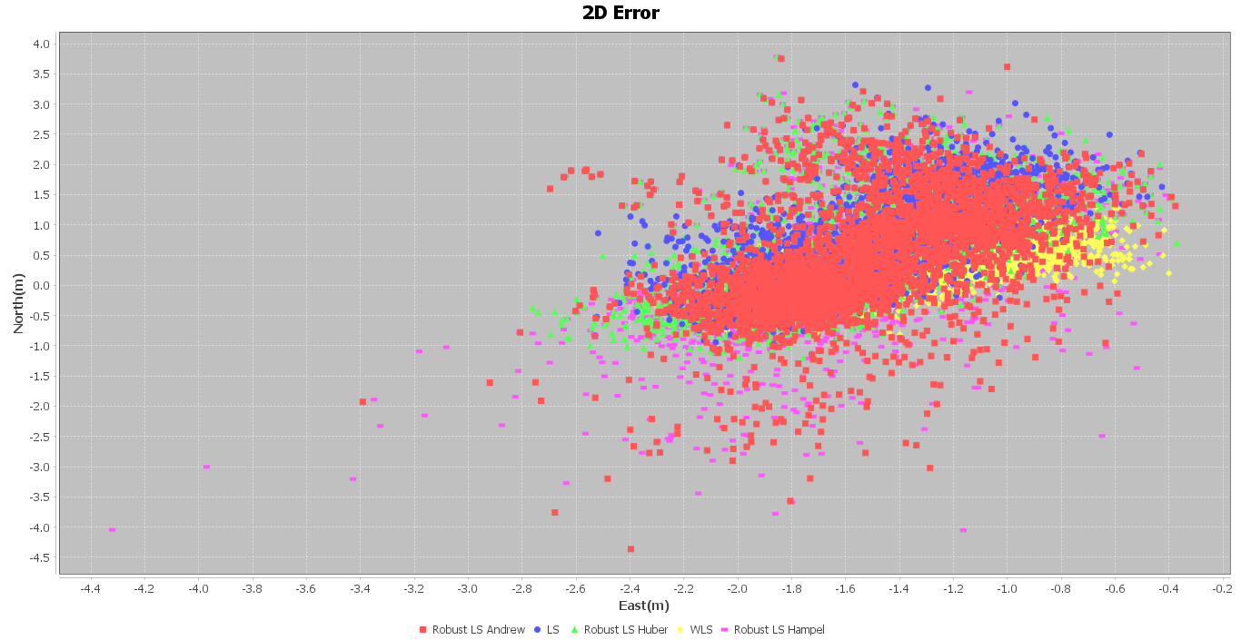

Figure : 2D Error(in m) for ENGO-625 Data

Figure : 3D RMSE(in m) For ENGO-625 Data

# Task 2 – Result Comparison and Analysis

## Compare and analyze the unknown parameter solutions from the Standard Least-Squares method in Lab 1 and the Robust Least-Squares method.

Analyzing the results obtained from ENGO-629 data(pg.3), the position accuracy/error values produced using Robust LS remain almost the same compared to the simple LS(weight = Identity) and WLS method(Table 4). My conclusion for results obtained using the ENGO-629 dataset are as follows:

1. There is certainly no significant advantage of Robust LS over the standard LS method for the ENGO-629 data set.
2. The tuning-constant settings(Table 3) for all the 3 different M-Estimators(Huber, Hampel, and Andrew) were decided using the hit-&-trial method. Even for all the other different combinations of tuning constants, no significant improvement( i.e., improvement in the order of decimeters) was ever observed.
3. The reason can be because the Weighted Least Square(WLS) is the most optimal estimator under perfect model conditions and Robust Least Squares is a suboptimal estimator which degrades the performance under nominal conditions(Medina et al., 2019). The ENGO-629 lab data, as stated in Table 2, is high-quality observation data(Error-Free data) and therefore resembles ideal conditions, which is why Robust LS has minimal to even degrading effect on positional accuracy.

To check the performance of Robust LS against suboptimal GPS observation data, I also tested my M-estimators/Robust LS algorithms against ENGO-625 lab data(pg.7). As stated in Table 2, ENGO-625 lab data is static but contains Ionospheric error. Following are the observations for EGNO-625 dataset:

1. Robust LS methods produce more accurate position results than Simple Least-Square(Weight = Identity), but still worse than the Weighted Least Squares method(Table 6). Following is the positional accuracy performance order:

WLS> Robust LS > LS(Weight=Identity)

Depending on the tuning-constant settings, Robust LS can produce better accuracy in Up(U) direction compared to WLS, but it was observed that 2D or horizontal accuracy for Robust LS have always been significantly worse compared to WLS(Figure 9)

1. The tuning-constant settings(Table 5) for the ENGO-625 dataset are different from ENGO-629. It is again chosen using the hit-&-trial method. A trend can be observed that as tuning constant values are decreased, the Up-Error values decrease, leading to a decrease in 3D RMSE value, but the horizontal(2D) error(East and North component) starts to increase. Still, the decrease in Up-Error is sharper than the increase in East and North Error, and therefore 3D errors decrease although 2D error increase. The constant settings for this dataset was chosen keeping in mind that 2D error for Robust LS don’t exceed the 2D error value produced by Simple Least Squares(Weight = Identity)
2. Among the M-estimators, for the chosen constant settings, the following is the order of 3D accuracy of the methods: Hampel > Andrew > Huber.
3. No definitive comment/conclusion can be made about the efficacy of the three M-estimators used in the experiment. Although Hampel and Andrew are more sophisticated compared to Huber and present an additional challenge of tuning more constants, they also provide the opportunity of defining better boundary conditions and thresholds.

### ENGO-625 Data Results and Graphs( Between-Single-Receiver-Differenced Measurements using Remote and Base Station Data)

To investigate and validate the third point specified under ENGO-629 datasets conclusions(pg.10) of Robust LS being a suboptimal estimator and will never produce better results for ideal dataset compared to Standard Least Squares. I also utilized the base-station data present in ENGO-625 lab dataset and performed between-single-receiver-differencing with respect to remote receiver data, which removed ionospheric error along with other errors and made the data ideal. Following settings and methods were utilized

1. Tuning-constant settings : Table 3
2. Standard Least Squares: Weight=Identity
3. Robust LS: Huber, Hampel, and Andrew

Table : RMSE(in m) for Between-Single-Receiver-Differenced ENGO-625 data

|  |  |  |  |  |
| --- | --- | --- | --- | --- |
| RMSE(m)/Method | Least Squares | Huber Robust LS | Hampel Robust LS | Andrew Robust LS |
| Easting | 0.4130 | 0.4169 | 0.4169 | 0.4133 |
| Northing | 0.5617 | 0.5610 | 0.5630 | 0.5613 |
| Up | 1.0776 | 1.1256 | 1.1341 | 1.0808 |
| 3d Error | 1.2835 | 1.3249 | 1.3331 | 1.2861 |
| 2d Error | 0.6972 | 0.6990 | 0.7006 | 0.6970 |
| Tuning Constant Setting No.1 (Table 3) has been used for Robust LS | | | | |

***NOTE: The term BRSD in the legends of Figures 11 and 12 means Between-Single-Receiver-Differenced. The Yellow Legend, which is defined only as ‘BRSD’ actually means BRSD Standard Least Squares.***

Figure : 2D error (in m) for Between-Single-Receiver-Differenced ENGO-625 data

Figure : 3D RMSE(in m) for Between-Single-Receiver-Differenced ENGO-625 data

No discernible improvement is observed for Robust LS compared to Standard Least Squares(weight=identity). Results in Table 7 and Figures 11 and 12 demonstrate that the Robust LS is suboptimal and will never perform better than Standard Least Squares in ideal conditions.

# Final Conclusion

* For both ENGO-629 and ENGO-625 lab data, Weighted Least Squares always outperforms M-Estimators/ Robust Estimation methods in terms of positional accuracy results.
* Robust Estimators can outperform the Simple Least Squares(Weight=Identity) method for low-quality data.
* In case, Elevation angle or Carrier-Noise ratio(SNR or signal strength), information is unavailable for GNSS observation data. And therefore, the weight matrix based on measurement covariance matrix cannot be determined. Robust Least Square can be used in place of Simple Least Squares(Identity = Weight) for better positional results, especially if the errors are still present in measurements.
* Robust Estimators produce much more noisy results than Standard Least Squares Method, especially in North and Up direction figures 2, 3, 7, and 8.
* Changing tuning constants(a, b, and c) settings may reduce error in Up-Direction, but it will also parallelly increase error in the horizontal plane.
* There is no definitive conclusion on the efficacy of the three M-estimators used(pg.11).

# References

Gao, Y. (2004). ENGO 629: ADVANCED ESTIMATION METHODS AND ANALYSIS. *Undefined*.

Medina, D., Li, H., Vilà-Valls, J., & Closas, P. (2019). Robust Statistics for GNSS Positioning under Harsh Conditions: A Useful Tool? *Sensors 2019, Vol. 19, Page 5402*, *19*(24), 5402. https://doi.org/10.3390/S19245402