PROJECT X

*Report submitted in partial fulfillment of the requirements for the award of degree of*

**Bachelor of Technology**

in

**Computer Science and Engineering**

*Submitted By*

**Roll Nos.- IIITU17314, 17514, 17538, 17547, 17548, 17554,**

**17555, 17566, 17569, 17572, 17574, 17581**



COMPUTER SCIENCE AND ENGINEERING DEPARTMENT

NATIONAL INSTITUTE OF TECHNOLOGY

HAMIRPUR – 177001

**November 2017**

**Acknowledgment**

We would like to express our deepest appreciation to all those who provided us the possibility to complete this report. A special gratitude to our teacher, Ms. Priyanka Raichand , whose contribution in stimulating suggestions and encouragement,  helped us to coordinate the project. Our special thanks and appreciation also goes to our colleagues in developing the project and people who have willingly helped out with their abilities.

**Abstract**

A dot-matrix display is a [display device](https://en.wikipedia.org/wiki/Display_device) used to display information on machines, clocks, railway departure indicators and many other devices requiring a simple display device of limited resolution.

The display consists of a [dot matrix](https://en.wikipedia.org/wiki/Dot_matrix) of lights or mechanical indicators arranged in a rectangular configuration (other shapes are also possible, although not common) such that by switching on or off selected lights, text or graphics can be displayed. A dot matrix controller converts instructions from a processor into signals which turns on or off lights in the matrix so that the required display is produced.

**Table of Contents**

1. Reading Electrical Schematics

1.1 LED

1.2 Arduino- uno

1.3 Resistors

1.4 Transistors

1.5 Integrated Cicuit

1.6 Jumper Cable

1.7 Breadboard

1.8 Prototype Board

1. Code of pattern used in project

2.1 Loading pattern

2.2 Snake Game

2.3 Wave pattern

1. Uses of Dot Matrix LED Display

**Table of Figures**

Figure 1.1 Light Emitting Diode

Figure 1.2 Circuit Diagram of LED Display Connections

Figure 1.3 (a) 1000 ohm Resistor

Figure 1.3 (b) 220 ohm resistor

Figure 1.4 Transistor BD139

Figure 1.5 Integrated Circuit (4017)

Figure 1.6 Jumper cable

Figure 1.7 Breadboard

Figure 1.8 Prototype Board

Figure 2.1 Loading Pattern

Figure 2.2 Snake Game Pattern

Figure 2.3 Wave Pattern

Figure 3.1 Motorcycle lights

Figure 3.2 Traffic lights

Figure 3.3 Display Board

Figure 3.4 Medical Application

Figure 3.5 Non visual application

Figure 3.6 Light bulbs

**Reading Electrical Schematics**

A schematic diagram is a drawing intended to indicate the electrical components used in the circuit .

The table 1 shows the electrical components used in the making of our project. These include led, arduino–uno,bread board, resistors (1kΩ &220Ω),transistors(BD-139),jumper cables, data cable ,prototype board.

|  |  |  |
| --- | --- | --- |
| **LED**  LED |  |  |
| ARDUINO |  |  |
| RESISTOR | Image result for RESISTOR |  |
| TRANSISTOR |  |  |
| IC |  |  |
| JUMPER CABLE |  |  |
| BREAD BOARD |  |  |
| PROTOTYPEBOARD |  |  |

**1. Led**

Led stands for “light emitting diode” and it is a diode .A diode is a device that allows current to pass only in one direction. Figure1 shows the direction of current. The current is passing in the direction in which the “arrow” is pointing that is from anode to cathode. The line at the point of the arrow reminds us that current in that direction, from cathode to anode. In our case, we are using light emitting diodes. When current flows, they light up.

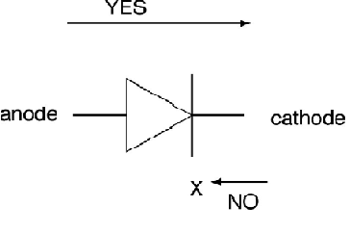

**Figure 1.1- Current flow in LED (****www2.ece.ohio-state.edu/LED_Instructions.pdf)**

1. **Arduino Uno**

Arduino is an open source computer hardware and software company, project, and user community that designs and manufactures [single-board microcontrollers](https://en.wikipedia.org/wiki/Single-board_microcontroller) and [microcontroller](https://en.wikipedia.org/wiki/Microcontroller) kits for building digital devices and interactive objects that can sense and control objects in the physical world.

[Arduino Uno](http://www.google.com/)is a microcontroller board based on the ATmega328P. It has 14 digital input/output pins), 6 analog inputs, a 16 MHz quartz crystal, a USB connection, a power jack, an ICSP header and a reset button. It contains everything needed to support the microcontroller; simply connect it to a computer with a USB cable or power it with a AC-to-DC adapter or battery to get started.

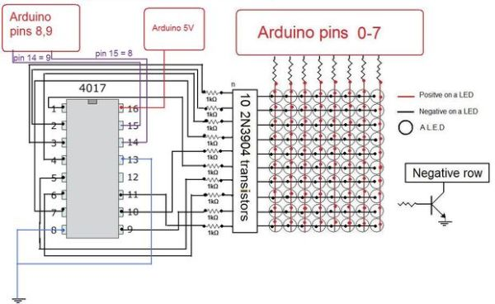

**Figure 1.2-Circuit Diagram of LED Display (**[**www.google.com**](http://www.google.com)**)**

1. **Resistor**

The purpose of resistor is to….resist electricity! Why do we want to do that?To control how much current goes where. One reason could be to protect other devices. We use resistors to basically control how much current passes through the light emitting diodes, both to control and light them. In this project, we have used two types of resistors with different resistances (one is of 1kΩ and other is of 220Ω).Each resistor has different use as one controls the current on the arduino side and the other controls the current to the integrated circuit.

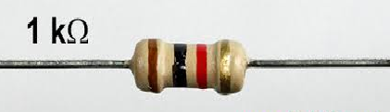

**Figure 1.3 (a) 1k ohm Resistor**

**220Ω**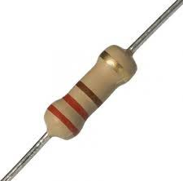

**Figure 1.3 (b) 220 ohm Resistor (****www.google.com****)**

1. **[Transistor](http://www.google.com)**

A transistor is a semiconductor device used to amplify or switch electronic signals and electrical power. It is composed of semiconductor material usually with atleast three terminals for connection to an external circuit.

In this project, we have used transistor of model BD 139.The BD139 transistor is a through hole NPN complementary low voltage transistor in TO-126 (SOT-32) package. This device was manufactured in epitaxial planar technology. It is used for audio amplifiers and drivers, utilizing complementary or quasi complementary circuits.

It has the following properties:-

* Collector to emitter voltage (Vce) is 80V
* Collector current (Ic) is 1.5A
* Power dissipation (Pd) is 12.5W
* Collector to emitter saturation voltage of 500mV at 0.5A collector current
* DC current gain (hFE) of 25 at 0.5A collector current
* Operating junction temperature range from 150°C

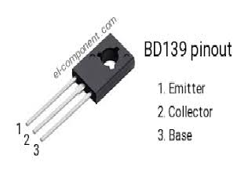

**Figure 1.4- BD139 Transistor (****www.google.com****)**

1. **Integrated circuit(IC)**

An integrated circuit is a set of electronics on one small flat piece (or “chip”) of semiconductor material, normally silicon. There are various features of the IC for which we have used it in the project. First of all, let us understand about IC. The IC’s mass production capability,reliability and building block approach to circuit design has ensured the rapid adoption of standardized IC’s.

ICs have two main advantages over discrete circuits: cost and performance. Cost is low because the chips, with all their components, are printed as a unit by photolithography rather than being constructed one transistor at a time. Furthermore, packaged ICs use much less material than discrete circuits. Performance is high because the IC's components switch quickly and consume comparatively little power because of their small size and close proximity. The main disadvantage of ICs is the high cost to design them and fabricate the required photo masks. This high initial cost means ICs are only practical when high production volumes are anticipated.

### Applications of Integrated Circuits

The applications of an ICs includes the following

* Radar
* Wristwatches
* Televisions
* Juice Makers
* PC
* Video Processors
* Memory Devices
* Logic Devices

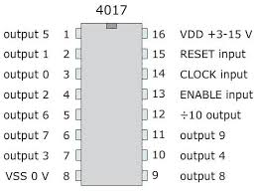

**Figure 1.5- Schematic Diagram of IC(****www.google.com****)**

A jump wire (also known as jumper, jumper wire, jumper cable, DuPont wire, or DuPont cable – named for one manufacturer of them) is an electrical wire or group of them in a cable with a connector or pin at each end (or sometimes without them – simply "tinned"), which is normally used to interconnect the components of a breadboard or other prototype or test circuit, internally or with other equipment or components, without soldering. Individual jump wires are fitted by inserting their "end connectors" into the slots provided in a breadboard, the header connector of a circuit board, or a piece of test equipment.

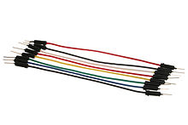

**Figure 1.6- Jumper Cables (****www.google.com****)**

1. **Bread board**

A breadboard is a solder less device for temporary prototype with electronics and test circuit designs. Most electronic components in electronic circuits can be interconnected by inserting their leads or terminals into the holes and then making connections through wires where appropriate. The breadboard has strips of metal underneath the board and connect the holes on the top of the board. The metal strips are laid out as shown below. Note that the top and bottom rows of holes are connected horizontally and split in the middle while the remaining holes are connected vertically.

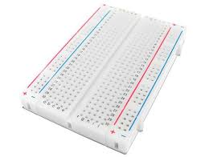

**Figure 1.7- Breadboard(****www.google.com****)**

**8. Prototype board**-Prototyping board is a material for prototyping electronic circuits (also called DOT PCB). It is a thin, rigid sheet with holes pre-drilled at standard intervals across a grid, usually a square grid of 2.54 mm (0.1 in) spacing. These holes are ringed by round or square copper pads, though bare boards are also available. Inexpensive prototype board may have pads on only one side of the board, while better quality prototype board can have pads on both sides (plate-through holes). Since each pad is electrically isolated, the builder makes all connections with either wire wrap or miniature point to point wiring techniques. Discrete components are soldered to the prototype board such as resistors, capacitors, and integrated circuits.

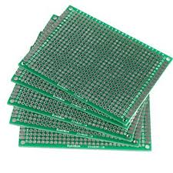

**Figure 1.8- Prototype Board (****www.arduino.org****)**

**Arduino codes of patterns used in project**

In this project , we have displayed different patterns such as “loading program”,

“snake and ladder game” , “wave pattern”, “printing different characters” etc.

Here we have presented the code of some of the patterns that we have displayed in the led display.

**1**. **Loading pattern:**

**// 10*8 LED matrix with 4017 IC**

**int clock = 9;// goes to the clock pin on the 4017 IC**

**int reset = 8;//goes to the reset pin on the 4017 IC**

**//x,y for the loop**

**int x;**

**int y;**

**const int loadingnum = 86;//this is the number of patterns you want to display**

**const int numPatterns3 = 2;**

**const int heartnum=28;**

**byte heartform[heartnum][10]={H01,H02,H03,H04,H05,H06,H07,H08,H09,H10,H11,H12,H13,H14,H15,H16,H17,H18,H19,H20,H21,H22,H23,H24,H25,H26,H1,space};**

**byte loading[loadingnum][10]={space,space,space,space,L1,L2,L3,L4,L5,L6,L7,L8,L9,L10,L11,L12,L13,L14,L15,L16,L17,L18,L19,L20,L21,L22,L23,L24,L25,L26,L27,L28,L29,L30,L31,L32,L33,L34,L35,L36,L37,L38,L39,L40,L41,L42,L43,L44,L45,L46,L47,L48,L49,L50,L51,L52,L53,L54,L55,L56,L57,L58,L59,L60,L61,L62,L63,L64,L65,L66,L67,L68,L69,L70,L71,L72,L73,L74,L75,L76,L77,L78,L79,Al,Al,Al};// the patterns order**

**byte patterns3[numPatterns3][10]={Al,space};**

**void setup(){**

**DDRD=B11111111;// this is a commed that makes pins 0-7 outputs(see more on the arduino site)**

**//simple stuff here**

**pinMode(clock,OUTPUT);**

**pinMode(reset,OUTPUT);**

**//reseting the 4017 IC, you have to do this**

**digitalWrite(reset,HIGH);**

**delayMicroseconds(5);**

**digitalWrite(reset,LOW);**

**//dis_loading(2);**

**//heart_form(5);**

**}**

**void dis_loading(int loops)//int loop acts like a delay, it take 8 mSecands to scan all of the rows so int loops = 15 is a good time for it**

**{**

**for(x=0;x<loadingnum-1;x++){ // loop over the patterns**

**for (int z=0;z<8;z++){ //scrolls one bite at a time**

**for(int t=0;t<loops;t++){// the delay we get with loops**

**for(y=0;y<10;y++){// loops over the array of bytes**

**byte temp = loading[x][y];**

**PORTD = temp;//writes digital outputs, Z is for how much bites it need to scroll**

**delayMicroseconds(300);// the time every row is one**

**PORTD=B00000000;// all pins are low, fixes the ghosting effect**

**// telles the 4017 IC to go to the next row**

**digitalWrite(clock,HIGH);**

**delayMicroseconds(5);**

**digitalWrite(clock,LOW);**

**}**

**}**

**}**

**}**

**for(x=loadingnum-1;x>0;x--){ // loop over the patterns**

**for (int z=0;z<8;z++){ //scrolls one bite at a time**

**for(int t=0;t<loops;t++){// the delay we get with loops**

**for(y=0;y<10;y++){// loops over the array of bytes**

**byte temp = loading[x][y];**

**PORTD = temp;//writes digital outputs, Z is for how much bites it need to scroll**

**delayMicroseconds(300);// the time every row is one**

**PORTD=B00000000;// all pins are low, fixes the ghosting effect**

**// telles the 4017 IC to go to the next row**

**digitalWrite(clock,HIGH);**

**delayMicroseconds(5);**

**digitalWrite(clock,LOW);**

**}**

**}**

**}**

**}**

**}**

**void display_pattern3(int loops)//int loop acts like a delay, it take 8 mSecands to scan all of the rows so int loops = 15 is a good time for it**

**{**

**for(x=0;x<numPatterns3-1;x++){ // loop over the patterns**

**for (int z=0;z<8;z++){ //scrolls one bite at a time**

**for(int t=0;t<loops;t++){// the delay we get with loops**

**for(y=0;y<10;y++){// loops over the array of bytes**

**byte temp = patterns3[x][y];**

**PORTD = temp;//writes digital outputs, Z is for how much bites it need to scroll**

**delayMicroseconds(100);// the time every row is one**

**PORTD=B00000000;// all pins are low, fixes the ghosting effect**

**// telles the 4017 IC to go to the next row**

**digitalWrite(clock,HIGH);**

**delayMicroseconds(5);**

**digitalWrite(clock,LOW);**

**}**

**}**

**}**

**}**

**}**

**void heart_form(int loops)**

**{**

**for(x=0;x<heartnum-1;x++){ // loop over the patterns**

**for (int z=0;z<8;z++){ //scrolls one bite at a time**

**for(int t=0;t<loops;t++){// the delay we get with loops**

**for(y=0;y<10;y++){// loops over the array of bytes**

**byte temp = heartform[x][y];**

**PORTD = temp;//writes digital outputs, Z is for how much bites it need to scroll**

**delayMicroseconds(800);// the time every row is one**

**PORTD=B00000000;// all pins are low, fixes the ghosting effect**

**// telles the 4017 IC to go to the next row**

**digitalWrite(clock,HIGH);**

**delayMicroseconds(5);**

**digitalWrite(clock,LOW);**

**}**

**}**

**}**

**}**

**}**

**void loop(){**

**//heart_form(4);**

**display_pattern3(15);**

**}**

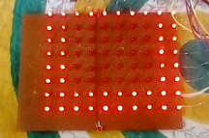

**Figure 2.1-Led pattern of “loading”**

**2. Snake game:** In this game , a snake moves along a path to catch the food and to eat it. In this game, as the snake eats food and its length increases and if the snake coincides with its body, the game is stopped and we are out.

The code for it is written as:

**// 10*8 LED matrix with 4017 IC**

**int clock = 9;// goes to the clock pin on the 4017 IC**

**int reset = 8;//goes to the reset pin on the 4017 IC**

**//x,y for the loop**

**int x;**

**int y;**

**const int snakenum = 168;**

**byte snake[snakenum][10]={S01,S02,S03,S04,S05,S06,S07,S08,S1,S2,S3,S4,S5,S6,S7,S8,S9,S10,S11,S12,S13,S14,S15,S16,S17,S18,S19,S20,S21,S22,S23,S24,space,space,A1,A2,A3,A4,A5,A6,A7,A8,A9,A10,A11,A12,A13,A14,A15,A16,A17,A18,A19,A20,A21,A22,A23,A24,A25,A26,A27,A28,A29,A30,A31,A32,A33,A34,A35,A36,A37,A38,A39,A40,A41,A42,A43,A44,A45,A46,A47,A48,A49,A50,A51,A52,A53,A54,A55,A56,A57,A58,A59,A60,A61,A62,A63,A64,A65,A66,A67,A68,A69,A70,A71,A72,A73,A74,A75,A76,A77,A78,A79,A80,A81,A82,A83,A84,A85,A86,A87,A88,A89,A90,A91,A92,A93,A94,A95,A96,A97,A98,A99,A100,A101,A102,A103,A104,A105,A106,A107,A108,A109,A110,A111,A112,A113,A114,A115,A116,A117,A118,A119,A120,A121,A122,A123,A124,A124,space,A124,space,A124,space,A124,space,A124,space};**

**void setup(){**

**DDRD=B11111111;// this is a commed that makes pins 0-7 outputs(see more on the arduino site)**

**//simple stuff here**

**pinMode(clock,OUTPUT);**

**pinMode(reset,OUTPUT);**

**//reseting the 4017 IC, you have to do this**

**digitalWrite(reset,HIGH);**

**delayMicroseconds(5);**

**digitalWrite(reset,LOW);**

**}**

**void dis_snake(int loops)//int loop acts like a delay, it take 8 mSecands to scan all of the rows so int loops = 15 is a good time for it**

**{**

**for(x=0;x<snakenum-1;x++){ // loop over the patterns**

**for (int z=0;z<8;z++){ //scrolls one bite at a time**

**for(int t=0;t<loops;t++){// the delay we get with loops**

**for(y=0;y<10;y++){// loops over the array of bytes**

**byte temp = snake[x][y];**

**PORTD = temp;//writes digital outputs, Z is for how much bites it need to scroll**

**delayMicroseconds(800);// the time every row is one**

**PORTD=B00000000;// all pins are low, fixes the ghosting effect**

**// telles the 4017 IC to go to the next row**

**digitalWrite(clock,HIGH);**

**delayMicroseconds(5);**

**digitalWrite(clock,LOW);**

**}**

**}**

**}**

**}**

**}**

**void loop(){**

**dis_snake(3);**

**}**

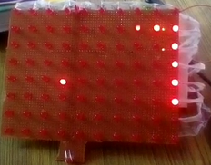

**Figure 2.2- Snake Game Pattern**

**3. Wave pattern:** This is the code of the wave pattern that is displayed on the screen.

**// 10*8 LED matrix with 4017 IC**

**int clock = 9;// goes to the clock pin on the 4017 IC**

**int reset = 8;//goes to the reset pin on the 4017 IC**

**//x,y for the loop**

**int x;**

**int y;**

**const int wavenum = 19;**

**const int waveloadnum = 10;**

**byte waveload[waveloadnum][10]={space,S01,S02,S03,S04,S05,S06,S07,S08,S09};**

**byte wave[wavenum][10]={S1,S2,S3,S4,S5,S6,S7,S8,S9,S10,S11,S12,S13,S14,S15,S16,S17,S18,S19};**

**void setup(){**

**DDRD=B11111111;// this is a commed that makes pins 0-7 outputs(see more on the arduino site)**

**//simple stuff here**

**pinMode(clock,OUTPUT);**

**pinMode(reset,OUTPUT);**

**//reseting the 4017 IC, you have to do this**

**digitalWrite(reset,HIGH);**

**delayMicroseconds(5);**

**digitalWrite(reset,LOW);**

**dis_waveload(3);**

**}**

**void dis_wave(int loops)//int loop acts like a delay, it take 8 mSecands to scan all of the rows so int loops = 15 is a good time for it**

**{**

**for(x=0;x<wavenum-1;x++){ // loop over the patterns**

**for (int z=0;z<8;z++){ //scrolls one bite at a time**

**for(int t=0;t<loops;t++){// the delay we get with loops**

**for(y=0;y<10;y++){// loops over the array of bytes**

**byte temp = wave[x][y];**

**PORTD = temp;//writes digital outputs, Z is for how much bites it need to scroll**

**delayMicroseconds(300);// the time every row is one**

**PORTD=B00000000;// all pins are low, fixes the ghosting effect**

**// telles the 4017 IC to go to the next row**

**digitalWrite(clock,HIGH);**

**delayMicroseconds(5);**

**digitalWrite(clock,LOW);**

**}**

**}**

**}**

**}**

**}**

**void dis_waveload(int loops)//int loop acts like a delay, it take 8 mSecands to scan all of the rows so int loops = 15 is a good time for it**

**{**

**for(x=0;x<waveloadnum-1;x++){ // loop over the patterns**

**for (int z=0;z<8;z++){ //scrolls one bite at a time**

**for(int t=0;t<loops;t++){// the delay we get with loops**

**for(y=0;y<10;y++){// loops over the array of bytes**

**byte temp = waveload[x][y];**

**PORTD = temp;//writes digital outputs, Z is for how much bites it need to scroll**

**delayMicroseconds(300);// the time every row is one**

**PORTD=B00000000;// all pins are low, fixes the ghosting effect**

**// telles the 4017 IC to go to the next row**

**digitalWrite(clock,HIGH);**

**delayMicroseconds(5);**

**digitalWrite(clock,LOW);**

**}**

**}**

**}**

**}**

**}**

**void loop(){**

**dis_wave(3);}**

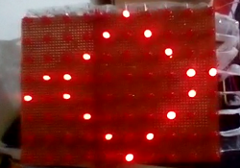

**Figure 2.3-Wave pattern**

**Uses of Dot Matrix Led Display**

1. In motor vehicles and bicycle lights.

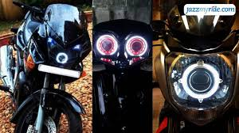

**Figure 3.1****(www.bikelovers.com****

2.In traffic light Indicators, signs and signals.

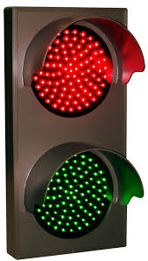

**Figure 3.2 (****www.trafficrules.com****)**

1. In data displaying boards.

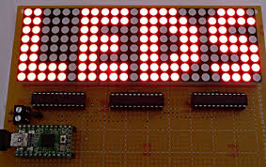

**Figure 3.3** **( www.arduino.org****

4.In medical applications and toys.

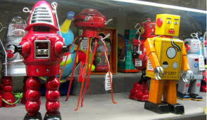

**Figure 3.4 (****www.sciencegeek.com****)**

. 5.Visual Applications.

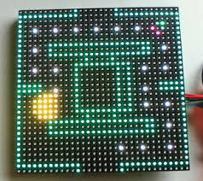

**Figure 3.5(****www.arduino.org****)**

6. In light bulbs and many more.



**Figure 3.6 (****[www.arduino.org](#_Hlk499223993" \s "1,19431,19446,0,,www.arduino.org))**

**References**

**[1**] S.Vadim, "10x8 LED matrix Display," vnunet.com, Nov , 2017. [Online]. Available: http://nl1.vnunet.com/news/1116995. [Accessed: Sept. 12, 2004].

[2] "Milestones:Invention of the First Transistor at Bell Telephone Laboratories, Inc., 1947". IEEE Global History Network. IEEE. Retrieved December 7, 2014.

[3] Andrew Wylie (2009). *["The first monolithic integrated circuits"](http://homepages.nildram.co.uk/~wylie/ICs/monolith.htm). Retrieved 14 March 2011*. Nowadays when people say 'integrated circuit' they usually mean a monolithic IC, where the entire circuit is constructed in a single piece of silicon.

[4] "Arduino - Introduction". arduino.cc.

David Kushner (2011-10-26). "The Making of Arduino". IEEE Spectrum

[5] U.S. Patent 3496419.: "Printed circuit breadboard", filed 25 Apr 1967, retrieved 14 July 2017

[6] "Inventor of Long-Lasting, Low-Heat Light Source Awarded $500,000 Lemelson-MIT Prize for Invention". Washington, D.C. Massachusetts Institute of Technology. April 21, 2004. Archived from the original on October 9, 2011. Retrieved December 21, 2011.