MINOR PROJECT SYNOPSIS
CAMPUS MERCHANDISING PLATFORM

Submitted in partial fulfilment of the requirement for the degree of
Bachelor of Technology
in
Computer Science & Engineering (Data Science)
K.R. Mangalam University


Submitted By
Naman Gupta – 2501420016
Paras Jain – 2501420040
Anupriya Agarwal – 2501420005
Tanvi Choudhary – 2501420022
Aarav Chauhan – 2501420027

Under the Supervision of
Mr. Deepak Kaushik

Table of Contents
 | Contents | Page No.
 | Abstract | 3
 | Introduction (description of broad topic) | 4
 | Motivation | 5
 | Literature Review | 6
 | Gap Analysis | 7
 | Problem Statement | 8
 | Objectives | 9
 | Tools / Platform Used | 10
 | Methodology | 11
 | References | 15

ABSTRACT
University campuses work like small marketplaces where students frequently buy items such as college merchandise, academic materials, event supplies, and department-related products. However, these items are usually sold through different channels like offline vendors, temporary stalls during events, or informal communication groups such as WhatsApp. Because of this, students often face problems like inconsistent pricing, difficulty finding products, and delays in purchasing required items.
This project proposes building a centralized digital platform that brings campus vendors, student clubs, and university merchandise together in one place. Through this platform, students will be able to browse available products, compare prices, place orders, and even participate in bulk purchases for events or societies. The goal of the system is to make campus purchasing simpler, more transparent, and more organized while benefiting students, vendors, and university organizations.

1. Introduction
1. Background of the Study
University campuses function as small marketplaces where students continuously purchase academic resources, laboratory kits, departmental merchandise, club uniforms, and event materials. These transactions are essential for both academic requirements and extracurricular activities within the campus ecosystem.

2. Existing System
Currently, most campus purchases take place through decentralized channels such as offline stores, temporary stalls during events, and informal communication groups like WhatsApp. Different vendors operate independently, leading to scattered and unorganized product availability.
3. Problems in the Current System
Due to the lack of centralization, students face difficulties in discovering products and identifying reliable vendors. Price variations across sellers create confusion, and student organizations often struggle to manage bulk orders efficiently for events and activities.
4. Need for the Proposed System
With the rise of digital commerce platforms, there is an opportunity to integrate these scattered activities into a unified system. A centralized platform can simplify product discovery, enable price comparison, and improve coordination between students and vendors.
5. Proposed Solution
The project aims to develop a web-based campus merchandising platform that connects students, vendors, and student organizations in one system. It will allow vendors to list products online while enabling students to browse, compare, and purchase items easily
6. Key Features of the System
The platform will include functionalities such as product listing, vendor management, order placement, and support for bulk purchases. These features will enhance efficiency and streamline procurement processes within the campus.

2. Motivation
Students struggle to easily find campus-related products due to scattered information across platforms like WhatsApp groups and informal channels. The absence of a centralized system makes product discovery confusing and time-consuming.
1 Challenge in Existing System
There is a lack of pricing transparency, making it difficult for students to compare options. Limited visibility and poor communication between vendors and students further complicate the procurement process, especially for bulk orders.
2 Need for a Centralized Platform
A unified digital platform can bring all campus merchandise into one place, allowing students to browse, compare, and access products easily while simplifying the overall process.
3 Expected Benefits
Such a system would improve product visibility and streamline communication between vendors and students. It would also reduce time, effort, and logistical challenges, particularly for large-scale events.

3. Literature Review
Existing research on digital marketplaces highlights the benefits of centralized e-commerce platforms in improving product discovery and reducing transaction inefficiencies. Studies on campus commerce systems demonstrate that internal university portals can simplify access to academic materials and institutional merchandise.
Procurement management systems used in organizations also show how vendor management, inventory monitoring, and digital ordering systems can streamline purchasing workflows. However, most existing systems are either designed for large scale corporate procurement or general e-commerce platforms and are not tailored specifically for campus ecosystems.

Table 1: Literature Review
Reference | Area of Study | Key Findings | Limitations
[1] | Digital Marketplace Systems | Centralized marketplaces improve product discovery and transaction efficiency. | Not designed for campus-specific procurement.
[2] | Campus E-Commerce Models | University portals simplify purchasing of official merchandise. | Limited vendor integration.
[3] | Procurement Management Systems | Digital procurement tools streamline vendor management. | Mostly used in corporate environments.
[4] | E-Procurement Systems | E-procurement reduces operational costs and improves efficiency through automation. | Requires strong IT infrastructure and user training.

4. Gap Analysis
Although multiple digital marketplaces and procurement platforms exist, none specifically address the unique requirements of campus ecosystems where student organizations, vendors, and institutions interact simultaneously. Current systems lack centralized vendor management, real time inventory visibility, and structured support for bulk orders placed by student societies.
Table 2: Gap Analysis
Platform | Strength | Gap
Amazon | Large product marketplace | Not campus specific
University Stores | Official merchandise | Limited product variety
Local Vendors | Campus availability | No centralized digital system

5. Problem Statement
1 Current Situation
In most university campuses, students purchase academic materials and merchandise through informal and scattered channels. Vendors usually sell products through temporary stalls, physical stores, or social media groups. Student societies also rely on manual coordination when ordering merchandise for events or activities.
2 Problems in the Existing System
This current system creates several problems:
- Students often struggle to find specific campus-related products.
- Prices are not transparent, and students cannot easily compare prices between vendors.
- Student societies face difficulty managing bulk purchases for events.
- Vendors do not have a centralized platform to showcase their products.
- Communication between buyer and sellers is often unorganized.
Because of these issues, the campus purchasing process becomes inefficient and time-consuming.
3 Need for a Solution
To solve these problems, a centralized digital platform is required where campus vendors, students, and organizations can interact. Such a system can improve product visibility, simplify purchasing, and make campus commerce more organized and transparent.

6. Objectives
1. To design a centralized platform that aggregates campus merchandise and vendors.
2. To enable students to easily browse, compare, and purchase campus related products.
3. To support bulk procurement for student clubs, departments, and university events.
4. To improve transparency in pricing and product availability.
5. To develop a scalable system capable of supporting multiple vendors and students.

7. Tool / Tech Used
Tool/Tech | Why it was used | How it was used | Where it was used
VS Code | Powerful development environment | Used to write and manage project code | Development
React | Efficient UI framework | Build dynamic user interface | Frontend
Node.js | Scalable backend runtime | Handle server logic and APIs | Backend
MySQL / MongoDB | Data storage system | Store product, user, and order data | Database

In this project, we are also exploring and learning new programming languages and technologies to enhance our development capabilities. While these advanced tools and frameworks will be incorporated in future iterations, the current implementation is based on our existing technology stack. This approach allows us to first build a strong foundational system and later upgrade it by integrating newly learned technologies for improved performance and scalability.

8. Methodology
The methodology of this project explains the steps followed to design and develop the campus merchandising platform. First, requirement analysis is conducted to understand the needs of students and vendors. After that, system design and database structure are planned for the platform. The system is then developed using web technologies and integrated with a database for storing product and order data. Finally, the platform is tested and prepared for deployment, as shown below,
Figure 1: System Architecture and Methodology Workflow
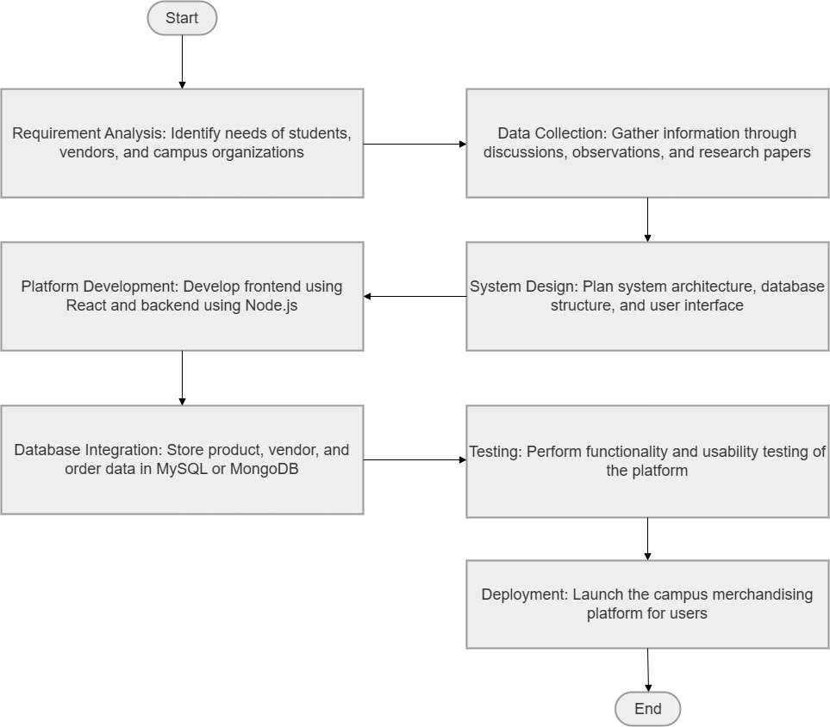

1 Research Design
The project follows a system development approach to design and implement a campus merchandising platform. The aim is to understand how students currently purchase campus-related products and identify the problems in the existing system. Based on these findings, a centralized digital platform will be designed. The platform will allow vendors to list products and students to browse and place orders. The overall workflow of the system is illustrated in Figure 1: System Architecture and Methodology Workflow
2 Data Collection Procedures
Data for this project will be collected using both primary and secondary sources. Primary data will be gathered through discussions with students, student societies, and campus vendors to understand their needs. This helps in identifying common purchasing patterns and problems faced during procurement. Secondary data will be collected from research papers, technical documentation, and studies on digital marketplaces. These sources help in understanding existing systems and designing a better solution.

3 Sampling Method
The study will use a convenience sampling method by selecting participants available within the campus environment. The sample mainly includes undergraduate students who frequently buy campus merchandise. It will also include student clubs that require bulk orders for events. Local vendors who sell products related to academic activities and events will also be considered. This sample group helps identify practical requirements for the proposed system.

4 System Development Process
The system will be developed using an iterative development approach where the platform is built in stages. The first step involves identifying system requirements and defining user needs. Next, the architecture of the system and database structure will be designed. The frontend will be developed using React and the backend using Node.js. Finally, the system will be tested to ensure proper functionality before deployment.

5 Data Analysis Techniques
The collected data will be analyzed to understand the effectiveness of the proposed platform. The analysis will focus on how easily students can discover products on the platform. Vendor participation and product availability will also be observed. The system will track orders and usage patterns to evaluate the platform's performance. Basic descriptive analysis will help understand how the platform improves campus purchasing processes.

6 Workflow of the Proposed System
The workflow of the proposed system describes how users interact with the platform. Vendors first register on the platform and upload product details. The product information is stored in the system database. Students can browse the product catalog and select items they want to purchase. Once an order is placed, the system processes the request and confirms the transaction.

9. References
[1] Laudon, K. C., & Laudon, J. P. – Management Information Systems.
[2] Turban, E., King, D., Lee, J., & Liang, T. – Electronic Commerce.
[3] React Official Documentation – https://react.dev
[4] E-Procurement Systems Research Paper – https://apps.aima.in/ejournal_new/articlesPDF/Avinash-Shukla-Ejournal.pdf

