**Driving License Application**

This window form application fetches the status of user’s Driving License Application from the database.

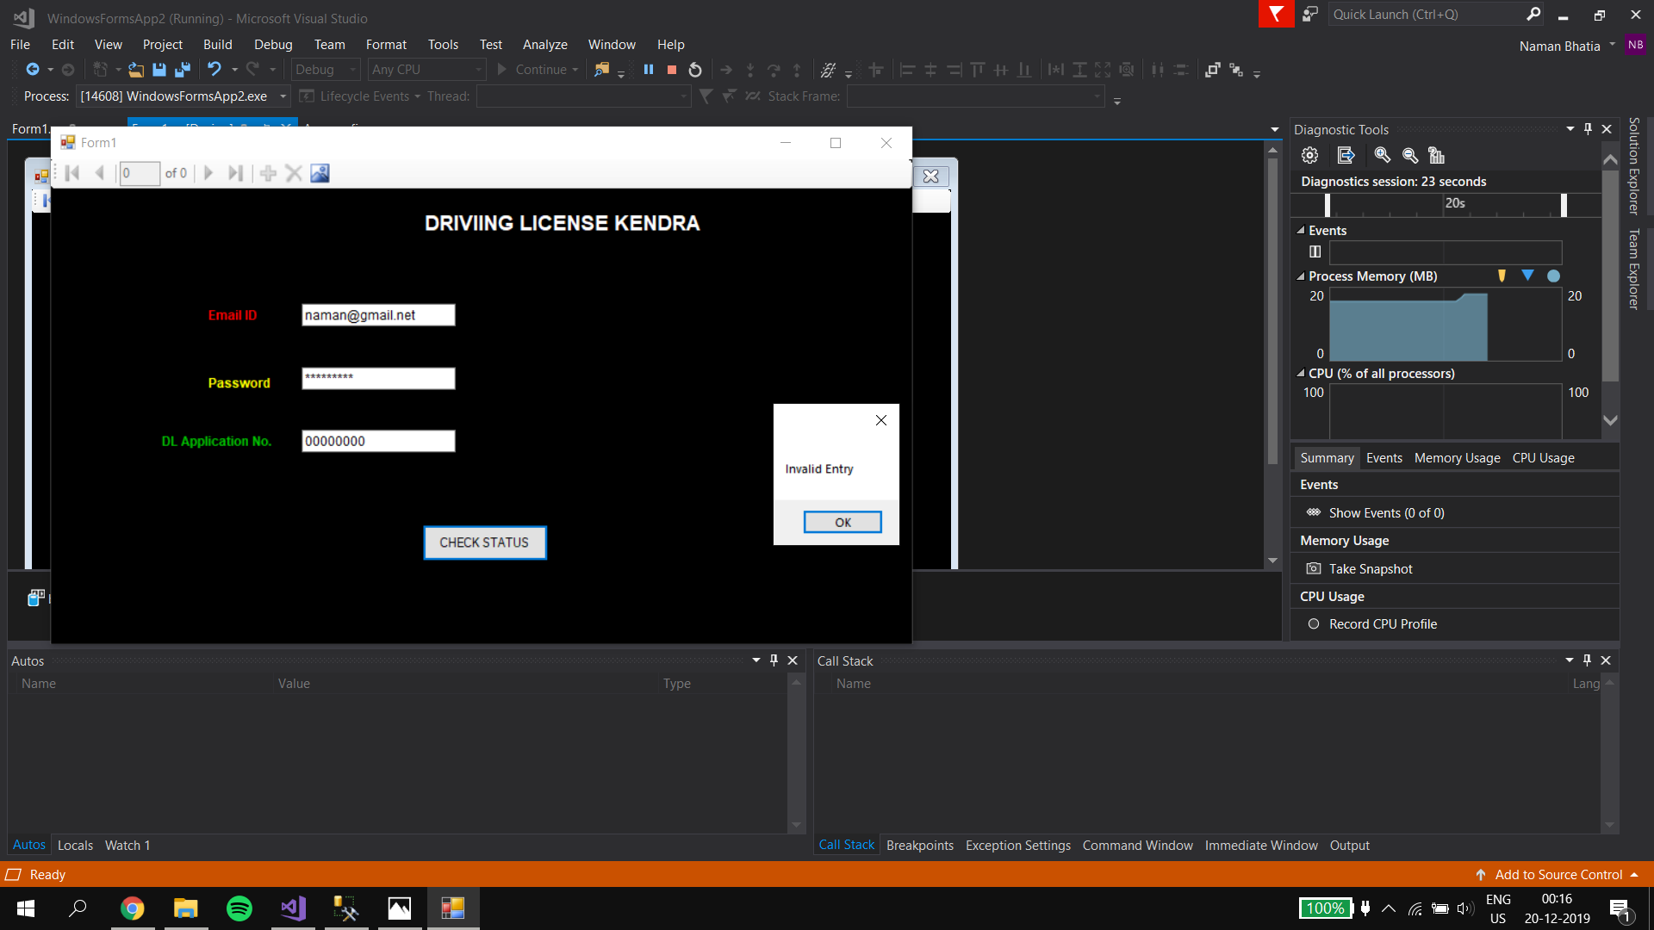

Figure 1Prints invalid entry for wrong input

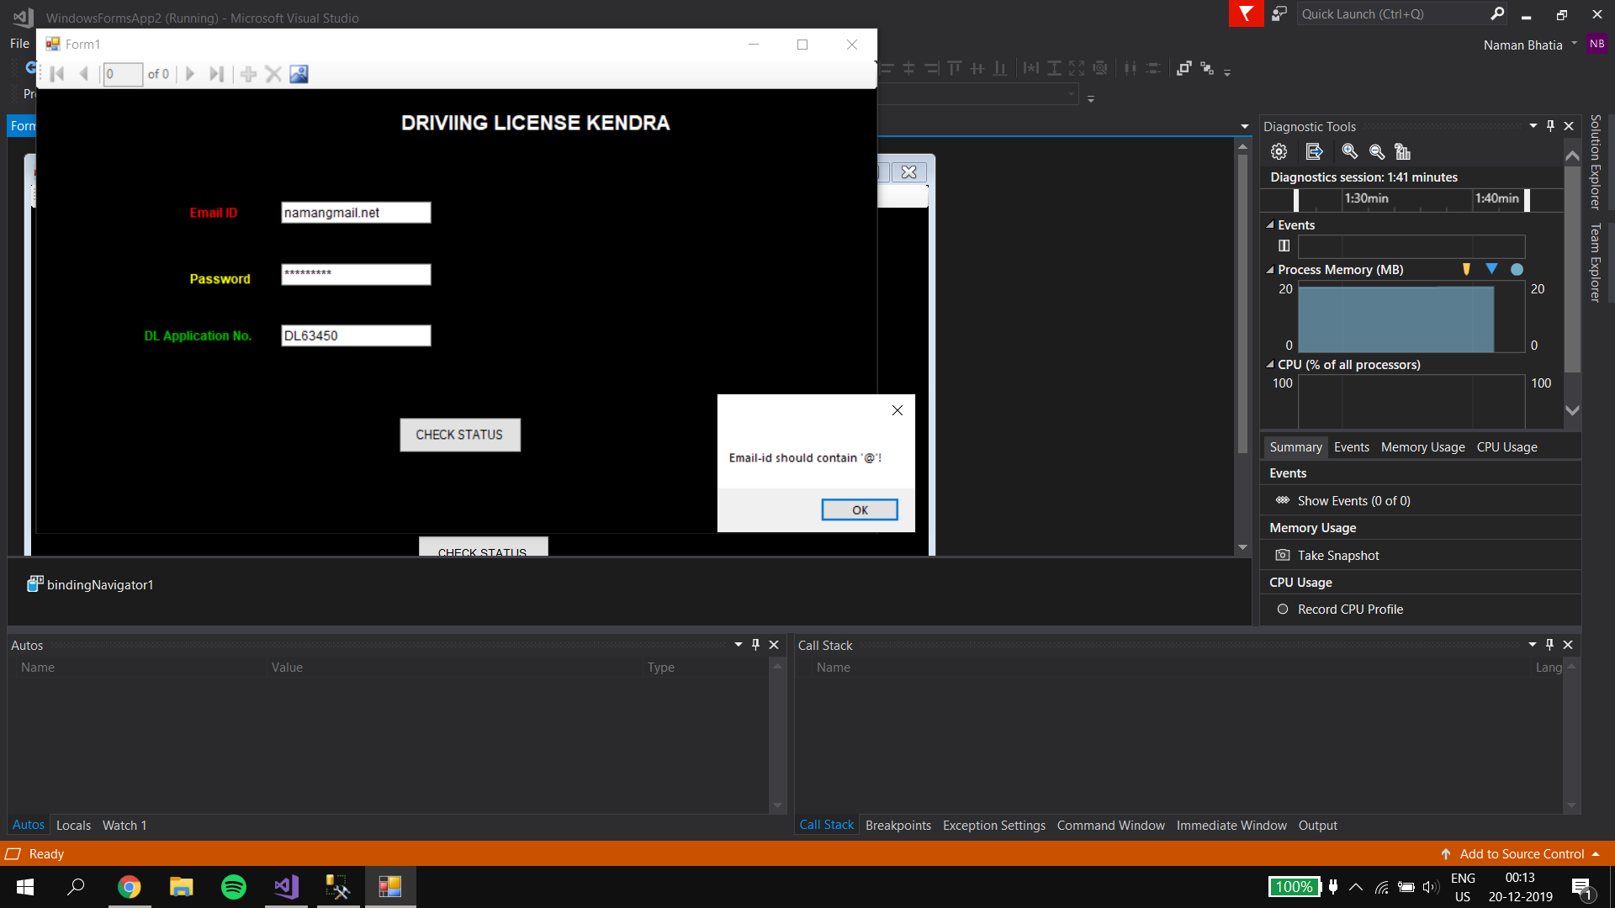

Figure 2Form Validation

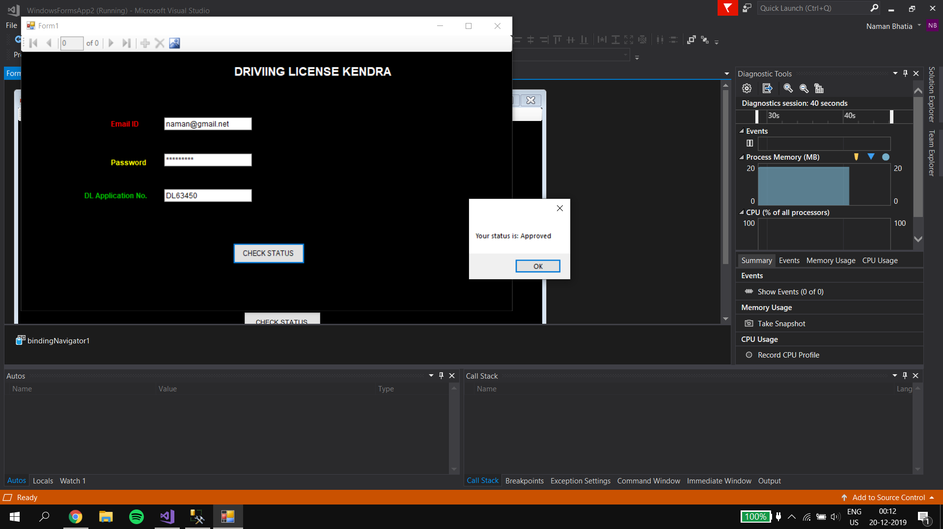

Figure 3Approves if the input is correct after validating from the database

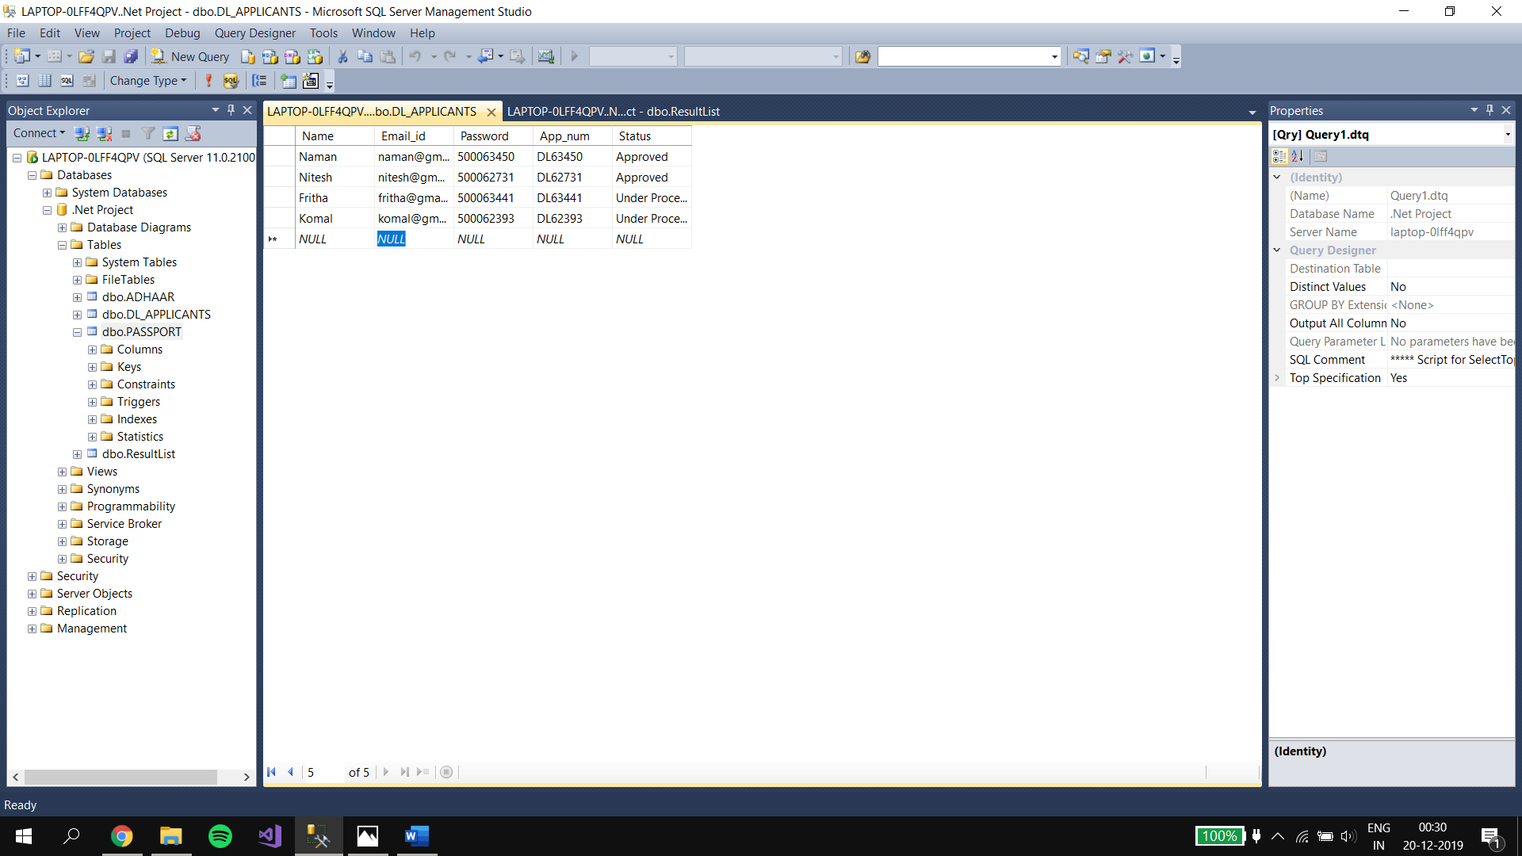

Figure 4Database used.