**2. Wireframe Document**

**2.1 Overview**

The wireframe for the **Turbo Engine RUL Prediction System** outlines the design of the Streamlit-based user interface. The wireframe includes key components and layout, providing a visual guide for the frontend design and user interaction flow.

**2.2 Wireframe Structure**

1. **Home Page (Prediction Input Screen)**:
   * This is the main screen where the user inputs operational settings and sensor readings.

**Components**:

* + **Header**: "Turbo Engine RUL Prediction"
  + **Sidebar**: Dataset description and model details.
  + **Inputs**:
    - Sliders for Operational Settings 1, 2, and 3
    - Sliders for Sensors 1, 2, and 3
    - A button for submitting the inputs and making the prediction.
  + **Prediction Result**: Displays the predicted RUL value with a maintenance prediction.

**Wireframe Layout**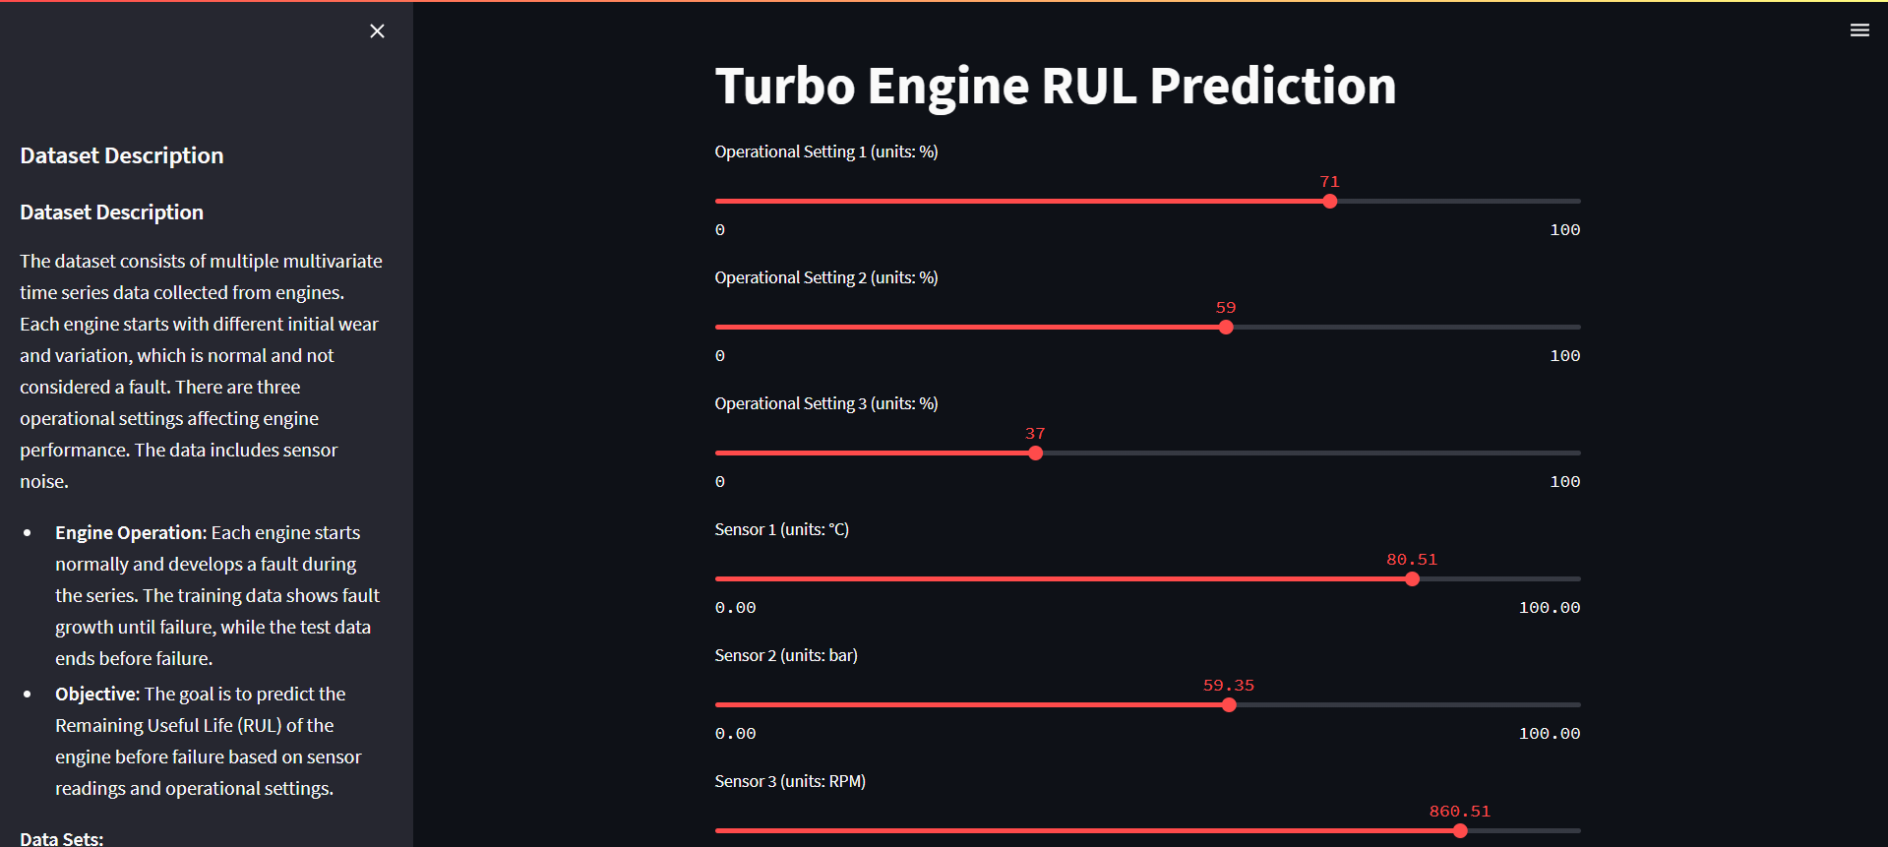

1. **Sidebar**:
   * **Header**: "Dataset Description"
   * **Content**: Text explaining the dataset used for the prediction model, including details on the operational settings, sensor types, and dataset overview.
2. **Main Screen (Prediction)**:
   * **Inputs**: Various sliders allow the user to adjust the operational settings and sensor data. Each slider should have a label indicating the parameter it controls.
   * **Predict Button**: The user clicks this to make the prediction.
   * **Output**: After clicking "Predict", the predicted RUL and an explanation of the result are shown.