**Deep Learning Model Tweaking with DevOps**

**Problem Statement:**

1. Create container image that has Python3 and Keras or numpy installed using dockerfile
2. When we launch this image, it should automatically start training the model in the container
3. Create a job chain of job1, job2, job3 and job4 using build pipeline plugin in Jenkins
4. Job1 : Pull the Github repo containing Dockerfile for Deep Learning environment automatically when some developers push the repo to Github
5. Job2 : Start the Deepl Learning container with the help of Dockerfile, and then train your model and predict accuracy or metrics
6. Job3 : If metrics accuracy is less than 90% , then tweak the machine learning model architecture
7. Job4 : Inform the developer through mail whether the accuracy is above 90% or not after tweaking the model appropriately

**Dockerfile for Deep Learning Environment:**

Push this file to GitHub as separate repository

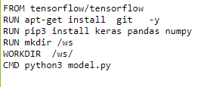

**Deep Learning Model Code (model.py) :**

Push this file to GitHub as separate repository

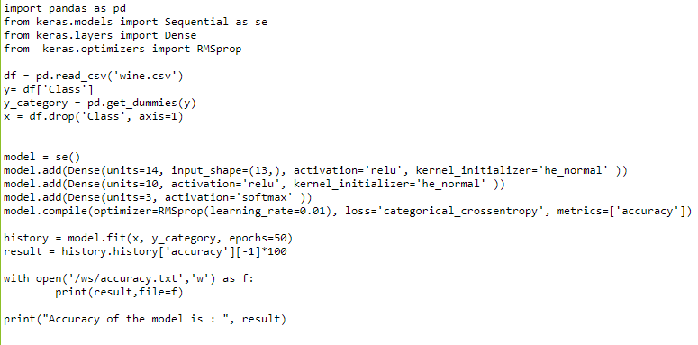

**Deep Learning Dataset (wine.csv) :**

Push this file to GitHub along with model.py in the same repository

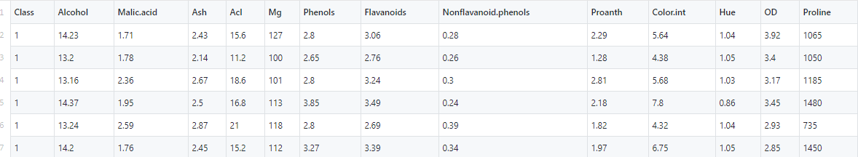

**Email Sender Code (mail.py) :**

Push this file to GitHub as separate repository

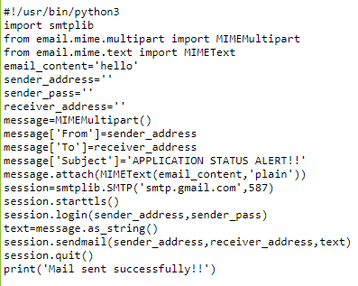

**Jenkins Job 1 (mlops-1) :**

This job will fetch the repository from GitHub which will create a docker image from the Dockerfile.

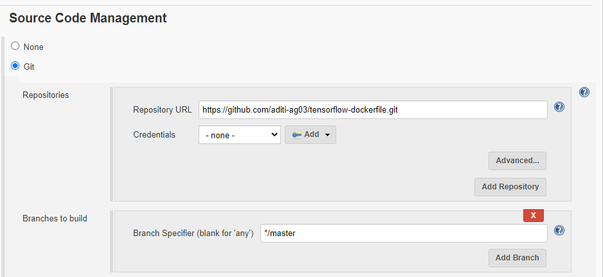

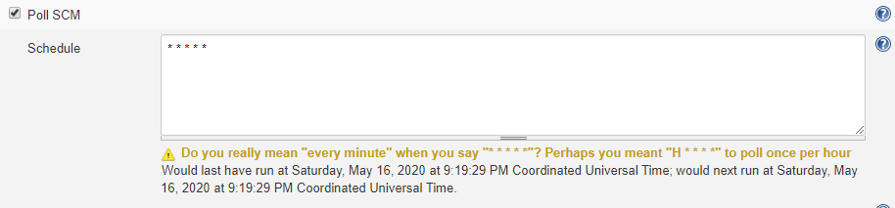

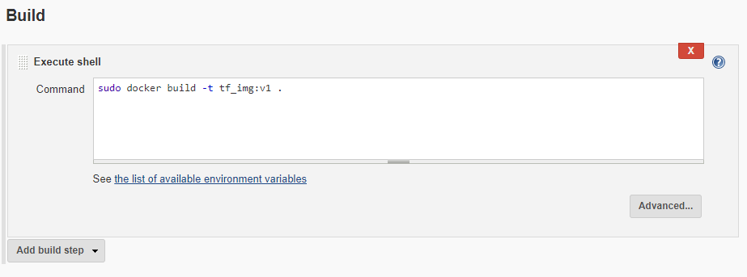

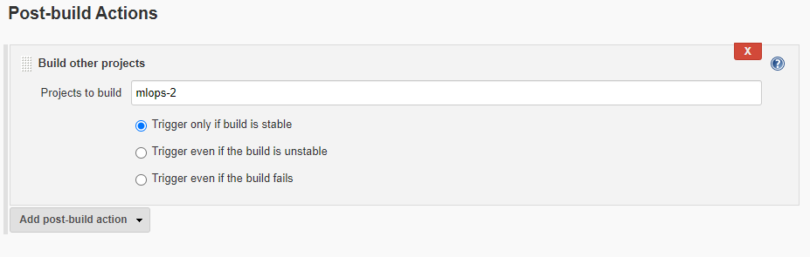

**Jenkins Job 2 (mlops-2) :**

This job will fetch the deep learning code repo from GitHub and launch the container to train the model.

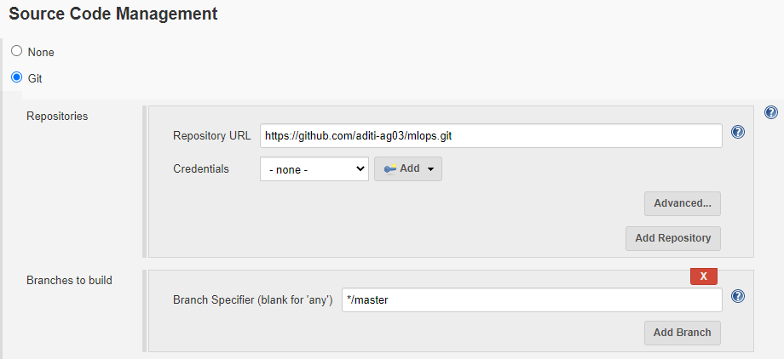

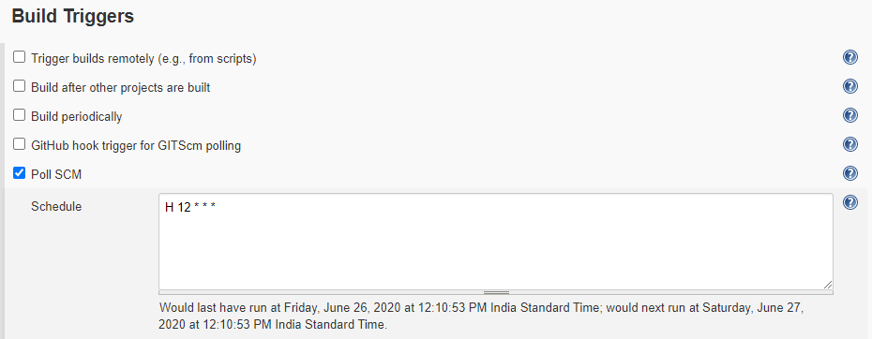

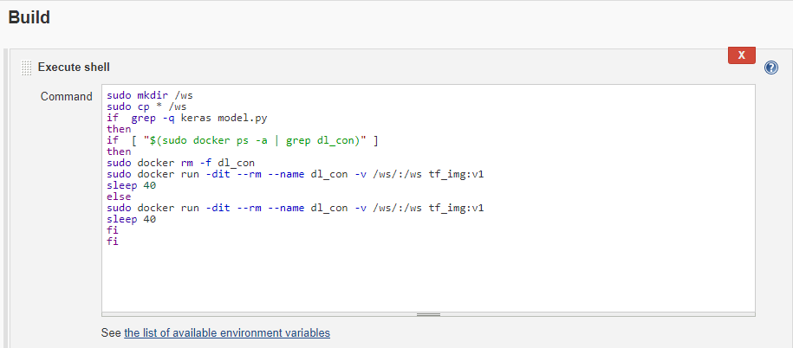

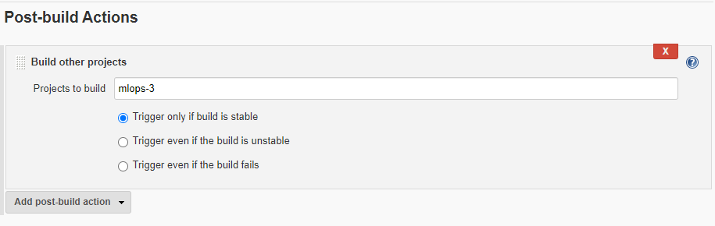

**Jenkins Job 3 (mlops-3) :**

This job will tweak the model by working on different hyper-parameters only if the accuracy is below 90%

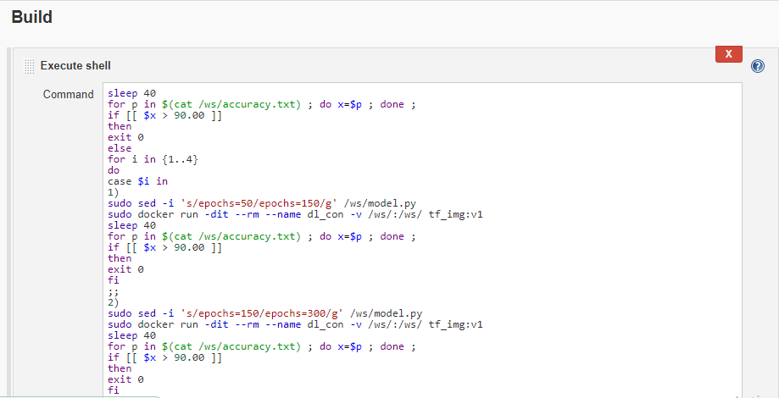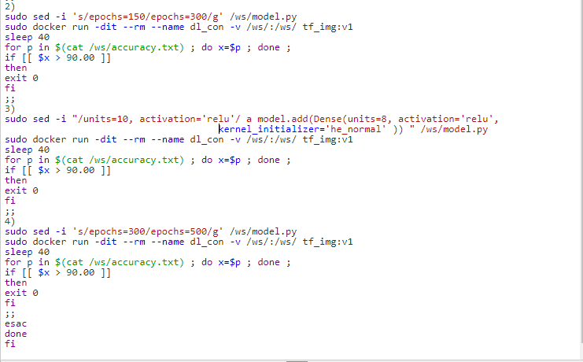

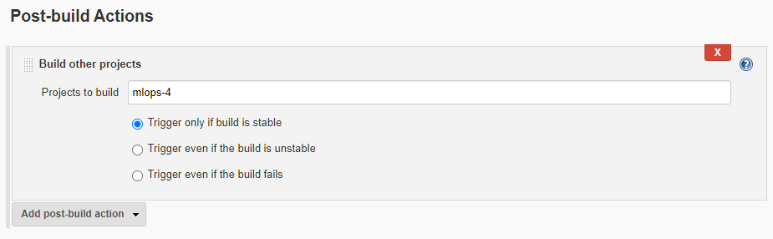

**Jenkins Job 4 (mlops-4) :**

This job will send the mail to the developer about accuracy (whether it is above 90% or below) of the model after training and tweaking.

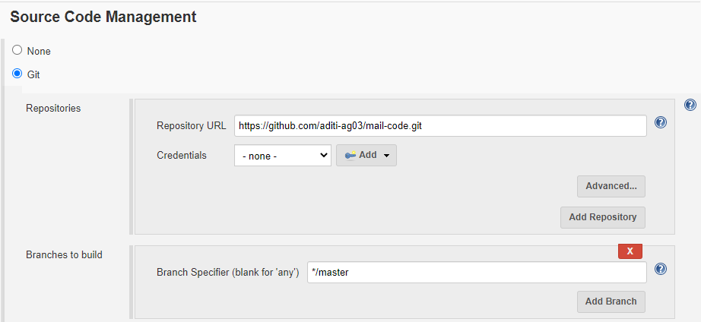

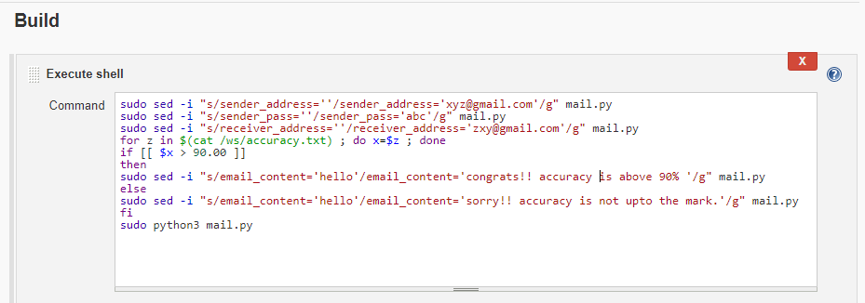

**Build Pipeline view of the Project :**

This view gives the knowledge about the pipeline/chaining of the jobs.

