**WORDPRESS & MYSQL SERVER SETUP ON EKS**

1. **Download aws-cli v2 & eksctl in your system**
2. **Create an IAM user in AWS account, with AdministratorAccess power**
3. **Configure aws**

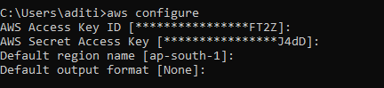

1. **Create *cluster.yml* file**

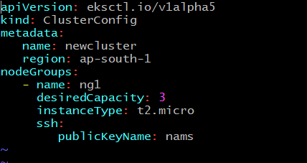

1. **Run *cluster.yml* for creating Kubernetes cluster on EKS**



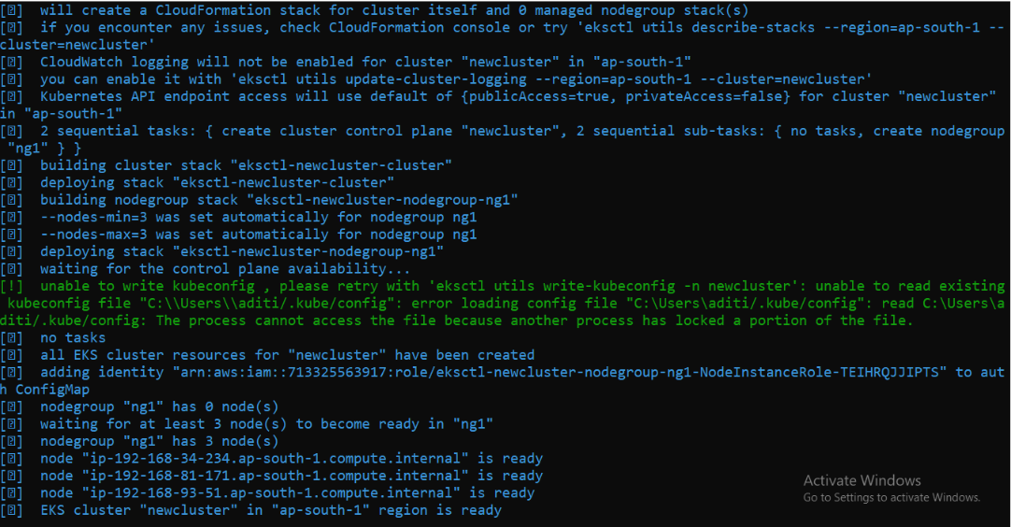

1. **Create an EFS in AWS using EKS cluster vpc**

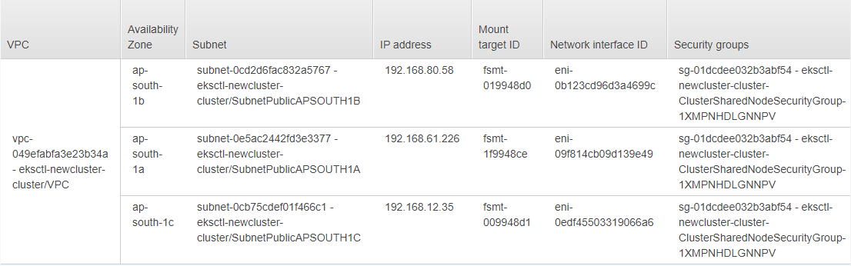

1. **Download *kubectl* in your system and update kube-config file with new EKS cluster**



1. **Create provisioner file for EFS as *efs-provisioner.yml***

This file will create a deployment which will help us to get access of EFS

* change the variable “FILE_SYSTEM_ID” & “server”, according to your efs storage

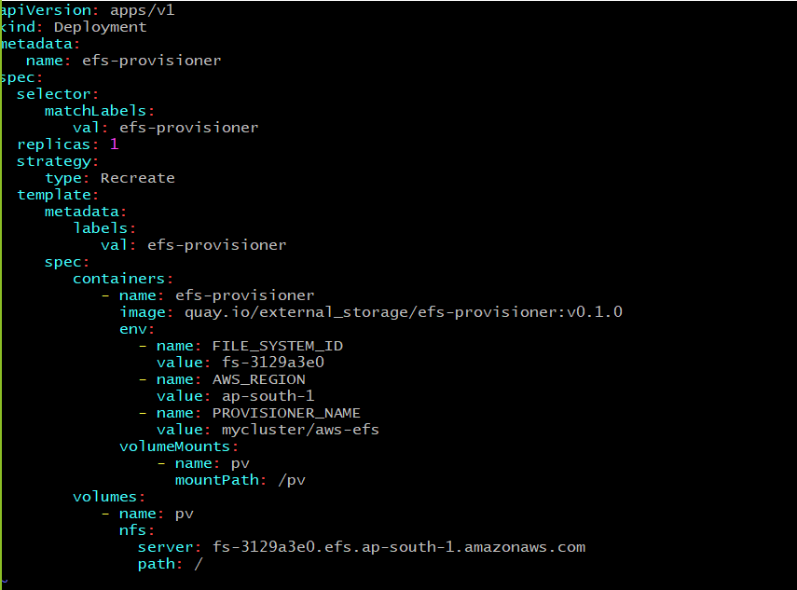

1. **Create “storage class”, “pvc” using *sc.yml* for taking storage from EFS**

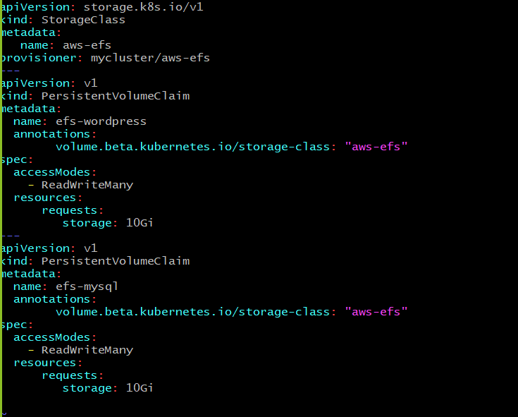

1. **Create *rbac.yml***

This file helps in security & accessof cluster

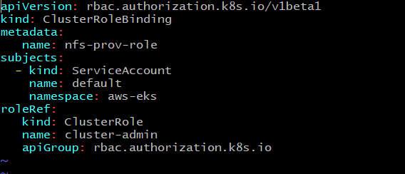

1. **Create a file *wpsdeploy.yml***

This file will create wordpress deployment with ELB of AWS

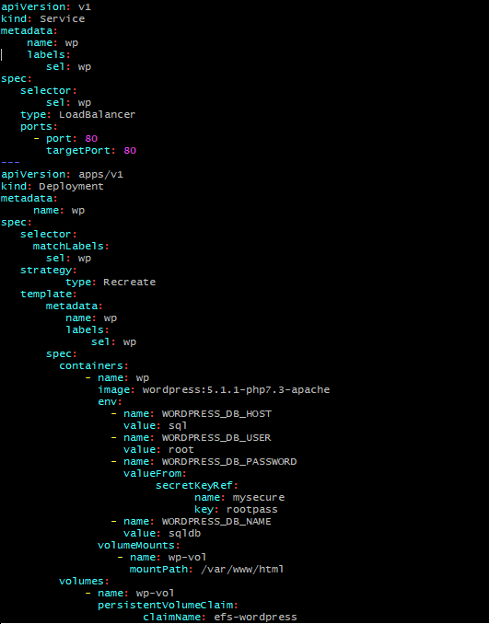

1. **Create a file *sqldeploy.yml***

This file will create a mysql database deployment for wordpress server

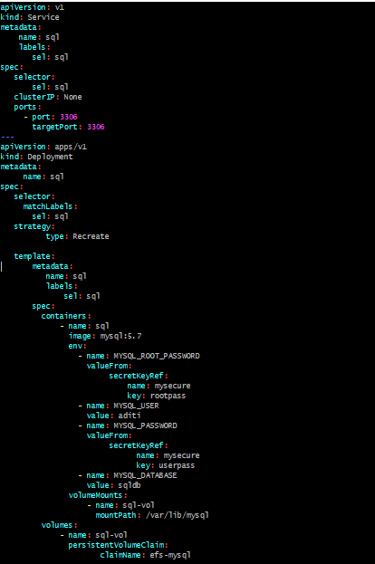

1. **Create *kustomization.yml* for binding all the files created above**

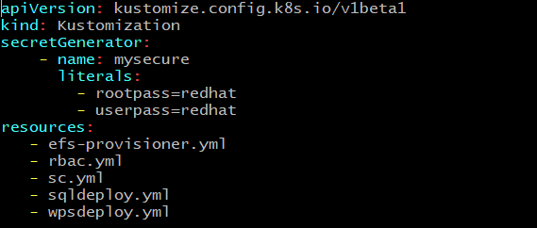

1. **Create a namespace *aws-eks* for deploying everything in a single umbrella**



1. **Run *kustomization.yml* in created namespace for finalizing the setup**

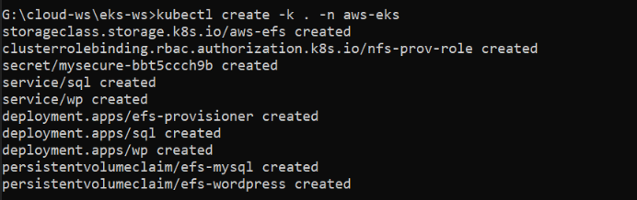

1. **Hurrayy!! Your wordpress setup is ready**

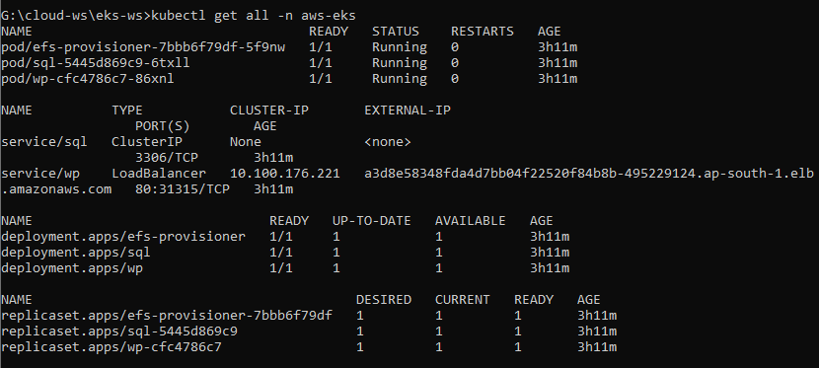

1. **Go to ELB in AWS and copy DNS**

Use DNS in your browser and access wordpress

