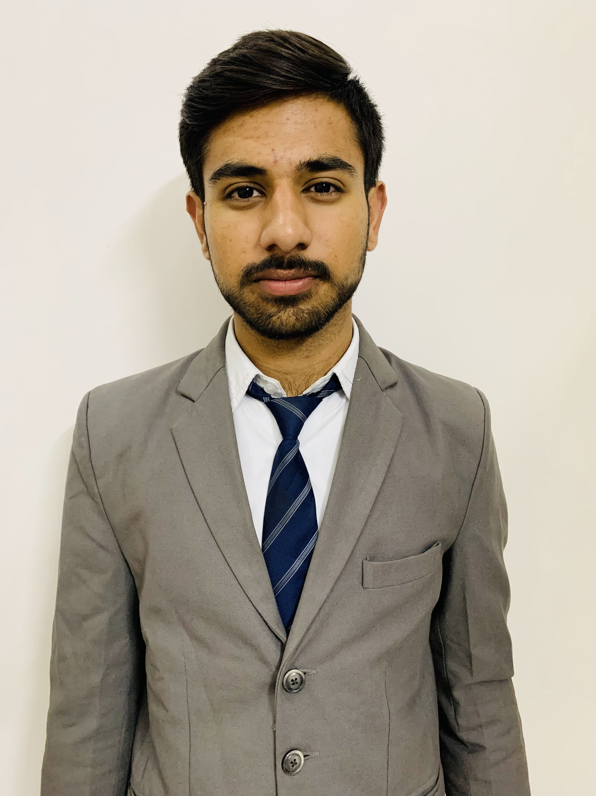Photo in Tie/Blaz
Naman Bhatia
The ICFAI University Hostel, Agra Road, Jamdoli, Jaipur
namanb.bcaai2022@iujaipur.edu.in
+91-9664423285
DOB: 12th March 2004

Academics

Program | Discipline/Specialization | Board/University | %/CGPA | Year of Completion
BCA | Artificial Intelligence | The ICFAI University, Jaipur | 7.5 | 2024
12th | Commerce, Economics | National Institute Of Open Schooling | 7.8 | 2021
10th | General | National Institute Of Open Schooling | 6.0 | 2019

Allied Credentials

- Certification on workshop for Data Science from Learn and Build(LnB).
- Certificate of participation in International Symposium on “New Trends In IOT”.

IT Skills

- MS-Office
- MS Excel
- (Basic) Java ,C ,C++, SQL
- Html, Css

Workshops/Conferences/Seminars

- Attended a Webinar on Job Suitability and Job Eligibility
- Attended Workshop on Data Analytics.
- Attended DEEKSHARAMBH – Student Induction Programme as a volunteer in Pixel Club.

Awards & Recognition

- Certification of Appreciation in DEESHARAMBH as a member in Pixel Committee.

Interests

- Badminton
- Photography
- Listening Music
- Gaming

Personal Details

Father’s Name: Sanjay Bhatia
Permanent Address: 37 ,Gurunanak Pura Raja Park, Rajasthan Pin-302004
Languages Known: English, Hindi
Nationality: Indian

