**Halsimplify.com website Content**

# 

Website Layout

Home

Our Differentiators

About us

WHO WE ARE?

WHAT WE DO?

2 Solutions

2.1 Hal ERP

2.2 Hal Business Suite

Sales

Finance

Inventory

HR

2.3 Hal Edgecation Suite

Admission

Fee

Finance

Inventory

Student Management

HR (Time and Attendance)

HR (Payroll)

Control Centre

3 Services

IT Strategy & Consulting

ERP Services

Business Intelligence & Analytics

Application Development & Maintenance

Mobility:

Professional Services:

Infrastructure Management Services:

4 Our Partners

5 Contact us

Functionalities to be added

# 

# 

# **Website Layout**

|  |  |  |  |  |  |  |
| --- | --- | --- | --- | --- | --- | --- |
| Home | About us | Solutions | Services | Partners | Career | Contact us |
|  |  | Hal ERP | IT Strategy & Consulting |  |  |  |
|  |  | Hal Business Suite | ERP Services |  |  |  |
|  |  | Hal Edgecation Suite | Business Intelligence & Analytics |  |  |  |
|  |  |  | Application Development & Maintenance |  |  |  |
|  |  |  | Mobility |  |  |  |
|  |  |  | Professional Services |  |  |  |
|  |  |  | Infrastructure Management Services |  |  |  |

# Home

Slide 1: Same as Present except change as suggested here

Responsive = Process Rich

Colourful = People Centric

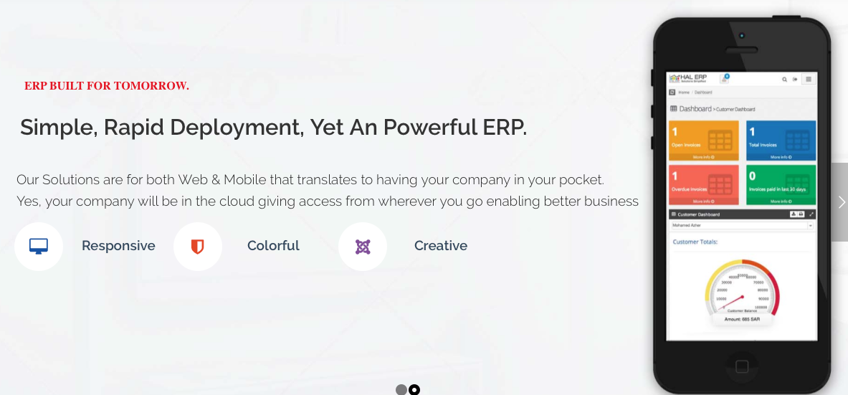

Slide 2: Mobility

It is not just building an App. Mobility is to understand the real business opportunity and avoid over engineering of the App. Build your app with our team of experts who carries this sense of understanding

Slide 3: Business Intelligence & Analytics

Through better strategic awareness, faster reporting, decreased operating costs/lower overheads and access to better quality data and information, BI can positively influence a company’s ROI.

Slide 4: IT Strategy & Consulting

Our Advisory services focus on:

* Management and technology consulting
* Big data
* IT security
* Business continuity planning (BCP)

Note: Replace the present three sections at bottom with following section. However save the content as it will be moved to Hal ERP page

### **WHAT WE DO?**

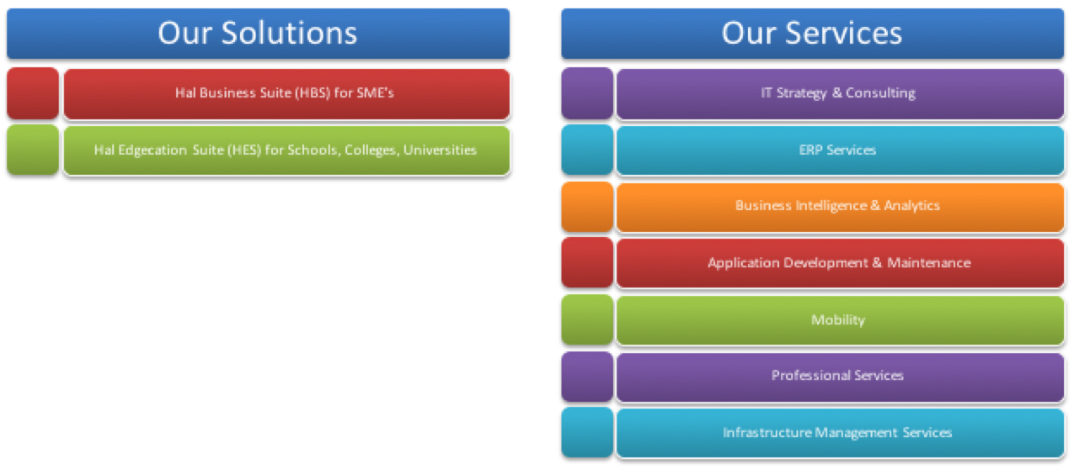

**Our Solutions**

Hal Business Suite (HBS) for SME’s

Hal Edgecation Suite (HES) for Schools, Colleges, Universities & Educational Institutions

**Our Services**

IT Strategy & Consulting

ERP Services

Business Intelligence & Analytics

Application Development & Maintenance

Mobility

Professional Services

Infrastructure Management Services

## Our Differentiators

Solutions Company

We understand one product will not fit all organizations so we develop solutions or offer services based on each Organization’s requirements and pain points.

Quality Conscious

We are obsessed with Quality so we deliver best of solutions and services

Affordability

Our engagement model is developed keeping Customer in mind, which means "Solution" at "Product" price or Services at highly competitive price

Support

We understand how much support Business needs from its partners so we stand to deliver a professional support

Continuous Improvement

We never get satisfied with what we have achieved. We keep learning and improving our services to our customers which helps us to bag number of satisfied customers

Bottom section as seen below should be changed as site map

# 

# About us

**Our Vision**

“Empowering

Businesses And Educational Institutions

To Go Beyond The Status Quo

With The Power Of Simplicity”

**Our Mission**

**“We Exist To**

**Build Next Generation Technology**

**And**

**ERP On Cloud From Scratch!”**

**We Love Solving Problems**

**We Are Unique As We Make Things Simple**

**We Re-think And Challenge The Status Quo**

**We Believe Delivering On Time Than Working Hard**

**We Are Here To Disrupt The ERP Space!**

### **WHO WE ARE?**

Hal is a niche technology company providing enterprise solutions through its Proprietary Cloud based ERP, Hal ERP and IT services that would help its customers to accomplish their Business & Strategic objectives

### **WHAT WE DO?**



Option 1

**Solutions**

Hal Business Suite (HBS) for SME’s

Hal Edgecation Suite (HES) for Schools, Colleges, Universities & Educational Institutions

Hal B2B Solution

**Services**

IT Strategy & Consulting

ERP Services

Business Intelligence & Analytics

Mobility

Application Development & Maintenance

Infrastructure Management Services

Professional Services

Option 2

We continue to challenge the status quo so we deliver best of Solutions and Services to our Customers

Hal ERP

<image>

Simplify, Streamline your Business execution and take it wherever you go

Mobility

# 2 Solutions

## 2.1 Hal ERP

Today’s ERP’s were created decades of years back and being continuously  
updated, forcing us to work on same old structure that was relevant for that  
time

So we came up with something new that is designed today and to be used  
for tomorrow

**User Experience ~ Let ERP be the way you look at things**

We particularly focused on giving an experience to users so that they love it,  
consider it to be part of themselves, at the same time both fluid and smooth

We have put whole ERP on web based interface to make them feel they are  
just browsing through a website or purely a social networking experience

orts

**Reports ~ Let us change the way it works**

Reports are integral part of ERP system helping users to make right decision  
at right time. We find most ERP’s force users to go to a particular place to  
fetch reports they want. This means they use it to submit reports not for  
what it should be i.e., keeping them up-to-date.

We thought about this really hard. We want to change the fundamental way  
of reporting. We wanted users to know what they are working on in few  
seconds, look at related history should they want more details, have birds  
eye on their organization or departments

So We went little far with reports and designed our ERP to have four level  
Reporting

SAG - Get status of anything in 10 seconds

Dashboard - Multiple levels right from organization to user level

Details Table - Dive deep down on transactions

Report Runner - Never miss your traditional and custom reports

**Inbox ~ Personal secretary for everyone in the office**

Right from the start, we wanted to make an ERP that works for you instead  
of you working for it.

We have understood that at work, we need alerts before something goes out  
of control, we need to know actions we have to take either approval or task,  
and Information we should know. So, We have consolidated all these in one  
place with just a tap on your inbox

**Accessibility ~ Put your office into your pocket**

Over the time, we have learnt that ability of users to access their work,  
reports, files whenever, wherever they want will increase productivity apart  
from the way it kills the time delays in getting work done.

Many attempted this with mobile apps but ended up not giving users the  
complete freedom and accessibility having limitation of mobile apps in  
restricted access, platform dependency and cost that is involved in  
developing it

So we went little further in bringing offices into pocket. We have made HAL  
ERP to work in any browsers without a need to develop an apps for each  
OS. Right from start, we made sure our designs passes the test of whatever  
works in computer screen should work in mobile screen as well

Then same content as in present home page

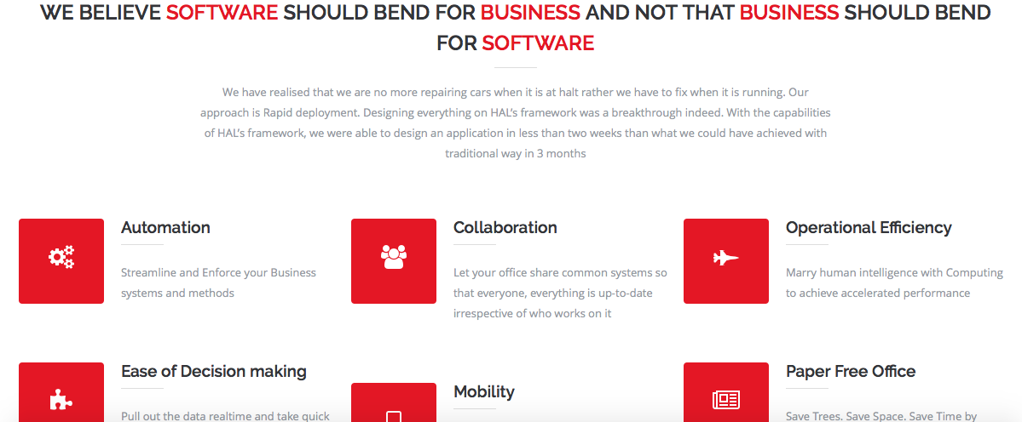

Ignore ERP story and jump to Differentiators Section

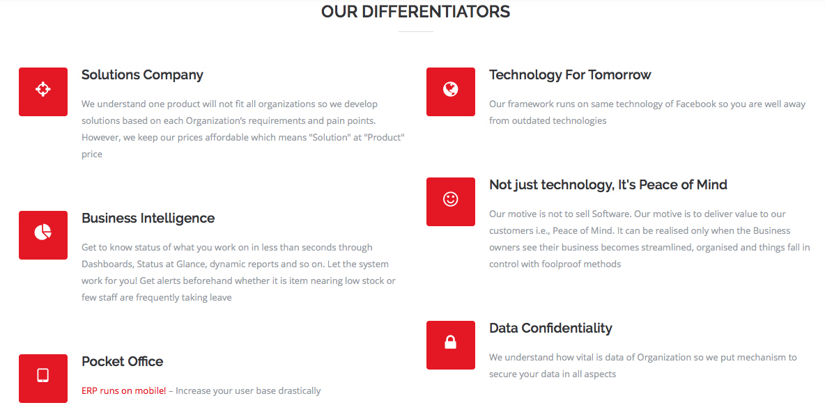

## 

## 

## 2.2 Hal Business Suite

**HAL Business Suite (HBS)**

*"We believe that software should accommodate your business, and not the other way around"*

Businesses today are competing at a much higher pace than before, in that we are required to make quick decisions, offer fast and quality services. The best way to stay ahead is to automate your business, ensuring the right data is recorded on time, ensuring it is retrievable at any point of time thereby enabling collaboration, communication and operational efficiency.

Having worked with a number of businesses, we've understood the bottom line of any business lies in its sales, financial, material and manpower management. The understanding was profound; we have come up with HAL Business Suite (HBS) comprising of these functions as a ready-to-start suite. We also understand that every business is unique, and has its own way of doing things. So HBS, along with Sales, Accounting, HR and Inventory can be customised with specific modules based on business needs.

## Sales

We wanted our HBS to do sales, just like we do sales. This opens the door of complexities, but we have kept it simple. In the human world, we issue quotations to close a deal knowing we may not have in stock what we are going to sell. So, we designed our system to create a potential purchase order from the very same quotation. This is just one example but you can do more...

* Create-Manage-Close quotations
* Convert quotation into Invoice
* Issue Purchase order based on Quotation
* For bigger projects, convert quotation into Sales order
* Debit Inventory with multiple delivery notes and credit accounting with Invoice
* Simple Sale, Issue Simple invoice!
* Manage on spot sales with Sales Receipts
* Manage Sales Returns
* Manage Customer Advances
* Mange customer database
* Analyse customer transactions with Dashboards

## Finance

Many of the legacy accounting softwares were developed years ago, which basically imitate the manual process and leave out the advantage computers can bring to the table. Accounting entries were POSTED separately after business activities. Now, we have seamlessly bridged the gap between business activities and accounting, which effectively means no separate accounting entries, rather ledgers that are posted when an invoice (business activity) is issued. This also means we don't need accountants trained on specific softwares to manage our businesses. This is just one example, there's a lot more you can do -

* Run multiple Projects for the same client with Jobs
* Get Project specific reporting
* Receive an item into inventory and get the bill paid with no effort
* Record general/petty expenses
* Record vendor expenses
* Record Future expenses
* Allocate budget for your subordinate to make expenses
* Control expenses with Approval workflow
* Manage vendor advance payments
* Manage vendor credits for item returns
* Multiple level Ledge account set up and mapping with Business activity
* Transfer funds between your accounts
* Get account balances while making payments or as a report
* Of course, power of Journal entries with Journal entry
* Trial Balance
* Balance Sheet at any moment
* On the fly Income-Expense
* Manage Vendor database
* Analyse vendor transactions with Dashboards

## Inventory

Money, Material and Manpower - these form an integral part of most organisations. Given that they are intertwined in day-to-day operations, the system should be able to work in any way it's required to. Therefore, we've associated Inventory activity with Accounting and vice-versa. You place a purchase order, HBS prepares the Bill to be paid and add items to your inventory. You sell an item, HBS reduces your inventory and adds money to your accounts. It's just that simple. This is just one example, there's more you can do -

* Create-approve Purchase Intent
* Convert Purchase intent to Purchase Order
* Convert Quotation to Purchase order
* Receive Items with Item Receipts/GRN
* Manage-Categorize Product/Items
* Get to know stock in hand at any moment
* Track Stock movement
* Review Stock history
* Multiple stores or warehouses
* Get timely alerts with Re-order tolerance

## HR

An organisation can take care of its business well, as long as it takes care of its employees well. Delays in crediting salaries, or missing out on employee's requests for leave / reimbursements / loans etc will affect staff motivation, without a doubt. This in turn affects growth of the business. Since timely responses are a key factor, we've automated our HR system to generate salaries, manage leaves with very few inputs in minimal time. This is just one example; you can do more -

* Induct new Staff into the organisation hierarchy and define Salary/leave packages
* Manage Offer letter to acceptance
* Mark staff attendance - Manual or biometric or RFID
* Employee Self Service - Leave to late request from mobile phones
* Define any number of leave packages
* Manage-adjust Leave quota
* Leave components as your organisation requires
* Manage different shifts
* Sandwich rules for weekends and holidays
* Encash or carry forward the leave as you like
* Define organisation Hierarchy
* Group or personalised payroll components
* One click payroll generation
* Push payslips to Employee self service
* Issue and recover Salary advance and loans
* HR adjustments
* Choose between working days/full month calculation method
* Manage Provident Fund
* Manage Insurance
* Manage Tax deductions
* Generate b2b forms for bank and statutory departments
* Manage Recruitment
* Conduct staff appraisal
* Salary increment by pay scale or hike percentage

## 2.3 Hal Edgecation Suite

**Hal Edgecation Suite**

With every passing day, school operations are getting more complex, with stakeholders more interested in how the school delivers. The management is concerned about performance, parents want real time information about their children and the quality of education, teachers want to focus on teaching more than mundane tasks, and the administrative staff are worried about smooth and hassle free operations.

We've designed a Hal Edgecation Suite ERP maintaining a diversified ecosystem of the school and their varied interests in mind, with the simple goal of making each school deliver excellence by better performance, communication and management all-round.

At the foundation, we have 8 core modules and a number of optional add-on modules as required by each school, specific to its requirements to deliver excellence.

## Admission

Say goodbye to face-offs with new parents; admissions will be streamlined hereafter.

One seat available. Whom to give it to: existing parent or new? Get information about the applicant instantly, on whether he has a sibling or not, and then decide. Exciting? There's more -

* Quick/detailed registration
* Manage sibling admissions
* Validate required documents
* Set up evaluation criteria - Scholastic or other parameters
* Enter Marks or points
* Configure Evaluation rules
* Do Manual evaluation or Lot system or Automatic evaluation
* Generate Student ID, Parent ID
* Attach to existing sibling and generate relevant child code
* Override Fee quarter/month applicability
* Generate Admission letter
* Keep them updated at each stage via SMS

## Fee

Let the Hal School ERP follow up with defaulters automatically!

Parents of three students waiting to pay fees? It isn't required to enter each student’s ID and waste time. The ERP would just pick up details of the rest of the siblings fee, with the student ID entered first. Great, isn’t it? You can do more than that…

* Pay fees at the counter or online or through your school’s apps
* Pay by Cash, Cheque, Cards or virtual accounts
* Pay by month, quarter, full year or in instalments
* One shot siblings payment
* Define Fee components as required
* Apply fee for class or shared interest group
* Annual fee set up
* Automated Fee defaulters follow up
* Manage Fine with your own rules
* Let the scholarship/discount appear automatically during payment
* On the fly invoice - Enjoy the freedom of changing fee through out the academic year
* Instant SMS acknowledgments
* Reconcile Fee collection
* Realtime defaulters report
* Get alerts over SMS or email when staff cancels the fee

## Finance

Why depend on your accountant, when you can get all your financial reports at the click of your mouse?

Was an expense approved without your choice, as staff have spent funds without prior approval? Let the HAL School ERP stop it. Your subordinates have spend limits based on a budget that you allocate. Brilliant, isn't it? Again, there's more -

* Receive an item into inventory and get the bill to be paid with no effort
* Record general/petty expenses
* Record vendor expenses
* Record Future expenses
* Allocate budget for your subordinate to make expenses
* Control expenses with Approval workflow
* Manage vendor advance payments
* Manage vendor credits for item returns
* Multiple level Ledge account set up and mapping with Business activity
* Transfer funds between your accounts
* Get account balances while making payments or as a report
* Of course, power of Journal entries with Journal entry
* Trial Balance
* Balance Sheet at any moment
* On the fly Income-Expense
* Mange Vendor database
* Analyse vendor transactions with Dashboards

## Inventory

For how long are you going to be in the dark about the exact stock levels at school?

Examinations are coming up. Do you know if you have enough answer sheets, office supplies and report cards? Get your exact stock in hand. Wonderful, isn't it? You can do more -

* Create-approve Purchase Intent
* Convert Purchase intent to Purchase Order
* Receive Items with Item Receipts/GRN
* Manage-Categorize Product/Items
* Get to know stock in hand at any point in time
* Track Stock movement
* Review Stock history
* Multiple stores or warehouses
* Get timely alerts with Re-order tolerance

## Student Management

Don't let continuous absentees miss your radar!

A student comes to school in shabby uniform often. You want to fix this. You record, then HAL School ERP will ask you whether to notify the parent or not. Your decision is final! Awesome, isn’t it? You can do more than that…

* Mark student Attendance
* Inform absentees parents over SMS
* Manage student discipline
* Issue TC
* Manage student drop off
* Re-admit Drop off students
* Block allocation
* Class room allocation
* House allocation
* Club allocation
* Sub group allocation (Extra Curricular Activities)
* Fee group allocation
* Scholarship allocation
* Examination allocation
* Language allocation
* Event groups allocation

## HR (Time and Attendance)

Are you losing new recruits owing to disorganised inductions? Not anymore.

A member of staff plans her leave dates few days in advance, and needs your approval. Due to busy schedules, she's unable to meet you. Her leave is uncertain, as are her plans as a result. Automate it! You approve her leave from your mobile phone, while she waits at your lounge. Everyone's happy!

You can do more -

* Induct new Staff into organisation hierarchy and define Salary/leave packages
* Manage Offer letter to acceptance
* Mark staff attendance - Manual or biometric or RFID
* Employee Self Service - Leave to late request from mobile phones
* Define any number of leave packages
* Manage-adjust Leave quota with its ledgers
* Leave components as your organisation requires
* Manage different shifts
* Sandwich rules for weekends and holidays
* Encash or carry forward the leave as you like
* Define organisation Hierarchy

## HR (Payroll)

You record staff attendance, and generate payroll in seconds instead of days.

A member of staff takes an advance on her salary, and a loan as well. She avails transport, and is absent for some days in that month. What’s going to be her Salary? Which of the loans should be recovered first? Is it complicated? But not for HAL School ERP. Calculate exact salary in few clicks. Cool, isn’t it? You can do more than that…

* Group or personalised payroll components both allowances and deductions
* Generate payroll with one click
* Push payslips to Employee self service
* Issue and recover Salary advance and loans
* Payroll adjustments
* Salary increment by pay scale or hike percentage
* Choose between working days/full month calculation method
* Manage Provident Fund
* Manage Insurance
* Manage Tax deductions
* Generate B2B forms for bank and statutory departments

## **Control Centre**

Let's stop chasing away users with overwhelming features and too many options! Personalise the application for each user.

A teacher joins the School. You give her the role of a Primary teacher. She gets automatically allocated to Students, Examination, Attendance & Discipline details of Primary students alone, without access to the whole HAL School ERP. Everything is interconnected. Great, isn’t it? You can do more than that…

* Configure your data that appears in drop down boxes
* Manage your document number sequences
* Manage your Business rules
* Localise your project
* Set up different type of permissions for each modules
* Create different roles at Designation/Department level
* Map unlimited permission with roles
* Create any number of users

# 3 Services

## IT Strategy & Consulting

Halsimplify’s IT Strategy and services help our customers understand and explore innovative opportunities for growth with technology strategies that align business and IT for the most value. Halsimplify has been expanding its advisory practice to provide the right mix of industry and functional expertise to help its clients address their most complex business issues and opportunities from strategy through execution.

Our Advisory services focus on management and technology consulting, including operations, finance, process improvement, HR, big data and analytics, IT security, risk mitigation and crisis management, business continuity planning (BCP) etc.

## ERP Services

Apart from Halsimplify’s proprietary cloud ERP solution, we do cater to the large spectrum of ERP services sought by large organizations, through our robust partner network.

Through our partners, our comprehensive services span the entire ERP ecosystem-from implementation, maintenance, support, upgrade, enhancements, reports building, bolt-on development, analytics, mobility and technical upgrades in the below ERPs:

* Oracle
* SAP
* Microsoft Dynamics

## Business Intelligence & Analytics

Business intelligence is no longer a term only associated with large organizations. As the price of hardware and storage drops, business intelligence technology is advancing with flexible deployment and licensing options that are easily available—rendering Business intelligence in reach for almost every organization.

Through better strategic awareness, faster reporting, decreased operating costs/lower overheads and access to better quality data and information, BI can positively influence a company’s ROI.

For more details about our BI service offerings, get in touch with us at [info@halsimplify.com](mailto:info@halsimplify.com).

## Application Development & Maintenance

Considering today’s business challenges, it is important to understand the customer’s vision and meet the overall objectives by creating a dynamic series of short development cycles. This not only helps to meet the changing user needs but also avoids cost escalation, delays, and unnecessary complexity.

Halsimplify offers a full range of application development and maintenance support services to ensure business continuity and long-term value. We also help organizations to stay on the cutting edge by developing robust applications that are scalable, secure and easily maintainable.

## Mobility:

Did you know that there will be 4.55 billion mobile users, with 1.75 billion mobile internet users worldwide this year, according to a new eMarketer report? That’s a tremendous marketing opportunity. Promotions are increasingly getting personal, across the world and the best and the most effective means of reaching out to your target audience is through their smart phones.

A comprehensive mobile strategy take into consideration not only having a mobile app but the mobility of your data and content in such a way that your customers or users could access information on any device in any form (web or mobile). Our mobility and industry experts engage with you to get a clear understanding of your existing business processes and roadmap. The team leverages ideas from our global engagement with varieties of projects across industries.

To know more about our mobility service offerings, contact us at [info@halsimplify.com](mailto:info@halsimplify.com)

## Professional Services:

Halsimplify has a stringent recruitment process to filter out the best of talent with good technical expertise clubbed with strong interpersonal skills. With a sizable investment in our offshore development center & a strong recruitment team, we cater to wide spectrum of requirements spanning architects, project managers, functional & technical consultants, developers, DBAs, support engineers in the below technologies:



Our Professionals are available for short term and long term assignments. Their expertise can be availed remotely from offshore development center and also on-site.

To know more about our service offerings, contact us at [info@halsimplify.com](mailto:info@halsimplify.com)

## Infrastructure Management Services:

Halsimplify offers end-to-end services on IT Infrastructure consultancy, implementation and maintenance of Hardware, Software & Networking systems, which in turn enables our customers to optimally utilize their available infrastructure to achieve greater productivity and efficiency.

To know more about our service offerings, contact us at [info@halsimplify.com](mailto:info@halsimplify.com)

# 4 Our Partners

Halsimplify has developed a chain of strategic alliances with Certified Partners to offer state-of-art solutions and consultancy to our customers.

Some of our channel partners include:

# 5 Contact us

1. In contact us section, we should have both India and Saudi arabia address

Saudi Office

P.O. Box 55555, Riyadh, 11544

011 4083344

+966 536 402 791

+966 550 934 303

[info@halsimplify.com](mailto:info@halsimplify.com)

India Office

90 Kamdar Nagar III St, Nungambakam, Chennai

044 42139881

+91 988 436 4736

[info@halsimplify.com](mailto:info@halsimplify.com)

2. Change the numbers at Call us on to

+966 536 402 791

+966 550 934 303

# 

# Functionalities to be added

1. Add Social media Icon with links at relevant place

Linkedin: <https://www.linkedin.com/company/13197583?trk=tyah&trkInfo=clickedVertical%3Acompany%2CentityType%3AentityHistoryName%2CclickedEntityId%3Acompany_13197583%2Cidx%3A0>

Facebook:

Twitter:

2. Place to post scrolling or moving updates below the slider area.