* Planning
* Review
* Retrospection

| **Date:** | 20 Jun 2018 |
| --- | --- |
| **Attendees** | | **Absent** |
| [Yendluri, Vemana Narayanan](https://confluenceglobal.experian.local/confluence/display/~c20893a)  [Mallina, Moulikrishnan](https://confluenceglobal.experian.local/confluence/display/~c20796a)  [Guha, Swapnadeep](https://confluenceglobal.experian.local/confluence/display/~c22256a)  [Paul, Jeejo](https://confluenceglobal.experian.local/confluence/display/~c22663a)  [Anvesh, Kathuri](https://confluenceglobal.experian.local/confluence/display/~c21044a)  [Kometireddy, Navaneeswar Reddy](https://confluenceglobal.experian.local/confluence/display/~c20692a)  [Gudisi, Diwakar](https://confluenceglobal.experian.local/confluence/display/~c21757a)  [Chopra, Naman](https://confluenceglobal.experian.local/confluence/display/~c21204a)  [Vedullapalli, Satya Venkata Venugopal](https://confluenceglobal.experian.local/confluence/display/~c20889a) | |  |

Ceremonies

| **Days** | 8 |
| --- | --- |
| **Sprint Start Date** | *04 Jun 2018* |
| **Sprint End Date** | 16 Jun 2018 |
| **Review** | 20 Jun 2018 |
| **Retro** | N/A |

Objectives

* 1. Critical and blocker Sonar Qube.
  2. QG bugs.
  3. Robo-Job validation on master and testing on clustered environment.
  4. Veracode Bema analysis and fixes.

Team Capacity

| **Name** | **Role** | **Allocated Role Capacity** | **Effective MD** | **Comment** |
| --- | --- | --- | --- | --- |
| [**Mahajan, Tarun**](https://confluenceglobal.experian.local/confluence/display/~c20794a) | **Dev** | **50%** | **4** |  |
| [**Chopra, Naman**](https://confluenceglobal.experian.local/confluence/display/~c21204a) | **Dev** | **80%** | **6** |  |
| [**Mallina, Moulikrishnan**](https://confluenceglobal.experian.local/confluence/display/~c20796a) | **Dev** | **100%** | **8** |  |
| [**Anvesh, Kathuri**](https://confluenceglobal.experian.local/confluence/display/~c21044a) | **Dev** | **90%** | **7** |  |
| [**Paul, Jeejo**](https://confluenceglobal.experian.local/confluence/display/~c22663a) | **Dev** | **90%** | **7** |  |
| [**Kometireddy, Navaneeswar Reddy**](https://confluenceglobal.experian.local/confluence/display/~c20692a) | **Dev** | **90%** | **7** |  |
| [**Yendluri, Vemana Narayanan**](https://confluenceglobal.experian.local/confluence/display/~c20893a) | **Dev** | **90%** | **7** |  |
| [**Upari, Preeti**](https://confluenceglobal.experian.local/confluence/display/~c20891a) | **QA** | **90%** | **7** |  |
| [**Vedullapalli, Satya Venkata Venugopal**](https://confluenceglobal.experian.local/confluence/display/~c20889a) | **QA** | **90%** | **7** |  |
| [**Guha, Swapnadeep**](https://confluenceglobal.experian.local/confluence/display/~c22256a) | **QA** | **90%** | **7** |  |
| [**Gudisi, Diwakar**](https://confluenceglobal.experian.local/confluence/display/~c21757a) | **Dev** | **100%** | **8** |  |

Planned Tasks

|  |
| --- |
|  |
| **T** | **Key** | **Summary** | **Assignee** | **Reporter** | **P** | **Status** | **Resolution** | **Created** | **Updated** | **Due** |
|  | [ANA-138737](https://jira.uk.experian.local/browse/ANA-138737?src=confmacro) | [Dev Analysis](https://jira.uk.experian.local/browse/ANA-138737?src=confmacro) | Chopra, Naman | Chopra, Naman |  | **COMPLETE** | Implemented | Jun 13, 2018 | Jun 13, 2018 |  |
|  | [ANA-138703](https://jira.uk.experian.local/browse/ANA-138703?src=confmacro) | [Pull Request](https://jira.uk.experian.local/browse/ANA-138703?src=confmacro) | Anvesh, Kathuri | Anvesh, Kathuri |  | **COMPLETE** | Implemented | Jun 12, 2018 | Jun 13, 2018 |  |
| [QA Sub-task](https://jira.uk.experian.local/browse/ANA-138702?src=confmacro) | [ANA-138702](https://jira.uk.experian.local/browse/ANA-138702?src=confmacro) | [Validation of ANA-136646 on Master build](https://jira.uk.experian.local/browse/ANA-138702?src=confmacro) | Guha, Swapnadeep | Guha, Swapnadeep |  | **COMPLETE** | Implemented | Jun 12, 2018 | Jun 13, 2018 |  |
|  | [ANA-138700](https://jira.uk.experian.local/browse/ANA-138700?src=confmacro) | [EA Call code review changes and code merged to master](https://jira.uk.experian.local/browse/ANA-138700?src=confmacro) | Gudisi, Diwakar | Gudisi, Diwakar |  | **COMPLETE** | Implemented | Jun 12, 2018 | Jun 18, 2018 |  |
| [QA Sub-task](https://jira.uk.experian.local/browse/ANA-138631?src=confmacro) | [ANA-138631](https://jira.uk.experian.local/browse/ANA-138631?src=confmacro) | [QA - Validation on Master Build 1590 with clustered environment](https://jira.uk.experian.local/browse/ANA-138631?src=confmacro) | Upari, Preeti | Upari, Preeti |  | **COMPLETE** | Implemented | Jun 12, 2018 | Jun 12, 2018 |  |
|  | [ANA-138608](https://jira.uk.experian.local/browse/ANA-138608?src=confmacro) | [Dev - Analysis](https://jira.uk.experian.local/browse/ANA-138608?src=confmacro) | Anvesh, Kathuri | Anvesh, Kathuri |  | **COMPLETE** | Implemented | Jun 12, 2018 | Jun 12, 2018 |  |
|  | [ANA-138607](https://jira.uk.experian.local/browse/ANA-138607?src=confmacro) | [Bema team critical sonar flaws](https://jira.uk.experian.local/browse/ANA-138607?src=confmacro) | Anvesh, Kathuri | Anvesh, Kathuri |  | **COMPLETE** | Implemented | Jun 12, 2018 | Jun 13, 2018 |  |
|  | [ANA-138591](https://jira.uk.experian.local/browse/ANA-138591?src=confmacro) | [Feature branch build and Pull Request](https://jira.uk.experian.local/browse/ANA-138591?src=confmacro) | Anvesh, Kathuri | Anvesh, Kathuri |  | **COMPLETE** | Implemented | Jun 11, 2018 | Jun 11, 2018 |  |
|  | [ANA-138452](https://jira.uk.experian.local/browse/ANA-138452?src=confmacro) | [Fix Veracode CWE 117 flaws in BPS(Service Wrapper)](https://jira.uk.experian.local/browse/ANA-138452?src=confmacro) | Paul, Jeejo | Paul, Jeejo |  | **COMPLETE** | Implemented | Jun 11, 2018 | Jun 13, 2018 |  |
|  | [ANA-138328](https://jira.uk.experian.local/browse/ANA-138328?src=confmacro) | [Fix Veracode CWE 117 flaws Bema Mapping Micro-Services](https://jira.uk.experian.local/browse/ANA-138328?src=confmacro) | Chopra, Naman | Chopra, Naman |  | **COMPLETE** | Implemented | Jun 08, 2018 | Jun 08, 2018 |  |
| [QA Sub-task](https://jira.uk.experian.local/browse/ANA-138324?src=confmacro) | [ANA-138324](https://jira.uk.experian.local/browse/ANA-138324?src=confmacro) | [Debugging test script for test case T17465118](https://jira.uk.experian.local/browse/ANA-138324?src=confmacro) | Vedullapalli, Satya Venkata Venugopal | Vedullapalli, Satya Venkata Venugopal |  | **COMPLETE** | Implemented | Jun 08, 2018 | Jun 19, 2018 |  |
| [QA Sub-task](https://jira.uk.experian.local/browse/ANA-138323?src=confmacro) | [ANA-138323](https://jira.uk.experian.local/browse/ANA-138323?src=confmacro) | [Debugging test script for test case T17465195](https://jira.uk.experian.local/browse/ANA-138323?src=confmacro) | Vedullapalli, Satya Venkata Venugopal | Vedullapalli, Satya Venkata Venugopal |  | **COMPLETE** | Implemented | Jun 08, 2018 | Jun 19, 2018 |  |
| [QA Sub-task](https://jira.uk.experian.local/browse/ANA-138315?src=confmacro) | [ANA-138315](https://jira.uk.experian.local/browse/ANA-138315?src=confmacro) | [Bug Fix Testing on Feature Branch](https://jira.uk.experian.local/browse/ANA-138315?src=confmacro) | Vedullapalli, Satya Venkata Venugopal | Vedullapalli, Satya Venkata Venugopal |  | **COMPLETE** | Implemented | Jun 08, 2018 | Jun 08, 2018 |  |
| [QA Sub-task](https://jira.uk.experian.local/browse/ANA-138314?src=confmacro) | [ANA-138314](https://jira.uk.experian.local/browse/ANA-138314?src=confmacro) | [Bug Fix Testing on Master](https://jira.uk.experian.local/browse/ANA-138314?src=confmacro) | Vedullapalli, Satya Venkata Venugopal | Vedullapalli, Satya Venkata Venugopal |  | **COMPLETE** | Implemented | Jun 08, 2018 | Jun 08, 2018 |  |
|  | [ANA-138181](https://jira.uk.experian.local/browse/ANA-138181?src=confmacro) | [Fix Veracode CWE 117 flaws Bema Token-Service Micro-Services](https://jira.uk.experian.local/browse/ANA-138181?src=confmacro) | Chopra, Naman | Chopra, Naman |  | **COMPLETE** | Implemented | Jun 07, 2018 | Jun 07, 2018 |  |
|  | [ANA-138179](https://jira.uk.experian.local/browse/ANA-138179?src=confmacro) | [Fix Veracode CWE 117 flaws Bema Origination Facade Micro-Services](https://jira.uk.experian.local/browse/ANA-138179?src=confmacro) | Chopra, Naman | Chopra, Naman |  | **COMPLETE** | Implemented | Jun 07, 2018 | Jun 07, 2018 |  |
|  | [ANA-138172](https://jira.uk.experian.local/browse/ANA-138172?src=confmacro) | [Review Pull Request](https://jira.uk.experian.local/browse/ANA-138172?src=confmacro) | Chopra, Naman | Chopra, Naman |  | **COMPLETE** | Implemented | Jun 07, 2018 | Jun 07, 2018 |  |
| [QA Sub-task](https://jira.uk.experian.local/browse/ANA-138169?src=confmacro) | [ANA-138169](https://jira.uk.experian.local/browse/ANA-138169?src=confmacro) | [Debugging test script for test case T17465124](https://jira.uk.experian.local/browse/ANA-138169?src=confmacro) | Vedullapalli, Satya Venkata Venugopal | Vedullapalli, Satya Venkata Venugopal |  | **COMPLETE** | Implemented | Jun 07, 2018 | Jun 14, 2018 |  |
| [QA Sub-task](https://jira.uk.experian.local/browse/ANA-138168?src=confmacro) | [ANA-138168](https://jira.uk.experian.local/browse/ANA-138168?src=confmacro) | [Debugging test script for test case T17465120](https://jira.uk.experian.local/browse/ANA-138168?src=confmacro) | Vedullapalli, Satya Venkata Venugopal | Vedullapalli, Satya Venkata Venugopal |  | **COMPLETE** | Implemented | Jun 07, 2018 | Jun 11, 2018 |  |
| [QA Sub-task](https://jira.uk.experian.local/browse/ANA-138167?src=confmacro) | [ANA-138167](https://jira.uk.experian.local/browse/ANA-138167?src=confmacro) | [Debugging test script for test case T17465211](https://jira.uk.experian.local/browse/ANA-138167?src=confmacro) | Vedullapalli, Satya Venkata Venugopal | Vedullapalli, Satya Venkata Venugopal |  | **COMPLETE** | Implemented | Jun 07, 2018 | Jun 19, 2018 |  |

Showing 20 out of [77 issues](https://jira.uk.experian.local/secure/IssueNavigator.jspa?reset=true&jqlQuery=team_select+%3D+Goblins+AND+Sprint+%3D+2888&src=confmacro) Refresh

**Review:-**

| **Date:** | 20 Jun 2018 |
| --- | --- |
| **Attendees** | | **Absent** |
| [Yendluri, Vemana Narayanan](https://confluenceglobal.experian.local/confluence/display/~c20893a)  [Gudisi, Diwakar](https://confluenceglobal.experian.local/confluence/display/~c21757a)  [Mallina, Moulikrishnan](https://confluenceglobal.experian.local/confluence/display/~c20796a)  [Chopra, Naman](https://confluenceglobal.experian.local/confluence/display/~c21204a)  [Guha, Swapnadeep](https://confluenceglobal.experian.local/confluence/display/~c22256a)  [Anvesh, Kathuri](https://confluenceglobal.experian.local/confluence/display/~c21044a)  [Paul, Jeejo](https://confluenceglobal.experian.local/confluence/display/~c22663a)  [Vedullapalli, Satya Venkata Venugopal](https://confluenceglobal.experian.local/confluence/display/~c20889a)  [Kometireddy, Navaneeswar Reddy](https://confluenceglobal.experian.local/confluence/display/~c20692a)  [Upari, Preeti](https://confluenceglobal.experian.local/confluence/display/~c20891a)  [Mahajan, Tarun](https://confluenceglobal.experian.local/confluence/display/~c20794a)  [Paul, Jeejo](https://confluenceglobal.experian.local/confluence/display/~c22663a) | |  |

# Summary

## **Sprint Dates**

| **Days** | **Start** | **End** | **Review** | **Retro** |
| --- | --- | --- | --- | --- |
| 8 | 04 Jun 2018 | 16 Jun 2018 | 20 Jun 2018 | N/A |

# Planned vs Completed

## **Summary**

|  | **Planned** | **Completed** | **Deferred** |
| --- | --- | --- | --- |
| User Stories | 3 | 3 | 0 |
| Bug | 4 | 4 | 0 |
| Tasks | 17 | 15 | 2 |
| QA Tasks | 3 | 3 | 0 |

## **SonarQube**

| **Rule** | **Completed** |
| --- | --- |
| NullPointerException | 10 |
| **Total** | **10** |

## **Veracode**

N/A

## **Deffered**

| **S.NO** | **Jira#** | **Why?** |
| --- | --- | --- |
| N/A | N/A | N/A |

# Sprint Metrics

## **Sprint Velocity**

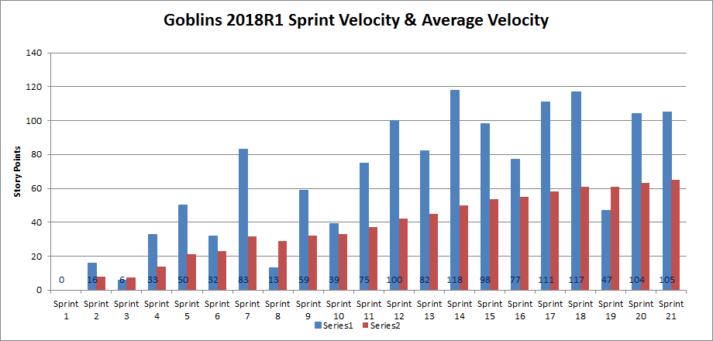

## **Focus Factor**

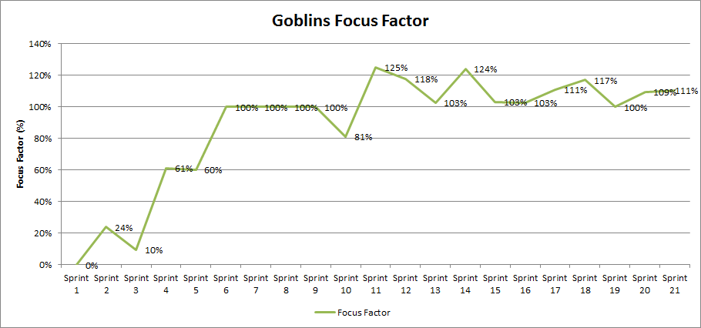

# Q&A

# Recording

N/A

**Retrospection:-**

| **Date:** | 20 Jun 2018 |
| --- | --- |
| **Attendees** | | **Absent** |
| [Yendluri, Vemana Narayanan](https://confluenceglobal.experian.local/confluence/display/~c20893a)  [Gudisi, Diwakar](https://confluenceglobal.experian.local/confluence/display/~c21757a)  [Mallina, Moulikrishnan](https://confluenceglobal.experian.local/confluence/display/~c20796a)  [Chopra, Naman](https://confluenceglobal.experian.local/confluence/display/~c21204a)  [Guha, Swapnadeep](https://confluenceglobal.experian.local/confluence/display/~c22256a)  [Anvesh, Kathuri](https://confluenceglobal.experian.local/confluence/display/~c21044a)  [Paul, Jeejo](https://confluenceglobal.experian.local/confluence/display/~c22663a)  [Vedullapalli, Satya Venkata Venugopal](https://confluenceglobal.experian.local/confluence/display/~c20889a)  [Kometireddy, Navaneeswar Reddy](https://confluenceglobal.experian.local/confluence/display/~c20692a)  [Upari, Preeti](https://confluenceglobal.experian.local/confluence/display/~c20891a)  [Paul, Jeejo](https://confluenceglobal.experian.local/confluence/display/~c22663a) | |  |

# Start:

# Continue:

1. Follow up on the comments mentioned on Sonar Dashboard by security champions.

# Action: