Question 11

Write a menu program for calculating Area of circle, square, triangle

According to user choice?

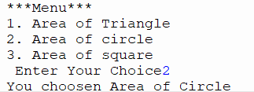

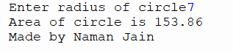

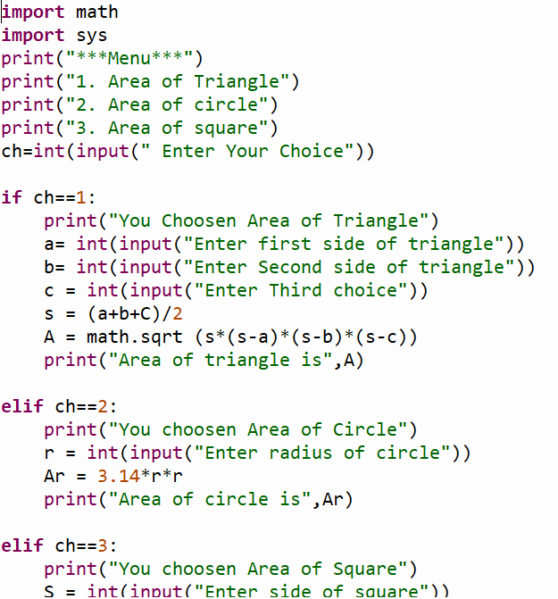,

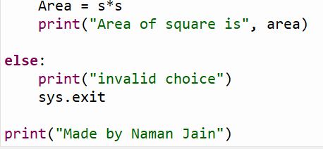

Question 12

Write a python program to display first five no using While Loop?

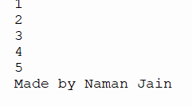

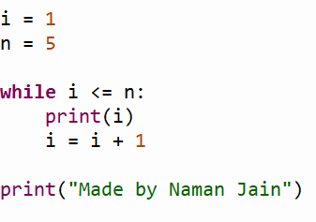

Question 13

Write a Python code to obtain a number from the user and display its factor?

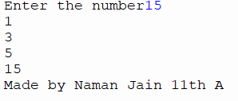

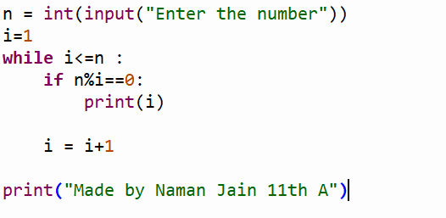

Question 14

Write a Python code to obtain a number from the user and then display the sum of its odd and even digits respectively

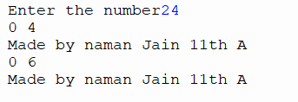

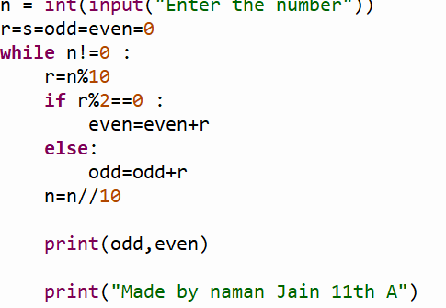

Question 15

Write a python program to find the sum of an integer number, input by user?

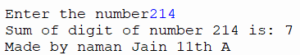

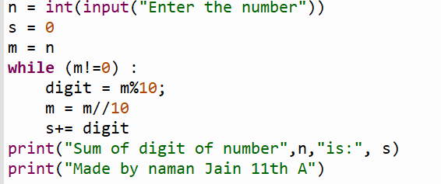

Question:16

Write a Python program to display the number pyramid

Til n number

1

1 3

1 3 5

1 3 5………n

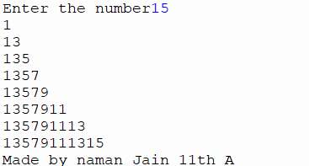

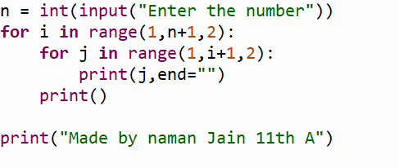

Question:17

Write a python program to display a number pyramid

Of: 1

1 2

1 2 3

1 2 3 4……….9

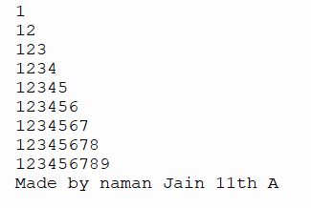

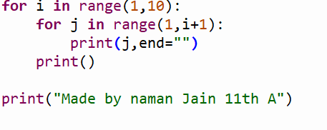

Question:17

Display this number pyramid using a nested loop:

1 2 3 4 5

1 2 3 4

1 2 3

1 2

1

